Biogeographia – The Journal of Integrative Biogeography 2025, 40 (2): a048
https://doi.org/10.21426/B6.47132

Genetic insights into the identity and distribution of
Tarentola spp. geckos on Lampedusa island

Emiliano MORI^{1,2}, Leonardo ANCILLOTTO^{1,2}, Matteo Riccardo DI NICOLA³, Luca VECCHIONI⁴, Francesco Paolo FARAONE^{4,*}

¹ Consiglio Nazionale Delle Ricerche, Istituto Di Ricerca Sugli Ecosistemi Terrestri, Via Madonna del Piano 10, 50019 Sesto Fiorentino, Firenze, Italy
² National Biodiversity Future Center, Piazza Marina 61, 90133 Palermo, Italy
³ Istituto Zooprofilattico Sperimentale del Piemonte, Liguria e Valle d’Aosta, Via Bologna 148, 10154 Turin, Italy
⁴ University of Palermo, Department of Biological, Chemical and Pharmaceutical Sciences and Technologies (STEBICEF), Via Archirafi 18, 90123 Palermo, Italy

* corresponding author, email: francescopaolo.faraone@unipa.it

Keywords: alien species, lizard, man-mediated dispersion, Phyllodactylidae, Sicily Channel.

SUMMARY
The Sicily Channel islands are known as biogeographic crossroads between European and African fauna. In this context, Lampedusa hosts a mainly Maghrebian herpetofauna, among which a Moorish gecko (sensu lato) belonging to a North African species-rank clade, provisionally named "Tarentola fascicularis/deserti" (sensu Rato et al., 2017). Here, we investigated the distribution of Tarentola spp. using the 16S mitochondrial DNA fragment on individuals from Lampedusa and verified the possible occurrence of T. mauritanica. This is a widely introduced species, hardly distinguishable based on morphological traits from T. fascicularis/deserti. Our molecular results support the hypothesis that both T. fascicularis/deserti and T. mauritanica occur in Lampedusa. Furthermore, nine out of eleven sequences are lumped together with T. fascicularis/deserti clade, suggesting the natural biogeographic connection between Tunisia and Lampedusa. Conversely, the detection of T. mauritanica haplotypes, exclusively within the Lampedusa port area, strongly point out a recent human-mediated introduction of the species. The finding of these two distinct mitochondrial lineages suggests the co-occurrence of African and European dispersion routes in the extant Lampedusa herpetofauna. In light of this, it is necessary to increase sampling efforts to other islands across Sicily Channel to better assess the origin and phylogenetic relationships of gecko populations.

INTRODUCTION
Islands, often described as natural laboratories, actually represent a unique context to understand biogeographic patterns and ecological processes (Whittaker et al., 2017). These isolated ecosystems, characterised by high levels of endemism and unique speciation events (Matthews and Triantis, 2021), are often also biodiversity hotspots. They also play a pivotal role as refuges and stopover sites for migratory species, thus contributing to global biodiversity networks (Moore et al., 1990; Sheehy et al., 2011). However, their sensitivity to environmental changes, particularly climate change and sea-level rise, makes them early indicators of broader global impacts (Kelman and West, 2009). The Mediterranean region, with its numerous small islands and archipelagos, offers a paramount example of these ecological dynamics. The Sicily Channel serves as a biogeographic crossroads, hosting a unique admixture of European and African flora and fauna (Fichera et al., 2022; Antinucci et al., 2024; Belluardo et al., 2024). These islands, though biogeographically significant, face increasing pressure from human activities, such as tourism, climate change-induced challenges, and possibly alien species introduction (Faraone et al., 2019; Surico, 2020).
Despite their ecological importance, detailed knowledge about the faunal and floral assemblages of these Palearctic islands remains limited (Angelici et al., 2009; Fichera et al., 2022; Sciandra et al., 2022). Comprehensive studies are necessary to understand their role as corridors for species dispersal and potential outposts for colonisation, especially in the context of climate change.
Lampedusa, the largest of the Italian Pelagie islands, provides an ideal model for such investigations (Surico, 2020), as hosting a unique herpetofauna, mostly composed by African taxa showing their only Italian population on the island [i.e., the Algerian psammodromus Psammodromus algirus (Linnaeus, 1758), the North African green toad Bufotes boulengeri boulengeri (Lataste, 1879), the Eastern Montpellier snake Malpolon insignitus (Geoffroy Saint-Hilaire, 1809) and the false smooth snake Macroprotodon cf. cucullatus (Geoffroy Saint-Hilaire, 1827) (Harris et al., 2009a; Nicolas et al., 2018; Faraone et al., 2020a, 2022)]. Gekkota species occurring in the island include the Mediterranean Turkish gecko Hemidactylus turcicus (Linnaeus, 1758) and a Moorish gecko (sensu lato) belonging to an unresolved North African clade here named “Tarentola fascicularis/deserti” following Rato et al. (2012) (see also Harris et al., 2009b; Belluardo et al., 2024). Recently, Rato et al. (2012) highlighted a great cryptic diversity within the genus Tarentola across the Mediterranean basin, including the “Tarentola fascicularis/deserti” clade, a monophyletic unit which encompasses specimens previously assigned to both T. fascicularis (Daudin, 1802) and T. deserti Boulenger, 1891. A strong pattern of hidden diversity is also noticeable for T. mauritanica (Linnaeus, 1758), which subsequently turned out to be a complex of six species-rank clades (Rato et al., 2016). Colonisation routes of T. mauritanica suggest the possible occurrence of this taxon in Lampedusa too (Rato et al., 2023). On two other islands located in the Sicily Channel, Linosa and Malta, only T. mauritanica is known to occur (Stöck et al., 2016), and in Pantelleria both Tarentola species have been recently recorded (Antinucci et al., 2024). Morphological features to distinguish between T. mauritanica and T. fascicularis/deserti are subtle and to date debatable (Sarra et al., 2013). For instance, T. fascicularis/deserti is generally more brightly coloured than T. mauritanica, but it often exhibits a more uniform coloration with less variation in pattern. Conversely, T. mauritanica can have more variable coloration with darker markings and spots. In T. fascicularis/deserti, the rostral scale is in direct contact with the nostril (Fig. 1), whereas the average number of interorbital scales is lower compared to T. mauritanica. Tarentola fascicularis/deserti tends to have a slender body shape compared to T. mauritanica, which is typically more robust. Lastly, T. fascicularis/deserti often have golden/brownish eyes, lighter in colour than T. mauritanica (Joger and Bshaenia, 2010; Aprea et al., 2011; Sarra et al., 2013) (Fig. 1). Since some of these traits are not strongly diagnostic, genetic analyses emerge as the most reliable system to distinguish between these species.

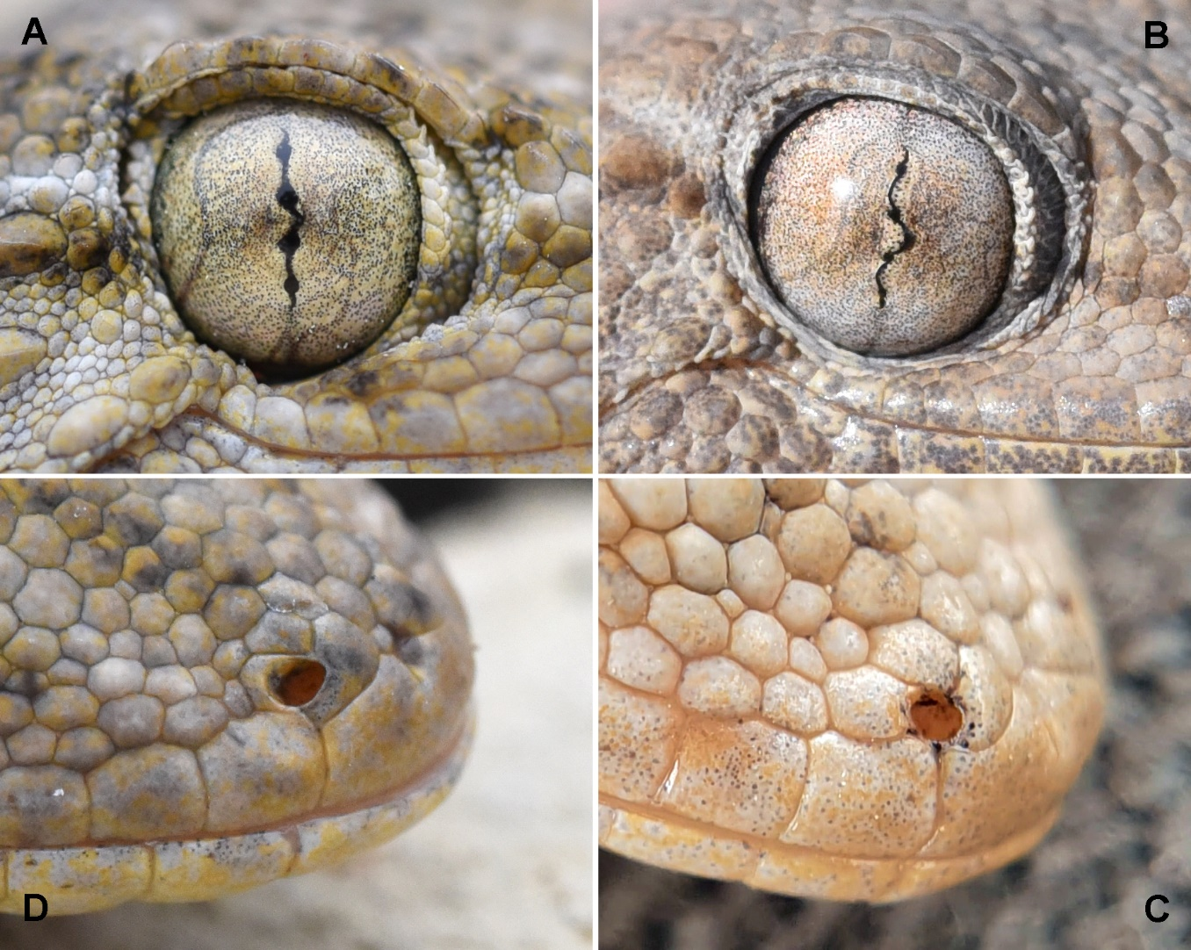

Figure 1. Photo details of the two “Moorish gecko” species present in Lampedusa. A, Tarentola mauritanica eye detail; B, T. fascicularis/deserti eye detail; C, T. fascicularis/deserti nostril and rostral scale detail; D, Tarentola mauritanica nostril and rostral scale detail.

In the present study, we increased the sampling of Tarentola specimens from Lampedusa to investigate the potential distribution of different genetic clades in the study area. Individuals were sampled both in urbanised (where introductions may have occurred) and in natural habitats. We hypothesised that both Tarentola taxa may occur in Lampedusa, with T. mauritanica restricted to urban environments (e.g., due to its putative recent, human-mediated introduction, see also Harris et al., 2004).

MATERIALS AND METHODS
Sampling
To build a genetic dataset, we sampled 11 Tarentola individuals from 11 locations within Lampedusa island, spanning from Spring 2023 to Autumn 2024, including the port and the town centre (Fig. 2). The individuals were captured by hand during both nocturnal and diurnal searches by hand. After capture, the terminal 2 cm of the tail was clipped and preserved in absolute ethanol. No animals were sacrificed to accomplish this study.

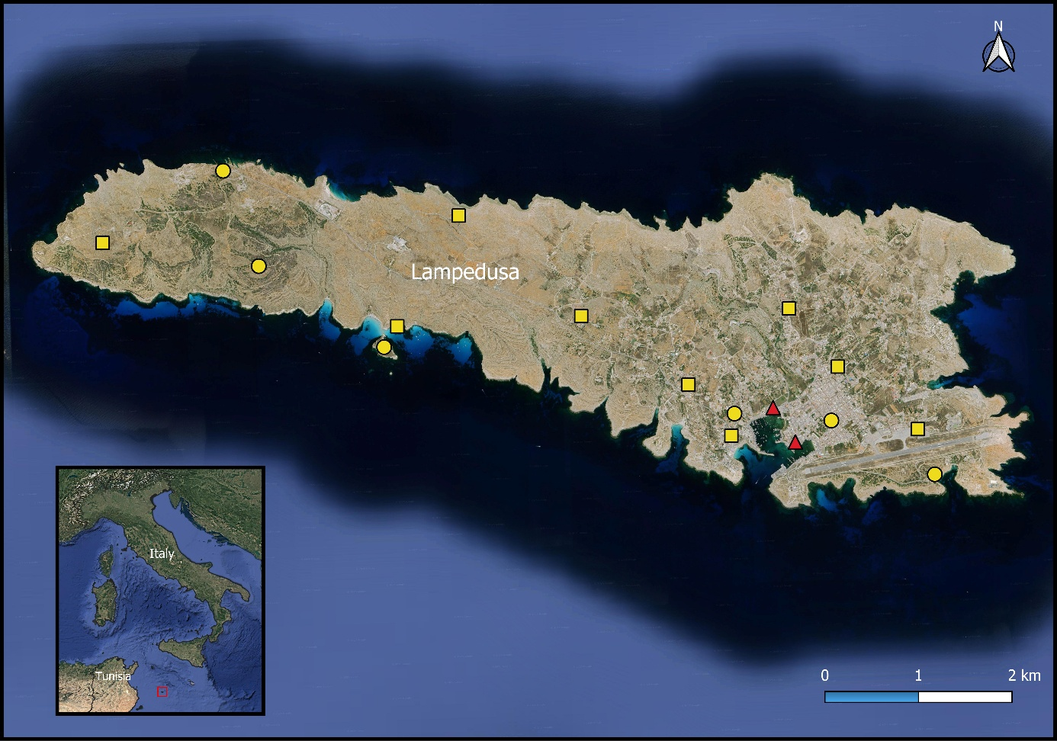

Figure 2. Distribution of sampled localities in Lampedusa and Conigli islands. Yellow dots refer to Tarentola fascicularis/deserti previously published records (Harris et al., 2009b; Rato et al., 2010, 2012; Stöck et al., 2016); yellow squares refer to T. fascicularis/deserti novel records; red triangles refer to T. mauritanica novel records.

Genetic analyses
DNA extraction was performed on a small tissue sample taken from the tails of each of the collected specimens. Prior to DNA extraction, the tissue was carefully cleaned and soaked in double-distilled water for 5 minutes, followed by processing using the BIORON GmbH “Ron’s Tissue DNA Mini Kit”. The primer pair 16sar-L and 16sbr-H (Palumbi et al., 1991) was used to amplify a fragment of the large ribosomal subunit 16S rRNA (16S). The composition of the polymerase chain reaction (PCR) mix and thermal cycling were performed according to Antinucci et al. (2024). The obtained chromatograms showed no peak ambiguities. All novel 16S rRNA sequences were uploaded to GenBank (Accession Numbers, A.N.s: PV715685-PV715695). These sequences were analysed and manually proofread using Chromas v. 2.6.2 (Technelysium Pty. Ltd., 1998, Queensland, Australia) and aligned using MEGA12 (Kumar et al., 2024).
The molecular identification of the specimens and the reconstruction of their phylogenetic relationships were performed using Bayesian Inference (BI) and Maximum Likelihood (ML) methods, implemented in MrBayes v. 3.2.7 (Ronquist et al., 2012) and PhyML v. 3.0 (Guindon et al., 2010), respectively. Branch support was assessed by reporting posterior probability values on the BI tree and calculating bootstrap values with 1000 replicates on the ML tree (Felsenstein, 1985). The optimal evolutionary model was selected from those analysed by MrBayes, using the Bayesian model choice criteria (nst = mixed, i.e., GTR+I+Γ) and then selected also in the ML analysis. In the BI analyses, two independent Markov Chain Monte Carlo analyses were run with one million generations (4 chains, temp.: 0.2; default priors). Trees and parameter values were sampled every 100 generations, resulting in 10.000 saved trees per analysis. Once convergence was reached (Effective Sample Size above 200), 2500 trees were conservatively discarded as “burn-in”.

RESULTS
Overall, 11 novel 16S sequences were obtained and included in the analyses, along with an additional 119 comparison sequences previously published and downloaded from GenBank (see Fig. 3 for their A.N.s). The length of the readable 16S PCR products ranged from 510 to 570 bp. After trimming the tails of the sequences, a 16S alignment of 464 bp was obtained. The phylogenetic trees based on BI and ML analyses, rooted on Tarentola chazaliae (Mocquard, 1895) (A.N., JQ300955 see also Fig. 3), showed topologies congruent with the currently known phylogenetic relationships of the analysed taxa (see Rato et al., 2012; Antinucci et al., 2024).
Nine of the 11 novel sequences from Lampedusa clustered with the clade VIII (sensu Rato et al., 2012) of the Tarentola fascicularis/deserti lineage, along with other samples from Lampedusa, Libya and Tunisia. Conversely, two sequences (GenBank A.N.s, PV715694-PV715695) fell into clade VI, which includes T. mauritanica samples from Morocco, Tunisia and all the European populations analysed (Italy, Malta, Spain), sharing the same haplotype. Both sequences in clade VI were obtained from individuals sampled at the port of Lampedusa (Fig. 2, 3).
Figure 3. Bayesian phylogram of Tarentola spp. based on a 464-bp fragment of the mtDNA 16S. A sample of T. chazaliae (Mocquard, 1895) (GenBank Accession Number, A.N.: JQ300955) was used as outgroup to root the tree. Node statistical support is reported as nodal posterior probabilities (Bayesian inference of phylogeny, BI)/bootstrap values (Maximum Likelihood, ML). Asterisks indicate bootstrap support values lower than 50. Rectangles group the samples according to their major clustering reported in Rato et al. (2012). The analysed specimens are reported using the A.N.s. The novel sequences are reported in bold.
DISCUSSION
Our work provided additional information on the genetic diversity of Tarentola geckos in the southernmost islands of Europe, highlighting the importance of these areas as a potential zone of species overlap and introduction. The obtained molecular results confirm the presence of two distinct genetic lineages of species rank within Lampedusa, supporting the hypothesis that both T. fascicularis/deserti and T. mauritanica occur on the island. The clustering of nine out of eleven sequences with T. fascicularis/deserti, along with samples from Libya and Tunisia, confirmed the natural biogeographic connection between North Africa and Lampedusa. This observation aligns with previous studies which emphasised the role of the Sicily Channel as a transitional zone between European and African fauna (Ancillotto et al., 2020; Faraone et al., 2020b; Fichera et al., 2022; Antinucci et al., 2024). Conversely, the biogeographic pattern of Tarentola geckos on Lampedusa is the opposite of the one observed in Pantelleria, which is located 160 km north to Lampedusa, where the European species is the most widely distributed and the African clade is very localised (Antinucci et al., 2024). The detection of T. mauritanica haplotypes exclusively within Lampedusa human settlements (i.e., in the port area) strongly suggests a recent human-mediated introduction of the species, likely through maritime routes (Mori and Plebani, 2012; Mori et al., 2022; Rato et al., 2023; Giacalone et al., 2024), as occurred with other lizards on the island (Lo Valvo and Nicolini, 2001; Lo Cascio et al., 2005). This is consistent with prior research, which has documented the anthropogenic dispersal of T. mauritanica across Mediterranean islands, particularly in urbanised settings (Harris et al., 2004). Such introductions raise important issues about potential ecological interactions between native and introduced species, as well as the long-term implications for Lampedusa herpetofauna assemblage. While T. fascicularis/deserti appears to be the naturally occurring taxon in the island’s less disturbed environments, further studies are needed to assess whether competitive displacement or potential hybridisation events may occur between the two species (Di Nicola et al., 2021).
The morphological similarities between Tarentola mauritanica and T. fascicularis/deserti add another layer of complexity to species identification in the field. As previously noted, minor variations in coloration, body shape, and head scales are often subtle and subject to individual variation (Joger and Bshaenia, 2010; Aprea et al., 2011; Sarra et al., 2013). Consequently, the use of genetic analyses is confirmed to be the most reliable method currently available for distinguishing amongst these taxa. The molecular approach used in this study not only reinforces the taxonomic status of the sampled individuals but also demonstrates the necessity of expanding genetic surveys to other nearby islands, e.g., Pantelleria, where similar taxonomic uncertainties occur (Rato et al., 2023; Antinucci et al., 2024;).
Our findings carry some potential conservation implications. The introduction of non-native species, particularly in ecologically fragile island environments, can lead to unforeseen disruptions in local ecosystems. Although Tarentola mauritanica, with few recent exceptions (see Renet et al., 2024), is not typically considered an invasive threat, its presence in Lampedusa raises concerns about potential competition with T. fascicularis/deserti, which has a more restricted range in the Mediterranean region (Di Nicola et al., 2021). Future monitoring efforts should focus on understanding population dynamics, habitat preferences, and potential interspecific interactions to evaluate whether conservation measures, such as controlling human-mediated dispersal, are necessary.
Additionally, the study highlights the broader importance of Mediterranean islands in tracking historical biogeographic patterns (Sciandra et al., 2022). The genetic links between Tarentola fascicularis/deserti populations from Lampedusa and North Africa provide further evidence of past dispersal routes and colonisation events during the Pleistocene (Rato et al., 2023). These findings enhance our understanding of how climate oscillations and sea-level fluctuations have historically shaped species distributions in the region. Given that island ecosystems are particularly vulnerable to climate change and anthropogenic disturbances, continued research is essential to assess how future environmental shifts may influence the composition and survival of native and introduced taxa.
In conclusion, this study confirmed the role of Lampedusa as a milestone for understanding Mediterranean biogeography and species dispersal in reptile taxa. The identification of two distinct genetic lineages within Tarentola populations not only confirms the co-occurrence of African and European dispersion routes in Lampedusa herpetofauna but also underscores the need for ongoing conservation and monitoring efforts. Future studies should aim to expand sampling efforts to other islands across the Sicily Channel to better define the phylogenetic relationships and origin of their gecko populations.

ACKNOWLEDGMENTS
We are grateful to Federico Marrone for his precious recommendations and to Elena Prazzi, Angelo Dimarca, and the “Isola di Lampedusa” Nature Reserve (Legambiente) for their generous availability, collaboration, and permits. Fabrizio Gili and Pietro Di Bari assisted us in data collection. Samplings were carried out with permissions from the Italian Environment Ministry and Sicilian Regional Government under the following permit numbers: Prot. ISPRA prot. N. 10201, 24/03/2021 and Regione Siciliana Prot. N. 0039049, 15/04/2021; MASE prot N. 0144175, 02/08/2024. LV was supported by the fund “NextGenerationEU” of the European Union (D.M. 737/2021—CUP B79J21038330001). EM and LA were funded by the National Recovery and Resilience Plan (NRRP), Mission 4 Component 2 Investment 1.4 - Call for tender No. 3138 of 16 December 2021, rectified by Decree n.3175 of 18 December 2021 of Italian Ministry of University and Research funded by the European Union – NextGenerationEU; Project code CN_00000033, Concession Decree No. 1034 of 17 June 2022 adopted by the Italian Ministry of University and Research, CUP B83C22002930006, Project title “National Biodiversity Future Center - NBFC”.

REFERENCES
Angelici, F.M., Laurenti, A., Nappi, A. (2009) A checklist of the mammals of small Italian islands. Hystrix, 20, 3–27. DOI: 10.4404/hystrix-20.1-4429
Antinucci, C., Gallozzi, F., Castiglia, R. (2024) Geckos on the borders: genetic evidence on co-occurrence of two species of wall geckos, genus Tarentola, on the island of Pantelleria, Italy. Herpetology Notes, 17, 395–402.
Aprea, G., Lo Cascio, P., Corti, C., Zuffi, M.A.L. (2011) Tarentola mauritanica (Linnaeus, 1758). In: Fauna d’Italia, Reptilia, vol. XLV. (ed. by C. Corti, M. Capula, L. Luiselli, E. Razzetti and R. Sindaco), pp. 277–285. Edizioni Calderini, Bologna.
Belluardo, F., Pellitteri‐Rosa, D., Cocca, W., Liuzzi, C., Rato, C., Crottini, A., Bellati, A. (2024) Multilocus phylogeography of Italian Moorish geckos adds insights into the evolutionary history of European populations. Zoologica Scripta, 53, 129–141. DOI: 10.1111/zsc.12642
Di Nicola, M.R., Cavigioli, L., Luiselli, L., Andreone, F. (2021) Anfibi & Rettili d’Italia. Edizione aggiornata. Edizioni Belvedere, Latina.
Faraone, F.P., Barraco, L., Giacalone, G., Muscarella, C., Schifani, E., Vecchioni, E. (2019) First records of the Brahminy blind snake, Indotyphlops braminus (Daudin, 1803) (Squamata: Typhlopidae), in Italy. Herpetology Notes, 12, 1225–1229.
Faraone, F.P., Melfi, R., Di Nicola, M.R., Giacalone, G., Lo Valvo, M. (2020a) The genetic identity of the only Italian population of the genus Macroprotodon Guichenot, 1850 on the island of Lampedusa, Sicily. Vertebrate Zoology, 70, 235–240. DOI: 10.26049/VZ70-2-2020-09
Faraone, F.P., Melfi, R., Di Nicola, M.R., Giacalone, G., Lo Valvo, M. (2020) Phylogenetic relationships of the Italian populations of Horseshoe Whip Snake Hemorrhois hippocrepis (Serpentes, Colubridae). Acta Herpetologica, 15, 129–135. DOI: 10.13128/a_h-9058
Faraone, F.P., Melfi, R., Di Nicola, M.R., Giacalone, G., Lo Valvo, M. (2022) Phylogenetic affinities of the Italian population of Eastern Montpellier snake, Malpolon insignitus (Serpentes: Lamprophiidae): Phylogenetic relationship of the Italian population of Malpolon insignitus. Herpetology Notes, 15, 711–715.
Felsenstein, J. (1985) Confidence limits on phylogenies: an approach using the bootstrap. Evolution, 39, 783–91. DOI: 10.2307/2408678
Fichera, G., Mucedda, M., Russo, D., Tomassini, A., Kiefer, A., Veith, M., Ancillotto, L. (2022) Pantelleria island (Sicily, Italy): a biogeographic crossroad for bats between Africa and Europe. Hystrix, 33, 135–138. DOI: 10.4404/hystrix-00503-2021
Giacalone, G., Faraone, F.P., Pecoraro, M., Sarà, M. (2024) Hidden in the bark: the unexpected presence of the leaf-toed gecko, Euleptes europaea (Gené, 1839) (Squamata, Sphaerodactylidae), in Sicily. Biogeographia - The Journal of Integrative Biogeography, 39, a036. DOI: 10.21426/B639263791
Guindon, S., Dufayard, J.F., Lefort, V., Anisimova, M., Hordijk, W., Gascuel, O. (2010) New algorithms and methods to estimate Maximum-Likelihood phylogenies: assessing the performance of PhyML 3.0. Systematic Biology, 59, 307–321. DOI: 10.1093/sysbio/syq010
Harris, D.J., Batista, V., Lymberakis, P., Carretero, M.A. (2004) Complex estimates of evolutionary relationships in Tarentola mauritanica (Reptilia: Gekkonidae) derived from mitochondrial DNA sequences. Molecular Phylogenetics and Evolution, 30, 855–859. DOI: 10.1016/S1055-7903(03)00260-4
Harris, D.J., Corti, C., Carretero, M.A., Perera, A., Lo Cascio, P. (2009a) Unexpected phylogeographic affinities of Psammodromus algirus from Conigli islet, Lampedusa. Acta Herpetologica, 4, 1–6. DOI: 10.1312
8/Acta_Herpetol-2949
Harris, D.J., Carretero, M.A., Corti, C., Lo Cascio, P. (2009b) Genetic affinities of Tarentola mauritanica (Reptilia: Gekkonidae) from Lampedusa and Conigli Islet (SW Italy). NW Journal of Zoology, 5, 197–205.
Joger, U., Bshaenia, I. (2010) A new Tarentola subspecies (Reptilia: Gekkonidae) endemic to Tunisia. Bonn Zoological Bulletin, 57, 267–274.
Kelman, I., West, J.J. (2009) Climate change and small island developing states: a critical review. Ecological and Environmental Anthropology, 5, 1–16. DOI: 10.1146/annurev-environ-012320-083355
Kumar, S., Stecher, G., Suleski, M., Sanderford, M., Sharma, S., Tamura, K. (2024) MEGA12: molecular evolutionary genetic analysis version 12 for adaptive and green computing. Molecular Biology and Evolution, 41, 1–9. DOI: 10.1093/MOLBEV/MSAE263
Lo Cascio, P., Corti, C., Billeci, V., Nicolini, G. (2005) “First came, first served”, or recent introduced lizard populations of Lampedusa Island (S Italy). In: 13th Ordinary General Meeting, Bonn (2005), Programme and Abstracts.
Lo Valvo, M., Nicolini, G. (2001) Presenza di una piccola popolazione di Lucertola campestre Podarcis sicula (Rafinesque Schmaltz, 1810) sull’isola di Lampedusa (Isole Pelagie). Naturalista siciliano, 25, 95–97.
Matthews, T.J., Triantis, K. (2021) Island biogeography. Current Biology, 31, 1201–1207. DOI: 10.1016/j.cub.2021.07.033
Moore, F.R., Kerlinger, P., Simons, T.R. (1990) Stopover on a Gulf coast barrier island by spring trans-Gulf migrants. The Wilson Bulletin, 2, 487–500.
Mori, E., Plebani, M. (2012) First records of Moorish gecko Tarentola mauritanica and Turkish gecko Hemidactylus turcicus (Squamata, Gekkonidae) in the Southern Metalliferous Hills, Tuscany, Italy. Atti della Società Toscana di Scienze Naturali, Memorie, 119, 51–54. DOI: 10.2424/ASTSN.M.2012.07
Mori, E., Andreone, F., Viviano, A. et al. (2022) Aliens coming by ships: distribution and origins of the ocellated skink populations in peninsular Italy. Animals, 12, 1709. DOI: 10.3390/ani12131709
Nicolas, V., Mataame, A., Crochet, P.A., Geniez, P., Fahd, S., Ohler, A. (2018) Phylogeography and ecological niche modeling unravel the evolutionary history of the African green toad, Bufotes boulengeri boulengeri (Amphibia: Bufonidae), through the Quaternary. Journal of Zoological Systematics and Evolutionary Research, 56, 102–116. DOI: 10.1111/jzs.12185
Palumbi, S.R., Martin, A.P., Romano, S.L., McMillan, W.O., Stice, L., Grabowski, G. (1991) The Simple Fool’s Guide to PCR. University of Hawaii, Honolulu.
Rato, C., Carranza, S., Perera, A., Carretero, M.A., Harris, D.J. (2010) Conflicting patterns of nucleotide diversity between mtDNA and nDNA in the Moorish gecko, Tarentola mauritanica. Molecular Phylogenetics and Evolution, 56, 962–971. DOI: 10.1016/j.ympev.2010.04.033
Rato, C., Carranza, S., Harris, D.J. (2012) Evolutionary history of the genus Tarentola (Gekkota: Phyllodactylidae) from the Mediterranean Basin, estimated using multilocus sequence data. BMC Evolutionary Biology, 12, 1–12. DOI: 10.1186/1471-2148-12-14
Rato, C., Harris, D.J., Carranza, S., Machado, L., Perera, A. (2016) The taxonomy of the Tarentola mauritanica species complex (Gekkota: Phyllodactylidae): Bayesian species delimitation supports six candidate species. Molecular Phylogenetics and Evolution, 94, 271–278. DOI: 10.1016/j.ympev.2015.09.008
Rato, C., Deso, G., Renet, J., Delaugerre, M.J., Marques, V., Mochales-Riaño, G. (2023) Colonization routes uncovered in a widely introduced Mediterranean gecko, Tarentola mauritanica. Scientific Reports, 13, 16681. DOI: 10.1038/s41598-023-43704-8
Renet, J., Dokhelar, T., Dubos, N. (2024) One gecko’s pain is another gecko’s gain: is the Moorish gecko Tarentola mauritanica becoming invasive in France? Herpetological Journal, 34, 84–91. DOI: 10.33256/34.2.8491
Ronquist, F., Huelsenbeck, J., Teslenko, M. (2011) MrBayes Version 3.2 Manual: Tutorials and Model Summaries, Manual MrBayes.
Sarra, F., Nabil, A., Rached, G., Khaled, S. (2013) Relationships of the Moorish Gecko Tarentola mauritanica sensu lato (Reptilia, Phyllodactylidae) populations in Tunisia: morphometric and karyological assessment. Annales Zoologici, 63, 149–156. DOI: 10.3161/000345413X666192
Sciandra, C., Mori, E., Solano, E., Mazza, G., Viviano, A., Scarfò, M., Bona, F., Annesi, F., Castiglia, R. (2022) Mice on the borders: genetic identification of rat and house mouse species in Lampedusa and Pantelleria islands (Southern Italy). Biogeographia - The Journal of Integrative Biogeography, 37, a013. DOI: 10.21426/B637155716
Sheehy, J., Taylor, C.M., Norris, D.R. (2011) The importance of stopover habitat for developing effective conservation strategies for migratory animals. Journal of Ornithology, 152, 161–168. DOI: 10.1007/s10336-011-0682-5
Stöck, M., Grifoni, G., Armor, N., Scheidt, U., Sicilia, A., Novarini, N. (2016) On the origin of the recent herpetofauna of Sicily: comparative phylogeography using homologous mitochondrial and nuclear genes. Zoological Anzeiger, 3, 70–81. DOI: 10.1016/j.jcz.2015.10.005
Surico, G. (2020) Lampedusa: dall’agricoltura, alla pesca, al turismo. Firenze University Press, Firenze.
Whittaker, R.J., Fernández-Palacios, J.M., Matthews, T.J., Borregaard, M.K., Triantis, K.A. (2017) Island biogeography: taking the long view of nature’s laboratories. Science, 357, eaam8326. DOI: 10.1126/science.aam8326

Submitted: 2 April 2025
First decision: 13 May 2025
Accepted: 3 June 2025
Published online: 2 July 2025
Edited by Federico Marrone

