The divergent orientations of the buildings of the Franciscan complex of San Gabriel Cholula, Puebla, Mexico

Arturo I. Gómez-Ruiz
CONAHCYT-Instituto Nacional de Astrofísica, Óptica y Electrónica
Antonio P. Molero Sañudo
Independent researcher

Abstract:
The Franciscan complex of San Gabriel in Cholula was one of the first establishments of the order of minor friars in New Spain. Its buildings were erected on the ruins of the pre-Hispanic ritual complex dedicated to the god Quetzalcóatl, using the materials from the old temple and annex buildings. The particularity of the structures built by instruction of the Franciscans is that they do not follow the orientation of the layout of the Cholula city, which is apparently solstitial, and therefore has given rise to multiple speculations in the studies of Cholula. In the present investigation we show evidence that the Royal Chapel of the architectural complex has a temporal orientation coinciding with the so-called sacred orientation of Teotihuacan, while the convent temple presents an orientation that is difficult to interpret, but where one of the definitions of equinox and the date of the patron saint's holiday are possible explanations.

Keywords: architecture, archaeoastronomy, calendrics, Cholula, Franciscans

Introduction
The presence of the Franciscan order in Puebla dates back to 1524, the year in which it is known that these missionaries arrived in the New Spain territory. The first convent to be established in this region was that of Huexotzingo, from where the friars made visits to Cholula, a place where they settled definitively towards the end of 1548 (Morales, 2005, p. 13). One of the first mentions of the construction of the Franciscan convent in Cholula is found in the royal decree of August 24, 1529 (Archivo General de Indias, México, 1088, L1, F.48V-49V), in which Queen Isabel of Portugal ordered to give the Franciscan friars the amount of 500,000 maravedis, for the work of the convents that were built in several provinces of New Spain, including Cholula. This grant is equivalent to 5% of the average annual income (in the period 1522-1531) of the Royal Treasury of New Spain (once subtracted what was remitted to the metropolis), or three times the cost of a transatlantic commercial shipment carried out during the last quarter of the 16th century (estimates based on the appendices of Martínez, 2001, pp. 324-338). This amount of money, although considerable, when divided among the various provinces (the royal decree mentions six in total: Cholula, Michoacán, Tlalmanalco, Acapistla, Villa Rica and Cempoala), could only have been enough for the first provisional buildings, basilica type, made of wooden beams (these first churches are described in Ledesma, 2016, pp. 23-36).

One of the first testimonies of the beginning of the construction of the definitive convent of lime and stone is found in a note from the royal treasurer, Juan Alfonso de Sosa, dated 1550, in which it is reported that that same year resources were granted to the administrator of the order of San Francisco, with the objective of acquiring the necessary instruments to carve the stone and the construction of the enclosure (Morales, 2005, p. 13). Two years later, in 1552, the councilors and mayors of the city sent a letter to Emperor Charles V in which they reported having built a temple for divine service and worship, stating that it was the most sumptuous and expensive existing in all of New Spain (Morales, 2005, p. 14). In the same letter, the intention to make buildings, streets, council houses and audiences in the style of Spain is announced. That is, the starting point of the new city would be the already built convent. With these data, it is estimated that the first construction stage of the Franciscan convent of San Gabriel de Cholula, made of lime and stone, was carried out between 1549 and 1552. Figure 1 shows what the convent temple looks like today. Particularly noteworthy is the platform that was possibly part of the pre-Hispanic building worshiping Quetzalcoatl, detailed later in the text.
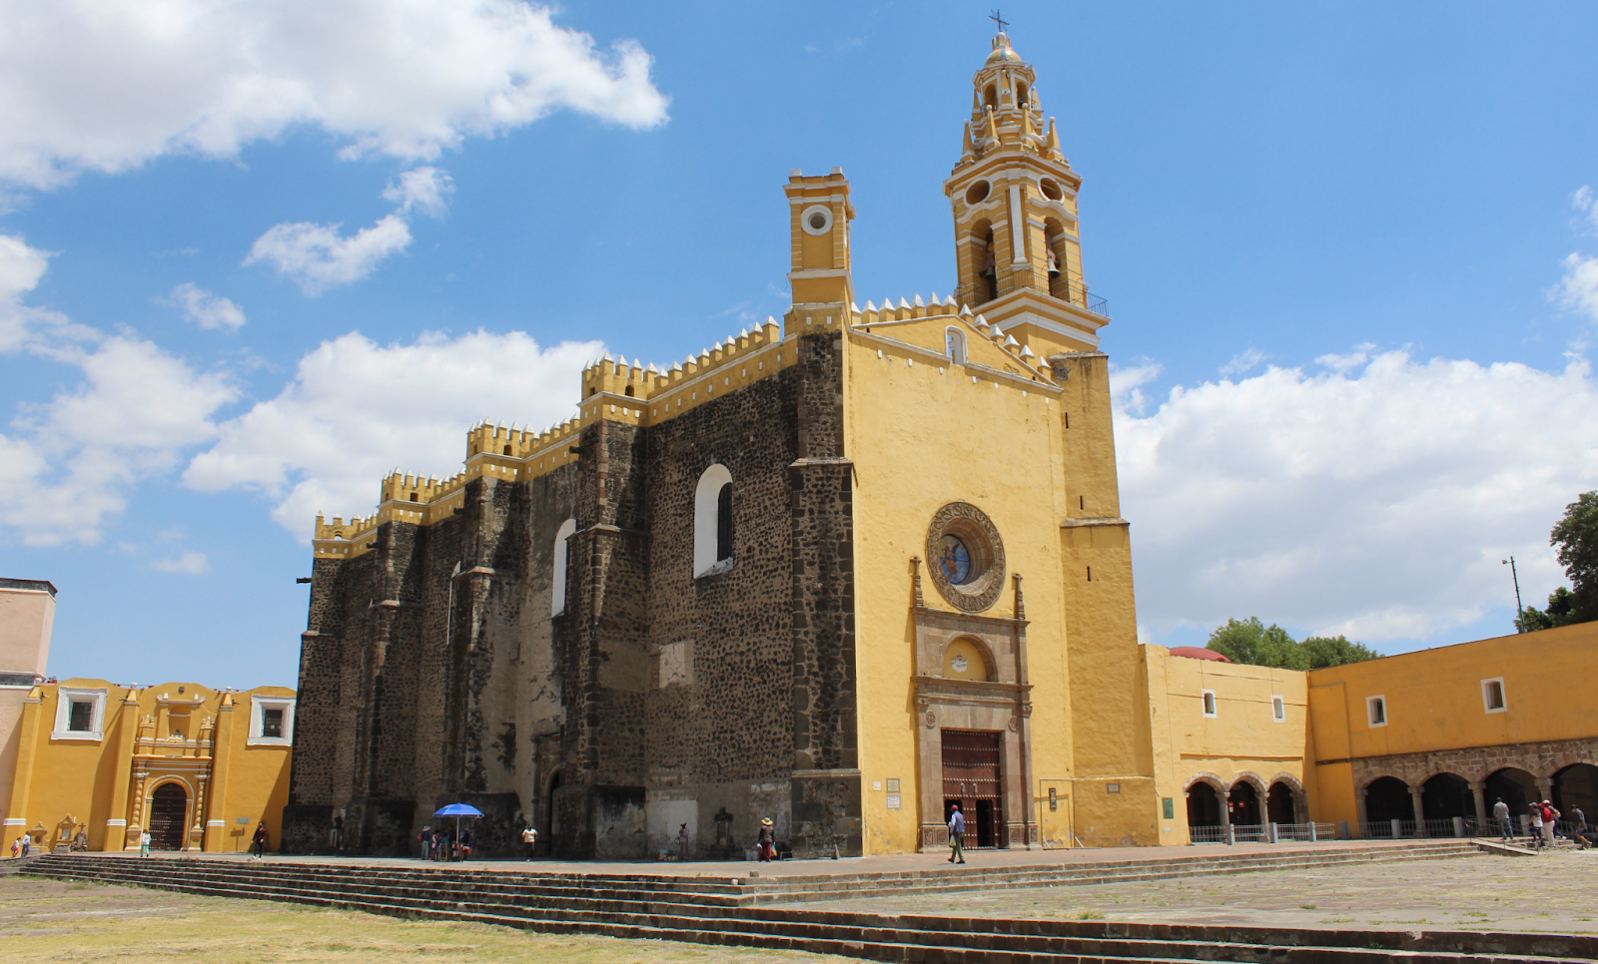
Figure 1. Convent temple of San Gabriel Cholula. On the right side it can be seen the access to the cloister and the pilgrim portal, while in the background on the left is the Chapel of the Third Order. Photo: A. Gómez.

The Royal Chapel of this convent complex is attached to the north of the Chapel of the Third Order, which in turn starts behind the apse of the convent church. Its construction began after finishing the convent, possibly between 1565 and 1570 (Morales, 2005, p. 15). The “Tratado docto y curioso” by Fray Alonso Ponce describes this chapel in 1585 with its arches and vaults, but with a weak structure, because they collapsed one night (Morales, 2005, p. 15). By the end of the 16th century it was roofed again, but apparently it did not last very long, since in the second half of the 17th century it was covered again, this time with domes. The work was completed in 1731 (Morales, 2005, p. 15; figure 2 presents a photograph of the current exterior state of the Royal Chapel).
The relevance of the convent complex is clear in the configuration of the city of Cholula since the beginning of Spanish rule. The Royal Chapel, which in its beginnings served as an open chapel, was the center of the religious celebrations of the indigenous people on their way to adapting to Catholic rites. The conventual church may have acquired a similar importance. In this sense, as a remnant of the calendrical custom of pre-Hispanic religions, the orientation of the new religious buildings with respect to astronomical phenomena was possibly of vital importance in the process of conversion or evangelization, in which the adaptation of local customs played a prominent role, at least for the mendicant orders. The presence of pre-Hispanic archaeological remains along with the first New Spain religious constructions, make Cholula an ideal site for the study of the connection between pre-Hispanic and New Spain religious architecture, particularly in terms of the alignment of its buildings to celestial phenomena.
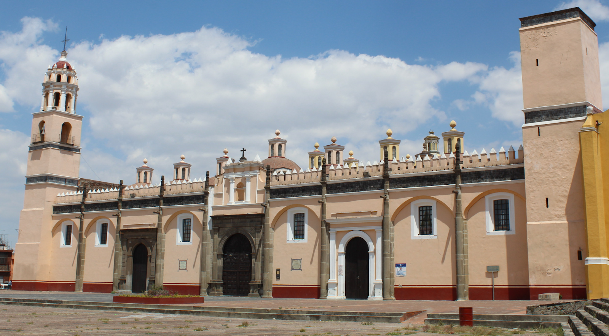
Figure 2. The Royal chapel or Capilla de Naturales of the convent complex of San Gabriel Cholula, located on the north side of the convent temple and linked to it through the Chapel of the Third Order. Photo: A.Gómez.

The city of Cholula is known for presenting a layout in which its streets supposedly follow the axes of symmetry of the Great Pyramid (Suárez Cruz, 2008, p. 107; Tichy, 1978, pp. 153-163). However, some authors have stated that the symmetry axis of the pyramidal quadrangle presents a deviation of approximately 24º with respect to the cardinal axes, so the azimuthal angle to the east, taking into account the height above the flat horizon, would be related to the summer solstice sunset; different by one or two degrees from the orientation of the current urban layout (deviation of 25º-26º south of the east), which rather corresponds to the sunrise on the winter solstice (Sprajc, 2001, p. 241). In this regard, it is pertinent to mention that the initial investigations of the orientation of the Great Pyramid of Cholula provided measurements of the angle of deviation in the range of 24º-26º, so both the sunrise on the winter solstice and the sunset on the summer solstice were considered as a possible interpretation of the orientation of the structure (Tichy, 1976, p. 2). On the other hand, the church of Nuestra Señora de los Remedios, located at the top of the pyramid, still has a different orientation from that of the axes of the pyramidal quadrangle or the layout of the city. Such orientation is related to the sunset on the day of the zenith passage over Cholula, which occurs on May 15, an alignment that has been verified through field observations (Suárez Cruz, 2008, p. 114).
Regarding the Franciscan convent complex, George Kubler had already noted that the church of the convent of San Gabriel and the Royal Chapel present a different orientation to the general layout of the city (Kubler, 1968, p. 6; see figure 3). In the case of the church of San Gabriel, he finds an orientation that approximately coincides with the position of sunrise on March 24 and 25, which coincide with the festivals of San Gabriel and the Annunciation. For the Royal Chapel, Kubler does not provide a definitive explanation, but its orientation is different from that of the conventual temple. Due to the proximity of the sunrise dates, this author mentions the possibility that the alignment of the church of San Gabriel is related to the spring equinox. In general terms, such an association with the equinox would be interesting since the majority of churches from the same period in Europe precisely follow, by Catholic tradition, an equinox orientation (González-García and Belmonte, 2015; Krauchi, 2021). Kubler proposes that the platforms of the pre-Hispanic buildings could have defined the first efforts of the builders to systematize the layout of the city, a first attempt being the alignment of San Gabriel between 1540 and 1550, and later between 1560 and 1570 with the Royal Chapel (Kubler, 1968, p. 7). On the other hand, Franz Tichy proposed that the orientation of the Royal Chapel is the same as that of Teotihuacan, based on his estimates of the azimuthal angle from the plans of the city of Cholula, which according to this author is 16º to the north of the west (Tichy, 1991, p. 45).
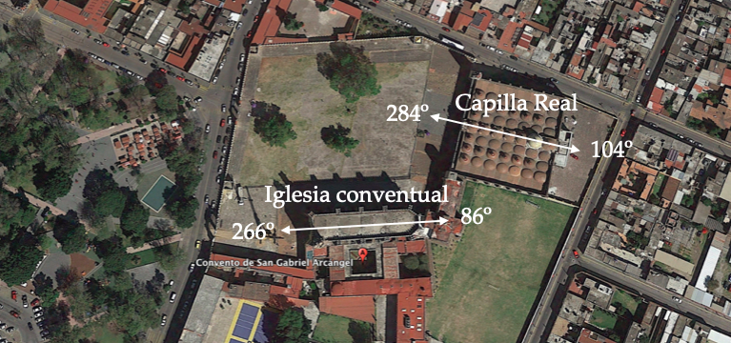
Figure 3. The convent church of San Gabriel Cholula and the Royal Chapel have a different orientation from each other (measurements indicated with the white arrows), but also different from the orientation of the city layout.

Complementary to the study of astronomical alignments, the search for light and shadow phenomena towards the interior of buildings is of special interest in the context of these investigations, since at least in the case of some European cathedrals these phenomena have been of practical use (Heilbron, 1999). In this regard, Sergio Suárez Cruz has reported the entry of sunlight rays through the windows of the lanterns of the domes of the Royal Chapel, on the date of the spring equinox, so a systematic study of this type of phenomena adds value to the analysis of the central theme of this research.

The orientation of the conventual temple of San Gabriel: a reference to the equinox?
The orientation measurements of the temple of San Gabriel result in the alignment of the architectural structure with the sun on the dates March 29 and September 13, for solar sunrises; March 13 and September 29, for sunsets. Figure 4 shows photographs of the sunset observed from the roof of the church on March 13 and 14. March 13 is when the longitudinal axis of the building is aligned with the last solar ray at sunset, while on March 14 the alignment occurs approximately with the complete solar disk touching the horizon profile. (northern slope of Popocatépetl). Figure 5, for its part, presents photographs of the sunrise in its alignment with the axis of the conventual temple on March 29. The observations, therefore, have confirmed the dates that were estimated using satellite images and computer programs. With these results we can discard Kubler's proposal about the alignment of the conventual temple towards sunrise on March 24 or 25.
When inspecting the position of the temple of San Gabriel in the diagram of azimuth frequencies and alignment dates of pre-Hispanic structures (figures 4 and 8 in Sprajc 2001, pp. 58 and 68), it is noted that it is located in an area of ​​little representativeness, so it was not a typical spatial or temporal orientation of the pre-Hispanic world. Furthermore, in the frequencies of the azimuthal deviation angle of 372 churches in the Puebla-Tlaxcala region presented by Tichy (figure 6-13 in Tichy 1991, p. 101), the value obtained for the church (approximately -4º) contains a single element in the histograms, from which it can be deduced that this orientation was also atypical in the construction of Catholic churches in New Spain.
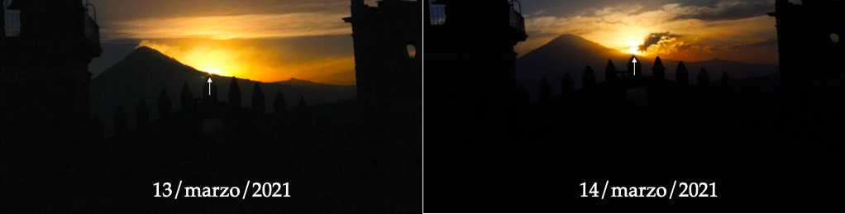
Figure 4. Photographs of the sunset from the roof of the San Gabriel Cholula temple on March 13 and 14, 2021. The last ray of sunlight aligns with the central part of the nave on March 13 (with reference indicated by the white arrow), while the approximate alignment with the complete solar disk touching the profile of Popocatépetl occurs on March 14. Photos: A. Gómez.
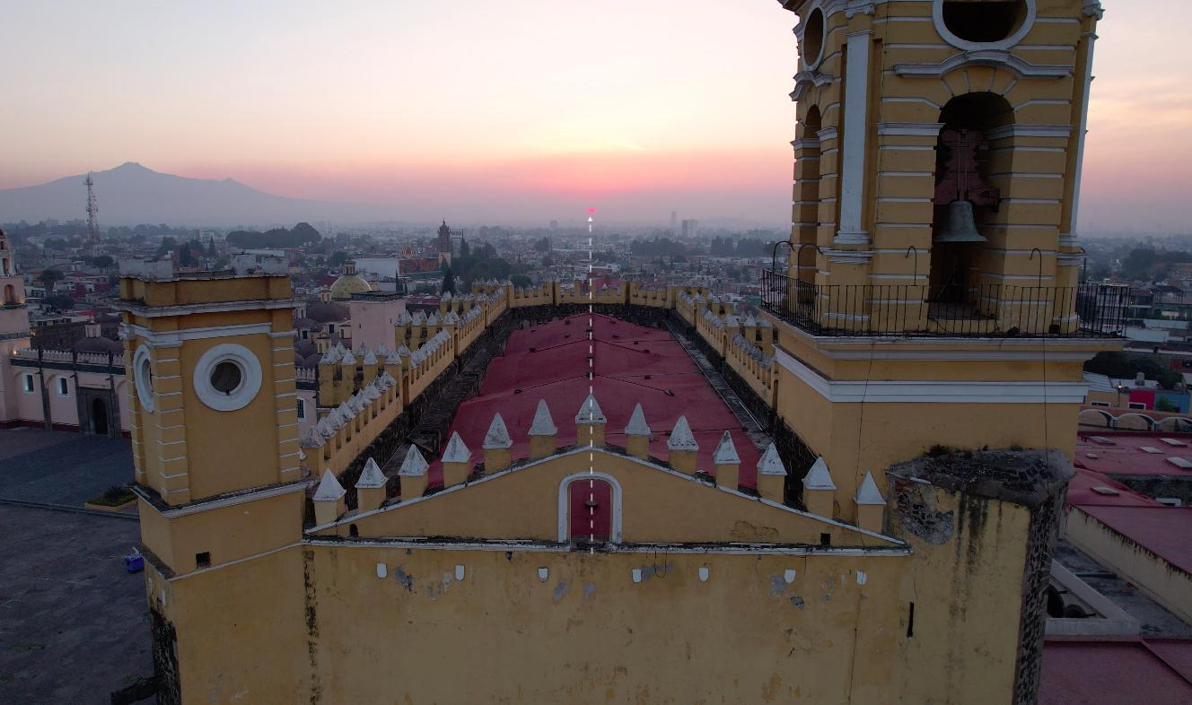
Figure 5. Sunrise on March 29, 2024, seen from the convent temple of San Gabriel Cholula. The white line indicates the longitudinal axis of the building, which coincides with the position of the sun at its sunrise that day.

Regarding the interpretation of the dates of alignment, in the first instance we could consider the date of the saint's festival, since when passing through the entrance to the temple we find a sign that tells us the date of the temple in 1549 and its festival on September 29, the latter coinciding with the second alignment towards solar sunset. However, when analyzing the historical sources we realize that such a date was imposed in the 20th century, particularly in the Calendarium Romanum promulgated by Paul VI in 1969, where the festivity of the archangels Michael, Gabriel and Raphael was combined in the same day (Calendarum Romanum, 1969, p. 173), so it could not have been the motivation of the temple builders. As for dates from previous centuries, one of the earliest sources from the year 1588 reports March 18 as the date of the celebration of Saint Gabriel the Archangel in Spain (Villegas, 1588, p. 918). This date would be considerable if it were in the Julian calendar, since Gregorian March 29 corresponds approximately to March 19 of the Julian calendar of 1580; However, by the reported date of 1588 the Gregorian calendar had already been implemented in Spain and New Spain (Uribe, 2022). With this information it is clear that the dates to which the convent is oriented do not seem to have a relationship with the festival of San Gabriel Archangel.
Another way to interpret the orientation of the conventual church is by analyzing the intervals of days between the alignment dates and the solstices. In the pre-Hispanic case, the counting of days, taking these dates as a reference, has been shown to have a relationship with the calendrical equation and the multiples of 13 and 20, trecenas and veintenas, that characterize the Mesoamerican calendar (Broda, 2000, pp. 227-229). In this way we have that between the solar sunsets to which the building is aligned, 165 days pass, while between March 13 and the summer solstice, and from this to September 29, 100 days pass, respectively (in total 200 days ). The 100 or 200 days are multiples of twenty, so these intervals could be represented in veintenas; while 165 days are a little more than 8 veintenas (8.25). On the other hand, 168 days pass between the sunrises of alignment, while between September 13 and the winter solstice, and from the latter to March 29, 99 and 98 days pass, respectively (a total of 197 days). In this case we notice that 197 days are almost 15 trecenas (15.15), while 168 days are almost 13 trecenas (12.92).
A final possibility of interpretation of the temporal alignment of the conventual temple of San Gabriel has to do with one of the definitions of equinox, in particular the one that determines it in the day that lasts 12:00 hours. For the geographical coordinates of San Pedro Cholula this occurs, if the horizon were flat, between March 13-14 and September 28-29, which would coincide with the dates to which the temple is aligned at sunset. However, as we know, the horizon that intersects the orientation of the building is far from flat, so taking into account the elevation of the mountains in the count of the time between sunrises and sunsets, a day length of 12 hours is obtained (within an uncertainty of one minute), on March 29 (sunrise at 06:32, sunset at 18:33) and September 12 (sunrise at 07:24, sunset at 19:24). In this case we have the coincidence with the alignment dates towards the sunrises to which the building is oriented. Depending on what the method would have been to determine the length of the day (taking into account or not the height of the horizon), it is clear that one of these two alignment options (sunrise or sunset) could have been used for the orientation of the building. However, it must be taken into consideration that although this possibility of the relationship with one of the definitions of equinox is very interesting, we must take into account that this is the most difficult to determine by experimental methods, since it requires the measurement of time with a precision of between 1-2 minutes (Ruggles, 1997, p. S47), which we do not know with certainty if it was within the technical possibilities, both for pre-Hispanic cultures and for the New Spain Franciscan friars of the 16th century.
To finalize the case of the temple of San Gabriel, figure 6 shows photographs inside the church taken during sunset on March 13 and 15, in which a beam of blue light can be seen, coming from the oculus or rose window located above the choir, which illuminates the central part of the baldachin that contains a sculpture of the Virgin Mary, just behind the main altar (details about this altar are given later). The phenomenon also includes the entry of sunlight through the main entrance of the church, which begins to travel along the central hallway until it approaches the altar (figure 7).
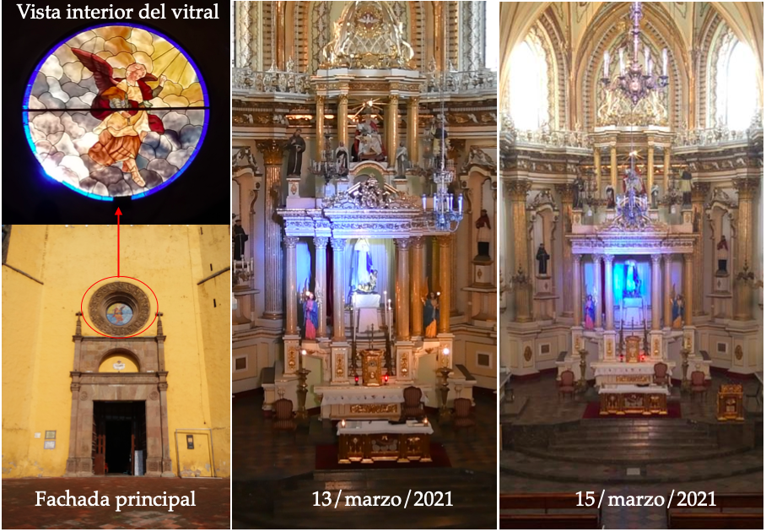
Figure 6. On the left is the main façade of the temple of San Gabriel, indicating the stained glass window in the choir rose window that produces a beam of light on days aligned with sunset. In the center and right, photographs of the main altar of the temple are shown, close to the time of sunset on March 13 and 15, 2021, showing a beam of blue light that illuminates the central part of the baldachin where the figure of the Virgin Mary is located. Photos: A. Gómez, A. Dávila and A. Molero.

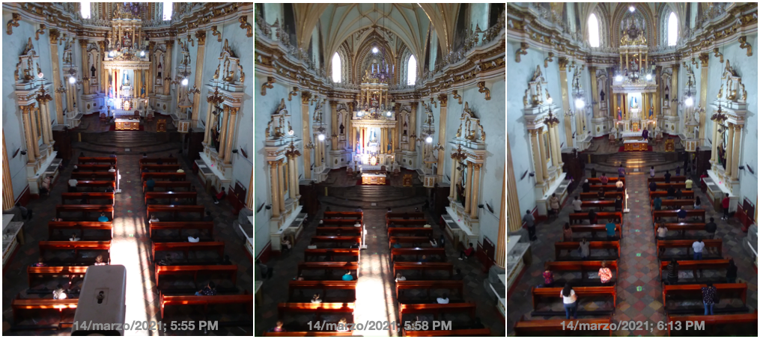
Figure 7. Sequence of photos of the central hallway and altar of the conventual temple of San Gabriel on March 14. As dusk approaches, the sunlight that enters through the main entrance approaches the altar area. Photos: A. Gómez.

The rose window on the facades of the conventual temples of the 16th century is considered an element inherited from Gothic architecture; In addition to Cholula, the temples of Atlixco, Yecapixtla or Totolapan present this architectural characteristic (Benítez, 2018, p. 89). In the case of the temple of San Gabriel, the oculus is covered by stained glass, most of which is in warm, gray tones (see figure 6). The blue color of the projected beam is due to the blue crystal ring that encloses the central scene of the Archangel Gabriel above the clouds. If this phenomenon represents some type of Catholic hierophany, it still needs to be explored in a deeper study of it and the symbols that we have represented inside the church. But it is relevant to note that the rose window has existed since the early stages of the convent church, as it is represented both on the map of the City of Cholula in the relación geográfica of Gabriel Rojas (1581), and in the Cholula codex (ca. 1586; de la Maza, 1968, pp.). Figure 8 shows both documents.
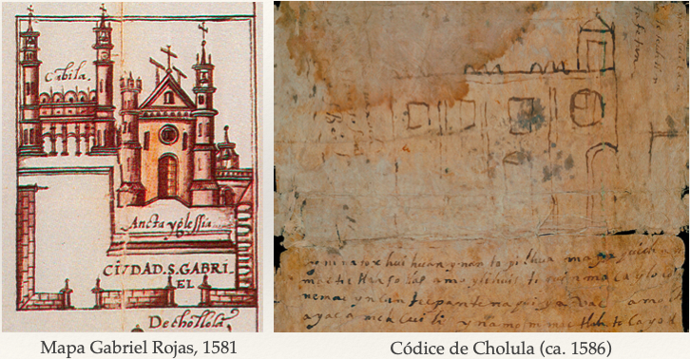
Figure 8. Historical documents from the 16th century showing the convent temple of San Gabriel Cholula with the presence of the oculus or rose window on its facade.

However, in photographs from the mid-20th century the absence of the stained glass window is noted (figure 9), consequently this must be from recent times, so the original phenomenon was a pristine beam of sunlight focused towards the apse of the temple. It is known that the current baldachin is a neoclassical work (Benítez, 2018, p. 101), so the aforementioned beam of light originally illuminated the central part of a 16th century altarpiece. The original altarpiece dated at least by 1580, being removed on a date after 1860 (de la Maza, 1968, p. 63). When looking in detail at the photographs in figure 6, it is noted that the light beam is a little more centered on the position of the sculpture of the virgin on March 15 than on March 13; the latter could be a consequence of the later placement of the same baldachin, since the original show had the purpose of lighting the central part of the altarpiece towards the back of the apse of the temple.
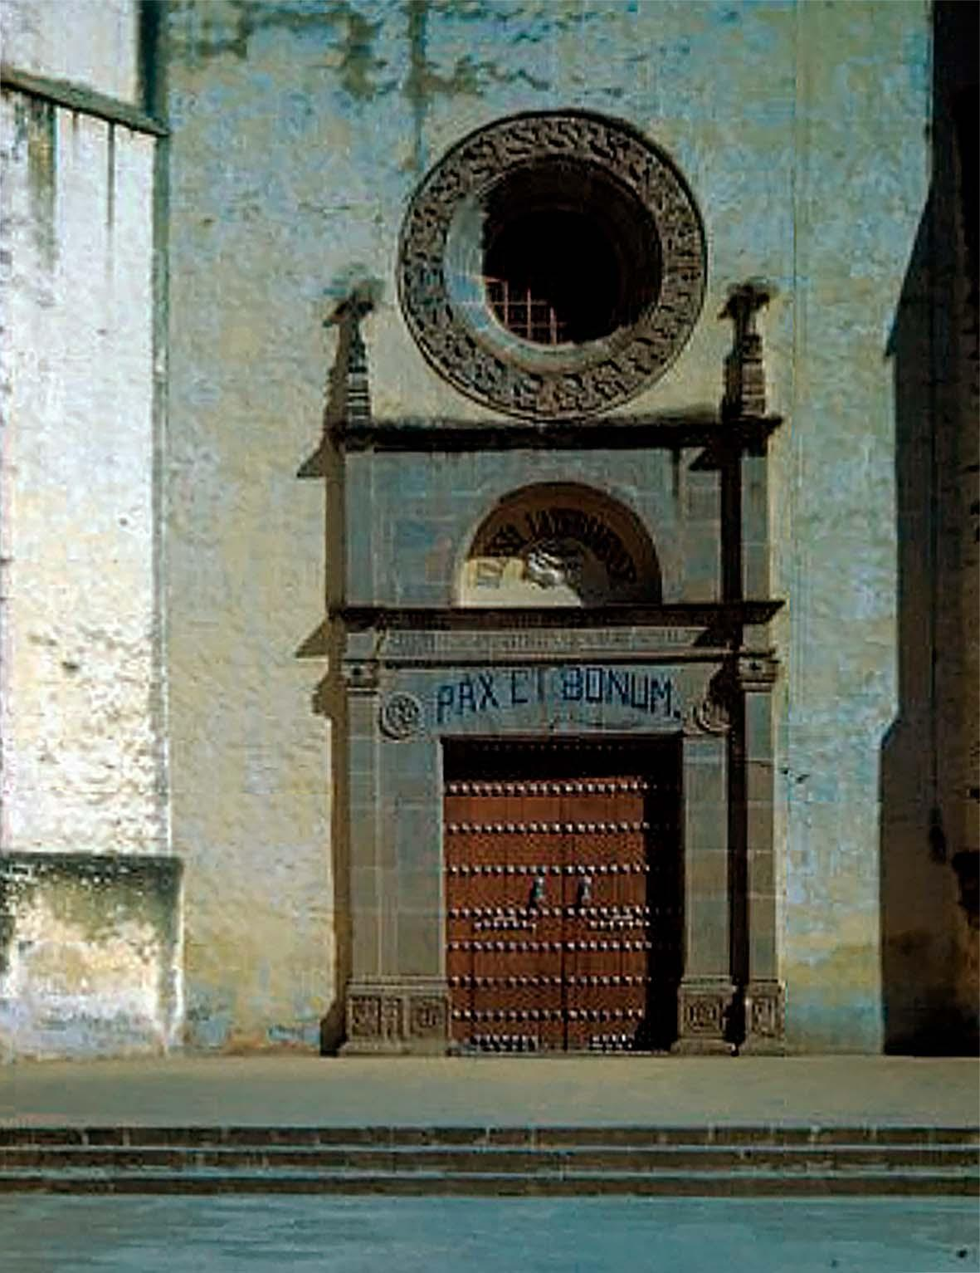
Figure 9. Facade of the church of the convent of San Gabriel in 1951. The absence of the stained glass window that now covers the oculus can be seen in the photograph. Photo: Peter Smithers, Mediateca INAH.

The orientation of the Royal Chapel: the canonical calendrical orientation of Mesoamerica
The dates to which the main axis of the Royal Chapel is oriented are for the solar sunrises on February 12 and October 28, while the dates April 28 and August 13 were obtained for the solar sunsets. Figure 10 shows a series of photographs from the end of April 2021; Unfortunately, the presence of clouds on the horizon did not allow us to observe the sunset until the end of the phenomenon. Coinciding with the beginning of the rainy season, this is one of the most difficult dates to verify; Fortunately, in April 2023 the weather was conducive to observing the sunset, verifying the alignment prediction, as shown in figure 11. For its part, figure 12 presents aerial photographs during solar sunrise on the 28th October 2021 and 2022, demonstrating the alignment of the building with the sunrise that day of the year. Finally, in the year 2023, the alignment with solar sunrise could be recorded on February 12, as presented in figure 13. These successful observations confirm that the estimation of the alignment dates towards solar sunrises and sunsets are correct.
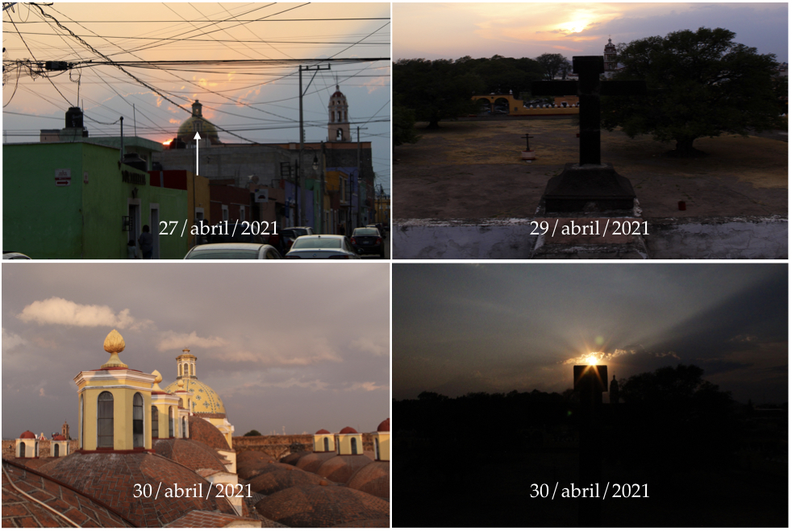
Figure 10. Photographs at hours close to sunset in the last days of the month of April 2021. The upper left photo was taken from Street 6 poniente in the direction of the central axis of the Royal Chapel, indicated with the white arrow. The photos on the right were captured from the roof, looking towards the west (the reference in the center of the building is the cross). The bottom left photo shows the shadows of the lanterns almost aligned with the central axis of the building. Photos: A. Gómez.

These dates obtained for the Royal Chapel of the convent complex of San Gabriel are similar, within a tolerance of two days, to those of the calendrical orientation of Teotihuacan, which have been previously indicated are February 12 and October 30 for sunrise, April 30 and August 13 for sunset (Broda, 2000, p. 246). The most discordant dates in our case are October 28 and April 28, but in this regard it is relevant to mention the uncertainty of up to 3 days in determining the dates of Teotihuacan (Sprajc, 2001, p. 204). The calendrical interpretation of the alignment dates of Teotihuacan comes from the 260 days that pass between February 12 and October 29 for sunrise, and between August 13 and April 29 for sunset; representing the ritual calendar or Tonalpohualli. On the other hand, from October 29 to the winter solstice and from this to August 13, 52 days pass respectively (the same happens from October 29 to the winter solstice and from this to February 12). This is a reference to the number 52, which are the years that must pass for the ritual and solar calendar to coincide.
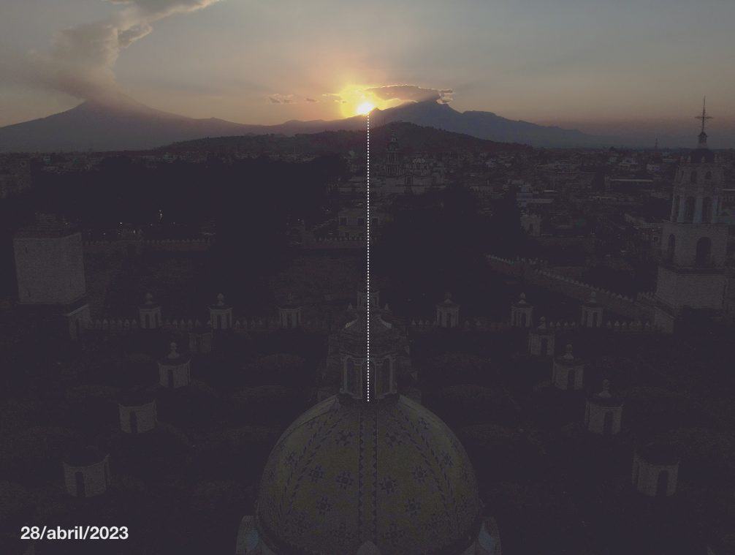
Figure 11. Aerial view of the sunset from the Royal Chapel on April 28, 2023. The white vertical line indicates the projection of the central axis of the building. Photo: A. Gómez.

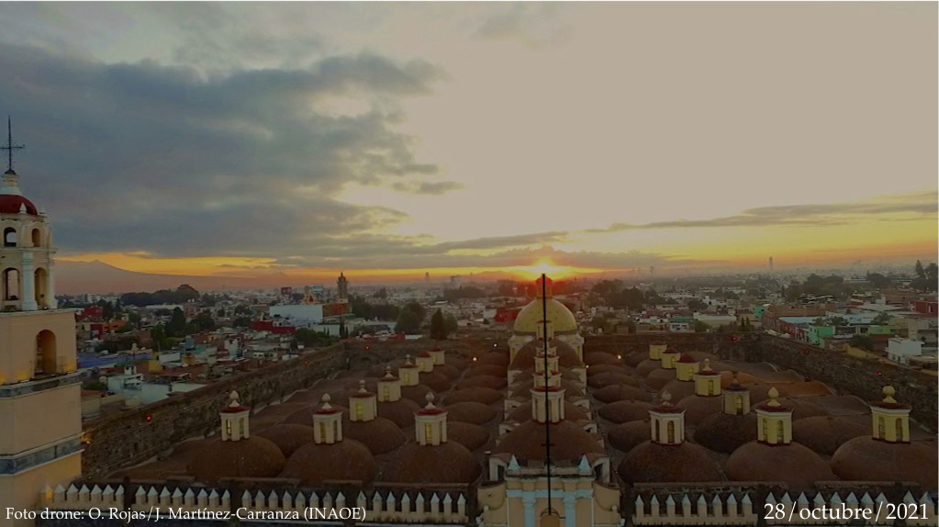
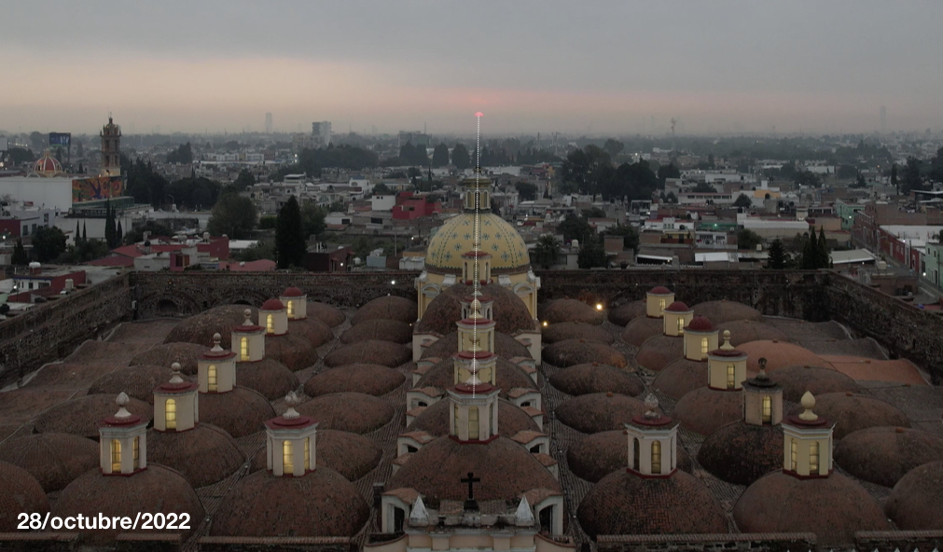
Figure 12. Sunrise on October 28, 2021 (above) and 2022 (below), seen from the Royal Chapel of the convent complex of San Gabriel Cholula. Photos: O. Rojas and J. Martínez (top), and A. Gómez (bottom).

The effort to align the main axis of the Royal Chapel to these dates reveals the builders' intention to reproduce this sacred calendrical orientation, which has been shown to be the most typical temporal orientation of pre-Hispanic constructions. On the other hand, it is noted that the degrees of deviation of the cardinal axes for the Royal Chapel are two degrees less (14º) than the most typical value of 16º for the sample of 372 churches in the Puebla-Tlaxcala region measured by Tichy. For the aforementioned author, this most typical value demonstrates that many of the New Spain churches followed the calendrical orientation, but, as we will discuss later, the spatial orientation is not the determining factor for the relationship with the alignments of pre-Hispanic structures, but rather the temporal orientation, which is obtained by taking into account the height above the horizon that intersects the orientation angle of the building in question. Therefore, it is the temporal orientation that is susceptible to a pre-Hispanic calendrical interpretation.
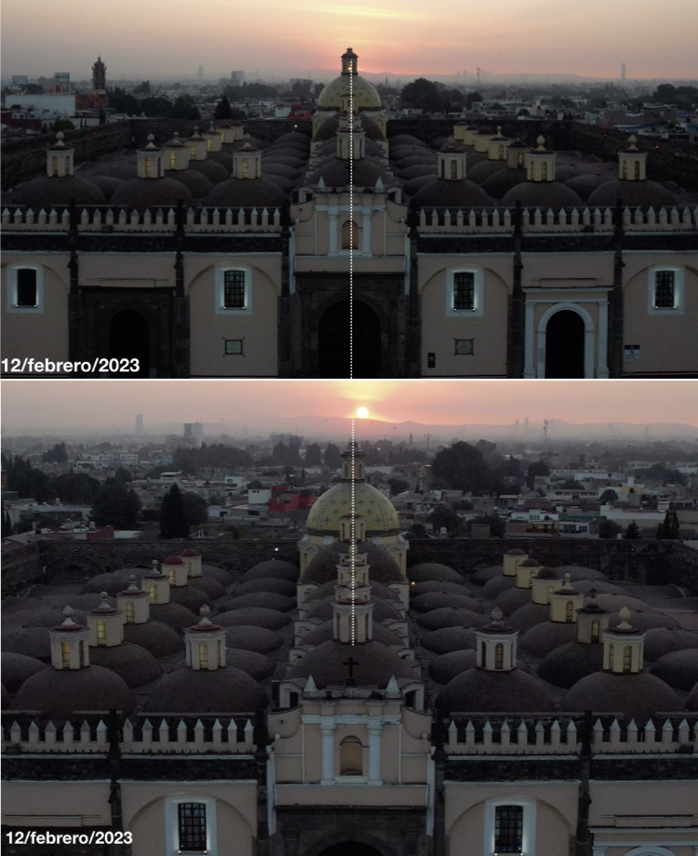
Figure 13. Aerial view of the solar sunrise on February 12, 2023. The photograph above shows the sun almost aligned with the central axis of the building. In the image below, with better framing, the sun has already fully risen and therefore a little out of alignment. However, due to its position it is inferred that it must have arisen very close to the central axis of the structure. Photos: A. Gómez.
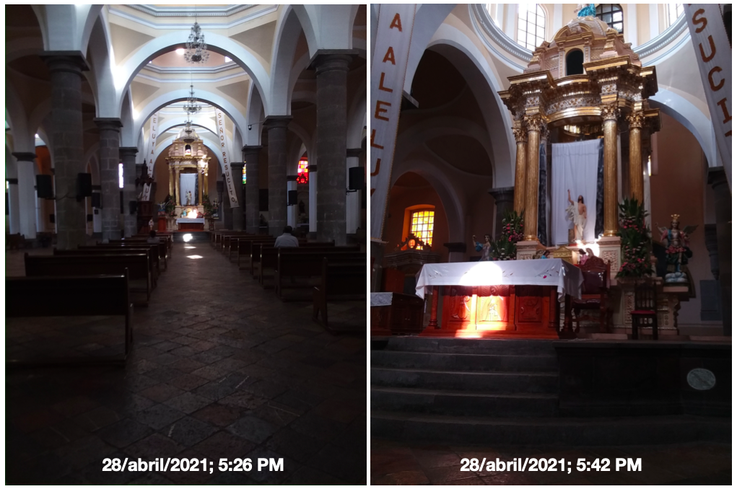
Figure 14. Photographs inside the Royal Chapel at a time close to sunset on April 28, 2021 (solar alignment day). Beams of light coming from the lantern windows of the central domes illuminate part of the central hallway and the altar. Photos: A. Gómez.

Now let's see what happens inside the Royal Chapel on the days of alignment with the sunset. Figure 14 shows two photographs taken approximately two hours before sunset on April 28, showing up to four beams of light coming from the lantern windows in the central domes, which illuminate a part of the central corridor and the altar. This phenomenon in itself could be related to the alignment towards the sunset of that day, although because it occurred a few hours before sunset, the position of the sun at that moment does not correspond to the alignment of the building. However, it is possible that the selection in the direction of the windows was such that this peculiar light display could occur on the alignment day. A similar phenomenon could also be witnessed, but this time at noon on August 9, 2021, with the light beams distributed along the central and lateral corridors (figure 15). This date is only four days away from the second alignment with the sunset estimated in this work for August 13. Again, this phenomenon could thus indicate the alignment of the building with the sunset on the designated day.
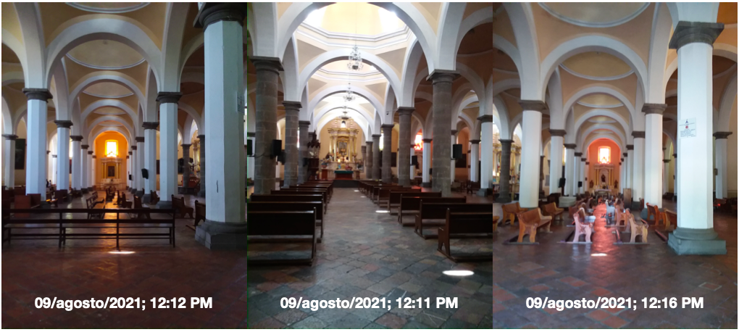
Figure 15. Photographs inside the Royal Chapel on August 9 around noon. In the central and lateral hallways, the presence of light beams from the lanterns in the domes can be seen, distributed symmetrically along the transverse axis of the building. Photos: A. Gómez.

Discusion
Archaeoastronomical studies of Cholula have focused above all on the astronomical orientation of the pyramidal quadrangle and the layout of the city, which coincide with solstitial dates, which has defined Cholula as a solstitial city. Another aspect that has been deeply studied is the horizon calendar observed from the Great Pyramid, through which prominences on the eastern and western horizon can be related to the annual path of the sun, indicating important dates of the agricultural calendar (Suárez, 2008, pp. 112-114). However, the New Spanish religious architecture of the city has usually been relegated from such studies, with the exception of the already mentioned case of the church of Nuestra Señora de los Remedios, on the pyramidal base of Tlachihualtepetl, oriented towards the sunset on the day of the zenith passage.
In this study it has been shown that the buildings of the main religious center of San Pedro Cholula, the convent complex of San Gabriel, are significant from the point of view of their astronomical orientation, so they deserve to be included in the global scheme of the cultural astronomy of the Cholula region. As it has already been pertinently indicated, the divergent orientations of the convent temple and its indigenous chapel had already been noted for many decades, but in no case had it been possible to rigorously relate it to its alignment towards sunrises and sunsets. Because of this, explanations about the reason for the divergence regarding the orientation of the Great Pyramid and the layout of the city had been ambiguous.
In the context of the divergent nature of the convent complex, it is notable that modern studies that address the issue of the layout of the city and its New Spain buildings do not mention the research of Franz Tichy published in 1991 in his work Die Geordnete Welt Indianischer Volker, where he had already proposed the similarity between the orientation of the Royal Chapel and that of Teotihuacan. However, Tichy's argument for this relationship was erroneous because of the following. Figure 5-4 of his work shows the plan of the convent complex showing the deviation of the azimuthal angles with respect to the E-W axis: for the Royal Chapel 16.5º north of west and for the convent temple 2.5º south of west (Tichy, 1991, p. 48). On the other hand, in his table 12-2 the azimuth reported for the Royal Chapel is 104º, while for the conventual temple it is 88º (Tichy, 1991, p. 212). Our results show that the azimuth is 104.2º for the Royal Chapel, a value coinciding with Table 12-2 of Tichy, but different by 2.3º with respect to the value given in his figure 5-4. In his discussion of the orientations of Cholula, Tichy relates the Royal Chapel to the 16º orientation of Teotihuacan, so it is inferred that his estimate corresponding to the azimuth is 106.5º (Az_E) and 286.5º (Az_W), thus we obtain a difference of 2.3º with respect to our results. According to the predictions of the Peakfinder program for these azimuth values, the alignment with sunrises and sunsets (taking into account the height of the horizon) would be February 6 and November 5 for sunrise, May 6 and May 5 August for sunset. These dates differ by 6-8 days from what was verified by field observations, so such an estimate of orientation was erroneous. This result reinforces the argument proposed in the present work, by highlighting that it is the temporal orientation that is important when seeking relationships with pre-Hispanic calendrical orientations.
In his proposal of the pre-Hispanic origin of the layout of the city of Cholula, Graziano Gasparini tries to explain the different orientation of the temple of San Gabriel and the Royal Chapel as an effort to reject the pre-Hispanic orientation of the city, trying to signify the advent of something totally new from what existed before (Gasparini, 1993, pp. 98-100). The rejection of the city layout by the convent buildings would be proof of the pre-Hispanic origin of the New Spain city plan. Plunket and Uruñuela, following Gasparini, add that the divergent orientation represents a rejection of the pre-Hispanic cosmology that saturated the temple of Quetzalcóatl, on whose remains the convent is built, an expression of the triumph of Christianity over idolatry (Plunket & Uruñuela, 2018, p. 248).
The contributions of this research work rule out the hypothesis of the rejection of pre-Hispanic cosmology, since at least in the case of the Royal Chapel we see the sacred orientation of pre-Columbian Mesoamerica represented. Being a city heir to the Teotihuacan culture, there could not be a better pre-Hispanic religious remnant than an Indian chapel built with this orientation so preeminent in all of Mesoamerica. Contrary to Gasperini's argument, the same divergent orientation of the building confirms his hypothesis of the continuity of the pre-Hispanic plan of the city in the New Spain era. In this regard, it is valuable to remember that in some pre-Hispanic cities there is not a unique orientation in their most important buildings, in some cases differing from the general outline of the same city, for example Xochicalco (Sprajc, 2001, p. 262) and Tula (Sprajc, 2001, p. 281).

Going deeper into the relationship between the Royal Chapel and Teotihuacan, Plunket and Uruñuela propose that this Catholic temple was located in the place of the so-called “casilla especial” of investiture of power, north of the temple of Quetzalcoatl, on which in turn the church and the convent cloister are located (Plunket and Uruñuela, 2018, p. 210). This suggestion could be supported by the results obtained for the temporal orientation of the chapel, since in the Pyramid of the Sun of Teotihuacan, since the 4th century, the new fire ceremony was celebrated, linked to the investiture ceremony of the new rulers, in a platform attached to this monument (Florescano, 2016, p. 237). Now, the relación geográfica de Cholula by Gabriel de Rojas (1581) mentions that in the Great Plaza of Cholula there was a special enclosure, where the high priests pierced the nose, lobes or lower lip of the king, to place an ornament and thus confirming his position as ruler (Florescano, 2016, p. 253). The graphic evidence of such a place is found in the Mapa de Cuauhtinchan No. 2 and in the Historia Tolteca-Chichimeca, showing in the first case its location to the left of the temple of Quetzalcóatl, and in the second presenting the Tlalchiah and Aquiach, the two high priests of Quetzalcoatl, inside the enclosure in the act of imposing insignia on two Chichimec chiefs (Lind and Barrientos, 2012, pp. 48-53). Therefore, the casilla especial in Cholula would be the equivalent of the investiture building attached to the Pyramid of the Sun in Teotihuacan, where the ceremony originated. Therefore, it is natural to think that given the correspondence between both enclosures, they should share architectural attributes such as their orientation. This reasoning is also reinforced by the fact that the new fire ceremony is closely linked to the 52-year cycle, which is alluded to by the count of days established by the sacred orientation of these buildings.
While the case of pre-Hispanic inspiration is robustly demonstrated for the Royal Chapel, for the convent temple it is more difficult to relate it to a pre-Hispanic or Christian origin, since as we have seen it presents a very unusual spatial and temporal orientation in both pre-Columbian and of the New Spanish churches. Although the possibilities discussed include the relationship to one of the definitions of the equinox or to the date of the patron saint's holiday, its definitive interpretation is still pending, so it will continue to give rise to new interpretations.
We consider that this research has increased the astronomical cultural value of the city of Cholula, since in addition to the already known solstitial orientations and the zenith passage, we can now add the Mesoamerican agricultural calendar represented by the sacred orientation of the Royal Chapel and the possible relationship of the orientation of the conventual temple with one of the definitions of equinox. Aside from the beautiful phenomena of light beams towards the interior of both religious buildings.

Conclusion
This research has focused on an analysis of the solar orientations of the architectural structures of the convent complex of San Gabriel in Cholula, especially noting the divergent configurations of the Royal Chapel and the convent temple. Although Franz Tichy had already suggested that the spatial orientation of the Royal Chapel resembles the sacred orientation of Teotihuacan, in this work it was demonstrated that the angle of orientation is not identical to that of the latter city, but rather that in this temple of Cholula, a spatial orientation was selected such that the date of alignment with solar sunrises and sunsets corresponded to the Teotihuacan case; that is, the temporal orientation is the one that follows the pre-Hispanic pattern. With this result, we reach the conclusion that instead of rejecting the pre-Hispanic worldview, since the temple has a different orientation to the layout of the city, as has been suggested by some researchers, the orientation of the native church confirms the persistence of such a worldview in the construction of these first New Spain temples. On the other hand, for the conventual temple of San Gabriel it was difficult to reach a definitive interpretation, since both its spatial orientation and the dates of alignment with the sunrises and sunsets are uncommon, both in the pre-Hispanic world and in the churches of central Mexico.

References
Benítez de Unánue, M. P. (2018). Templos conventuales: instrumentos de evangelización. En Perales y Benítez (coord.), Los conventos del siglo XVI en Puebla y Morelos (pp. 85-103). Universidad Popular Autónoma del Estado de Puebla.
Broda, J. (2000). Mesoamerican Astronomy and the ritual calendar. In H. Selin (Ed.), Astronomy Across Cultures: The History of Non-Western Astronomy (pp. 225-267). Kluwer Academic Publishers.
Calendario Romanum (1969). Librería Vaticana.
De la Maza, F. (1954). La ciudad de Cholula y sus iglesias. Universidad Nacional Autónoma de México.
Florescano, E. (2016). ¿Cómo se hace un Dios? Creación y recreación de los dioses en Mesoamérica. Taurus.
Gasparini, G. (1993). The prehispanic grid system : The urban shape of conquest and territorial organization. In R. Bennett (Ed.), Settlements in the Americas: Cross-Cultural Perspectives. Associated Universities Presses.
González-García, A. C., & Belmonte, J. A. (2015). The Orientation of Pre-Romanesque Churches in the Iberian Peninsula. Nexus Network Journal 17, 353-377.
Heilbron, J. L. (1999). The Sun in the Church: Cathedrals as Solar Observatories. Harvard University Press.
Krauchi, K. (2021). How has a christian church been aligned towards the east? Conclusion from statistical analyses of churches between 300 and 1300. Archaeometry 63 (3), 668-683.
Kubler, G. (1968). La traza colonial de Cholula. Estudios de Historia Novohispana 2 (2), 1-30.
Ledesma Gallegos, L. (2016). Génesis de la arquitectura mendicante del siglo XVI en el Plan de Las Amilpas y las Cañadas de Morelos. Instituto Nacional de Antropología e Historia.
Lind, M., & Barrientos, C. (2012). Así era la Gran Plaza de Tollan-Cholollan. Arqueología Mexicana 115, 48-53.
Martínez López-Cano, M. P. (2001). La génesis del crédito colonial. Ciudad de México, siglo XVI. México: Universidad Nacional Autónoma de México.
Morales, F. (2005). Los Franciscanos y Cholula. En Cholula un vínculo de sabiduría y fraternidad (pp. 13-17). UDLAP publicaciones.
Plunket Nagoda, P., & Uruñuela Ladron de Guevara, G. (2018). Cholula. Fondo de Cultura Económica y El Colegio de México.
Ruggles, C. (1997). Whose Equinox? Archaeoastronomy 22, S45-S50.
Sprajc, I. (2001). Orientaciones astronómicas en la arquitectura prehispánica del centro de México. CONACULTA-INAH.
Suárez Cruz, S. (2008). Cholula y su paisaje, un ejemplo de orden social ligado al calendario de horizonte. Antropología. Boletín Oficial del Instituto Nacional de Antropología e Historia 83-84, 106-115.
Tichy, F. (1976). Orientación de las pirámides e iglesias en el altiplano mexicano. Suplemento Comunicaciones, Proyecto Puebla-Tlaxcala 4. Fundación Alemana para la Investigación Científica.
Tichy, F. (1978). El calendario solar como principio de organización del espacio para poblaciones y lugares sagrados. Comunicaciones 15, 153-163.
Tichy, F. (1991). Die Geordnete Welt indianischer Völker: ein Bespiel von Raumordnung und Zeitordnung im vorkolumbischen Mexiko. Franz Steiner Verlag.
Uribe, R. (2022). El calendario gregoriano en el Nuevo Mundo. Historia global, cultura escrita, tiempo universal. Nuevo Mundo Mundos Nuevos. Debates, Online since 21 February 2022, connection on 10 June 2024. URL: http://journals.openedition.org/nuevomundo/87249; DOI: https://doi.org/10.4000/nuevomundo.87249
Villegas, A. (1588). Flos sanctorum y Historia general, de la vida y hechos de Iesu Christo, Dios y señor nuestro y de todos los sanctos de que reza y haze fiesta la Yglesia Catholica, conforme Breviario Romano, reformado por decreto del santo Concilio Tridentino, junto con las vidas de los santos propios de España, y de otros Extravagantes. Pedro Madrigal.

One peso of common gold is equivalent to 272 maravedis (Martínez, 2001, p. 324), therefore, 500,000 maravedis are equivalent to 1,838 pesos of common gold.
The prediction was taken from the webpage http://timeandate.com/sun/
The estimation of the time of sunrise and sunset was carried out through the program Peakfinder, centered on the position of the conventual temple.

