The Churches of Santiago de Compostela, a diachronic analysis of their orientations
A. César González-García¹, Vicky Lianou²

¹Institute of Heritage Sciences, INCIPIT, CSIC, Santiago de Compostela, Spain
² Museum of Ancient Greek Technology, Athens, Greece

Abstract:
The orientation of nearly 50 churches in the historic city of Santiago de Compostela are presented. These include churches built along the history of the town, from the early Medieval period until the end of the 20th century. Interestingly, all churches built before the Council of Trent appear to have orientations consistent with canonical prescriptions, notably in two flavors. One would be consistent with the canonical equinox at the date of construction, possibly dictated by the orientation of the Cathedral itself. The other orientation is set a few degrees south of due east and could be dictated by the streets of the Medieval town. After the Council of Trent churches were built mostly to have the façade perpendicular to a main street, so that the apse and the altar no longer are systematically facing towards the rising sun.
Keywords: Church Orientation; Santiago de Compostela; Medieval church; Diachronic analysis; Calendar

Introduction
Santiago de Compostela is world known as the end of the pilgrimage route that leads to the alleged tomb of the apostle Saint James. This small, but very important town in the Northwest of Spain is intertwined with the history of the Catholic church, as well as with that of the whole country.
According to Christian tradition, apostle Saint James, Santiago in Spanish, preached in Hispania before returning to Jerusalem to be beheaded soon after by order of Herod Agrippa (Voragine 1998; see, e.g. Deswarte 2015, pp. 477-482; the author also makes a short account on how such tradition built over time during the early Middle Ages). After his martyrdom, commonly celebrated on March 25th, his body was miraculously transported to the Northwest of the Iberian Peninsula where, after several events it was finally laid down in a place near Pico Sacro, or Sacred Mountain, a landmark in the vicinity of present-day Santiago (see e.g. Liber Sancti Iacovi or Codex Callistinus, Book III for a detailed description of the mythological arrival of the body to Galicia; López-Mayán 2010, pp. 41-44; the translation of his body and its final burial are celebrated at two other times, December 30th and July 25th).
The place now housing the town was possibly a crossroad in prehistory and antiquity (Suárez Otero & Caamaño Gesto 2003, p. 37). A few places near Santiago today house Bronze age carvings characteristic of Galicia (e.g. Santos-Estevez 2010), as well as Iron Age hillforts (Fernández Pereiro & Sánchez-Pardo 2022). Santiago itself might have been the location of a Roman mansio, near one of the Roman routes crossing the western part of the Iberian Peninsula (Suárez Otero & Caamaño Gesto 2003, pp. 28-29; Fletcher 1984, pp. 57-59). Some scattered remains, mostly funereal, pottery and tegulae, although a few walls and remains of controversial buildings, have been uncovered, notably within and surrounding the grounds of the Cathedral (Guerra Campos 1982; Suárez Otero & Caamaño Gesto 2003, p. 25, pp. 38-39). During Germanic times, apparently the area was only used as a necropolis, the habitat areas being thus abandoned.
According to the legend, the tomb of the saint was forgotten, and it was at the turn of the IX century when, first Beato, a very influential monk in the court of Asturias, advocated for Santiago as the patron Saint of Hispania (Deswarte 2015, pp. 480-481), and a few years later the tomb was re-discovered by a hermit on the slopes of a hill covered by a forest. Accordingly, Santiago was founded by mid IX century CE after the discovery of the tomb of apostle Saint James. After the discovery and ratification of the tomb by bishop Teodomiro of nearby Iria Flavia, the king of Asturias Alphonse II, the ruler over these lands at that time, ordered that a church was built to hold the tomb and the relics of the Apostle (Williams 2015, pp. 545-546). Such first building was later replaced by a second and larger church built under the command of Alphonse III (Guerra Campos 1982; López-Mayán 2010). This is significant, as this king was the one that ordered the construction of many churches within his realm at that time. Soon after this moment a small pilgrimage centre and hamlet first, but later a small town was growing surrounding this church (Suárez Otero 2003, pp. 49-53).
At the turn of the 11th century, Santiago was already the seat of a bishop, with a cathedral and its adjacent dependencies. Next to them there were a number of other small churches and monasteries. Notably, San Salvador or San Paio de Antealtares and Santa María de la Corticela. They were all mostly destroyed by the Muslim ruler Al-Mansur (Almanzor), who set fire to the church and the village but, according to Christian and Muslim chronicles, respecting the tomb of the Apostle (Farina 2018, pp. 48-49, p. 73).
Soon after, the village was rebuilt and a new cathedral, now in Romanesque style, was commenced in 1075 (Armas Castro 2003, p. 99; Farina 2018). At this moment a number of other churches were started within the walled limits of the early mediaeval town. Significantly the town grew under the patronage of the bishop who had a great local power and also due to the arrival of pilgrims following the Way of Saint James, provisions had to be made to accommodate them. Besides, the Cathedral was the preferred resting place for several kings both of Galicia, and later of the kingdom of Leon (Pallares & Portela 2003; Castro Díaz 2010, p. 100).
The project of the Romanesque cathedral implied the reform of some of the areas next to it, the inclusion within its limits, as chapels, of old churches such as Santa María de la Corticela, the only surviving after Al-Mansur’s attack, or the replacement of old monasteries, such as San Paio de Antealtares (Armas Castro 2003, p. 99; Karge 2015, p. 590). At the same time, a number of other Romanesque churches were built within the town walls, such as Santa María Salomé, San Miguel dos Agros, or outside like Santa Susana, Santa María de Sar or the monastery of San Martín Pinario (Armas Castro 2003, pp. 99-101). In the late Middle Ages, several other monasteries, like San Francisco or Santo Domingo de Bonaval, appeared in the surroundings of Santiago to house monks and give shelter to the pilgrims arriving to the town (Armas Castro 2003, pp. 102-103; González Vázquez 2003, pp. 212-215). There was even the project to replace the Romanesque cathedral with a Gothic style one, that was started but left unfished, and whose remains are now under the stairs located in the Quintana square, next to the Puerta Santa, the door that only opens in a Holly Year (González Vázquez 2003, pp. 211-212; López Mayan 2010, pp. 64-65; Puente Míguez 1985).
The University of Santiago was founded in 1495 (Rey Castelao 2003, p. 399; Castro Díaz 2010, p. 187), and with it came to the town new inhabitants, however, it was at the 17th and 18th centuries, with the reform of the cathedral and the new provisions after the Council of Trent, that new churches were built and several of the existing ones were reformed under the new baroque style (Saavedra Fernández 2003, p. 232; Castro Díaz 2010, pp. 128-132). This was a momentous time in Santiago: the Baroque reform of the Cathedral was the culmination of a project to convert Sant James as the only patron saint of Spain, something that was finally ratified by the pope in the mid 18th century.
Finally, in the last two centuries new churches were built especially when the town definitely trespassed the old medieval walls (Barreiro Fernández 2003, p. 433; Iglesias Amorín 2010, pp. 213-231).
Concerning the history of the church we must highlight several key moments for our study. First is the Gregorian reform at the turn of the millennium. This was a moment of great intellectual change in the Catholic realm when the church advocated for a return to the essences. Thus, new rules for monks were provisioned, and a new liturgy, the Roman one, was promoted to become general for all Catholic kingdoms. This was especially followed and fostered by the monastic order of Cluny (Sánchez Domingo 2013).
This order helped in the establishment and stimulus of the Way of Saint James, especially within the Christian kingdoms of the Peninsula with a varied influenced in each of them. One of the reforms they also advocated for was the change of the old Mozarabic rites to the Roman ones. This was done at different times in each kingdom. Also, they were one of the key vectors to introduce the Romanesque style within the Peninsula. This style is very well represented in Santiago, not only the Cathedral itself is one of the paramount examples of the Romanesque in the Peninsula, but there are several churches in this style in the town. This was slowly substituted with the Gothic architecture, that in Santiago has fewer examples in churches, but we could mention the church of the monastery of San Domingos de Bonaval.
The renaissance styles are more frequent in the town, with new buildings that in some cases are finished when a new artistic expression, the Baroque, is commencing. This is a moment of key importance for the Church, as it was the moment of the Counter-Reformation and the council of Trent. This council lasted from 1545 to 1563 and it was the answer to the Reformation, and consequently the Council adopted several provisions that changed a number of key elements in the liturgy (McNally 1965). As indicated above several Romanesque churches of the town were reformed, like the Cathedral itself, of directly rebuilt at this time. We can name among the last San Martín Pinario or San Miguel dos Agros.
When laying out a church, one of the key elements to decide is its orientation, as it sets how the rituals need to be performed within its walls. It was very early indicated (Apostolic Constitutions (II, 57) Funk 1905; see Vogel 1962; Romano 1997; McCluskey 1998; Urrutia et al. 2021 and González-García 2015a for recent reviews) that the church was to be set in such a way that the priest and the community should face east, in particular to where the sun was rising. For instance, Saint Athanasius says that in this way the faithful would be looking towards where Jesus Christ would return at the end of times as the Sun of Justice. These prescriptions were even clearer with time, indicating the need to orient the churches towards equinoctial east and even avoiding the solstices. Therefore, it should not be surprising to find that both the pre-Romanesque churches in Spain (González-García & Belmonte 2015) and Galicia (González-García 2015b) or the Romanesque ones along the Way (Urrutia-Aparicio et al. 2022) are facing this part of the horizon, with few exceptions (Pérez Valcárcel & Pérez-Palmero 2021).
Such prescription, that compelled to build the churches in a particular way, was nuanced for the first time at the Council of Trent. This was collected in the writings of the arch-bishop of Milan, Carlos Borromeo, who gives prescriptions for building new churches (Instructiones fabricae et supellectilis ecclesiasticae I, 10; Borromeo, 1577). In them, he indicates that the church should be built facing east when this was possible. This last part, ‘when it was possible’, meant that now other orientations where allowed, and indeed, we can see that this was the case in a sample of Cathedrals in the Iberian Peninsula (Urrutia-Aparicio et al. 2024) where those built after 1560s present a larger spread than those built before that time.
In the present study we perform a diachronic study on the orientations of churches of Santiago de Compostela. First, we want to see if the prescription on the orientation towards east was generally followed in a pilgrimage city, and if not why. Then we would like to see how such may have been accommodated to a growing community along time, or if they somehow constrained the development of that town along time to within a set of limits. In short, the aim would be to see to what extent the rules and prescriptions, that had a clear astronomical target to achieve a ritual prescription, shaped and dictated human environments throughout history.

Methodology and data acquisition
The methodology applied to retrieve the orientation data is based on two pillars: field survey and data processing. In the first case, we used a professional Suunto R360 tandem with a clinometer (with accuracy according to the manufacturer 1/3°) and a magnetic compass (1/4°). With it we were able to determine the azimuth and the angular height of the horizon of each church. After carefully inspecting the perimeter wall of the building, as well as the position occupied by each sanctuary, the azimuth was determined as the mean of a number of measurements. Although almost all the churches had been reformed or even reconstructed over the years, in many occasions replacing the original construction, data collection was possible. During the research, we set a minimum of 4 azimuth measurements for each church, a sufficient number that would allow us to produce results with different values regarding the orientation of the different churches.
Two of the main issues we faced during the project were the reliability of the azimuth and altitude measurements. The first condition is due to the existence of magnetic noise, resulting from the presence of metallic objects (e.g., pipes, signs), which significantly affect the environmental geomagnetic field (Ali and Cunich 2001, p. 159). To minimize the problem and make the most accurate measurements possible, we took as many measurements in each church as possible. This not only minimized potential interferences, but also allowed us to identify possible locations where local magnetic alterations were larger, and therefore discard them. The second condition concerns the measurement of the angular height of the horizon. The historic centre of Santiago de Compostela is quite densely populated, so that the skyline from the front and back of the churches is obstructed by various buildings such as schools, stores, and residences. In this way, the data in some cases were impracticable to collect. This rendered that the use of the clinometer to determine the altitude was used in about 38% of all churches.
To calculate the altitude of the horizon in the line of sight, we then used heywhatsthat (Pauketat 2020), to find the altitude of each church in those cases where we were not able to extract a direct reading on site.
The azimuth readings were converted to true north using the estimates of the World Magnetic Model (WMM) 2019-2024 found at the National Oceanic and Atmospheric Administration (NOAA) website. With this we corrected the magnetic declination on the days on which the measurements were made. With our corrected measurements, we extracted the mean azimuth towards the apse of the church from our observations in situ. The next step is to calculate the mean standard deviation (in our case with an average error of about 0.88 degrees) of this mean in order to assess for the reliability of our measurements.
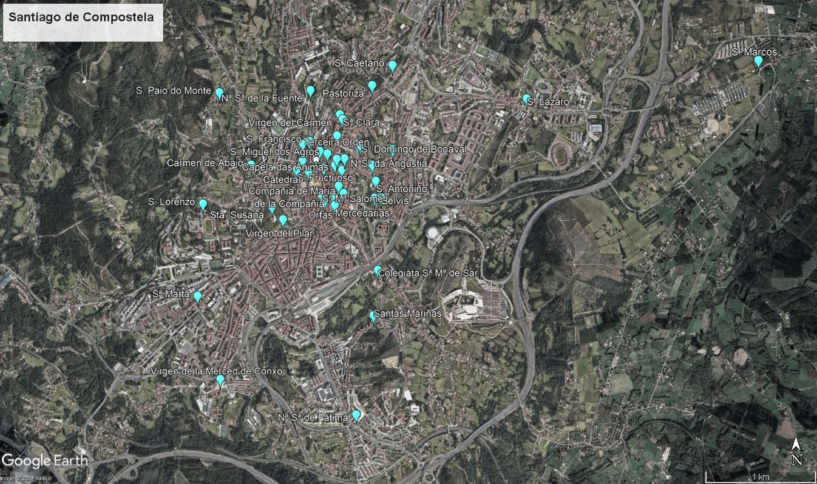
Figure 1. Aerial photograph of the research area, most churches, indicated in blue, are located in the old town of Santiago de Compostela (Modified from Google Earth Pro).

The second part of the analysis had the main objective of identifying the astronomical declination of each church. The astronomical declination is a celestial coordinate that provides the vertical distance of heavenly bodies with respect to the celestial equator. This is a handy coordinate as it directly relates the direction we have measured and the altitude of the horizon with the rising or setting of those celestial bodies, such as the sun, by the formula
sin(δ) = sin(φ) sin(h) + cos(Α) cos(φ) cos(h).
Where δ is the declination, φ is the latitude, h is the altitude and A is the calculated azimuth (see e.g., Magli 2016, pp. 4-5). The results of our measurements are given in table 1.
With this information, we can now determine the possible date where the sunrise would coincide with the orientation of the church, in those cases where this is possible. These data are crucial for the identification of patterns both within the town of Santiago and in relation to the traditional architectural patterns of Christian churches of Galicia.

Church | φ (°/') | λ (°/') | Α (°) | h (°) | δ (°) | Year | date
Catedral | 42/53 | 8/33 | 86 ± 1.0 | 1 | 3.3 | 900 | 25/3-10/9
Sta. Mª de la Corticela | 42/53 | 8/33 | 79 ± 1.0 | 1.8 | 8.6 | S. X | 9/5-25/8
San Fiz de Solovio | 42/52 | 8/32 | 103.5 ± 0.4 | 3 | ‒7.7 | S. X | 25/2-9/10
San Miguel dos Agros | 42/53 | 8/33 | 85.14 ± 0.8 | 1.26 | 4.4 | S. X | 26/3-7/9
Catedral | 42/53 | 8/33 | 83.8 ± 1.0 | 1 | 4.9 | 1075 | 25/3-8/9
Santa Susana | 42/53 | 8/33 | 89.7 ± 0.6 | 1.6 | 1.1 | 1102 | 16/3-14/9
San Benito del Campo | 42/53 | 8/33 | 103.5 ± 0.7 | 2.08 | ‒8.6 | X (XVIII) | 20/2-10/10
San Pedro Apostol | 42/53 | 8/32 | 96.4± 0.8 | 2.25 | ‒3.4 | XII | 6/3-27/9
Colegiata de Santa María de Sar | 42/52 | 8/33 | 91.3 ± 0.5 | 6.36 | 3.3 | XII | 23/3-9/9
Santa María Salomé | 42/53 | 8/33 | 108.14 ± 0.5 | 2.01 | ‒11.8 | XII | 11/2-20/10
San Paio do Monte | 42/52 | 8/34 | 112.2± 1.0 | 2.2 | ‒14.7 | XII | 2/2-28/10
San Lorenzo | 42/52 | 8/33 | 98± 1.0 | 3 | ‒4 | 1216 | 3/3-26/9
Catedral | 42/53 | 8/33 | 83± 1.0 | 1 | 5.5 | 1258 | 27/3-2/9
San Fransisco | 42/53 | 8/33 | 95.4 ± 0.7 | 8 | 1.4 | XIII | 17/3-12/9
S. Domingos de Bonaval | 42/53 | 8/32 | 101.2± 0.7 | 7 | ‒3.4 | XIV | 4/3-24/9
Convento de Belvís | 42/53 | 8/32 | 88.8± 0.8 | 3 | 2.8 | XIV | 20/3-8/9
Capela Nª Sª de la Fuente | 42/53 | 8/33 | 128.3± 1.1 | 8 | ‒20.9 | XI-XV | 8/1-18/11
Hospital dos Reis Católicos | 42/53 | 8/33 | 92.1 ± 3.2 | 4.16 | 1. | 1501 | 14/3-11/9
San Martin Pinario | 42/53 | 8/33 | 257.0± 1.0 | 0.5 | ‒9.5 | 1597 | 24/2-18/10
San Roque | 42/53 | 8/33 | 97.1± 1.0 | 2.8 | ‒3.5 | XVI | 12/3-2/10
San Agostiño | 42/53 | 8/32 | 109± 0.5 | 3 | ‒11.9 | 1650 | 17/2-24/10
Convento de la Merced de Conxo | 42/52 | 8/33 | 168.7± 0.6 | 4.3 | ‒41.9 | 1671 | ----
Convento de Las Mercedarias | 42/53 | 8/33 | 153.9 ± 0.8 | 0.65 | ‒40.56 | 1671 | ----
Convento das Orfas | 42/52 | 8/33 | 167.8± 1.0 | 0 | ‒46.3 | 1671 | ----
Santa Clara | 42/53 | 8/32 | 82.5± 1.0 | 5.3 | 9.0 | XVII | 13/4-30/8
Capela da Virgen del Portal | 42/53 | 8/32 | 358± 0.8 | 3.8 | 50.7 | XVII | ----
Santa Maria del Camino | 42/53 | 8/32 | 107.7 ± 0.7 | 5 | ‒9.5 | 1770 | 24/2-18/10
Capela de Ánimas | 42/53 | 8/32 | 20.4 ± 1.2 | 2.16 | 45.39 | 1784 | ----
Nosa Señora das Angustias | 42/53 | 8/32 | 78.0 ± 0.9 | 1.35 | 9.7 | XVIII | 14/4-29/8
San Caetano | 42/54 | 8/32 | 113.4± 0.5 | 1.9 | ‒15.8 | 1701 | 5/2-5/11
San Paio de Antealtares | 42/53 | 8/33 | 95.6 ± 1.4 | 1.8 | ‒3 | 1707 | 13/3-1/10
Orden Terceira | 42/53 | 8/33 | 186.6 ± 0.8 | 1.18 | ‒45.53 | 1714 | ----
Capela do Pilar | 42/53 | 8/33 | 243. 7 ± 0.8 | 0.86 | ‒18.36 | 1717 | ----
da Universidade | 42/53 | 8/33 | 83.7 ± 0.3 | 1.4 | 5.3 | 1720 | 3/4-9/9
San Fransisco | 42/53 | 8/33 | 3.9 ± 0.7 | 1.9 | 48.86 | 1742 | ----
San Fructuoso | 42/53 | 8/33 | 258.4± 0.5 | 0.63 | ‒8.3 | 1754 | 27/2-15/10
Carme de Abaixo | 42/53 | 8/33 | 250.8 ± 0.4 | 6 | ‒9.8 | 1760 | 23/2-19/10
Capela da Pastoriza | 42/53 | 8/32 | 172.5± 1.0 | 8.6 | ‒38.2 | 1761 | ----
Compañia de Maria | 42/53 | 8/32 | 108.4 ± 1.1 | 3 | ‒11.4 | 1765 | 19/2-23/10
Carme | 42/53 | 8/32 | 280.7± 1.1 | 1.5 | 8.6 | XVIII | 12/4-1/9
Capela de San Antoniño | 42/53 | 8/32 | 274.2± 0.7 | 0.4 | 3 | XIX -1939 | 28/3-15/9
San Lázaro | 42/52 | 8/31 | 99± 0.5 | 2 | ‒5.4 | 1924 | 7/3-7/10
Capela de San Marcos | 42/52 | 8/31 | 250.2± 1.1 | 0 | ‒14.8 | 1965 | 9/2-2/11
Santa Marta | 42/51 | 8/33 | 106.7± 1.1 | 5.7 | ‒8.3 | S XX | 27/2-14/10
Stas. Mariñas | 42/52 | 8/31 | 203.4± 1.2 | 10.5 | ‒32.6 | S XX | ----
Virgen de Fátima | 42/52 | 8/32 | 41± 0.6 | 5 | 37.5 | S XX | ----
Table 1. Data for the 48 churches measured in our sample. The columns include the name of the church with its latitude (φ), longitude (λ), azimuth (Α), with an estimate of its uncertainty, altitude of the horizon in that direction (h) and declination (δ). The last column includes the foundation date of the church. In those cases where there are two phases either the church is included twice, as in the Cathedral, or two dates are given.

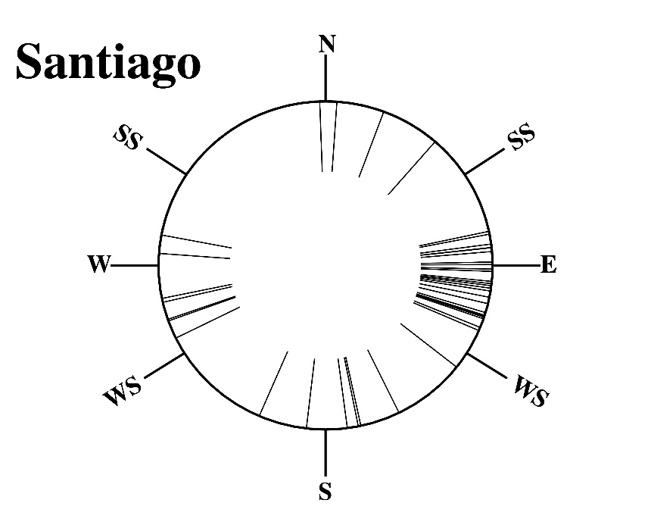
Figure 2. Orientation diagram summarizing the azimuth values of the churches of Santiago de Compostela. Around the circle are classified the cardinal directions, the summer solstice (SS) and the winter solstice (WS). A particular concentration is observed towards the eastern part of the horizon.
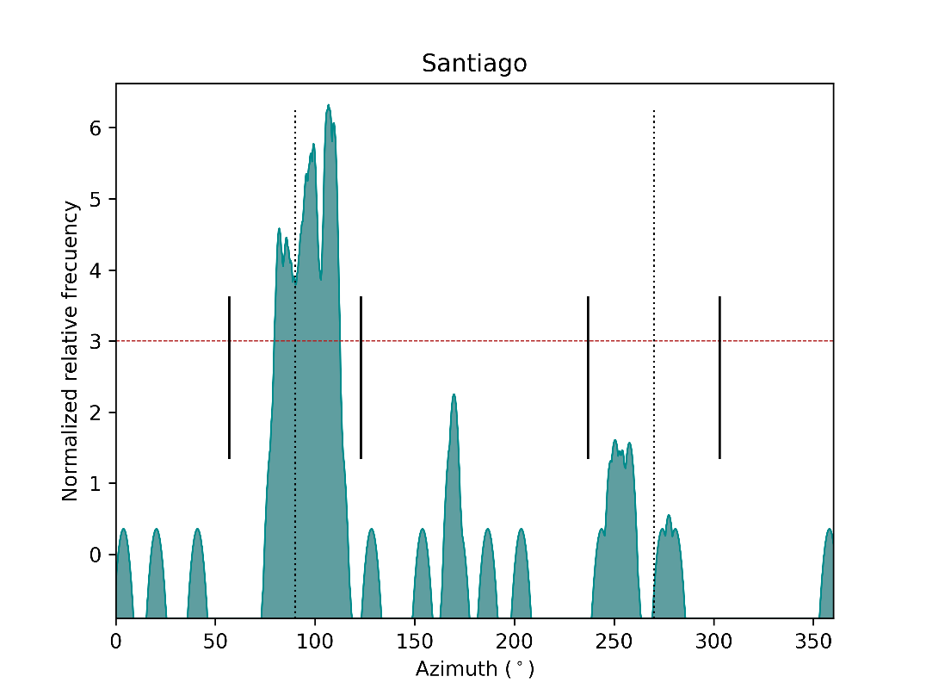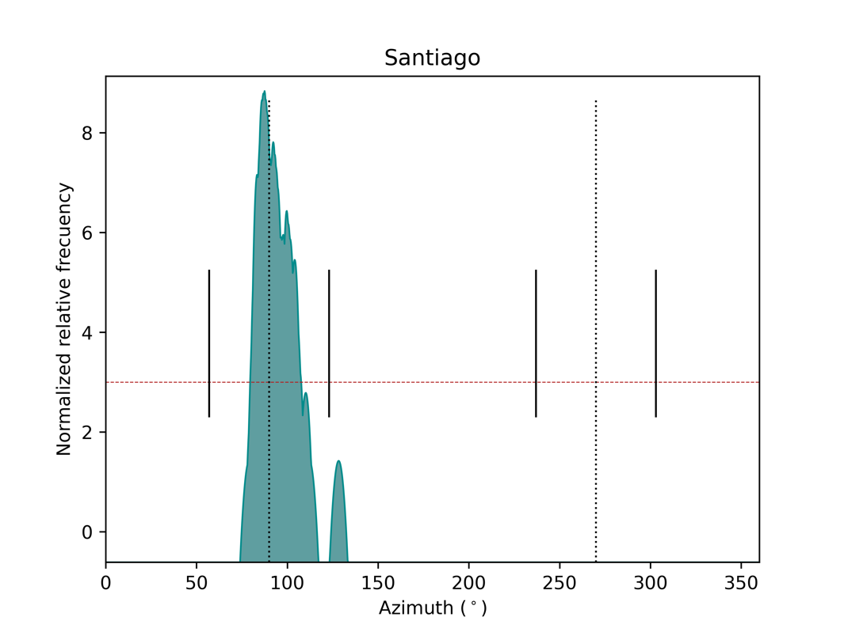
Figure 3. Top: azimuth histogram of the 48 churches studied. The vertical dotted lines indicate East and West, while the smaller continuous lines indicate the solstices. The data above the horizontal red dotted line are discussed in the text below. Bottom: azimuth histogram for those churches prior to the Council of Trent.
Results
The azimuth values obtained from the measurement of the churches are given in Table 1 and shown in figure 2. In this graph, commonly called an orientation diagram, the small outer lines indicate the cardinal directions, and the points on the horizon of the sunrise and sunset at the solstices, while the larger inner lines within the circle indicate the measurements. This orientation diagram helps us to identify common patterns indicating either predetermined architectural practices or different types of orientations.
As shown in the figure 2, about 76% of the churches are oriented towards the eastern and south-eastern part of the horizon. It is further observed that there is a concentration around east, within the limits of sunrise. The exceptions are 10 of the 48 churches, which are oriented towards the western part, having different orientations: 1 faces North, 7 face West withing sunset limits and 2 South.
Figure 3 presents a curvigram with the azimuth values that present larger concentrations according to our measurements. To do this plot, each measurement is considered as a Gaussian kernel where the mean is the azimuth value obtained and the width is the uncertainty in the measurement. This provides the probability density estimate of our measurements, in other words it tells us where we have the larger probability to find our orientations. This diagram confirms that the greater concentration of azimuths is towards the east, but with a larger number slightly south of due east. The curvigram demonstrates that most of the churches in Santiago are located within the solar rising range and are mainly oriented towards the southern part of the east (90-135°). In this analysis, the altitude of the horizon was not considered.
In order to derive more precise results on the relationship between the orientation of churches and astronomical phenomena, we created a curvigram, this time considering the declination. The results are presented in figure 4. To verify if the concentration is significant against a random hypothesis we have compared our data with respect to a uniform distribution, where we have extracted a few thousand random distributions with the same number of elements as in our sample. This allows us to calculate the expected variations due to randomness. We then compare our data with such samples by constructing the so-called z-score. In this case values above the line of z=3 can be regarded as highly significant.
The first thing to note, as indicated above, is that most orientations are within the limits of the solar range, with only a handful of churches with orientations outside these limits. With respect to the concentration within the solar range, we may observe two maxima, on both sides of the δ=0° line indicating the astronomical equinox. The first maximum is at a value of c. –10°, while the second appears at a value of c.7°, also with slightly larger values at negative declinations.
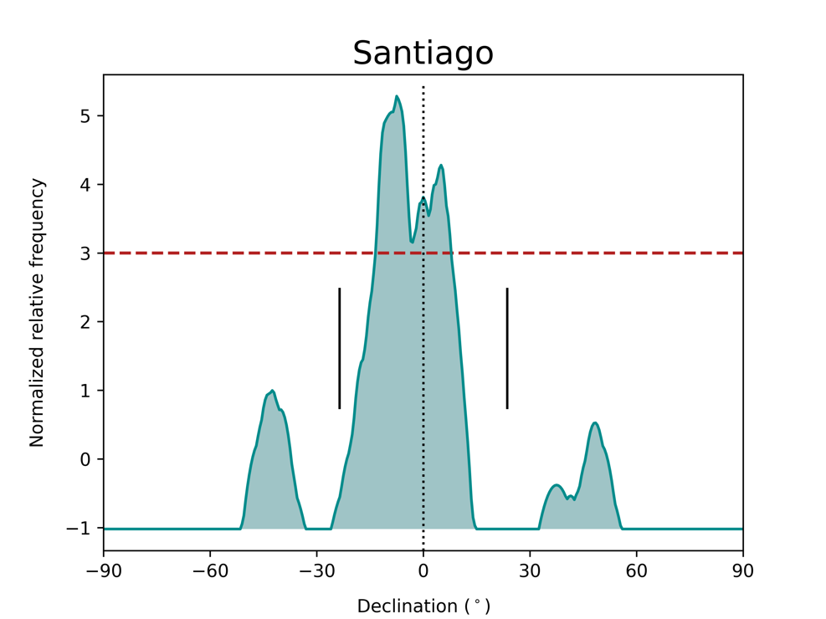
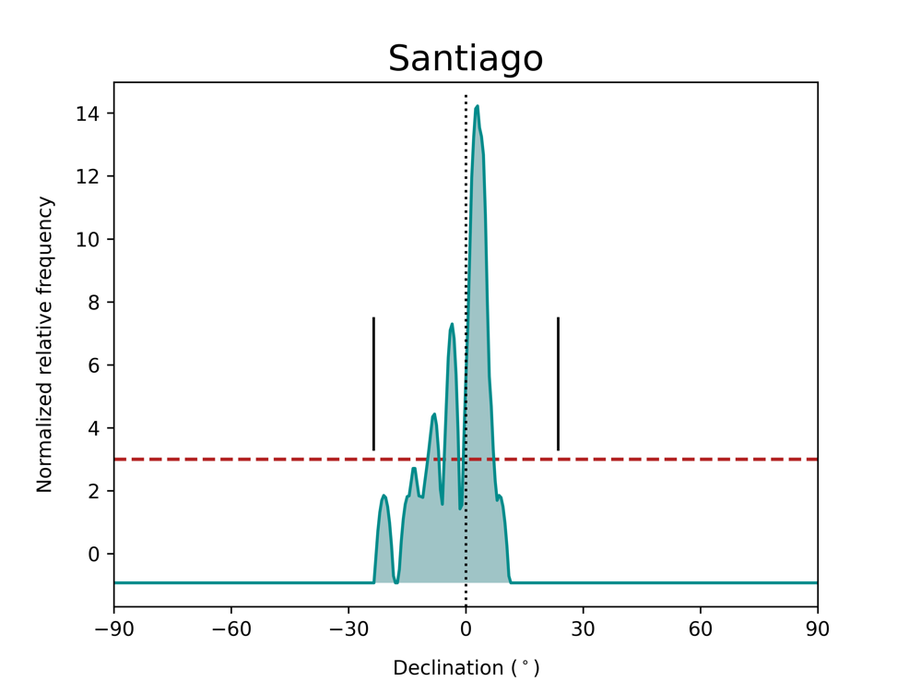
Figure 4. Top: declination histogram based on the normalized relative frequency taken from the azimuth data of the churches, on a latitude of 42° 50’. The astronomical equinox is defined by the vertical dotted line and the solstices by the small black lines. As a refence for statistical significance, the horizontal red line represents the 3σ level. Bottom, declination histogram for the churches built prior to the Council of Trent.
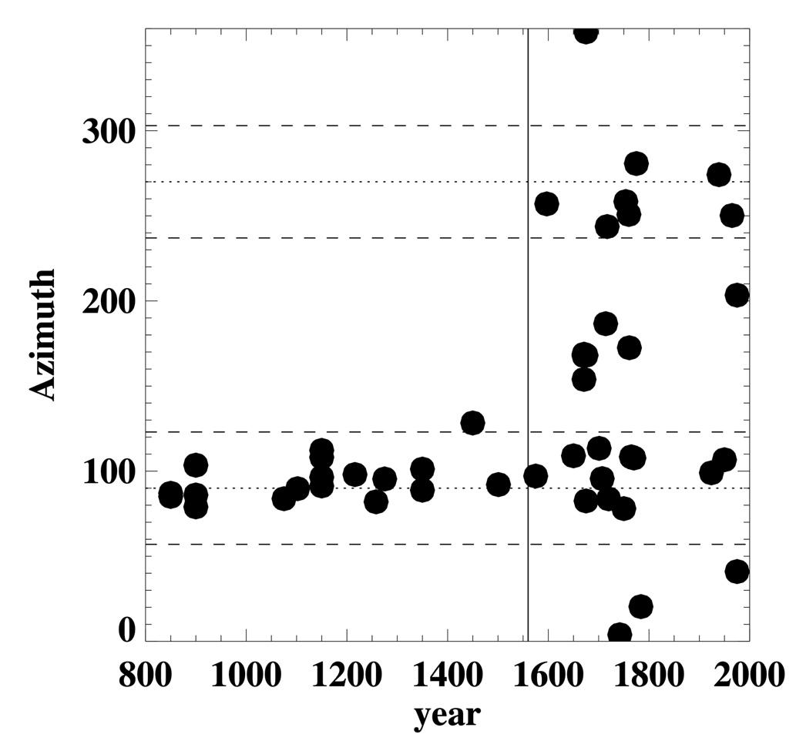
Figure 5: Orientation of churches along time. Each church in our sample is indicated as a filled dot. The horizontal dashed lines indicate the solar rising and setting limits. The dotted lines indicate due east and west. The vertical solid line is drawn at 1560 to indicate the Council of Trent. Note the systematic orientation within the limits of sunrise prior to this limit. For details see text.
If we translate the above declination values into dates, we do not find significant correlations between the patron saint of the churches and the date corresponding to the rising of the sun at the corresponding orientation. The only case, that might be of interest is the Cathedral of Saint James with the date of the Martyrdom of the saint on March 25th, and perhaps Santa María Salomé on October 22nd.
Finally, figure 5 indicates the azimuth values with respect to time. We can see how the earlier churches seem to be all of them within the solar range limits, until a date close to the second half of the 16th century. The only church slightly out of it is NªSª de la Fuente, but when considering the altitude of the horizon, it is compatible with being inside the solar range. After such date, the spread is much larger, and although most churches are still within the solar range limits, now both at east and west, there appear churches with orientations also to the west and more significantly towards north and south, previously absent from the values found.

Discussion
After the archaeological excavations carried out in the mid 20th century in the Cathedral, it was already noted by Guerra Campos the change in orientation between the pre-Romanesque church of Alphonse III and the Romanesque one (Guerra Campos 1982). It was indicated later on that such change was consistent with the change along time of the 25th March due to the Julian calendar discrepancy with the Tropical year (González-García 2015a).
The same orientation was retrieved outside the medieval city walls in the churches of Santa Susana, San Francisco (the Romanesque church) and especially at the collegiate church of Santa María de Sar.
However, as we can see in figure 4, the most common orientation among the churches of Santiago, especially prior to the Council of Trent, is the one at nearly 105°, or a declination of c. –8°. This orientation can be found in the churches along the streets of the medieval part, notably Santa María Salomé, San Fiz de Solovio or San Benito do Campo.
This dichotomy seems interesting, with a preferred orientation along the streets of the medieval town and another one in the Cathedral itself and the churches outside of the city walls.
Among the first group we could indicate that they seem to follow the orientation perpendicular to the streets (as indicated by Urrutia Aparicio et al. 2023). Among these churches we may note the orientation of Santa María Salomé with 108° and 2° of horizon altitude, would correspond to c. −12° in declination and dates of February 17 or October 25. This could have some significance as the celebration date of the saint is October 22. Indeed, in this case, where the church is celebrating the mother of Apostle Saint James, it could be interpreted as highly relevant in this town.
However, the foundation of this church is commonly thought to be in the 12th century, sometime later than the foundation of the city and of the laying out of those streets. At this point, it could be interesting to indicate that the only remains of a Roman building, apart from the Roman mausoleum where the alleged tomb of the apostle is located, was found during the archaeological excavations below the present floor of the Cathedral (Guerra Campos 1982). There, next to the central part of the southern arm of the transept the archaeologists recovered the remains of a Roman building, sometimes controversially interpreted as a Roman Sauna, with an orientation skewed nearly 12° south of east (A=102°). This would also be the mean orientation of the ancient necropolis that it was also discovered at the time.
We could speculate, together with many other authors (see e.g. Rodríguez Álvarez 2010, p. 31; Suárez Otero & Caamaño Gesto 2003, p. 35), that both the Mausoleum and the necropolis, commonly located on the sides of the roads leading to the Roman habitats and therefore perpendicular to it, might indicate, together with the Roman building, the orientation either of the Roman Mansio or that of the ways leading to it. In that case, p–erhaps the orientation of the churches of the Medieval part of Santiago, perpendicular to the Medieval streets, are reflecting the fossilization in the landscape of the old Roman roads.
Such is clearly broken after the Council of Trent and the new indications for the construction and orientation of churches of Carlos Borromeo (Urrutia-Aparicio 2024). The first construction to adhere to such new prescriptions is the new church of the San Martín Pinario Monastery (Pernas Varela 2015), next door to the Cathedral. The monastery was reformed at the end of the 16th century, demolishing the Romanesque church, whose exact location and orientation are lost. Remains of this church are still to be seen in the fundaments of the western walls of the monastery, possibly close to where the church once stood, but until archaeological excavations are undertaken in this area we cannot say further. The new church, that houses an impressive early Baroque decorative program in the interior, and an extraordinary façade like a stone altarpiece, actually presents a dual orientation: while the main nave is oriented towards west, the same altar has a secondary chapel on the back, that it is actually the altar for the monks of the congregation and therefore would be oriented towards east as prescribed. Many other elements inside this church would be worth indicating but will be the outcome of a forthcoming paper devoted to this church only.
Three other churches built at this time, Orfas, La Merced de Conxo and Mercedarias have orientations towards south very consistent among them, although they are located at different areas of the town. Conxo is the replacement of a Romanesque church of the monastery by a Baroque one, something quite common at this time in Galicia. The remains of the Romanesque cloister are still visible, allowing to trace the orientation of the old church. Something similar happens at the site of San Francisco monastery, where the only old remain is the cloister. The old church was replaced by a massive baroque and neo-Classic style church that is now oriented towards north. With this orientation, the new church façade is facing south towards the newly open street that connects directly this area with the Obradoiro square, allowing for a picturesque as well as a highly representative scenery, that was before less dramatic. This is something common at this time, providing a clear explanation for the large spread that show the orientations of religious buildings at the town after the Council of Trent.
The 19th and 20th centuries continue with this tendency with a more dramatic effect, since now the churches directly accommodate themselves to the already planned street layout. This is specially so during the 19th century expansion of the city outside the Medieval city walls (demolished by the middle of that century and replaced in most parts by a new street that still follows the trace of the wall).
Conclusions
The early medieval churches in Santiago appeared in two main orientations. On the one hand, following the orientation of the Cathedral towards sunrise on March 25th along time, several churches, especially outside the Medieval city walls, and notably far from the Cathedral itself, follow a nearly equinoctial orientation. A typical example is the church of Santa Susana, the traditional co-protector of the city along with St. James, or the church of Santa María de Sar. On the other, most of the Medieval churches inside the city walls are compatible with orientations skewed some 12° to 15° south of east. This could be linked either with the orientation of Santa María Salomé and the rising sun of the day of its patron saint, or perhaps more plausibly, with the orientation of the ancient roads crossing this area, that perhaps were reflected in the Roman remains found in the Cathedral itself.
All these churches followed the canonical prescription of facing towards the rising sun, and in most cases (save que popular chapel of Nª Sª de la Fuente) avoid the solstices.
After the Counter-Reformation, and the Council of Trent and the indications by Borromeo, the orientation of churches in the city of Santiago are rather more dispersed. Possibly in most cases this was due to the need to accommodate the orientation of monasteries and churches to the already existing streets. In some cases, they also sought to enhance the picturesque and representation of the church and monasteries in the town that at that time was ratified as the end of the most famous pilgrimage route in Western Europe and housing the patron saint of Spain. To do so, the façade was made facing towards the street, with the consequent change in orientation of the apse and the main altar.
Thus, in the early Medieval times astronomy did seem to play a role singularly to find the correct orientation of the churches that were close to that of the Cathedral. To find such they had either to watch sunrise at the correct time or try to calculate such by one of the means indicated by Vitruvius and other architects (Steinrücken 2018; Ginovart et al. 2021). In any case, all those methods did recourse to some kind of astronomical observation. It is therefore interesting to note that in those cases the sky did indicate and possibly dictate the orientation.
It is interesting, though, that the orientation of the layout of the already existing roads might explain the orientation of the Medieval streets. In this sense, such orientations were allegedly not determined astronomically, but just followed roughly perpendicular to the road, in a way that was compatible with the canonical prescription.
After the council of Trent, the orientations of churches in most cases did no longer dictate the orientation of the towns, and the new foundations, and the reforms of old buildings, did accommodate to new needs of a growing town where rationalist planning now dictated the orientations. In this sense it is paradoxical to note that the orientations of cultic buildings in Santiago seem more consistent, and therefore perhaps rational, before Trent, than after.
Conversely, the prescriptions before the Baroque age, and the Enlightenment that provide a clear pattern of orientation, can be seen as the reflection of the ordered and constrained society of the Medieval and Renaissance times. However, such was broken after Trent and the new prescriptions also paved the way for new concepts of town, and society.
Acknowledgements
Part of this work was funded by the State Research Agency (AEI), the Spanish Ministry of Science and Innovation (MICIN) and the European Regional Development Fund (ERDF) under grant with reference PID2020-115940GB-C22 “Orientatio ad Sidera V”. The cooperation between the authors was established within the framework of the Erasmus+ programme of the University of the Aegean.

Bibliography
Ali, R.J. & Cunich, P. (2001). The Orientation of Churches: Some New Evidence. The Antiquaries Journal 81, 159.
Armas Castro, J. (2003). El Afianzamiento de la realidad Urbana Después del año Mil. In E. Portela Silva (Ed.) Historia de la Ciudad de Santiago de Compostela (pp 81-126). Universidade de Santiago de Compostela.
Barreiro Fernández, X.R. (2003). De la Tutela Eclesiástica a los Inicios de la Andadura Burguesa (1808- 1875). In E. Portela Silva (Ed.) Historia de la Ciudad de Santiago de Compostela (pp 433-472). Universidade de Santiago de Compostela.
Borromeo, C. (1577). Instructionum Fabricae et Supellectilis Ecclesiasticae. Librería Editrice Vaticana (2000).
Castro Díaz, B. (2010). De la Ciudad Medieval a la Barroca: Transformaciones y Pervivencias en Santiago de Compostela en la Época Moderna. In B. Castro Díaz & M. López-Mayán (Eds.) Historia de Santiago de Compostela (pp 127-212). Vía Láctea Ed.
Deswarte, T. (2015). St. James in Galicia (c. 500-1300). In J. D’Emilio (Ed.) Culture and Society in Medieval Galicia. A Cultural Crossroads at the Edge of Europe. The Medieval and early Modern Iberian World, 58, 477-511. Brill.
Farina, W. (2018). Saint James the Greater in History, Art and Culture. McFarland & Company.
Fernández Pereiro, M., Sánchez Pardo, J.C. (2022). Buscando un castillo altomedieval en la vegetación. El caso de Castro Valente (Padrón , Galicia). Cuadernos de Aqueología de la Universidad de Navarra 30(2), 55-72
Fletcher, R.A. (1984). Saint James’s Catapult: The Life and Times of Diego Gelmirez of Santiago de Compostela. Oxford.
Funk, F. X. (1905). Didascalia et Constitutiones apostolorum. Libraria Ferdinandi Schoeningh.
Ginovart, J.L., Lluís Teruel, C., and Ugalde Blázquez, I. (2021) Cosmology and Precision in the Val d’Aran. Nexus Network Journal, 23, pp. 433–451. DOI: https://doi.org/10.1007/s00004-021-00551-2
González-García, A. C. (2015a). A voyage of Christian medieval astronomy: symbolic, ritual and political orientation of churches. In F. Pimenta, N. Ribeiro, F. Silva, N. Campion, A. Joaquinho y L. Tirapicos (Eds.), SEAC 2011 Stars and Stones: Voyages in Archaeoastronomy and Cultural Astronomy, pp. 268-275. BAR International Series, 2720.
González-García, A. C. (2015b). La orientación de las iglesias prerrománicas de Galicia: análisis y resultados preliminares, Estudos do Quaternário/Quaternary Studies, 12, 133-142.
González-García, A. C. & Belmonte, J. A. (2015). The orientation of Pre-Romanesque churches in the Iberian Peninsula, Nexus Network Journal, 17 (2), 353-377. https://doi.org/10.1007/s00004-014-0231-7
González-Vázquez, M. (2003). Lugar de Culto y Centro de Cultura. In E. Portela Silva (Ed.) Historia de la Ciudad de Santiago de Compostela (pp 173-224). Universidade de Santiago de Compostela.
Guerra Campos, J. (1982). Exploraciones arqueológicas en torno al sepulcro del Apóstol Santiago. Santiago de Compostela.
Iglesias Amorín, A. (2010). Santiago en la Edad Contemporánea: de ciudad en decadencia a capital de Galicia. In B. Castro Díaz & M. López-Mayán (Eds.) Historia de Santiago de Compostela (pp 213-294). Vía Láctea Ed.
Karge, H. (2015). The European Architecture of Church Reform in Galicia. The Romanesque Cathedral of Santiago de Compostela. In J. D’Emilio (Ed.) Culture and Society in Medieval Galicia. A Cultural Crossroads at the Edge of Europe. The Medieval and early Modern Iberian World, 58, 573-630. Brill.
Kosowsky, M. (2020). HeyWhatsThat. Available at: https://www.heywhatsthat.com/.
Liber Sancti Jacobi. Codex Calixtinus. Eds. Klaus Herbers and Manuel Santos Noia. Santiago de Compostela, 1998.
López Alsina, F. (1988). La Ciudad de Santiago de Compostela en la alta Edad Media. Santiago de Compostela
López Mayan, M. (2010). Origen y Desarrollo de Santiago en época medieval: del locus Sanncti Iacobi a la ciudad de Santiago. In B. Castro Díaz & M. López-Mayán (Eds.) Historia de Santiago de Compostela (pp 39-125). Vía Láctea Ed.
McCluskey, S. (2015). Orientation of Christian Churches. In C. L. N. Ruggles (Ed.) Handbook of Archaeoastronomy and ethnoastronomy (pp. 1703–1710). Springer. DOI: https://doi.org/10.1007/978-1-4614-6141-8_173
McNally, R.E. (1965). The Council of Trent, The Spiritual Exercises and The Catholic Reform. Church History 34(1), 36-49. doi:10.2307/3162870
Magli, G. (2016). Archaeoastronomy: Introduction to the Science of Stars and Stones. Springer.
National Centers for Environmental Information. Magnetic Declination Estimated Value. Available at: https://www.ngdc.noaa.gov/geomag/calculators/magcalc.shtml.
Pallares M.C., Portela, E. (2003). Reyes, Obispos y Burgueses. In E. Portela Silva (Ed.) Historia de la Ciudad de Santiago de Compostela (pp 127-172). Universidade de Santiago de Compostela.
Pérez-Valcárcel, J. and Pérez-Palmero, V. (2021). La orientación de las iglesias medievales en la Península Ibérica. Universidade da Coruña, Servizo de Publicacións.
Pernas Varela, A. (2015). La Arquitectura del Conjunto Monumental de San Martín Pinario en Santiago de Compostela. Universidade da Coruña. PhD Thesis.
Puente Míguez, J.A. (1985). La Catedral Gótica de Santiago de Compostela: un proyecto frustrado de D. Juan Arias. Compostellanum, 30, 245-276.
Rey Castelao, O. (2003). La Cultura y sus Expresiones en una ciudad clerical y universitaria. In E. Portela Silva (Ed.) Historia de la Ciudad de Santiago de Compostela (pp 369-430). Universidade de Santiago de Compostela.
Rodríguez Álvarez, E. (2010). Compostela antes de Santiago: las ocupaciones de la ciudad y su entorno desde la Prehistoria a la Tardoantigüedad. In B. Castro Díaz & M. López-Mayán (Eds.) Historia de Santiago de Compostela (pp 13-38). Vía Láctea Ed.
Romano, G. (1997). Deviazioni negli orientamenti del tipo «Sol Aequinoctialis». Memorie della Società Astronomica Italiana, 68 (3), 723–729.
Saavedra Fernández, P. (2003). El Dinamismo Socio-económico del Principal Núcleo Urbano de Galicia. In E. Portela Silva (Ed.) Historia de la Ciudad de Santiago de Compostela (pp 225-310). Universidade de Santiago de Compostela.
Sánchez Domingo, R. (2013). El rito hispano-visigótico o mozárabe: Del ordo tradicional al canon romano. In F.J. Campos y Fernández de Sevilla (Ed.) Patrimonio Inmaterial de la Cultura Cristiana (pp. 215–236). Ediciones Escurialenses.
Sanjurjo-Sánchez, J., and Pérez Mato, M. (2013). Delimiting the Urban Growth of Santiago de Compostela (NW Spain) by OSL Dating of Medieval Anthropogenic Sediments. Mediterranean Archaeology and Archaeometry 13 (3), 165.
Santos-Estévez, M. (2010). El Castriño de Conxo y los territorios en la Edad del Bronce. TAPA: traballos de arqueoloxía e patrimonio 41, 159-165
Suárez Otero, J. (2003). Del Locus Sancti Iacobi al Burgo de Compostela. In E. Portela Silva (Ed.) Historia de la Ciudad de Santiago de Compostela (pp 49-80). Universidade de Santiago de Compostela.
Suárez Otero, J. & Caamaño Gesto, M. (2003). Santiago antes de Santiago. In E. Portela Silva (Ed.) Historia de la Ciudad de Santiago de Compostela (pp 23-48). Universidade de Santiago de Compostela.
Steinrücken, B. (2018). Auf die Sonne ausgerichtet? – Zur Problematik einer möglichen solaren Ausrichtung von Kirchen am Beispiel der spätkarolingischen Stiftskirche in Meschede. In G. Wolfschmidt (ed.), Baudenkmäler des Himmels – Astronomie in gebautem Raum und gestalteter Landschaft (pp. 167-190). Tredition.
Urrutia-Aparicio, M., González-García, A. C. y Belmonte, J. A. (2021a). Ad orientem: Las iglesias románicas del Camino Francés en los reinos de Castilla y León bajo la perspectiva de la Astronomía Cultural. Arqueología de la Arquitectura, 18: e122. https://doi.org/10.3989/arq.arqt.2021.014
Urrutia-Aparicio, M., González-García, A. C. y Belmonte, J. A. (2021b). East or Easter? Keys to the orientation of Romanesque churches along the Way of Saint James. Journal for the History of Astronomy, 52 (3), 289-310. https://doi.org/10.1177/00218286211026209
Urrutia-Aparicio, M., Belmonte, J. A., and González-García, A. C. (2022). Land-and Skyscapes of the Camino de Santia-go: An Astronomy and World Heritage Sustainable Approach. Sustainability, 14 (5), 3047. DOI: https://doi.org/10.3390/su14053047
Urrutia-Aparicio, M., Belmonte, J. A., and González-García, A. C. (2024). A Diachronic analysis of the orientation of the cathedrals of Por-tugal and Spain. Mediterranean Archaeology and Archaeometry, in press.
Voragine, J. de (1998). Legenda Aurea. Ed. Giovanni Paolo Maggioni.
Vogel, C. (1962). Sol aequinoctialis. Problèmes et technique de l’orientation dans le culture chrétien. Revue Sciences Religieuses, 36(3-4), 175–211. DOI: https://doi.org/10.3406/rscir.1962.2332
Williams, J. (2015). The Tomb of St. James. Coming to Terms with History and Tradition. In J. D’Emilio (Ed.) Culture and Society in Medieval Galicia. A Cultural Crossroads at the Edge of Europe. The Medieval and early Modern Iberian World, 58, 543-572. Brill.
Zotti, G., and A. Wolf. (2023). Stellarium 23.1 User Guide. Available at https://stellarium.org/.

Through the platform Magnetic Declination Estimated Value.

