TEACHERS’ FORUM

Enhancing the Textbook’s Cultural Content within the University Museum: Students’ Perceptions of Two Activities

NAUSICA MARCOS MIGUEL

XXXXXX University

E-mail: nausica.marcosmiguel@ugent.be

MEGAN HANCOCK

Denison University

E-mail: hancock@denison.edu

The authors, a language instructor and a museum educator, collaborated to enhance a textbook’s cultural content in a Spanish L2-third semester class. We integrated the university museum’s artifacts and one exhibition within regular classroom instruction and co-designed two activities. The activities were connected to the textbook’s cultural content. Each activity included a visit to the museum, a worksheet to work in the museum, and a written and oral task after the visit. Thirty-five students completed a questionnaire at the end of the semester to rate the integration of these museum visits with the rest of the Spanish curriculum. Most students were positive about the effects of the experience on their learning and did not see the activities as something extraneous to the language curriculum. This article offers food for thought to other language practitioners and museum educators regarding textbooks’ cultural content and university museums.
_______________

INTRODUCTION

Most US universities have museums contributing to the university-wide curriculum and second language (L2) classes (e.g., Díaz, 2016; Matthias, 2017). This article describes how we, Nausica and Megan, a language instructor and a museum educator, collaborated to design activities that enhanced the Spanish L2 textbook used in a third-semester language course by including activities with artifacts from the permanent collection as well as with a temporal exhibition. We collected data on students’ perceptions of the activities during their implementation.
For researchers and museum educators, this project provides insights into language learners’ and language instructors’ priorities when visiting a museum as part of their regular classroom instruction. For language educators, this project suggests ideas for connecting the classroom with a university museum or other nearby museums.

THE CONTEXT

At the time of the project, we were both working at Denison University, a Liberal Arts College (LAC) in the Midwest of the United States. The Denison Museum is a teaching museum committed to creating exhibitions and learning experiences that help fulfill the university’s mission to “inspire and educate our students to become autonomous thinkers, discerning moral agents, and active citizens of a democratic society” (mission statement). Over one hundred classes from a variety of departments engage with the collections and exhibitions annually.
One of the museum’s goals is to foster Object-Based Learning (OBL) (e.g., Chatterjee & Hannan, 2015). Whether students respond to exhibitions or interpret items in the collection, the experience places them in conversation with objects, prompting learning through discussion, labs, textual analysis, and guided research. Megan works closely with faculty members to understand their needs, generate ideas, and create activities. Activities range from casual visits introducing the museum resources to collaboratively curated exhibitions and lesson plans that integrate OBL into the core curriculum of a course.
The third-semester Spanish course, for which the activities were designed, focuses on language development and increasing students’ cultural knowledge. Moreover, the course brings together students interested in pursuing further studies in Spanish, with students completing a language requirement, i.e., the university-wide language requirement or one specific to their major.
Several third-semester sections are offered every semester, ranging from four to six sections. This study collected data in the Fall of 2021 and Spring of 2022, when five sections were taught each semester. The textbook and the syllabus, which included the assessment procedures, were shared among sections. The instructors could slightly adapt the course content and materials to their class needs.
To better situate the background of the activities, we provide support from the literature about why museums are fundamental companions of formal education and, specifically, why they can amplify learning opportunities in L2 classrooms.

Museums and Formal Education

Across institutions, the teamwork between museum and language educators shapes museum activities and connects visits with the class curriculum. In their Framework for Museum Practice, DeWitt and Osborne (2007) establish four main principles to guide museum educators when designing effective learning experiences:

- Principle 1: Engaging with the instructors and their needs,
- Principle 2: “Providing structure”,
- Principle 3: “Encouraging joint productive activity,” and
- Principle 4: “Supporting dialogue, literacy, and/or research skills.”

While the instructor clarifies the curriculum, the museum educator introduces the artifacts and methodologies that the museum can bring into a classroom. Both educators must work together to set clear learning goals and objectives for the visit (before, during, and after). Moreover, their frameworks for teaching and learning need to be explicit.
In this project, the framework for conducting pedagogical activities in the museum is OBL. OBL is an experiential pedagogy focusing on close, tactile interaction with physical materials (including works of art, cultural artifacts, documents, specimens, etc.) and sensory experiences, i.e., an approach to learning “about, with, and through objects” (Paris, 2002, xiv). Because of this physicality, active and experiential learning strategies are also included within this framework (Chatterjee, 2010). OBL also prompts inquiry into complex socio-political or scientific issues; it helps cultivate skills in visual literacy, critical thinking, teamwork, and written and oral communication. Megan organizes their collaboration with other colleagues across campus using this pedagogy. For example, she team-taught in a sociology class that combined in-class and museum work during one semester. At the end of the semester, the students showed “progress in identifying and understanding themes in the course, […] ability to define and conceptualize [the main class concept], formal analysis skills, and critical thinking” (Noy & Hancock, 2021, p. 40).

Language Textbooks & Museum Worksheets

Textbooks are fundamental elements in understanding curricular content (see Remillard & Heck, 2014). Although not all language instructors use a textbook as their point of departure for designing a course, in universities and LACs in the United States, where several sections or professors use the same textbook, the textbook becomes a unifying factor (e.g., Marcos Miguel, 2015). Moreover, the textbook is adapted to the instructor’s and learners’ needs and goals (see McDonough et al., 201). Thus, a visit to a museum can be understood as a textbook adaptation.
In museum education research, other printed materials, such as worksheets, are more relevant than textbooks (e.g., Hauan & DeWitt, 2017; Kisiel, 2003). Thanks to worksheets, students can draw, talk about drawing, and extend their engagement with museum objects. The worksheets allow for building something off the paper and transferring it beyond the museum since they provide students with a new language (technical and general) and scaffolding.
With the digitalization of L2 education (see Godwin-Jones, 2021), printed materials, both textbooks and worksheets, can also be digital. Both kinds of materials operationalize the learning goals of a lesson. While the textbook needs a higher level of engagement from the instructor regarding selection and adaptation (e.g., Marcos Miguel, 2015), the worksheets are more specific in that they represent the task that will be carried out in the museum.
In the field of museum education, several studies have analyzed learners’ interactions with worksheets. For example, Kisiel (2003) observed twelve schools in self-guided tours with worksheets. The teacher-designed worksheets varied in the level of specificity of questions (i.e., related or not to the exhibits), the time needed to be completed, the information source (i.e., object- or label-dependent), the freedom of choice for the students, and the cognitive level of the questions. The successful implementation of the worksheet varied because of its structure and the pedagogical knowledge of the adults supervising the students (e.g., experienced teachers versus volunteering chaperones). The author concluded that a concept agenda-based worksheet, i.e., focusing on fewer items of the exhibition but in more detailed analysis and with opportunities for collaboration and choice, will contribute to deeper learning. Moreover, interactions between the instructor and students will influence the worksheet’s success.

Museums in L2 Language Classes

The current research emphasis on multiliteracies has produced several accounts of successful L2 learning in and with museums (e.g., Barabas, 2022; Palpacuer Lee, 2019). Following multiliteracies pedagogies, as meaning is not only provided by printed texts but by an array of semiotic resources (e.g., audiovisual materials, visual materials, gestures, etc.), museums are ideal spaces for learning (e.g., Warner & Embeywa, 2022). Beyond the multiliteracies approach, there is nothing more crucial to language practitioners when planning a lesson than the need to bring artifacts to the classroom, especially images, that facilitate learning (e.g., Woodward, 2001). A museum can bring real objects to the students (e.g., Matthias, 2017).
Although adapting a textbook is a common practice for language teachers, little research on L2 and museums references the class textbook. When the activity is planned from the museum educator’s perspective, the pedagogical activities can be planned without much input from the textbook or the instructor as long as there are connections to the curricular needs of the age group (e.g., Fazzi, 2018, 2020; Fazzi & Lasagabaster, 20021). Nevertheless, some instructor-researchers have already emphasized the importance of connecting the museum visit with the classroom textbook (e.g., Parra & Di Fabio, 2017).
Doubtless, museums can contribute to developing students’ cultural knowledge that is already targeted in textbooks. In their Five C’s framework (communication, cultures, connections, comparisons, and communities), The National Standards Collaborative Board (2015) establishes three main elements to organize the teaching of culture: products, practices, and perspectives. The museum objects are the products to which the L2 learners need to be exposed. While in the textbook, these objects can be included as audiovisual material (i.e., in videos and photos), in the museum, students can see and even touch them. Thanks to museum educators, the learners can deepen into the perspectives and practices of the communities that created and used the objects. That is, through these exchanges, the learners have the opportunity to inquire further about the products, practices, and perspectives.
Focusing on university education, several remarkable projects have integrated museum objects into language classes (e.g., Díaz, 2016; Matthias, 2017; Parra, 2013; Parra & Di Fabio, 2017; Sederberg, 2013). In these projects, the instructors work with materials related to the museum, such as readings, images, museum objects, videos, etc. Most of these studies reported students’ perceptions based on questionnaire data, student output, and/or instructors’ perceptions of the project’s success. Because of the small scale of these projects, systematic data collection and analysis do not happen often. Nevertheless, most instructors in these studies seem positive about outcomes in students’ language use and cultural knowledge.

THE ACTIVITIES

The Museum Resources and the Textbook Content

The Denison Museum has a large collection of molas, textile artifacts designed and crafted by the Guna people of Panama and Colombia. Figure 1 depicts one such mola.

Figure 1
Crab Mola Panel (mid-1900s) (DU1972.341)

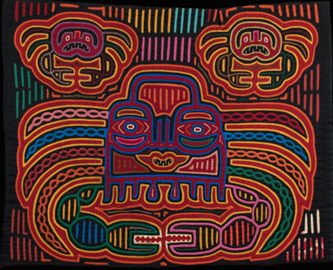

Because of the broad scope of the collection, Megan, the museum educator, has realized collaborations with internationally renowned museums. Given their relevance and connection to Latin America, Megan has made the Spanish language instructors aware of the existence of this collection in the university museum. When Nausica learned about the collection, she remembered that the language textbook (Blanco & Donley, 2021) had already discussed these artifacts. Therefore, the first museum activity we describe is adapted from a textbook section on Panama, where the molas were presented. Figure 2 shows the section dedicated to las molas in chapter 12. Figure 2 was the only text and activity in the textbook about this topic.

Figure 2
Textbook Fragment (Blanco & Donley, 2021, p. 411)

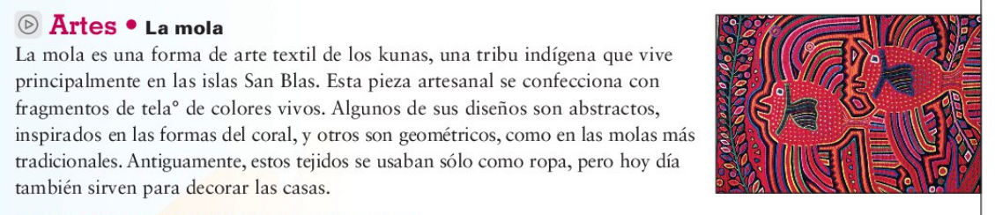

The museum also curates two rotating exhibitions every academic year in their two main exhibit halls. Therefore, for the second activity, in Spring 2022, an email announcement from the museum about the semester exhibition on RYAN! Feddersen sparked a conversation between Megan and Nausica about how the exhibition could connect to one of the textbook’s chapters on nature and natural disasters, where little factual content was provided (Chapter 13). Thus, we adapted the textbook chapter to include world events, history, and indigenous people. As an example, Figure 3 shows one chapter activity. Although this activity serves as a starting point of discussion by including vocabulary, it does not offer any new information. This activity is based on learners’ prior knowledge of nature and natural disasters.

Figure 3
Textbook Fragment (Blanco & Donley, 2021, p. 419)

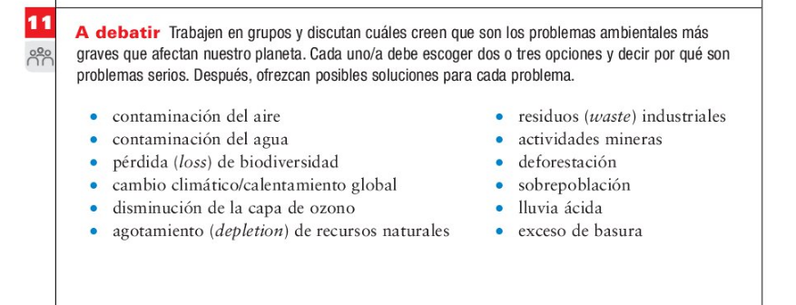

The Designed Activities

The first activity, the mola activity (see Appendices A-B), was carried out for several semesters. The second activity was contingent on the RYAN! Feddersen exhibition in Spring 2022 (see Appendix C). In both cases, we met to prepare the activities, which included planning the visits and designing the worksheets. For the visit, the students met in the Museum during their regular class time (a session of 50 minutes). Both visits required time for Megan to orient the class, present the material, provide context, and introduce objects and ideas before students engaged alone or in small groups.
The worksheets structured the museum activities, and as such, we considered them the lesson plan for the museum. The worksheets also included a final task for the language class (e.g., for the first one, describing a mola in an oral presentation and an essay). In brief, the worksheets were completed during the museum visit and used as a reference tool for the homework assignments, i.e., the final tasks.
The activities exposed most students to OBL for the first time. Following OBL and connecting it with the class goals of increasing knowledge about cultures in the Spanish-speaking world with language skills, students interacted with the objects by touching and looking at them closely. Beyond the museum, students continued exploring their cultural and historical relevance while practicing their presentational skills.
The principles used to organize the visits aligned with the recommendations by DeWitt and Osborne (2007, p. 689-691), as the activities provided structure to the visits and the subsequent tasks. Other recommendations were also followed. For example, the activity after the museum helped the “reinforcement of the learning experience” (principle B2), while the activities in the museum and class contributed to the “discussion among peers” and with the instructor and museum curator (principle 3a). The students were also given some “choice and control” (principle 3c). For instance, students could choose the mola to work on and some aspects they wanted to emphasize in their essays and presentations.
Whereas in some museum visits, the L2 is mainly used (e.g., Fazzi, 2018, 2020), in these activities, the visit was carried out in the L1 as Megan did not speak Spanish. When Nausica spoke to the class, she used the target language as much as possible. In this bilingual atmosphere, the worksheets included Spanish and English vocabulary. Part of this specialized terminology was also new in English for the students. That is, the content was learned first in the L1 with continuous references to the L2, and the final task was fully carried out in the L2.
The difference between both activities was due to the goal of each visit. The mola activity focused on the object, vocabulary, and close-looking. The mola worksheets followed a concept agenda as they had few questions, “opportunities for more student choice, and a greater emphasis on student observation of objects rather than label reading” (Kisiel, 2003, p. 15). The RYAN! Feddersen activity emphasized events outside the exhibition by connecting the exhibition to current and older news. Students read newspaper articles in small groups to increase their factual knowledge. Next, the two activities will be described in detail. In both activities, we sought to connect cultural knowledge (products, practices, and perspectives) with language practice and acquisition while following the tenets of OBL.

Mola Activity

We implemented the mola activity in the Spring of 2017 for the first time. Then, Nausica shared the activity with other colleagues, who also collaborated directly with Megan to carry out the activity. Every semester, the class began with Megan placing herself behind a table where several molas were displayed. From that position, every student could see the sewing patterns. In addition to the main table, six tables were placed in the room, with two molas each. Since, according to OBL, touching objects enhances students’ learning (see Chatterjee, 2010; Chatterjee & Hannan, 2015), Megan invited students to feel the molas as they heard about the processes and techniques involved in their making.
With the OBL framework in mind, the students searched for specific patterns in the molas, such as “tas-tas” and embroidery, by looking at them closely, touching them, and writing their names in the worksheets (see Appendix B). That way, students could better understand the description of the sewing patterns. Once the time was up, students reported what they had found to the class and received feedback. Next, students in pairs (or groups of three if needed) selected a mola and sketched it. Megan emphasized the importance of drawing (basic shapes, with notes) to develop visual literacy, i.e., describing what one can see in detail. This strategy helped the students engage with the object longer. The worksheet (see Appendix A) had additional questions to guide them through the exercise of noticing. These questions helped develop the skill of close looking and served as language practice. For example, students found questions such as 10.a. What do you see in the middle? 10.b. What do you see on the side?, or 10.d. Does it have geometrical shapes?, which were followed by useful vocabulary such as, On the right, we see (10.b.i) or squares, rectangles, triangles, rhombus, circles (10.d.ii). At the end of the visit, each pair of students briefly described their molas.
After the visit, the students had a week to write a description of the molas and present their molas to the class using the new terminology. The notes in the worksheets would be used after the visit to prepare these texts. To sum up, this activity allowed students to discuss patterns, shapes, and even narratives while encouraging close looking and detailed descriptions. Moreover, this activity contributed to learners’ written and oral skills in Spanish while focusing on the molas as cultural products and their associated practices.

RYAN! Feddersen activity

The second activity related to the RYAN! Feddersen exhibition on campus (see Appendix C) was implemented during the semester of the temporary exhibition. On this occasion, Megan proposed an activity she had already carried out within a course in the Global Health major. Feddersen’s installation, Black Snake Rising, was part of their investigation into the impact of petroleum extraction. For the Spanish class, we adapted the activity to fit with a textbook chapter, where the students learned vocabulary about nature and natural disasters and discussed issues related to these topics in the Spanish-speaking world. We searched for suitable articles in English that provided information on the history and use of petroleum, health issues surrounding oil drilling, and indigenous groups’ perspectives on the petroleum industry.
Figure 4 shows the interactive exhibition. As part of the installation, visitors placed stickers on the wall depicting a variety of plastic products. The stickers were outside of the room so that visitors could take them before or after entering the room. Students sat in a circle in this same room for the in-class discussion.

Figure 4
RYAN! Feddersen, Black Snake Rising, 2022

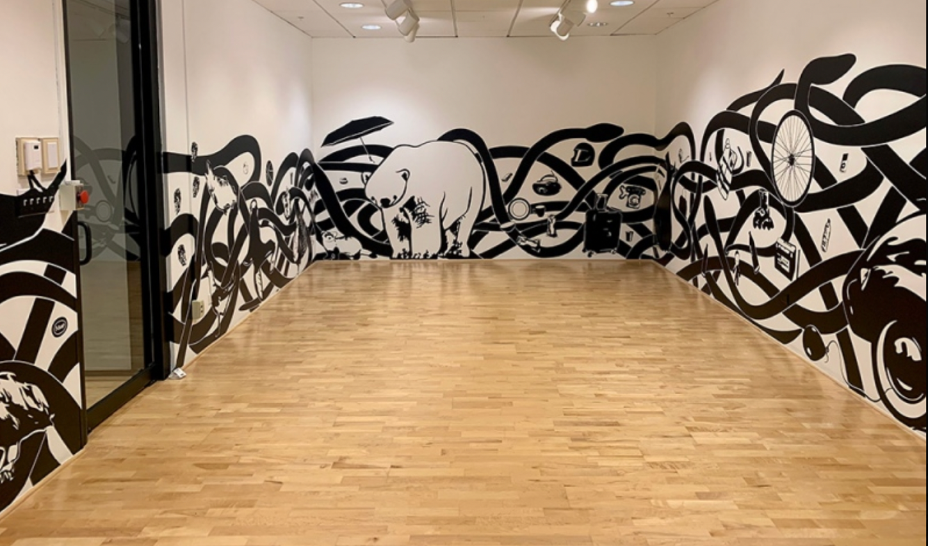

Once in the room, the students described the exhibition with Megan’s help. Next, students placed the stickers around the room and closely observed and touched the pattern on the walls. After this, the students said the terms of the plastic objects (e.g., bottles, toothbrushes, forks, etc.) in Spanish and English (Nausica provided the terms in Spanish if needed). Through this experience, students explored Feddersen’s interactive depiction of “black snakes,” petroleum products, and species affected by oil spills.
Following this initial step, the students were organized into groups of three to four. They took their stools and found a place to read the selected articles, whether in the room in Figure 4 or an adjacent room. Finally, they summarized their readings and discussed the tensions between petroleum as a driver of economic development and the adverse ecological and health outcomes associated with petroleum extraction. Overall, the activity provided information on different Spanish-speaking countries’ cultural practices and perspectives. As a post-task, students repeated the activity in class: they brought a summary and explained their articles to their classmates in Spanish L2. This task repetition ensured better comprehension and practice of the new vocabulary.

STUDENTS’ PERCEPTIONS

After implementing the mola activity over several semesters, we were convinced of its effectiveness; other colleagues, for instance, had also introduced it and it was included in the syllabus for all sections. Megan was interested in collecting still further evidence of how the museum contributed to the Spanish curriculum and offered opportunities for meaningful learning.
Given that Nausica is an experienced researcher in L2 learning, she suggested connecting the activities within the context of textbook adaptation (see McDonough et al., 2013; McGrath, 2013). Following this approach helped elucidate the connection between the museum and regular classroom instruction. We decided to focus on students’ perceptions. Nausica designed a questionnaire with the goals of exploring: 1. Whether students perceived the museum visit as part of the class curriculum, i.e., is the museum visit working as a textbook adaptation and, as such, is it well connected to the class?; and 2. how they perceive the adaptations, namely the museum visit, worksheets, and post-tasks (essays/presentations).

Questionnaire

The questionnaire (see Appendix D) included statements that the students rated and open-ended questions. Options to rate the statements were strongly agree (7), agree, somewhat agree, neither agree nor disagree, somewhat disagree, disagree, and strongly disagree (1). We analyzed the open-ended questions by exploring repetitions, similarities, and differences between participants (see Ryan & Bernard, 2003).
The anonymous questionnaire was administered via Qualtrics. Volunteering students took it on their own. Data was collected in Fall 2021 and Spring 2022. Only the students completing the questionnaire in Spring 2022 received the questions about the Feddersen exhibition. Although we invited instructors teaching sections of the course both semesters to share the questionnaire with their students, all participants (n=35) but one were taking the class with Nausica. Therefore, students mostly belonged to one of two sections in the fall and one in the spring taught by Nausica. The enrollment limit for students was 20 in each class. These three classes included 19 and 12 students each in the fall semester and 19 students in the spring semester. Participating students received extra participation points once they sent a screenshot of the last screen in the questionnaire.

Perceptions

Figure 5 displays the average level of agreement with each statement from the questionnaire about the mola activity. The scale was from one (strongly disagree) to seven (strongly agree).

Figure 5
Students’ Opinions about the mola activity

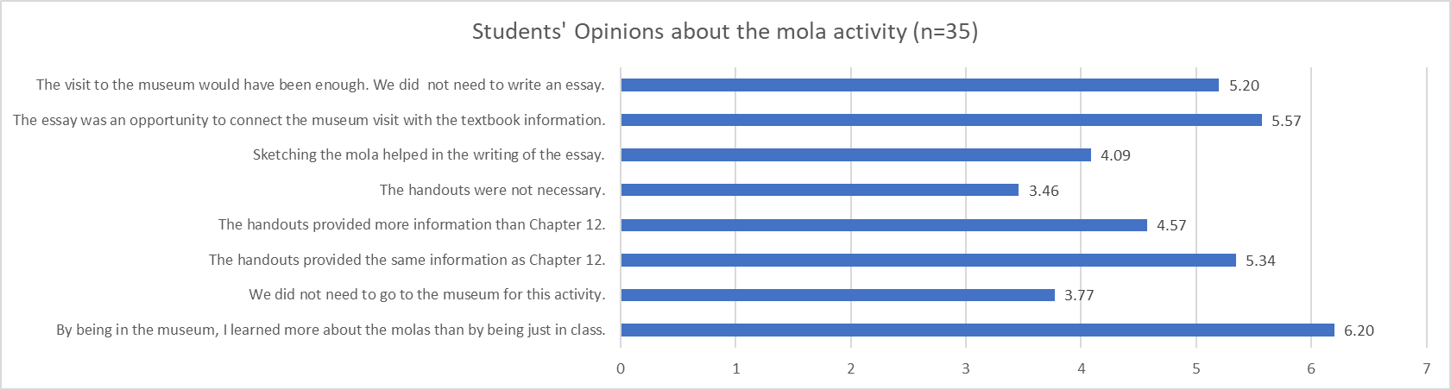

Students rated the highest the statement that by being in the museum, they learned more about the molas than by being in class, which is congruent with their disagreement with the statement saying it was unnecessary to visit the museum. Students also agreed that the post-task essay helped connect the visit with the textbook information. Moreover, students were positive about the worksheets, as their answers suggested they were necessary. However, the statement that the worksheets provided the same information as Chapter 12 was slightly surprising. Students were neutral towards rating how sketching the molas helped them.
Five students provided comments on the open-ended question. The comments have two main topics: 1. Students who enjoyed the activity because of being in the museum (see comments 1-3), and 2. Students who did not enjoy the essay (4-5).

Table 1
Comments about the mola activity

1. It was a fun interesting activity. Every once and a while, it is fun to get out of class and have a different learning experience.
2. I liked going to the museum and seeing the Molas in person.
3. I enjoyed this activity because it wa (sic) something different.
4. I dont (sic) think the essay was necessary for students who went during class, if students went by themselves then it would be.
5. The mola activity, especially the essay felt over done (sic). The essay felt like busy work and the length requirement was well over what was necessary to portray the information we had learned about the Molas.

Figure 6 displays the average level of agreement with each one of the statements in the questionnaire about the Feddersen activity. The scale was from one (strongly disagree) to seven (strongly agree).

Figure 6
Students’ Opinions about the RYAN! Feddersen activity

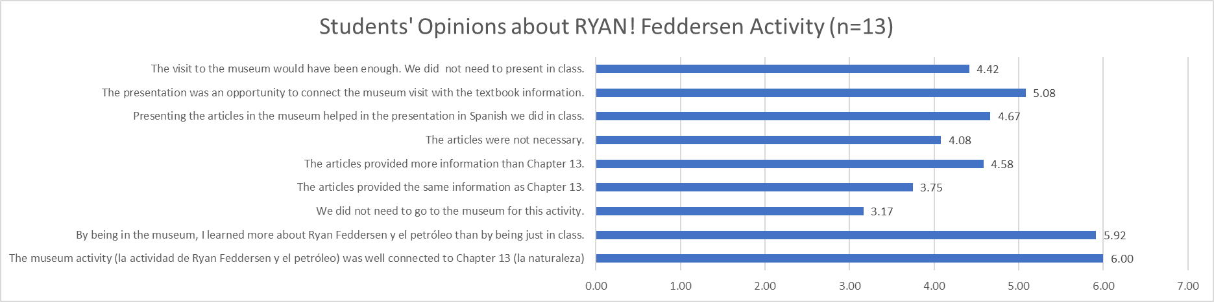

Like Figure 5, students stated that they learned more being in the museum than just being in class. Even though this activity dealt with the exhibition plus articles, students found it necessary to visit the museum to complete the activity; they also agreed that the activity was well connected to the textbook. There was a slightly lower level of agreement with the statement that the presentation connected the museum visit with the textbook information, but the average still indicates agreement. The students seemed more neutral towards the articles they read but indicated they provided more information than the textbook chapter. No additional responses were given.

DISCUSSION AND CONCLUSION

Our description of the project has shown how museums can become part of the language curriculum. Museum visits can bring novelty but consistency, which is fundamental to structuring a successful learning experience in the museum (see DeWitt & Osborne, 2007). Close collaboration was essential to integrating course content with the museum. Through this collaboration, neither of us has been a passive participant in the design of the activities, which seems to be a feature “widely reported in the literature in museum studies” for teachers (Fazzi, 2020, p. 426). By working together, we complemented each other and enhanced the class curriculum. Such a team brings a broad knowledge of museum pedagogy, content knowledge, and language pedagogy. Thus, we encourage other practitioners to carry out similar projects.
The data collected helped us learn about students’ opinions. Overall, students perceived the visit as part of the class curriculum since they saw a connection between the activities and the textbook. Students were positive about visiting the museum and completing the activities there. In general, there were similar responses towards both exhibitions (one focused on the objects and another focused on the objects plus additional reading). Based on these findings, we recommend that other educators experiment with 1) object- and label-dependent tasks and 2) questions more or less related to the exhibits (see Kisiel, 2003).
Although students considered the mola worksheets necessary for the during-class activity, they did not necessarily find sketching helpful. Here, the difference between the goals of the museum learning, e.g., developing close looking, and the language class goals might have played a role. Close looking was not a curricular goal in the class, and a session of 50 minutes might not be enough for students to develop the skill and understand its purpose. Museum goals might also be included within regular classroom instruction as these form part of students’ general development.
For the Feddersen activity, adding more material layers (i.e., textbook-museum-worksheet-articles) contributed to more information, which the students perceived. However, whereas the mola worksheets did provide more information than the textbook, students did not necessarily perceive this (see Figure 6). This could suggest that students were more interested in a deeper understanding of nature-related issues in Spanish-speaking countries than a simple worksheet could provide.
Three additional factors could have influenced students’ reception: the medium, the timing of the activities, and their cognitive demands. First, whereas the mola worksheets were on paper, the RYAN! Feddersen worksheet was digital. The change in medium (i.e., physical copy versus PDF) could affect perceptions (see Sheppard-Carey & Mathieu, 2022). Second, the in-class activity made the students more aware of the Feddersen worksheet: students read the articles linked in the worksheet and added some terms to it in class. For the mola activity, students used the worksheet as a space to draw and find new vocabulary. However, they did not actively read anything from it during class. Third, the activities in the museum might have been less cognitively demanding as they were carried out in the students’ L1s. For instructors who want to implement similar activities, the advantages and disadvantages of these three factors should be considered.
To sum up, in a museum visit and follow-up class session of 50 minutes each, we included tailored discussion, hands-on work, and a class presentation. These activities contributed to students’ linguistic and cultural development. Moreover, designing the activities and writing this article helped us better understand each other’s curricular goals. We hope we have encouraged language instructors and museum educators to connect L2 instruction and museum education goals.

REFERENCES

Barabas, C. D. (2023). Museum‐based pedagogy in an adult language immersion course. TESOL Journal, e741. https://doi.org/10.1002/tesj.741
Blanco, J. A., & Donley, P.R. (2021). Panorama. 6th Edition. Vista Higher Learning.
Chatterjee, H. J. (2010). Object-based learning in higher education: The pedagogical power of museums. University Museums and Collections Journal, 3(10), 179-182. https://doi.org/10.18452/8697
Chatterjee, H.J. & Hannan, L. (2015). Engaging the senses: Object-based learning in higher education. Routledge.
Cubillos, J. H. (2014). Spanish textbooks in the US: Enduring traditions and emerging trends. Journal of Spanish Language Teaching, 1(2), 205-225. https://doi.org/10.1080/23247797.2014.970363
Díaz, E. M. (2016). Expanding the Spanish classroom: The 'art' in liberal arts. Hispania, 436-448. http://www.jstor.org/stable/44112894
DeWitt, J., & Osborne, J. (2007). Supporting teachers on science‐focused school trips: Towards an integrated framework of theory and practice. International journal of science education, 29(6), 685-710. https://doi.org/10.1080/09500690600802254
Fazzi, F. (2018). Museum learning through a foreign language. In C. M. Coonan, A. Bier & E. Ballarin (Eds.), La didattica delle lingue nel nuovo millennio Le sfide dell’internazionalizzazione (pp. 519-537). Edizioni: Ca’ Foscari.
Fazzi, F. (2020). Stakeholders’ Perceptions over the Integration of CLIL and Museum Education and Methodological Implications. EL.LE, 9(3), 407-436. https://doi.org/10.30687/ELLE/2280-6792/2020/03/005
Fazzi, F. & Lasagabaster, D. (2021). Learning beyond the classroom: students’ attitudes towards the integration of CLIL and museum-based pedagogies. Innovation in Language Learning and Teaching, 15(2), 156-168. https://doi.org/10.1080/17501229.2020.1714630
Godwin-Jones, R. (2021). Evolving technologies for language learning. Language Learning & Technology, 25(3), 6-26. http://hdl.handle.net/10125/73443
Guerrettaz, A. M., Engman, M. M., & Matsumoto, Y. (2021). Empirically defining language learning and teaching materials in use through sociomaterial perspectives. The Modern Language Journal, 105(S1), 3-20.
Hauan, N. P., & DeWitt, J. (2017). Comparing materials for self-guided learning in interactive science exhibitions. Visitor Studies, 20(2), 165-186. https://doi.org/10.1080/10645578.2017.1404349
Harwood, N. (2013). English language teaching textbooks: Content, consumption, production. Springer.
Kisiel, J. F. (2003). Teachers, museums and worksheets: A closer look at a learning experience. Journal of Science Teacher Education, 14(1), 3-21. https://doi.org/10.1023/A:1022991222494
Marcos Miguel, N. (2015). Textbook consumption in the classroom: Analyzing a classroom corpus. Procedia-Social and Behavioral Sciences, 198, 309-319. https://doi.org/10.1016/j.sbspro.2015.07.449
Marks, D. (2016). Molas: Dress, identity, culture. University of New Mexico Press.
Matthias, B. (2017). Talking images: Exploring culture through arts-based digital storytelling. In L. Parkes, & C.M. Ryan (Eds.), Integrating the Arts: Creative Thinking about FL Curricula and Language Program Direction (pp. 37-56). Cengage.
McDonough, J., Shaw, C., & Masuhara, H. (2013). Materials and Methods in ELT. A Teacher’s Guide. Wiley-Blackwell.
McGrath, I. (2013). Teaching materials and the roles of EFL/ESL teachers: Practice and theory. A&C Black.
Noy, S., & Hancock, M. (2021). Teaching international development locally: Using museum collections to ground students’ learning. Teaching Sociology, 49(1), 32-44. https://doi.org/10.1177/0092055X20966719
Palpacuer Lee, C. J. (2018). Multiliteracies in action at the art museum. L2 Journal, 10(2). https://escholarship.org/uc/item/17c2m0k3
Paris, S.G. (2002). Perspectives on object-centered learning in museums. Routledge.
Parra, M. L. (2013). Expanding language and cultural competence in advanced heritage-and foreign-language learners through community engagement and work with the arts. Heritage Language Journal, 10(2), 253-280. https://doi.org/10.46538/hlj.10.2.7
Parra, M. L., & Di Fabio, E. G. (2017). Languages in partnership with the visual arts: Implications for curriculum design and teacher training. In L. Parkes, & C.M. Ryan (Eds.), Integrating the Arts: Creative Thinking about FL Curricula and Language Program Direction (pp. 11-35). Cengage.
Remillard, J. T., & Heck, D. J. (2014). Conceptualizing the curriculum enactment process in mathematics education. Zdm-Mathematics Education, 46(5), 705-718. https://doi.org/10.1007/s11858-014-0600-4
RYAN! Feddersen (2017). Black Snake Rising [Vinyl]. http://ryanfeddersen.com/black-snake-rising/
Ryan, G. W., & Bernard, R. H. (2003). Techniques to identify themes. Field Methods, 15(1), 85-109. https://doi.org/10.1177/1525822X02239569
Sederberg, K. (2013). Bringing the museum into the classroom, and the class into the museum: An approach for content‐based instruction. Die Unterrichtspraxis/Teaching German, 46(2), 251-262. https://doi.org/10.1111/tger.10144
Shepard-Carey, L. J., & Mathieu, C. S. (2022). Technology and Translanguaging: Examining the Roles of iPads in Collaborative Translation Activities with Young Emergent Bilinguals. In D. K. LaScotte, C.S. Mathieu, & S.S. David (Eds.), New Perspectives on Material Mediation in Language Learner Pedagogy (pp. 189-204). Springer International Publishing.
The National Standards Collaborative Board. (2015). World-Readiness Standards for Learning Languages. 4th ed. Alexandria, VA: Author.
Warner, C. & Embeywa, R. (2022). Multiliteracies at the Museum: A resource book for language teachers. Pressbooks, University of Arizona. https://opentextbooks.library.arizona.edu/multiliteraciesatthemuseum/
Woodward, T. (2001). Planning lessons and courses: Designing sequences of work for the language classroom. Cambridge University Press.

Appendix A. Molas

[In Spanish]

Artesanía: la mola

Antes de ir al museo:
- Lee el mini párrafo de “Artesanía: la mola” en la página 411-412 de nuestro libro.
- Piensa: ¿Has visto molas antes?
Clase del viernes (25 de febrero de 2022):
- La clase será con Megan Hancock que es una de las encargadas del museo de Denison.
- Estad puntuales a la hora de clase en el museo.
Trabajo en y después del museo:
- Para entregar por escrito el viernes 4 de marzo.
- Extensión: de 1 a dos páginas a doble espacio (por parejas)
- Escribe primero un breve párrafo donde contestéis a las siguientes preguntas. Si no estáis seguros, preguntadle a Megan:
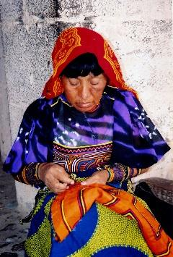
  - ¿Qué es una mola?
  - ¿Quién las fabrica?
  - ¿Por qué las fabrican?
  - ¿Cómo las fabrican?
  - ¿Cuándo las fabrican?
  - ¿Dónde las fabrican? (Pista: hay un mapa al final del documento)

Fuente
- Elige con un compañero una mola que os guste de la selección.
- Realiza un bosquejo (sketch) de la mola. Servirá para tener una referencia visual. No tiene que ser perfecto ☺
- Describe la mola:
  - ¿Qué veis en el centro?
    - En el centro vemos…
  - ¿Qué veis en los laterales?
    - A la derecha vemos…
    - A la izquierda vemos…
    - Arriba vemos…
    - Abajo vemos…
  - ¿Cómo son los colores?
  - ¿Tiene formas geométricas?
    - Si la respuesta es afirmativa, ¿cómo son?
    - Cuadrados, rectángulos, triángulos, rombos, círculos, etc.
  - ¿Tiene objetos, animales o personas?
    - En caso afirmativo, ¿cuáles?
  - ¿Narra una historia?
    - Si la respuesta es afirmativa, ¿qué historia narra?
  - ¿Qué técnicas de costura tiene? (Ver número 7 en vocabulario útil)
  - ¿Para qué sirve esa mola en específico?
- Para concluir tu texto:
  - ¿Por qué elegisteis esa mola?
  - ¿Qué os ha llamado la atención?
- No olvides escribir el número de tu mola o del panel de la mola en el catálogo del museo.

Vocabulario útil:
- Capas: layers
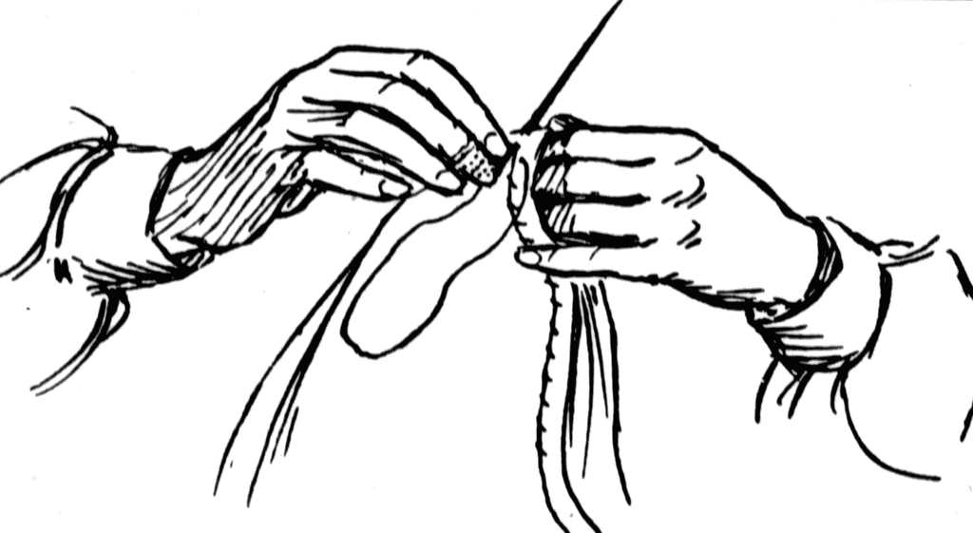

Fuente

- Coser:

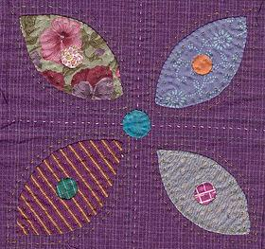
Fuente

- Aplique (bordar apliques) al derecho o al revés

En inglés: Appliqué (“An appliqué is ornamental needlework in which pieces of fabric are sewn or stuck onto a larger piece to form a picture or pattern.” Wikipedia)
Aplique al derecho: surface appliqué
Aplique al revés: reverse appliqué

- Tejido: fabric (en el caso de las molas)
- Puntada(stitch)
Das puntadas cada vez que coses.
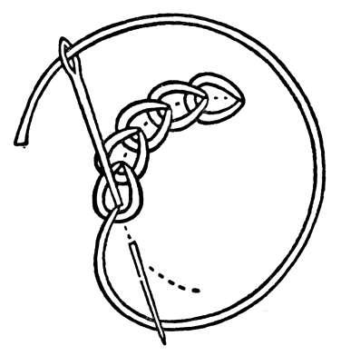
Fuente

- Cortar:
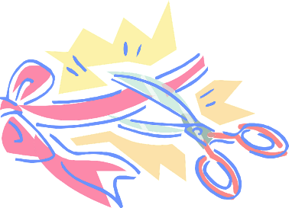

- Técnicas de costura (de coser)
  - tas-tas: hendiduras verticales u horizontales
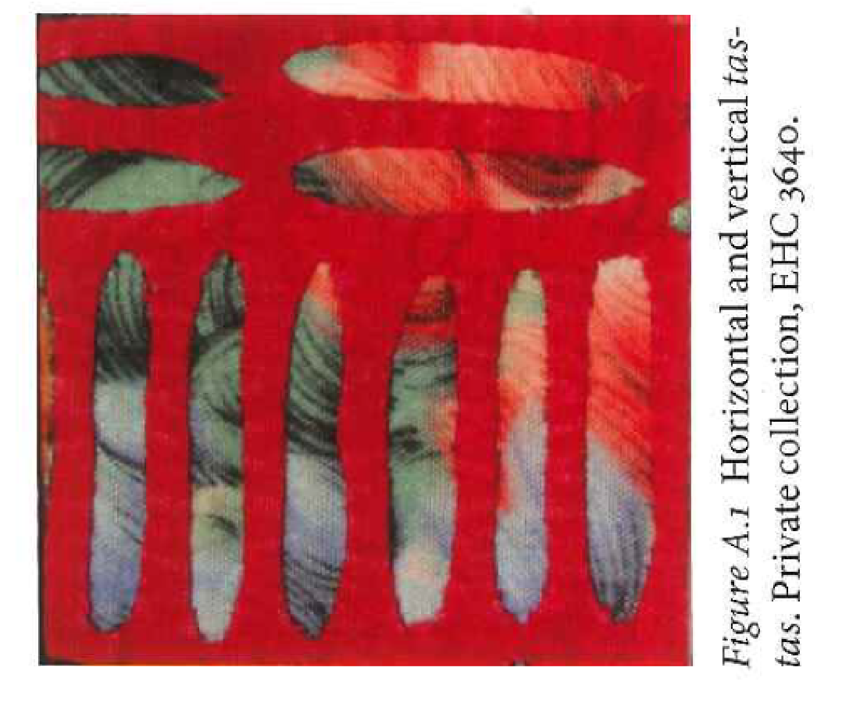
(Marks, 2016, p. 193)

  - dientes: patrón (pattern) con forma de dientes
  - bisu-bisu: patrón con forma de laberinto
  - bordado: embroidery

- Todas las blusas tienen dos mangas
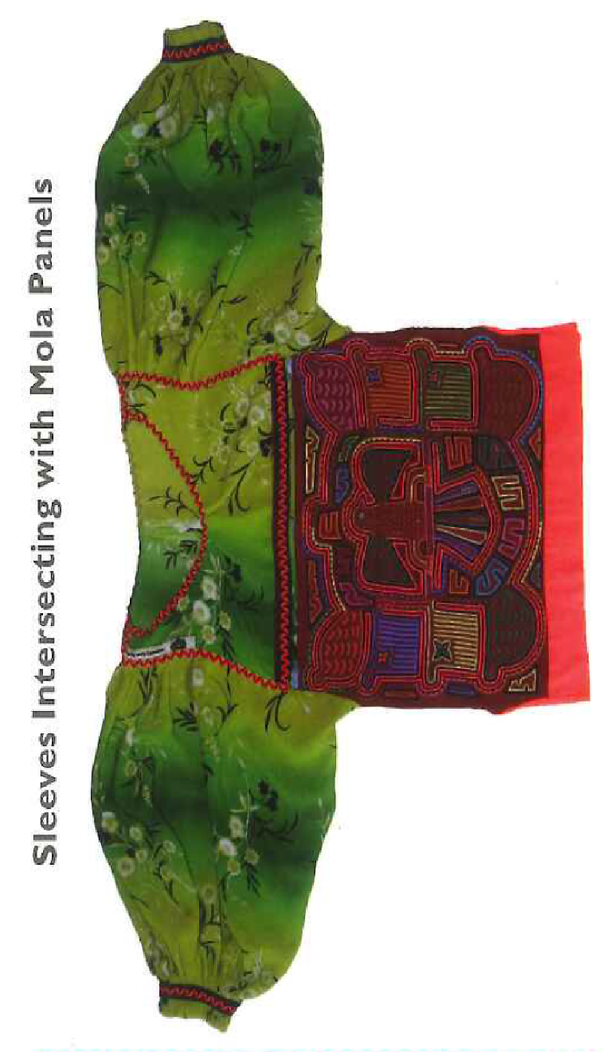

(Marks, 2016, p. 203)

- Mapa de la comarca Kuna:

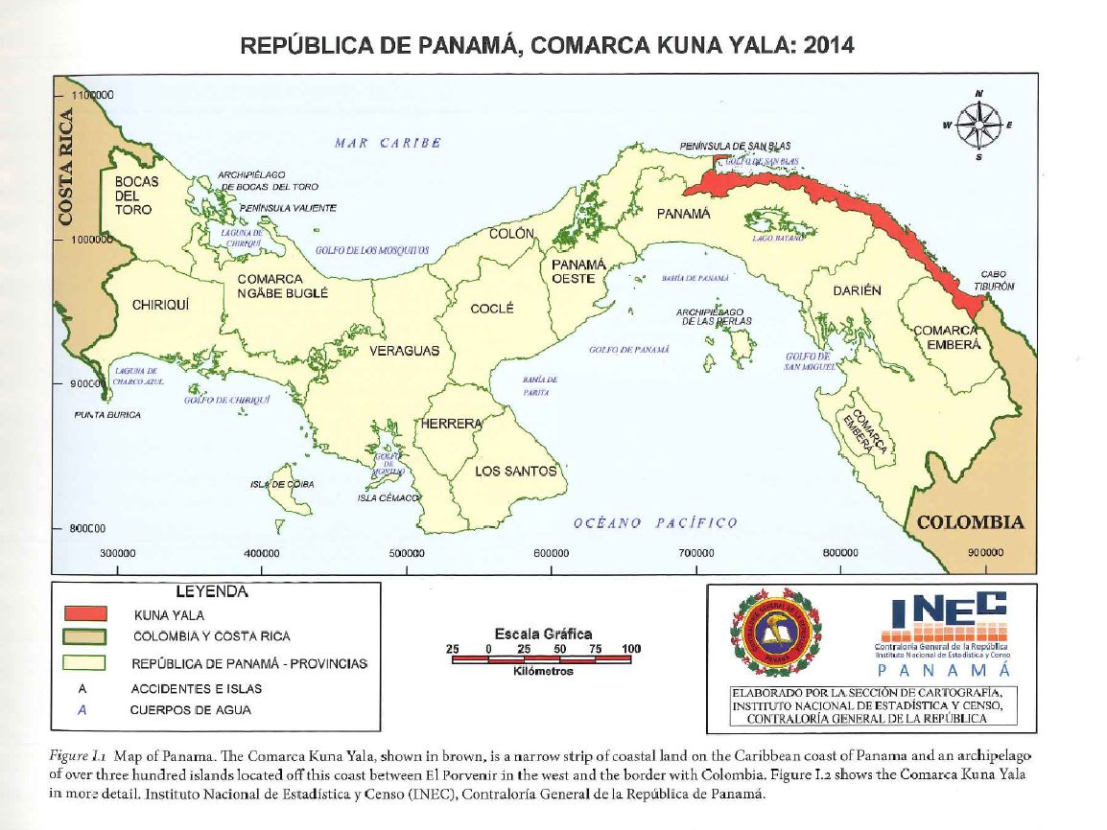

(Marks, 2016, p. 103)

[In English]

Before going to the museum:
- Read the short paragraph “Craft: la mola” on pages 411-412 in our textbook.
- Think: Have you seen molas before?
Friday class (February 25th, 2022):
- The class will be with Megan Hancock, who works in the university museum.
- Be on time at the museum.
Work in and after the museum:
- To turn it in on Friday, March 4th.
- Extension: one or two pages double-spaced (in pairs)
- Write a short paragraph where you answer the following questions. If you are unsure, ask Megan.
  - What is a mola?
  - Who makes them?
  - Why do they make them?
  - How do they make them?
  - When are they made?
  - Where are they made? (Clue: there is a map at the end
of the document)

Source
- Choose with your partner a mola that you like.
- Draw a sketch of the mola. It will help as a visual reference. It does not need to be perfect☺.
- Describe the mola:
  - What do you see in the middle?
    - In the middle, we see…
  - What do you see on the side?
    - On the right, we see…
    - On the left, we see…
    - Above we see…
    - Below we see…
  - What are the colors like?
  - Does it have geometrical shapes?
    - If so, what are they like?
    - Squares, rectangles, triangles, rhombus, circles, etc.?
  - Does the mola have objects, animals, and people?
    - If so, what does it have?
  - Does the mola tell a story?
    - If so, what is the story?
  - What sewing techniques do you recognize? (See number 7 in useful vocabulary)
  - What is the purpose of that mola?
- To finish your text:
  - Why did you choose that mola?
  - What does stand out in the mola (in your opinion)?
- Remember to write the number of your mola or of the panel. These numbers refer to the museum catalog.
Useful vocabulary:
- Capas: layers
- To sew:

Source

- Aplique (to embroider an appliqué)

Source

In English: Appliqué (“An appliqué is ornamental needlework in which pieces of fabric are sewn or stuck on to a larger piece to form a picture or pattern.” Wikipedia)
Aplique al derecho: surface appliqué
Aplique al revés: reverse appliqué

- Tejido: fabric (for molas)

- Puntada (stitch)
You use stitches every time you sew.

Source

- Cortar: (cut)

- Técnicas de costura (sewing techniques)
  - tas-tas: vertical and horizontal cuts
(Marks, 2016, p. 193)

  - teeth: teeth-shaped patterns
  - bisu-bisu: maze-shaped patterns
  - bordado: embroidery

- All blouses have two sleeves.
(Marks, 2016, p. 203)

- Kuna region map:

(Marks, 2016, p. 3)

Appendix B. Handout in Museum (Molas)

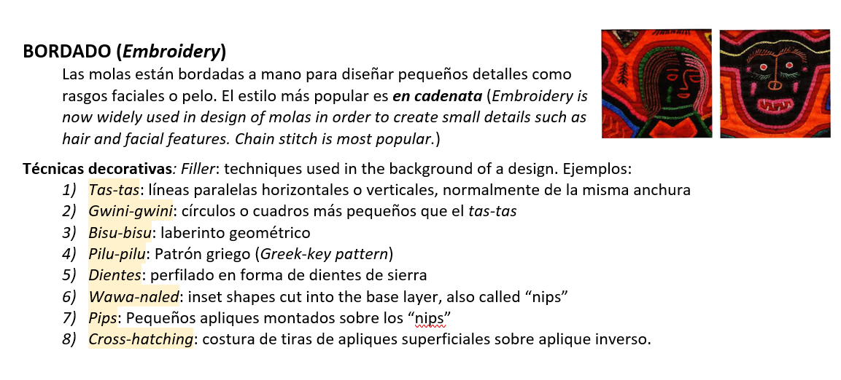
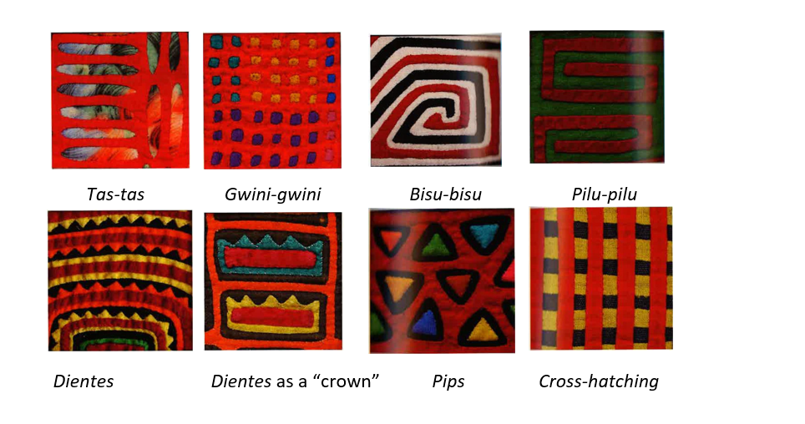
(Marks, 2016, p. 195-196)

Molas
Write the Denison University Numbers/Names for the molas under each technique.
1. Find 4 examples of tas-tas:
2. Find an example of a mola with 4 capas (layers):
3. Find 1 example of bisu-bisu:
4. Find 2 examples of el bordado (embroidery):
5. Find 2 examples of dientes:
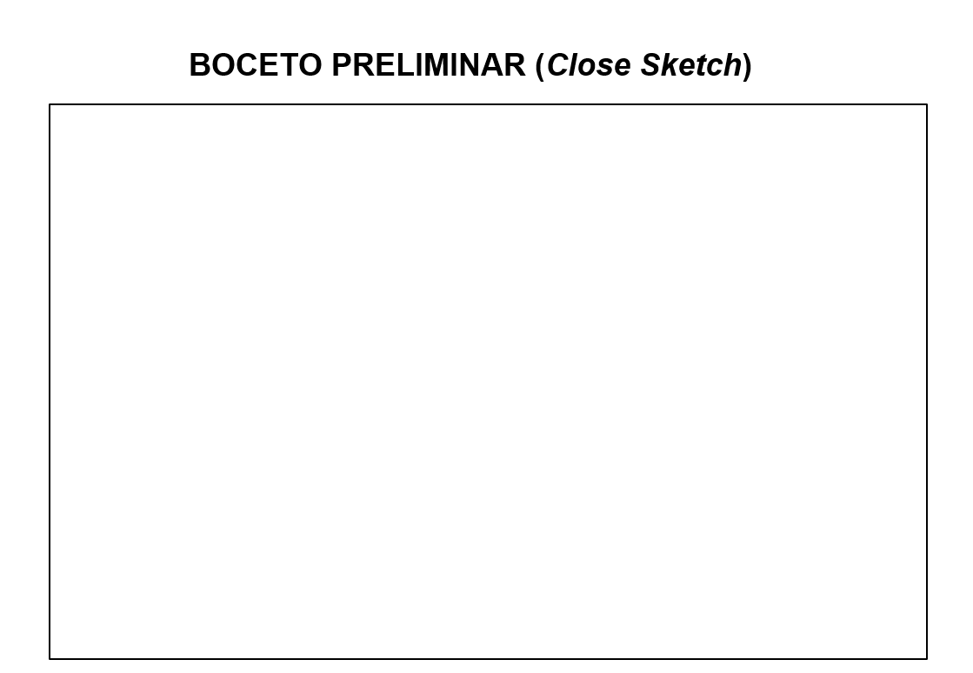

Appendix C. “Black Snake Rising” By Ryan! Feddersen

- Interpretation, argument, and analysis start with sources.

- How you tell a story depends on your sources.

In this activity, I’m asking every team the same two questions, but the teams have different combinations of sources. All teams will use the RYAN! Feddersen exhibition as one source and then combine them with the information in their other assigned sources in order to answer the two questions below. Teams will have approximately 15 minutes to interpret their sources and answer the questions. We will reconvene to share our findings after 15 minutes.

Steps:
- Each team receives a list of sources below. Team members review the sources & examine RYAN! Feddersen’s installation.
- Using the sources, investigate the following two questions:
1.Where is this happening? Who are the parties involved? Can you summarize the authors’ perspective?
2. How does this relate or contrast to the Black Snake Rising exhibition? How do these articles further our understanding of indigenous rights, Climate Change, or renewable resources? (Pick One)
- Talk through how your team will present its answers to the two questions in five minutes or less.

New Sources:

Group 1
- https://web.williams.edu/AnthSoc/native/ama-oil.htm
- https://news.mongabay.com/2010/07/oil-devastates-indigenous-tribes-from-the-amazon-to-the-gulf/
- https://latinamericareports.com/indigenous-group-wins-historic-land-battle-against-the-ecuadorian-government/1844/

Group 2
- https://www.nytimes.com/2018/12/24/world/americas/ecuador-china-dam.html
- https://archive.internationalrivers.org/resources/ecuador-s-most-spectacular-waterfall-threatened-by-chinese-funded-hydroelectric-project
- https://www.reuters.com/article/ecuador-power-china/ecuador-power-company-discovers-more-problems-at-chinese-built-plant-idUSL1N2OW10M
- https://en.wikipedia.org/wiki/Coca_Codo_Sinclair_Dam

Group 3
- https://en.wikipedia.org/wiki/Prestige_oil_spill
- https://safety4sea.com/cm-learn-from-the-past-prestige-sinking-one-of-the-worst-oil-spills-in-europe/
- https://www.theguardian.com/environment/2002/dec/16/oilspills.pollution
- https://english.elpais.com/elpais/2017/11/20/inenglish/1511186498_158426.html

Group 4
- https://nacla.org/news/2020/05/06/green-erasure-indigenous-life
- https://e360.yale.edu/features/in-colombia-indigenous-lands-are-ground-zero-for-a-wind-energy-boom
- https://theglobalamericans.org/2021/11/colombia-a-renewable-energy-powerhouse/
- https://www.ccacoalition.org/en/news/colombia%E2%80%99s-ndc-increases-its-2030-climate-change-ambition-and-integrates-new-targets
- https://en.wikipedia.org/wiki/Renewable_energy_in_Colombia

Términos relevantes en inglés (pensamos traducciones después de o durante la clase con Megan Hancock)
Escribiréis en español un resumen de lo que habéis encontrado y haremos una presentación como la mola para la clase en español.
Escribe al menos 10 términos relevantes.*
Grupo 1 | Grupo 2 | Grupo 3 | Grupo 4
*Important terms in English (we will think of the translation after or during class with Megan). You will write a summary in Spanish of what you have found, and we will have in class presentations like for the mola activity. Write at least 10 terms.

Appendix D. Questionnaires

Students had to select one of the following options for each statement, unless otherwise indicated:
- Strongly disagree
- Disagree
- Somewhat disagree
- Neither agree nor disagree
- Somewhat agree
- Agree
- Strongly agree

Mola activity
1. The museum activity (la actividad de las molas) was well connected to Chapter 12 (la vivienda)
2. This was the first time I visited the Denison Museum.
- Yes
- No
- Other __________________________________________________
- By being in the museum, I learned more about the molas than by being just in class.
- We did not need to go to the museum for this activity.
- The handouts provided the same information as Chapter 12.
- The handouts provided more information than Chapter 12.
- The handouts were not necessary.
- Sketching the mola helped in the writing of the essay.
- The essay was an opportunity to connect the museum visit with the textbook information.
- The visit to the museum would have been enough. We did not need to write an essay.
- Did you go to the museum on your own for the activity?
- No, I went with my class
- Yes, I went on my own to the museum because I missed class the day of the museum visit
- I did not go to the museum at all for this activity
- Other __________________________________________________
- Feel free to share any other comment about the Mola Activity.
________________________________________________________________

RYAN! Feddersen’s Activity
- The museum activity (la actividad de RYAN! Feddersen y el petróleo) was well connected to Chapter 13 (la naturaleza)
- By being in the museum, I learned more about RYAN! Feddersen y el petróleo than by being just in class.
- We did not need to go to the museum for this activity.
- The articles provided the same information as Chapter 13.
- The articles provided more information than Chapter 13.
- The articles were not necessary.
- Presenting the articles in the museum helped in the presentation in Spanish we did in class.
- The presentation was an opportunity to connect the museum visit with the textbook information.
- The visit to the museum would have been enough. We did not need to present in class.
- Did you go to the museum on your own for the activity?
- No, I went with my class
- Yes, I went on my own to the museum because I missed class the day of the museum visit
- I did not go to the museum at all for this activity
- Other __________________________________________________
- Feel free to share any other comments about the activity on RYAN! Feddersen y el petróleo.
________________________________________________________________

Demographic information:
- Year
oFirst year student
o Sophomore
o Junior
o Senior
- Did you take Span 112 at Denison?
o Yes
o No
o Other __________________________________________________
- This semester your professor is
(Names of instructors to select from)

https://en.wikipedia.org/wiki/List_of_university_museums_in_the_United_States
https://denison.edu/campus/about/vision-values
Sasardi Muladub community. Cotton; reverse appliqué, appliqué, embroidery; 44.5 x 48.3 cm. Denison Museum, Denison University, Gift of Dr. Clyde Keeler, 1972.341, https://museumcollection.denison.edu/
https://denison.edu/places/museum/wh/134629
The students wore gloves for the activity.
https://denison.edu/events/event/144645
In the questionnaire, we used the term “handout” instead of “worksheet” as the term was used with the students. We have kept the term “worksheet” in this article as this is the term most frequently used by researchers on museum education.

