TEACHERS’ FORUM

Designing a Decentering Learning Experience with Advertisements: Teaching to Broaden Learners’ Interpretive Disposition

ISABELLE DREWELOW

University of Alabama
E-mail: idrewelow@ua.edu

In line with the perspective of Álvarez Valencia and Michelson (2022) and Liddicoat and Scarino (2013), who see interpretation and meaning-making as core features of teaching for interculturality, this article delves into the potential of advertisements to foster the development of learners’ interculturality. Focused on a curricular sequence designed for an advanced French course, it offers an example of a classroom learning experience intended to create an increasingly dissonant context to decenter learners’ frames of reference surrounding symbolic representations of Frenchness. Advertisements are particularly effective in eliciting decentering because they are filled with culturally situated references. Whether explicit or implicit, these references can create both consonance and dissonance, thus exposing the subjective nature of interpretation and meaning-making. The article begins by outlining the approach and frameworks used to structure the sequence. It then details the methodology employed to search for, select, and sequence advertisements. Additionally, the article explains the choices of cultural references related to Frenchness and their potential to create consonance and dissonance. The description of the sequence highlights the questions guiding classroom interactions, illustrating how the selected advertisements successfully cultivate learners’ dispositions to move beyond the constraints of their frames of reference and interpret meaning from a different perspective. The article concludes with pedagogical interpretations and strategies for implementing a decentering-focused pedagogy using advertisements.
_______________

INTRODUCTION

Second language learners’ competence to interact across cultures has been a constant targeted outcome of Second Language Acquisition (SLA). In the last fifty years, the terms “communicative” and “intercultural” have been predominantly associated with competence. These two concepts have been reprised in many approaches and frameworks that continue to drive current pedagogical practices. In their critical examination of the most commonly referenced intercultural competence models (Byram, 1997; Deardorff, 2006; Fantini, 2009), Álvarez Valencia and Michelson (2022) argue that the shortcomings and issues related to their practical implementation in the foreign language classroom stem from how these models frame communication as information exchange through language. Further, they articulate competence around distinctive cognitive, behavioral, and affective dimensions that need to be measured and assessed. While acknowledging the models’ utility and contributions to the field, Álvarez Valencia and Michelson point out that by providing an inventory of what being intercultural should look like, such models have encouraged a conception of competence as a measurable performance and overlooked how to effectively guide its development. Rather than targeting outcome achievements, the authors propose to attend to the process of “becoming intercultural,” which entails “knowing how to read new signs and symbols and their uses within different discourse contexts” (p. 9).
The term “becoming” allows for a rereading of competence as encompassing resources and dispositions that facilitate the interpretation of various situated meanings in the practice of communicating. In this perspective, teaching for intercultural competence can be conceived as supporting the personal growth of interpretive capacities, which requires engaging reflections on “the multiple possibilities of interpretation resulting from the possible presence of multiple constructs, value systems and conceptual associations which inform the creation and interpretation of messages” (Liddicoat, 2009, p. 131). Raising awareness of the situatedness of cultural representations and subjective dimension of frames of reference creates a context for decentering, or stepping “outside one’s existing, culturally constructed, framework of interpretation” (Liddicoat & Scarino, 2013, p. 58), and develops a readiness and openness to interpret meaning from different cultural points of view.
This article proposes to use advertising to create a decentering experience. As a communication tool, advertisements are “culturally inspired and created within the expectations of a culture” (Taylor, Hoy, & Haley, 1996, p. 2), thus offering the possibility to encounter “divergent subjectivities and historicities” (Kramsch, 2011, p. 356). Considering the quantity and variety of advertisements produced on a yearly basis around the world, at first glance the task of curating advertisements meant to foster learners’ flexible interpretive dispositions may seem daunting. This article reports on the methodology employed to assemble a collection of advertisements for an upper division French for specific purposes course focused on communication and marketing practices at a large public university in the Southeast region of the United States. Examples from the assembled corpus are presented in a three-stage sequence to illustrate how to create an increasingly dissonant context to decenter interpretations. The objective is for this curricular sequence to serve as a model or at least as an inspiration that can be adapted to other languages or levels and that teachers can customize to their curricular contexts, purposes, or needs.

Decentering, an Integral Component to the Process of Building Interpretive Disposition

The act of interpreting the meaning of a communicated message is a subjective endeavor guided by one’s culturally constructed interpretive framework (e.g., Liddicoat, 2009). Individuals tend to rely on assumptions, beliefs, values, and cultural references shaped and influenced by personal experiences and their own language and culture to guide interpretation. These mental constructs and associations are readily available in their familiarity and, as Byram and Cain (1998) point out, “escape control and interfere with [the] perception of other cultural systems” (p. 36). Therefore, without cultural content and learning activities that actively call attention to “the differing perceptions and modes of thought with which the L2 operates” (K.A. Byram, 2011, p. 528), learners are likely to—unwittingly or otherwise—continue applying their existing interpretive framework (Drewelow, 2013).
To move beyond the natural inclination to draw on one’s available cultural references requires realizing that communicating is a culturally, historically, socially, or politically situated subjective practice governed by the shared collective knowledge of members of a cultural community. Focusing learners’ attention on the situatedness of interpretation exposes symbolic meanings, values, and myths that may not fit their expectations, creating a context to reflect on “what it is that others, in diversity, understand them to mean” (Scarino & Liddicoat, 2016, p. 33). When the possibility of multiple points of reference becomes apparent, the opportunity arises to decenter from taken-for-granted (heretofore unquestioned) cultural references and assumptions (Byram & Wagner, 2018).
In the preeminent models of intercultural and transcultural learning (Byram, 1997; Deardorff, 2006; Kramsch, 2009; Liddicoat & Scarino, 2013), decentering is viewed as fundamental to developing interculturality because it enables learners “to more effectively ‘move between’ and negotiate the diverse linguistics, cultural, and knowledge worlds that their learning brings together” (Scarino & Liddicoat, 2016, p. 33). As they decenter, learners can develop the cognitive readiness and openness to rethink the primacy of the references and assumptions supporting their points of view.
Álvarez Valencia and Michelson’s (2022) proposition to step away from considering competence as a measurable outcome is itself an invitation to decenter from current practices and focus on designing learning experiences that build learners’ resources to move between “different sociocultural practices and choices” (p. 16) in various forms of intercultural or intracultural communications. Becoming intercultural involves learning to consider the world through the perspectives of others, which requires cognitive flexibility or the ability to “switch frames from etic to emic and back again” (Deardorff, 2006, p. 250). A pedagogical context that aims to foster learners’ disposition to interpret beyond their existing knowledge and frames of reference can support learners’ decentering from their monocultural and monolingual perspectives. With a focus on the decentering process to cultivate cognitive flexibility for interpretation, it becomes possible to shift away from measuring and assessing learners’ intercultural competence “against the backdrop of the prescribed ingredients” (Álvarez Valencia & Michelson, 2022, p. 9) outlined by various models. Emphasis is placed on developing, not evaluating, intercultural competence. Providing a context where learners can connect with points of view supported by differing cultural references gives them the opportunity “to make the strange familiar and the familiar strange” (Byram, Gribkova, & Starkey, 2002, p. 19) and broaden their interpretive disposition by learning to apply an insider (emic) stance when interpreting meaning.

A Curricular Context to Decenter: Experience and Reflection

With decentering as a central pedagogical objective, the curricular sequence described below follows the approach to intercultural language learning and teaching outlined by Liddicoat and Scarino (2013). They propose four interconnected processes (noticing, comparing, reflecting, interacting) to design learning experiences that engage and support interpretation and meaning-making. Any of these processes provides opportunities to engage with the subjective nature of interpretation; however, Liddicoat and Scarino suggest noticing as a starting point because it “is not necessarily a naturally occurring activity in the classroom” (p. 60). Learners need to be guided in what to notice to compare similarities and differences between cultures (their own and the target culture) but also between the information they already know and what is presented. Comparing cultural references, myths, or symbols can reveal dissonances and consonances, which become a source of reflection as learners engage in interpersonal, intracultural, and intercultural interactions. The interpretive responses learners formulate when interacting with classmates, the instructor, the texts, and their personal (intra) cultural framework become available for further noticing and comparing, making the process circular. Both reflections and interactions create a context for decentering by facilitating the interplay of cultural references and constructs and by exposing the possibility of multiple interpretations—and therefore, the subjectivity of the act of interpreting.
Liddicoat and Scarino (2013) explain that “the framework of interpretive resources that people bring to the interaction in seeking to understand” can “both enable and limit understanding” (p. 67). As studies have shown, learners tend to continue to rely on their existing knowledge and frames of reference as the normative categories by which to compare (Drewelow, 2011, 2013; Johnson, 2015). Experiencing dissonance (or consonance) does not necessarily incite learners toward decentering to consider how other frames may be in play. It is the reflection supporting the processing of the experience and using (or acting with) the new understandings in subsequent interactions that provide the space to develop the awareness that our usual frames of reference may be as unfamiliar to others as others’ interpretive frames are to us. When becoming intercultural is viewed as the process of building the “self-awareness of their own interpretive system” (Liddicoat & Scarino, 2013, p. 64), emphasis is placed on personal growth through experience and reflection rather than performance. As pointed out by Liddicoat and Scarino, the connection between experience, reflection, and personal growth underlines the experiential dimension of their approach.
What makes experiential learning particularly relevant to becoming and decentering is the emphasis on experience and reflection as particularly significant in personal development, “which is understood as the process of extracting personal meanings from experience through reflection” (Kohonen, 2001, p. 32). Although personal growth through decentering is highly subjective and may not be entirely visible or measurable, it is worth pursuing as a pedagogical objective; as Fantini (1999) observed, knowledge can be forgotten but awareness is irreversible. Interactions should be understood as an opportunity for learners to create personal interpretive meaning by actively connecting their new interpretations with their past ones and with those of others, thereby (re)framing and (re)contextualizing meaning. In this perspective, both the target and the learners’ own language and culture are a part of the reflection. By understanding themselves as participants in more than one culture, they can begin to see themselves as interpreters of cultural meanings.

Advertising, Consonance, and Dissonance

Advertisements are ubiquitous in our virtual and physical landscape, from streets to screens, across media and modalities (Angelini & Frederico, 2010; Hobbs, He, & Robbgrieco, 2014). As a genre of text, their purpose is familiar: advertising aims to sell, persuade, inform, or promote a product or service. Designed to create instant recognition and emotional appeal (De Mooij, 2014; Rentel, 2012; Martin, 2012), advertisements commonly rely on codes, myths, symbols, stereotypes, connotations, and associations populating the collective cultural knowledge of a group to convey meaning without having to provide longwinded explanations (De Iulio, 2016). As noted by Anholt (2000), “advertising is not made of words, but made of culture” (p. 5). This cultural dimension underlines that advertising interpretation is conditioned by the subjectivity of cultural narratives. In an intracultural context, interpreting the message might be effortless because of one’s familiarity with the explicit and implicit symbolic meanings of the cultural references employed. However, considering that “where a different language is spoken, there is likely to be a different set of symbolic references, including myths, history, humour, and the arts” (De Mooij, 2004, p. 181), in an intercultural context a lack of knowledge might interfere with interpretation because connotations and associations might be too unfamiliar to be noticed or might be misinterpreted.
As a cultural phenomenon, advertisements targeting a specific market use local cultural references (Angelini & Frederico, 2010; Martin, 2012; Simon, 2019; Taylor et al., 1996) which give learners “access to the cultural categories and assumptions according to which one culture construes the world” (McCraken, 1988, p. 17). French advertising is particularly distinctive in this regard. As Angelini and Frederico (2010) note: “The universe of reference for the French consumer is all of France: its regions, its history, its art, its literature, the character of the people who live there and their mentality. French advertising continually makes reference to French culture rather than just simply to the product itself” (p. 120). Consonances and dissonances can arise when learners’ images and representations of France, its culture and people, encounter those present in French advertisements. For example, advertisers often use specific landmarks or monuments to evoke a country without having to explicitly name it. One of the most recognizable associations with France (or Paris) is the Eiffel Tower, which is found across multiple cultures including the United States and fosters a sense of consensus through its iconic status. Recognizable connotations and associations create familiarity, offering the possibility to engage with the consonant dimension of cultural references by investigating the underlying reasons consonance is experienced.
Noticing and comparing instances of consonance provide an opening to reflect on the intracultural nature of cultural references and to uncover how they may be connected to the intraculturality of others, initiating “a first interpretive position in relation to the new” (Liddicoat & Scarino, 2013, p. 57). However, French advertisers might use the Eiffel tower to conjure up connotations that rely on cultural knowledge familiar to a French audience (e.g., the Eiffel Tower serves as a radio antenna), but are less evident for learners to interpret because they may not connect or link the Eiffel Tower to the relevant invoked meaning (in this example, a radio antenna). Divergent or unfamiliar cultural references expose dissonances and discrepancies that can challenge taken for granted associations and connotations. Questioning what is unfamiliar, how, and why opens a path to decenter as learners must engage in the practice of interculturality by interpreting meaning from the points of view (intracultural positioning) of others rather than their own.

Criteria Used to Select and Sequence Advertisements

A central objective of the course in which the curricular sequence is taught is to foster interculturality by broadening learners’ interpretive frameworks and decentering their perspectives through exploring the cultural situatedness of interpretations. The curriculum is organized around a semester-long simulation, which guides learners in developing a product envisioned specifically for the French market. By the end of the semester, learners produce marketing-related materials (a website, a static web advertisement, and a 45-second video advertisement) to present their product. Course content is designed to support learners in defining their product specifications and outlining its positioning and messaging. Various advertising and marketing practices are examined to explore what guides product consumption and consumer choices in France. One of the marketing strategies analyzed in this course is Frenchwashing, which can be defined as the practice of using French cultural elements, including language, symbols, fashion, and iconic imagery, to market a product or brand. The curricular sequence presented below is taught in week three of a 15-week semester. The goal is to raise learners’ awareness of the importance of moving beyond their own cultural frameworks when targeting a specific consumer market, particularly as they encounter representations of Frenchness in advertisements intended for the French market.

Advertisement Format

To design a curricular sequence where various interpretations could be considered and examined, I elected to use print and online static advertisements to maximize opportunities for in-class discussions. Print advertisements usually rely on a single image and a few words to convey meaning (Martin, 2012), depending on the reader to activate their cultural knowledge to decipher the intended message. This “relative simplicity of elements” (Hobbs, et al., 2014, p. 4) allows for a focus on the explicit meanings of the image and words, their implicit associations as well as the cultural references that are relied upon but not explicitly stated.

Approach to Curating Advertisements for the Sequence

To create a decentering experience, it is vital to give learners the opportunity to use their prior knowledge to allow them to experience consonance with familiar cultural references. This in turn sets the stage to decenter their interpretation when they face dissonance. Symbols and stereotypes are particularly pertinent to explore situated meanings because they represent encoded consensus in terms of associations and connotations (Bennett, 1998; Dyer, 1993; Stangor & Schaller, 1996). Given the learning context and purpose described above, the three criteria guiding the selection of advertisement were: 1) cultural references related to Frenchness (either in the imagery or the wording), 2) brands or products easily recognizable by American learners of French and, 3) advertisements targeted at a French audience. My background as a French national who has taught French in American higher education for nearly two decades and researched assumptions and stereotypes in the foreign language classroom provides me with a solid understanding of stereotypical representations of France and the French people in the United States, as well as French brands familiar to Americans. This experience informed the criteria I used for selecting advertisements.
I decided to start the curating task—that is, compiling potential advertisements—with two advertising campaigns that I was familiar with, from internationally renowned and established brands: McDonald’s “Come as you are” [Venez comme vous êtes] campaign and Air France’s “France is in the air” campaign. The imagery in McDonald’s advertisements incorporates icons from American as well as French pop culture, which have the potential to elicit both consonance and dissonance. Air France’s advertisements are full of allusions to France’s cultural heritage and stereotypes about the country or its people (Simon, 2019). Although many references are generally recognizable by a non-French audience, some historical allusions might not resonate with learners and could create dissonance. Searching for each campaign by name in a web browser produced a large number of advertisements in the image tab.
Next, in line with the theme of brand representation and recognition, I used another American brand recognized all over the world. In a web browser, I searched for Coca-Cola advertisements in France that use French symbols. This search also produced advertisements from a well-known French beer manufacturer featuring Parisian landmarks (the Arc de Triomphe and the Eiffel Tower). I then combined the key words “advertisements in France” with “beret” and “striped shirt,” as these two clothing items have become iconic symbols of French culture. Using the numerous references to French history featured in Air France’s “France is in the air” campaign as inspiration, I also targeted significant and widely known characters and events: Napoleon, Louis XIV, Marie-Antoinette and the French Revolution. Only the latter generated results. At the time I was curating advertisements, the 2022 FIFA World Cup was going on and the media was brimming with images of French supporters, draped in the national colors of blue, white, and red, proudly wearing rooster-themed hats. These visuals inspired me to search for advertisements featuring these two symbols. While France’s colors are widely recognized, the rooster might be less familiar to many learners.

Selecting and Sequencing the Advertisements

My personal interpretation of the cultural references that might be consonant or dissonant for the learners in my course guided the selection process. With the objective of gradually creating dissonance, I grouped advertisements in the following way:
- Familiar references resonating across cultures: the French flag; iconic characters from American pop culture; French food; the French Revolution.
- Familiar references which could be understood differently or cause confusion because of implicit associations: the Eiffel Tower is also a radio antenna; the Arc de Triomphe is a roundabout for cars; the beret (a soft, round hat) is typically worn by older French men and doesn’t really correspond to the stereotype of Parisian feminine chic.
- Unfamiliar references: Marianne (the embodiment of the French Republic, a personification that dates back to the French Revolution); the rooster (a national symbol of France as a nation, used as an emblem by the French national sport teams in international competitions); the French nickname for the English “les rosbifs” (French spelling of roast beef, a playful jibe dating back to the 18th century); iconic characters from a French comic book series (Astérix and Obélix, heroes of the series set in 50 BC in a fictional village in Gaul or modern-day France that resists Roman occupation), commonly seen as symbols of France’s defiant spirit.

The selected advertisements appeared in print publications and online—either on the companies’ or third-party websites—between 2009 and 2022. After grouping the advertisements according to the above categories, I sequenced them to progress from most consonant to most dissonant. I developed questions to facilitate noticing, interpretations and reflections, based on the framework outlined by Liddicoat and Scarino (2013).

The Curricular Sequence

The course meets twice a week in face-to-face session of 75 minutes. The curricular sequence is divided in three stages and can be taught during one session. The instructional approach follows a think-pair-share model. Each advertisement is projected individually, and learners are first invited to observe it for a few moments. Then, questions are displayed on the screen alongside the advertisement. Learners pair up with a partner (or form groups of three) to discuss the questions. Finally, the learners share their analysis and interpretations with the entire class. This process is repeated for each advertisement. For the purposes of this article, I present goals and rationale for advertisement selection and question design at each stage of the sequence, followed by a few illustrative examples. The advertisement slogans and the related questions are provided in English; however, it should be noted that French is the language used in the classroom.
Stage 1 – Familiar References: Consonance and Interpretations

The objective of this first stage is to discuss why some references can be shared within and across cultures. Advertisements were selected for their potential to explore what contributes to the broad recognition of certain references, as well as the implicit associations and connotations that create consensus. Questions encourage learners’ reflections on the consonance of references and intracultural connections across cultures. For this stage of the sequence, I grouped advertisements from Coca-Cola, McDonald’s, Air France, and Renault because the references they contain are easily recognizable.
In the Coca-Cola advertisement (Figure 1), the only color is the red of the Coca-Cola bottle. It is the preceding words—“bleu” [blue], “blanc” [white] in front of the red bottle—that create an association with the French flag.

Figure 1. xxxxx

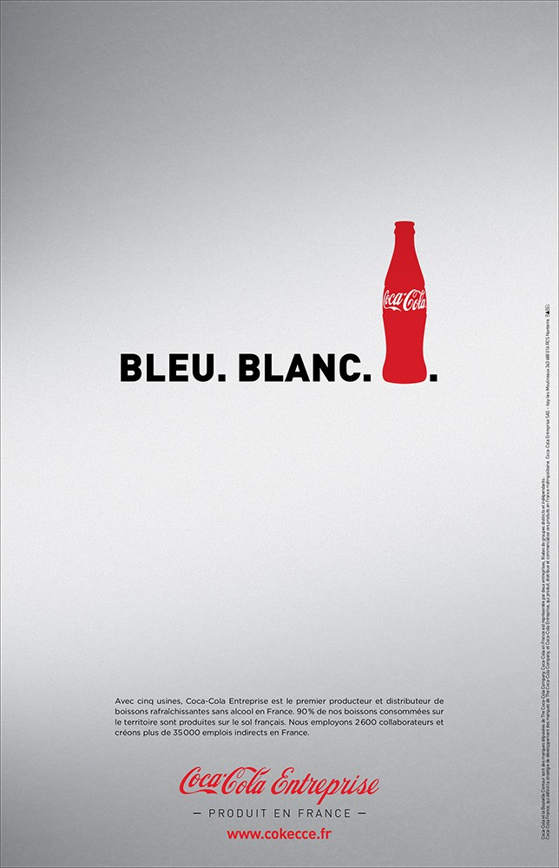

© Coca Cola Company; the image is not covered by this article's CC BY-NC-ND license.

The following questions invite learners to consider how their familiarity with the symbolic word order allow them to interpret the implicit message.
- What symbol is used in this advertisement to refer to France?
- Since the words are written in black and the only color is the bottle, how do you know?
- How is Coca-Cola (a quintessential American brand) positioning itself as French?

The McDonald’s advertisement features Darth Vader (Figure 2), one of the most recognizable villains from the Star Wars trilogy, a world-famous movie franchise. Another possibility is to use the advertisement with King Kong (Figure 3).
Figure 2. xxxxx

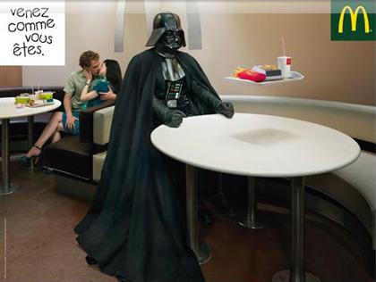

© McDonald’s; the image is not covered by this article's CC BY-NC-ND license.

Figure 3. xxxx


© McDonald’s; the image is not covered by this article's CC BY-NC-ND license.

The following questions explore Hollywood’s widespread influence and the familiarity of its references across cultural contexts.
- Can you identify the character in this advertisement? Who is he?
- Can you name the movie?
- Why is this reference obvious to you?
- Why is it evident to the American public in general and to a French audience?

The Air France advertisement refers to France’s renowned culinary culture. This advertisement was selected because the French (Figure 4) and English versions (Figure 5) share the same image but the slogans slightly differ. Presenting them side by side offers the opportunity to engage reflections on how meaning is conveyed across cultures.

Figure 4. xxxxx Figure 5. xxxxxx

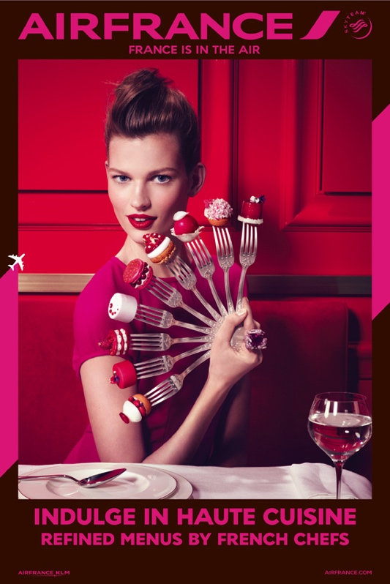

© AirFrance; these images are not covered by this article's CC BY-NC-ND license.

The questions encourage learners to consider that while an image may be meaningful across multiple cultures, direct translation of words is not as easily feasible because “the expression of values […] varies according to the language used” (De Mooij, 2004 p. 187). Comparing the qualifiers employed directs attention to the situatedness of interpretation: a chef to a French audience does not in itself evoke refinement and prestige; it is the reference to the Michelin stars awarded only to the most outstanding chefs that creates the association.
- What does this advertisement suggest about French food?
- What do you notice about the image used in both advertisements?
- The French version refers to “chefs étoilés” whereas the English version uses “French chefs.” How can you explain this difference of qualifiers? Do you know what “étoilés” might refer to?

Stage 2 – Familiar References Requiring (Some) Interpretation

In the second stage, the goal is to explore how references that seem familiar can become dissonant. Advertisements were selected based on their symbolic associations and connotations that might not resonate with learners’ intraculturality. Questions encourage learners to move beyond their initial interpretation and consider what is implied or alluded to. This approach can help them understand that interpreting the message’s meaning requires connecting with the cultural knowledge shared by the targeted audience (in this case, French consumers). For this stage of the sequence, I grouped advertisements from Air France, Uber, and French beer maker Kronenbourg 1664 because the references used, although familiar, could challenge taken for granted associations.
In the Air France advertisement (Figure 6), the image and the slogan (“Un confort révolutionnaire, Nouveau siège business” [Revolutionary comfort, new business class seat]) conjure up the gardens of the Versailles castle and the 1789 French revolution, a momentous event in French history. However, learners might miss the allusion to Marianne (discussed above) because, within their interpretive framework, a young woman wearing a blue-white-red rosette in her hair might not evoke this icon, which is displayed in townhalls across France, on the official French government logo, and on postage stamps.

Figure 6. xxxxx



© AirFrance; this image is not covered by this article's CC BY-NC-ND license.

The questions below guide learners in identifying the main cultural reference and direct their attention to its implicit association.
- What first comes to your mind when looking at this advertisement?
- What is the woman wearing?
- What colors?
- What historical event is evoked by the colors the woman is wearing and the word “revolutionary”?
- Use your phone to look up popular symbols of the French Revolution. Who might the woman in the advertisement be associated with?
- Why could this reference be unclear to someone who is not French?

With the following Uber advertisement (Figure 7), the goal is to challenge assumptions and stereotypes about the beret by questioning who stereotypically or typically wears one in France.

Figure 7. xxxxx


© Uber; this image is not covered by this article's CC BY-NC-ND license.

When answering the first question below, learners tend to agree that it would probably be an elegant, slim woman from Paris. The questions are designed to point out that to fully appreciate the meaning of the message, it is necessary to apply an emic perspective: everybody should start using Uber, as even older men do. In other words, as suggested by the slogan (“Uberet – Commandez votre chauffeur dans plus de 10 villes en France” [Let’s Uber – Book your driver in more than 10 cities in France], Uber is accessible and appealing to people of all ages, making it an ubiquitous and essential part of contemporary urban life.
- Who do you typically picture wearing a beret in France?
- Where does your image come from?
- Why are the elderly gentlemen in this advertisement wearing a beret then?
- What does this advertisement suggest about who the French typically see wearing a beret?
- “Uberet” sounds like “Ubérez,” how do you interpret the message of this advertisement? (Note: Ubérez can be translated by “let’s Uber”)

The Kronenbourg 1664 advertisement pictured below (Figure 8) features the Arc de Triomphe, one of the most recognizable monuments of the Parisian skyline. However, to interpret the message of the advertisement requires awareness that the landmark is a major roundabout linking five important avenues, including the famous Champs-Élysées. The questions guide interpretation of the implicit meaning of the message. Just like the Arc de Triomphe is not an ordinary roundabout (as the slogan points out, “C’est un peu plus qu’un rond point” [It’s a little more than a roundabout]), the beer Kronenbourg 1664 is also considered special (“C’est un peu plus qu’une bière” [It’s a little more than a beer]). The beer is portrayed as an emblem of “le goût à la française” [French taste], paralleling how the Arc de Triomphe serves as a symbol of Paris. Another advertisement from the same campaign featuring the Eiffel Tower could be used instead or both can be displayed side by side (Figure 9).
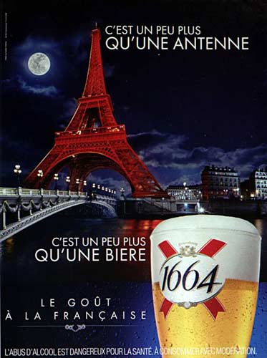
- With which city do you associate this monument?
- What does the slogan suggest about the monument? About the beer?
- Could the monument serve a different function for the French? Which one?
- Why is Kronenbourg 1664 using this monument to advertise its product?
- How do you understand the message of this advertisement?

Figure 8. xxxxxx

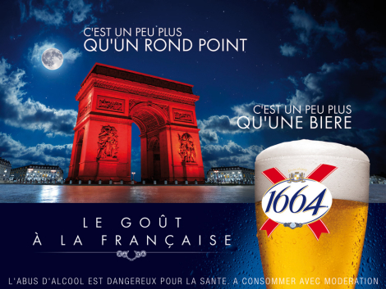

© Kronenbourg; this image is not covered by this article's CC BY-NC-ND license.

Figure 9. xxxxx

© Kronenbourg; these images are not covered by this article's CC BY-NC-ND license.

Stage 3 – Unfamiliar References: Experiencing Dissonance

In the third and final stage in the sequence, learners should experience dissonance and encounter connotations and associations that they cannot easily connect with or decipher. Advertisements were selected because they feature messaging (whether through visuals or wording) that relies on frames of reference unfamiliar to learners. Questions focus attention on noticing of the dissonance and guide intercultural practice, encouraging learners to interpret from the point of view of the audience to whom the advertisement is directed rather than relying on their own perspective. For this stage, I use advertisements from Pari Mutuel Urbain (PMU), a sport betting organization well-known in France, as well as from McDonald’s and Uber.
The PMU advertisement was part of a campaign during the Euro 2012 football tournament that showcased stereotypes about the French national team’s adversaries and symbols designed to appeal to a French audience. Although the slogan “Nous sommes prêts à ficeler les Anglais” [We are ready to tie up the English] supports identification of the symbolic meaning of the rooster and cut of roast beef (The French team is ready to beat the English team), this implicit association is not part of the American interpretive framework.

Figure 10. xxxx
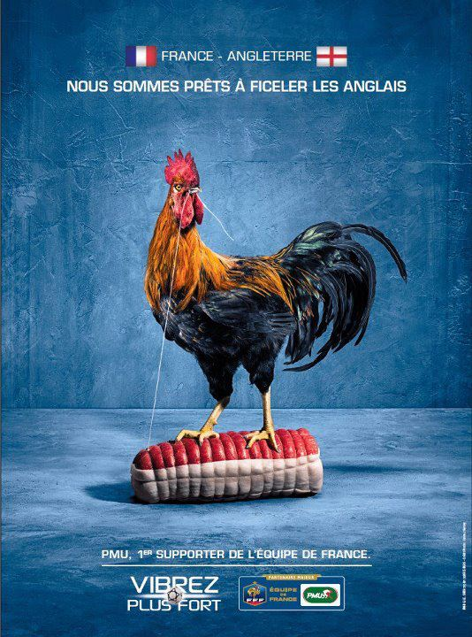

© PMU this image is not covered by this article's CC BY-NC-ND license.

The questions aim to assist learners in unraveling what the image implies but does not explicitly state, encouraging reflection on the fact that interpreting meaning in an intercultural context requires familiarity with the other’s interpretive framework.
- What symbolizes France?
- What symbolizes England?
- Use your phone to look up the French nickname for “the English” on the Internet. What did you find?
- What is your interpretation of this advertisement?
- If the French national team were playing against the American national team, what symbol would be used in this advertisement?
- Do you think that the reference would be clear to someone who is not American? Why or why not?

In the McDonald’s advertisement (Figure 11), the traditional banquet scene that concludes each adventure of the Astérix and Obélix comic book series is set inside a restaurant of the fast-food chain. Although the brand itself is familiar, the comic book reference might not resonate with learners.

Figure 11. xxxxx

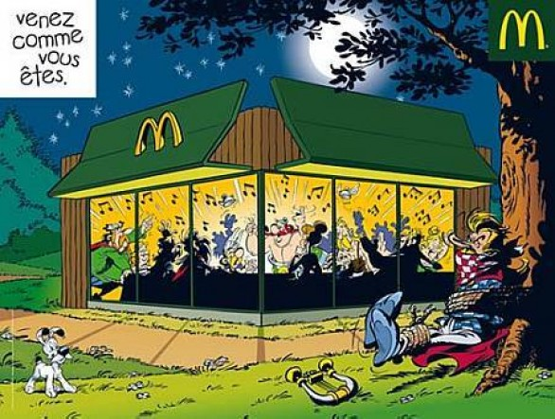
© McDonald’s; this image is not covered by this article's CC BY-NC-ND license.

The following questions explore how unfamiliarity with references can limit the interpretation of explicit and implicit meanings to engage reflections on the situatedness of pop culture references.
- What do you notice about this advertisement?
- Can you identify the characters in this advertisement? Who are they?
- What are they doing?
- Use your phone to look up the most popular comic book series in France on the Internet. What did you find about the characters? About the celebration scene?
- Why is this reference obvious to a French audience, but not to you?
- Why did McDonald’s choose to use characters from this comic book series in its French version of the campaign?

In the below Uber advertisement (Figure 12), the dissonance is created by the slogan “Uberbapapa – Profitez de trajets à un prix abordable” [Uberbapapa – Enjoy affordable rides]. What creates confusion is the connection between the visual of the cotton candy, the two children, and the word “bapapa.” Cotton candy is called ‘barbe à papa’ in French.

Figure 12. xxxxxI


© Uber; this image is not covered by this article's CC BY-NC-ND license.

The questions encourage a reflection on how something familiar (such as Uber or carnival prizes and food) can become unfamiliar because words—like symbols, characters, or events—can serve as cultural references.
- Where do you think the two children are coming from? How do you know?
- Do you know how to say in French what they are eating? Can you guess?
- Why is this advertisement difficult to interpret for someone who is not French?
- How do you interpret the message of this advertisement?

PEDAGOGICAL IMPLICATIONS

Teaching for decentering inherently involves a process-oriented approach that requires adjustment and refinement to account for the diverse perspectives and subjectivities of teachers, learners, advertisement creators, and audience. Regarding the curricular sequence presented above, the decision to focus on symbols and stereotypes of Frenchness, the methodology employed for searching and selecting advertisements, the structuring of the sequence, and the selection of specific cultural references were all guided by my personal interpretation of what might be consonant or dissonant to the learners in the context of my course. These decisions and choices will vary depending on context, objectives, and teachers’ and learners’ cultural backgrounds.
The following are some practical strategies to consider when implementing a decentering-focused pedagogy with advertisements:
- Identify a central theme to decenter. This choice should align with the course’s topics and objectives. Depending on the goals and context, the focus might be on one or more countries in which the target language is spoken.
- Determine symbols, stereotypes, codes, events, representations, or values related to the theme. Use these elements to guide the online search for advertisements. Embracing one’s own subjectivity is inevitable in this process. As the search progresses, new cultural references might emerge and can be used to refine the search.
- Search for brands or products familiar to learners. This will help avoid lengthy explanation about what is being advertised. The goal is to create dissonance through cultural references, not through the products themselves.
- Group advertisements based on their potential for creating consonance and dissonance. Consider the teacher’s own interpretations, as well as the perspectives of learners and the intended audience.
- Once the advertisement selection and analysis process are complete, use the three-stage sequence proposed above to guide the development of questions. These questions should support the noticing of cultural references, the comparison of interpretations, and reflections on consonances and dissonances.

This approach focuses on designing in-class activities that foster the personal growth of interpretive capacities as part of the process of developing intercultural competence. However, as noted by one of the anonymous reviewers of this article, without learning assessments, how can we determine an approach’s pedagogical effectiveness? The curricular sequence presented above does not include an assessment tool to objectively measure the extent to which learners are successfully decentering from their existing cultural frames of reference by the end of the lesson. While the marketing-related projects produced by the learners in the course provide valuable opportunities for practicing an emic or insider’s point of view when creating meaning, they may not fully capture the broadening of learners’ existing interpretive framework. These projects do, however, offer insights into learners’ ability to engage with different perspectives and cultural frames of reference. Incorporating reflective journals and peer assessments could complement the project and offer a more comprehensive evaluation of the effectiveness of a decentering-focused pedagogy.

CONCLUSION

Álvarez Valencia and Michelson’s (2022) conceptualization of interculturality as a process of becoming together with Liddicoat and Scarino’s (2013) processes of intercultural learning offer educators the possibility to design learning experiences to cultivate learners’ dispositions for interculturality rather than to assess how interculturally competent they are. Expanding learners’ interpretive system as a core outcome of foreign language learning allows us to think about what learners need in order to move beyond the constraints of their frames of reference to be able to interpret meaning from a cultural framework different from their own. Although exposure to divergent and alternate frames of reference is not guaranteed to lead to decentering, the use of authentic resources such as advertisements to generate consonances and dissonances serves as a catalyst for reflection on how one’s interpretive frameworks might be challenged, and perhaps transformed, through the experience. By grasping how assumptions and cultural references guide and influence interpretation, learners can build their “skills of interpreting semiotic choices” (Álvarez Valencia & Michelson, 2022, p. 15). Multiple and cumulative experiences that nurture the disposition to interpret from another point of view encourage intercultural becoming. As a resource, advertisements lend themselves particularly well to disrupting, dislodging, and decentering meaning making to support interpretation within and across languages and cultures.
REFERENCES

Álvarez Valencia, J. A., & Michelson, K. (2022). A design perspective on intercultural communication in second/foreign language education. Journal of International and Intercultural Communication, 16(4), 399-418. https://doi.org/10.1080/17513057.2022.2066152
Angelini, E. M., & Frederico, S. (2010). Understanding French culture through advertisements networking and technology. Global Business languages, 3, 109-120.
https://docs.lib.purdue.edu/gbl/vol3/iss1/10
Anholt, S. (2000). Another one bites the grass. Making sense of international advertising. John Wiley & Sons.
Bennett, M. J. (1998). Intercultural communication: A current perspective. In M. J. Bennett (Ed.), Basic concepts of intercultural communication (pp. 1–34). Intercultural Press.
Byram, K. A. (2011). Using the concept of perspective to integrate cultural, communicative, and form-focused language instruction. Foreign Language Annals, 44(3), 525-543.
https://doi.org/10.1111/j.1944-9720.2011.01145.x
Byram, M. (1997). Teaching and assessing intercultural communicative competence. Multilingual Matters.
Byram, M., & Cain, A. (1998). Civilization/cultural studies: An experiment in French and English schools. In M. Byram & M. Fleming (Eds.), Language learning in intercultural perspective (pp. 32-44). Cambridge University Press.
Byram, M., Gribkova, B., & Starkey, H. (2002). Developing the intercultural dimension in language teaching: A practical introduction for teachers. Council of Europe.
Byram, M., & Wagner, M. (2018). Making a difference: Language teaching for intercultural and international dialogue. Foreign Language Annals, 51(1), 140-151. https://doi.org/10.1111/flan.12319
De Iulio, S. (2016). Étudier la publicité. Presses Universitaires de Grenoble.
De Mooij, M. (2004). Translating advertising: Painting the tip of an iceberg. The Translator, 10(2), 179-198. https://doi.org/https://doi.org/10.1080/13556509.2004.10799176
De Mooij, M. (2014). Global marketing and advertising: Understanding cultural paradox (Fourth ed.). Sage.
Deardorff, D. K. (2006). Identification and assessment of intercultural competence as a student outcome of internationalization. Journal of Studies in International Education, 10(3), 241-266. https://doi.org/10.1177/1028315306287002
Drewelow, I. (2011). Learners’ selective perceptions of information during instructed learning in French: Consequences. The Modern Language Journal, 95(Supplementary Issue), 27-41. https://doi.org/10.1111/j.1540-4781.2011.01239.x
Drewelow, I. (2013). Impact of instruction on shaping or reshaping stereotypical cultural representations in an introductory French course. Foreign Language Annals, 46(2), 157-174. https://doi.org/10.1111/flan.12029
Dyer, R. (1993). The matter of images: Essays of representation. Routledge.
Fantini, A. E. (1999). Comparisons: Towards the development of intercultural competence. In J. K. Phillips (Ed.), Foreign language standards (pp. 165–218). National Textbook Company.
Fantini, A. (2009). Assessing intercultural competence. In D. K. Deardorff (Ed.), The Sage handbook of intercultural competence (pp. 456–476). Sage Publications.
Hobbs, R., He, H., & Robbgrieco, M. (2014). Seeing, believing, and learning to be skeptical: Supporting language learning through advertising analysis activities. TESOL Journal, 6(3), 447-475. https://doi.org/10.1002/tesj.153
Johnson, S. M. (2015). Adult learning in the language classroom. Multilingual Matters.
Kohonen, V. (2001). Towards experiential foreign language education. In V. Kohonen, R. Jaatinen, P. Kaikkonen, & J. Lehtovaara (Eds.), Experiential learning in foreign language education (pp. 8-60). Pearson Education.
Kramsch, C. (2009). Third culture and language education. In V. Cook & L. Wei (Eds.), Contemporary applied linguistics (Vol. 1, pp. 233-254). Continuum.
Kramsch, C. (2011). The symbolic dimensions of the intercultural. Language Teaching, 44(03), 354-367. https://doi.org/10.1017/s0261444810000431
Liddicoat, A. J. (2009). Communication as culturally contexted practice: A view from intercultural communication. Australian Journal of Linguistics, 29(1), 115-133. https://doi.org/10.1080/07268600802516400
Liddicoat, A. J., & Scarino, A. (2013). Intercultural language teaching and learning. Wiley-Blackwell.
Martin, E. (2012). Using advertising to explore French language and culture in the classroom. Global Business languages, 17(1), 161-170. http://docs.lib.purdue.edu/gbl/vol17/iss1/13
McCraken, G. (1988). The long interview. Sage.
Rentel, N. (2012). Translating cultural values in marketing communication. A cross-cultral pragmatic abalysis of French and german magazine advertising. In J. K. Dick & S. Schwerter (Eds.), Transmissibility and cultural transfer: Dimensions of translation in the humanities (pp. 157-180). ibidem-Verlag.
Scarino, A., & Liddicoat, A. J. (2016). Reconceptualising learning in transdisciplinary languages education. L2 Journal, 8(4). https://doi.org/10.5070/l28429918
Simon, M. (2019). Culture(s) publicitaire(s) en classe de français langue étrangère: “France is in the air”, analyse d’une campagne Journal of Foreign Languages, 11(2), 251-269. https://doi.org/10.4312/vestnik.11.251-269
Stangor, C., & Schaller, M. (1996). Stereotypes as individual and collective representations. In C. N. Macrae, C. Stangor & M. Hewstone (Eds.), Stereotypes and stereotyping (pp. 3–37). The Guilford Press.
Taylor, R. E., Grubbs Hoy, M., & Haley, E. (1996). How French advertising professionals develop creative strategy. The Journal of Advertising, 25(1), 1-14. https://doi.org/10.1080/00913367.1996.10673492

