Reconceptualizing the Teaching of the Five-Paragraph Essay Through Concept-Based Language Instruction to English as a Second Language Writers

TIANZHI ZHANG

University of Pittsburg

E-mail: tiz56@pitt.edu

This case study reports a pedagogical approach informed by Concept-Based Language Instruction, which aimed to orient English as a second language learners to a systematic conceptual understanding of rhetorical skills in five-paragraph essay writing. The 12-week pedagogical intervention focused on teaching the organizational structure of the five-paragraph essay and modes of persuasion through SCOBAs (Schemas for a Complete Orienting Basis of Actions) in a test preparation course for the writing tasks in the Test of English as a Foreign Language (TOEFL). Six participants completed three writing assignments and one analytic essay of a writing sample across the 12 weeks and received one-on-one individual tutoring sessions in the last week. The results demonstrate a holistic quality improvement in students’ five-paragraph essays and an observable improvement in the use of rhetorical appeals of Ethos and Logos strategies. In addition, the student-generated SCOBAs showed learners’ abilities to intentionally manipulate the SCOBAs to serve their internalization processes of the target concepts.
_______________

INTRODUCTION

In the instruction of school-based expository text, the five-paragraph essay (FPE) stands as a ubiquitous organizational template, occupying a place in the curricula of mainstream English and English as a Second Language (ESL) classrooms around the globe (Caplan & Johns, 2019). FPE, often lauded for its structural clarity and pedagogical convenience, has become a fundamental template for introducing students to school-based writing. Despite its widespread adoption, the FPE has attracted substantial criticism for its over-reliance on a formulaic approach that may stifle creativity and oversimplify the complexity of writing (Tardy, 2019). To extend the affordances of the FPE beyond an over-simplistic, formulaic template, this article introduces an alternative approach inspired by Concept-based Language Instruction (C-BLI) (Lantolf et al., 2021) to teach rhetorical skills and organizational structure in the FPE as systematic, holistic concepts. The approach was designed to orient learners to a systematic understanding of the target concepts and develop their abilities to control rhetorical and organizational decisions in FPE writing voluntarily. The purpose of this study is to investigate how this approach contributed to learners’ conceptual understanding of the rhetorical and organizational skills in FPE and changes in the writing quality of their FPEs.

LITERATURE REVIEW

Affordances and Critiques of FPE

The five-paragraph essay (FPE) gained its predominant status in English language classrooms in the 1950s and perpetuated its dominance in secondary and tertiary English writing teaching in current classrooms (Caplan & Johns, 2019; Nunes, 2013). The five-paragraph essay also dominates English as a Foreign Language (EFL) classrooms worldwide and ESL writing classrooms across first-year composition courses in English-medium colleges and writing courses in intensive English programs (IEPs) (Crusan & Ruecker, 2019). In the U.S., the FPE is one of the most common structures in genre-based writing courses in IEPs and first-year composition programs (Caplan & Johns, 2019). Globally, researchers have found that EFL learners are often taught the five-paragraph essay, especially in environments with strict testing policies or intense testing pressures (Ngo, 2018). For example, Vietnamese EFL learners often learn English rhetorical structure primarily through the FPE because the writing assignments are based on standardized language tests such as the International English Language Testing System (IELTS) and the Test of English as a Foreign Language (TOEFL) (Pham & Bui, 2019). Chinese and Korean EFL learners are trained on the FPE starting in high school for better test performance on standardized tests associated with high school graduation and college admissions (Ma & Cheng, 2015; West & Thiruchelvam, 2018).
The pervasive persistence of the FPE can be attributed to a few obvious advantages. It provides a clear, straightforward structure that is easy for students to learn and for teachers to instruct. This structure helps students organize their thoughts and present their arguments logically, which is a fundamental skill in academic writing (Bacha, 2010). In fact, the FPE is still one of the most used organizational structures to introduce fundamental skills in argumentation in school writing (Wingate, 2012). For multilingual writers, the clarity and predictability of the FPE provide an accessible framework to develop a basic understanding of the organization and coherence in writing for persuasion and argumentation. The proponents of the FPE suggested that the FPE serves as “training wheels” for novice writers to grasp a well-formed structure to organize their thoughts and a “building block” to prepare learners for the complexity of more sophisticated rhetorical structures and the potential of creativity in the future (Seo, 2007).
However, many scholars have pointed out the inherent drawbacks of teaching the FPE, given its decontextualized and over-simplistic nature. Teaching the FPE is often viewed as surface-level, unengaging, formulaic, over-simplistic, and one-size-fits-all (Warner, 2018). Literacy specialists have often lamented that the overemphasis on the FPE stifles writers’ creativity and limits the development of their rhetorical repertoires (Nunes, 2013; Wesley, 2000). In reality, institutional pressure such as high-stakes standardized testing and product-based performance evaluation often leads L2 writing practitioners to reduce the complex rhetorical skills in expository writing to a simplified five-paragraph structure even though argument skills are widely documented as crucial to developing students’ critical thinking and problem-solving (Tardy, 2019).
However, some of the misgivings of teaching the FPE are not in the organizational pattern itself but in how it is taught. Studies that investigated ESL learners’ perceptions of FPE have revealed that learners often memorize the structure as a rule of thumb without knowing the underlying rationale or alternative ways to construct arguments (Kim & Emeliyanova, 2021).
Indeed, FPE is often presented as an unbreakable set of rules but not as one organizational structure that contains rhetorical and organizational skills transferable to other genres of academic writing. For example, the requirement of stating a claim in the topic sentence and supporting it through evidence in an FPE’s body paragraph is a skill applicable across many academic text types. By explicitly teaching the writing skills in the FPE and encouraging flexibility and creativity beyond this foundational framework, students can learn to apply the core principles they've mastered through the five-paragraph essay to a broader range of writing scenarios. If the pervasiveness of FPE in second language (L2) writing classrooms continues, then FPE teaching is ripe for reconceptualization so that it is valuable for multilingual writers’ writing competence development, rather than a rigid template to memorize and comply with.
To explore an alternative approach to teaching rhetorical and organizational skills in the FPE, this study investigated the effects of Concept-based Language Instruction (C-BLI) (Lantolf et al., 2021) in a TOEFL writing preparation course that regarded the mastery of FPE writing as one of the major instructional objectives. The pedagogical intervention aimed to help learners develop a conceptual understanding of the writing skills in the FPE not merely as concepts to be memorized but as tools enabling them to develop voluntary control of the rhetorical and organizational choices in their FPEs.

Concept-Based Language Instruction

Concept-based language instruction, as an L2 teaching approach originating in sociocultural theory, has gradually gained prominence in the field of second language acquisition. Over the past two decades, there have been many studies focused on incorporating C-BLI into L2 teaching environments (e.g., Kim, 2013; Thorne et al., 2008; van Compernolle, 2012). C-BLI distinguishes itself from the “present, practice, perform” approach to instruction by reducing verbal descriptions of general rules of thumb. Instead, the C-BLI employs visualized models aiming to orient learners to a higher level of mental development which underscores the role of systematic and conceptual understanding (Gal’perin, 1989; 1992). The “concept” emphasized in C-BLI was derived from Vygotsky’s perspective on scientific concepts (Vygotsky, 1997). Vygotsky differentiated scientific concepts from everyday concepts, which are generally formed either during concrete daily experiences or by directly observing empirical features. Unlike everyday concepts, which are often fragmented and situational, scientific concepts are systematic, coherent, and recontextualizable (Lantolf, 2011). The formation of a scientific concept requires “systematic analysis of a particular domain” (Lantolf & Poehner, 2014, p. 64). They are integrated into an organized body of knowledge that individuals can apply across various contexts. Vygotsky believed that the purpose of education was to establish an environment where learners were exposed to and develop scientific concepts (Vygotsky, 2012). Inspired by Vygotsky’s scientific concept, the ultimate goal of C-BLI is to enable learners to internalize scientific concepts and develop the capability of conceptual thinking and independent performance in situated contexts.
In addition to scientific concepts as the core of the pedagogical approach, C-BLI emphasizes a gradual transformation of external material activity into internal mental operations. Gal’perin divided the process into three stages of the action: (1) the material stage where learners engage directly with physical objects or their symbolic counterparts like models or diagrams; (2) the verbal stage where learners articulate their understanding through dialogical or inner speech; and (3) the mental stage where learners conduct the action purely within the cognitive realm, independent of physical interaction or spoken language (Arievitch & Haenen, 2005). The three stages of action correspond to three procedural components in C-BLI: (1) the materialization of the concept through a careful visual representation; (2) learners’ verbalization of their thinking process and understanding of the concept while using it in practical goal-oriented activities (Lantolf & Poehner, 2014); and (3) learners’ internalization of the concept (Arievitch & Haenen, 2005).
The materialization of the target concept in C-BLI is called Schemas for a Complete Orienting Basis of an Action (henceforth, SCOBA) (Gal’perin, 1989). It refers to visual representations that encapsulate the meanings, structures, and functions of the target scientific concepts. To orient learners to the scientific and abstract understanding of the concept, mere verbal explanations are insufficient and probably lead to rote memorization of the target concept due to the sequential nature of spoken and written language (Lantolf, 2011). Therefore, a visualized representation of the concept – SCOBA – is needed to not only introduce the concept but also become a mediational tool that learners use and adapt in each of their pathways of conceptual development. SCOBAs are ideally systematic, holistic, and well-structured (Lantolf & Tsai, 2018). Once the concept is presented through one or a set of SCOBAs, learners are encouraged to talk through their understanding of the concept with the instructors or peers or in the form of self-talk when the learners perform their conceptual understanding in concrete problem-solving tasks. Finally, the goal of instruction is to enable students to achieve the internalization of the target concepts, which means that the learners make the concepts their own and perform the conceptual understanding independently across various contexts with conscious control over their performance in concrete tasks.
Currently, the majority of L2 C-BLI studies have focused on grammatical knowledge of languages (Gregory & Lunn, 2012; Negueruela, 2003), the development of pragmatic competence (Nicholas, 2015; Thorne et al., 2008; van Compernolle, 2012), and the conceptual development of rhetorical skills and figurative language (Kim, 2013; Wang & He, 2021). C-BLI has also been applied to skill-based courses that focus on English literacy for specific purposes. For example, Ferreira (2005) designed a course for developing students’ theoretical thinking through writing practice and the meaning-making process. She found that concept-based instruction was successful in developing students’ theoretical thinking ability through analyzing students’ essays and verbalization. Kurtz (2017) designed a C-BLI to teach the concept of analogical reasoning to L2 law students to enhance their overall legal analytical skills. The study found that the C-BLI, through systematic conceptual mediation, effectively promoted students' understanding of analogical reasoning in reading and reasoning within the U.S. common law.
A few studies have examined the effect of C-BLI in ESL academic writing contexts (Fogal, 2015; Hadidi, 2021; Yáñez Prieto, 2010). Yáñez Prieto (2010) proposed an alternative stylistics-oriented, literature-through-language course in response to the traditional dichotomy between meaning and form in the mainstream undergraduate FL curriculums at American universities. This study demonstrated the efficacy of C-BLI in helping students internalize stylistic concepts and facilitating students’ conceptual development of text, genre, aspect, and tense. Fogal (2015) designed a 3-week intensive, argument writing course guided by C-BLI to teach five voice features: hedges, boosters, attitude markers, authorial self-mention, and direct reader references. The findings demonstrated improvements in learners’ overall quality of writing and a nonlinear path of concept development of authorial voice. In a related study, Hadidi (2021) applied Tolmin’s (2003) model of argumentation through a central SCOBA and a think-sheet as an auxiliary mediating tool to develop learners’ argumentative rhetorical abilities in a pre-university IEP program. The C-BLI of the target concept led to noticeable gains in the students' cognitive awareness and the caliber of their written work, both throughout and following the instructional period.
To my knowledge, no study has applied C-BLI to teach rhetorical and organizational skills in the FPE for multilingual learners. This study was designed to integrate C-BLI into a TOEFL writing course focusing on three concepts – the modes of persuasion, the regressive mode of reasoning (Schlesinger et al., 2001), and the organizational structure of the FPE –relevant to the persuasion, argumentation, and organization of the FPE. The C-BLI approach provided an alternative to the traditional formulaic, form-focused instruction of the FPE (Miller, 2010) by fostering a conceptual understanding of rhetorical and organizational skills underlying the FPE. The materialized concepts and the instructional materials were designed to teach both the “how” of FPE writing and, more importantly, the “why” and “so what” of learning and writing FPE in order to address the conceptual development of the rhetorical and organizational skills needed to write beyond the formulaic FPE.

SCOBAs: Rhetorical and Organizational Skills in the Five-Paragraph Essay

The leading concept of the set of SCOBAs – Modes of Persuasion – was originally derived from Rhetoric, a classic work originated from Aristotle who systematically explained rhetoric as a medium or communicative process through which people share meanings of things with others in a most persuasive sense (Crowley & Hawhee, 2004). The SCOBA included three autonomous but intertwined rhetorical appeals – Logos, Pathos, and Ethos. Logos is usually understood as the logic or reason which is enacted through a well-conceived structure of the composition and suitable and effective reasoning, such as deduction and induction (Richards, 2007). Pathos refers to the emotional appeal that enables the speaker to address and respond to the affective needs of the target audiences, which is usually achieved through the usage of figurative language and the narration of a touching or affection-provoking narrative. Ethos refers to the character of the speaker, which provides credibility and convinces the audience. This aspect is usually realized in writing by listing facts and statistics, citing canonical quotes, and demonstrating authorial credibility through language use (Richards, 2007). The SCOBA visualized the relationship among the three modes in a triangle shape and explained the three modes through annotated texts (see Figure 1). The texts in the SCOBA explained the literal meaning of each term and provided “techniques” instantiating the strategies that can be used to achieve the rhetorical goal of each aspect. The equilateral triangle was used because it represents how the three modes of persuasion are equally fundamental and interconnected in creating a persuasive argument. The effectiveness of one mode often relies on the support of the others. For example, a logical argument (Logos) is more compelling when the speaker is credible (Ethos) and can connect emotionally with the audience (Pathos). The concept of modes of persuasion was chosen and materialized because it provided a heuristic model of three fundamental rhetorical skills – Logos, Pathos, and Ethos – that guide writers to establish effective argumentation in an FPE. It is widely taught in ESL writing classrooms, such as first-year composition courses and IEP programs at U.S. colleges (Ferris & Hedgcock, 2013). In addition, this concept provides an overarching explanatory framework for the other two SCOBAs, which illuminate the argument structure at the paragraph level and the overall organization of the FPE.

Figure 1
SCOBA 1: Modes of Persuasion

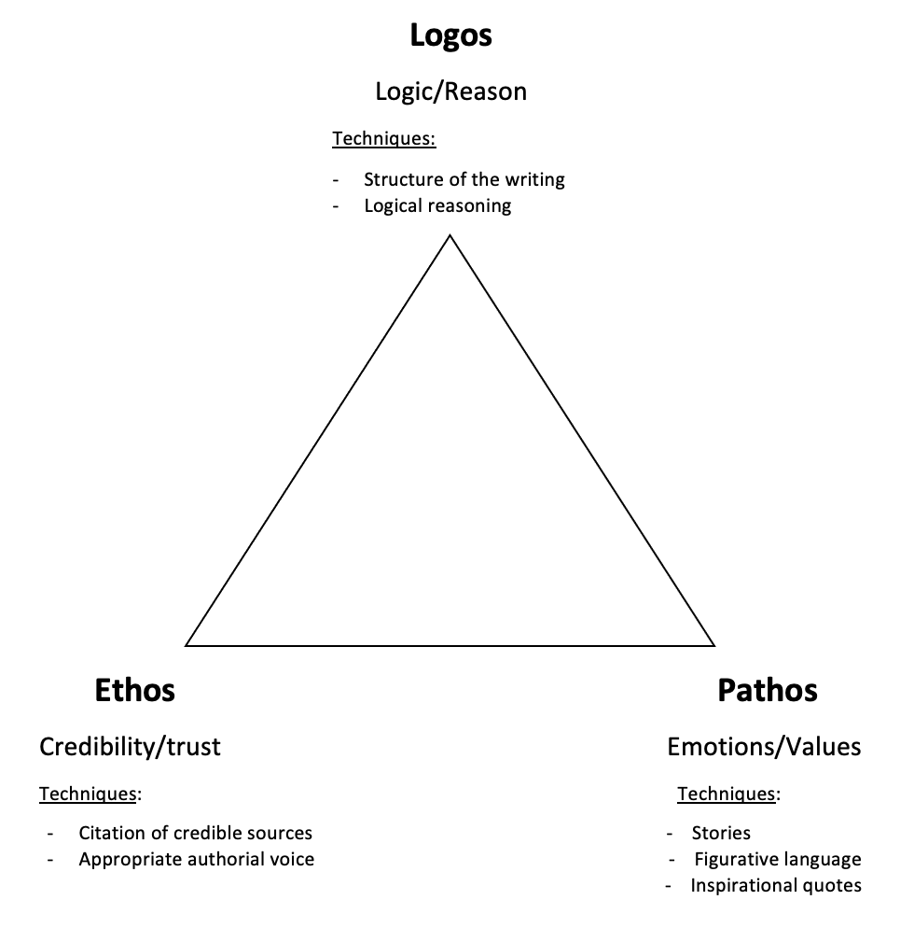

The second SCOBA illustrates the concept of the Regressive Mode of Reasoning (See Figure 2). This concept is a sub-concept of Logos often used in the FPE. When it comes to the reasoning for organizing a paragraph, there are two ways of making the same point: the “progressive mode of reasoning” and the “regressive mode of reasoning” (Schlesinger et al., 2001). The progressive mode of reasoning unfolds the argument starting from the premises and draws from them a conclusion; that is, the conclusion is presented at the end based on a series of premises. On the contrary, in the regressive mode, the argument starts with the conclusion and then backtracks. In other words, it justifies the conclusion by presenting the premises leading to it (Schlesinger et al., 2001). The regressive mode of reasoning is pervasively found in school-based argumentative writing, including the FPE, in which topic sentences are presented at the beginning of the body paragraphs, followed by evidence, warrant, and a brief concluding remark (Caplan & Johns, 2019). This SCOBA aimed to assist learners in understanding the argumentative reasoning underlying the paragraph structure in the FPE.
The SCOBA represents the regressive mode of reasoning in an iconic diagram (See Figure 2). The first shipping box is an analogy that compares the statement of a claim to an unopened box filled with ideas on which the writer plans to elaborate. In line with the regressive mode of reasoning underlying the body paragraph structure in the FPE, the argumentation of the statement or claim will be “unpacked” until the elaboration of argumentation with justification (the reasons or arguments that show the claim is reasonable or necessary), accounting (the acts of giving an account or a narrative to explain why something happened), and warrant (the facts or reasoning that connects the evidence to the claim), like the open shipping box on the left side of the SCOBA. This SCOBA aimed to enable learners to recognize the argumentative components of the regressive mode of reasoning and the sequence of presenting them in the five-paragraph essay.

Figure 2
SCOBA 2: Regressive Mode of Reasoning
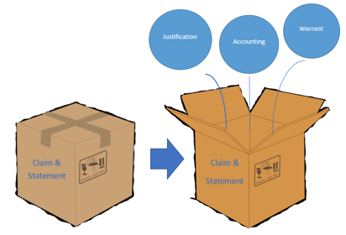

The third SCOBA was designed to offer a detailed explanation of the organization of a five-paragraph essay under the guidance of the leading concept of the mode of persuasion.

Figure 3
SCOBA 3: Organization of the Five-Paragraph Essay

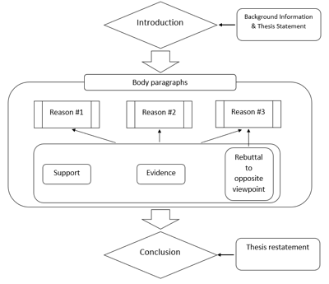

In this SCOBA (Figure 3), the organization of the FPE was broken down into three parts: introduction, body paragraphs, and conclusion. The rectangular box in the middle of the flow chart annotates the content that should be included in each body paragraph. The aims of this SCOBA were twofold: 1) to familiarize learners with the overall and skeletal structure of the five-paragraph essay and 2) to build connections between the organizational structure and the three rhetorical appeals explained in the first SCOBA. To connect this SCOBA to the leading concept, i.e., Modes of Persuasion, the instructor asked facilitating questions such as, “How will you use the concept of the mode of persuasion to organize each reason?” and “How will you use the regressive mode of reasoning to govern each body paragraph?” These questions were designed to encourage learners to think of how to flesh out this skeletal structure with specific rhetorical strategies guided by the leading concept.

THE STUDY

The study presented here analyzed data from a twelve-week instructional unit (two 1-hour lessons per week) with a focus on the FPE for six multilingual learners in a non-profit, community-based adult ESL education institution in the Mid-Atlantic region of the United States. The twelve-week unit was embedded in a 16-week TOEFL writing course that I designed and taught. The course consisted of two sections: TOEFL independent writing (a writing task that asks test-takers to express and support their opinions on a given topic) from week 1 to 12 and TOEFL integrated writing (a writing task that asks test-takers to summarize and compare key points from a short reading and listening passage) from week 12 to 16. The data in this study were collected in the first 12 weeks of the course during the section of the TOEFL independent writing. The research questions that guided the study were:
- Does the C-BLI approach to teaching rhetorical skills in the five-paragraph essay change the writing quality of the FPE?
- How do the SCOBAs influence the conceptual development of ESL writers?

Participants

Six participants were enrolled in the TOEFL course, and each consented to participate in this study. The participants came to the class with different linguistic and cultural backgrounds (see Table 1). Sukarno, Tianyun, and Qin (pseudonyms used for all participants) were dependents of visiting scholars who planned to apply for graduate schools in the U.S. Sophia was a foreign worker who needed to pass the TOEFL test to obtain a working visa in the U.S. Hanqin and Kuram were graduate students who needed a desirable TOEFL score to apply for doctoral programs. All the students planned to take the TOEFL test three months after the course. Most students came to the course with limited experience in TOEFL test training and writing in English for academic purposes (see Table 1).

Table 1
Participants’ Information
Pseudonym | L1 | Gender | Previous experiences of TOEFL training (month) | Experiences of English writing in academic context (year)
Sukarno | Indonesian | Male | 0 | 0.5
Qin | Mandarin | Female | 3 | 1
Tianyun | Mandarin | Female | 0 | 0
Hanqin | Mandarin | Male | 8 | 1.5
Sophia | Arabic | Female | 0 | 0.5
Kuram | Nepali | Female | 4 | 0.5

C-BLI Lessons

As Table 2 shows below, the SCOBAs were introduced after four weeks of community-building and an overview of the TOEFL writing tasks and necessary groundwork in vocabulary, sentence structure, and essay planning. The front-loaded procedure aimed to prepare learners to understand and apply the SCOBAs in their FPE sample analysis and FPE writing. The instruction of the three SCOBAs differs from traditional ways of teaching the FPE for L2 writers in two ways. First, C-BLI emphasizes a holistic understanding of the target concepts instead of fragmented rules to remember. For example, I taught the SCOBA of Modes of Persuasion through modeling how to use the concept for sample analysis, scaffolding learners to collaboratively analyze a writing sample with the SCOBA and guiding individual freewriting to apply the concept. In the sequence of “I do”, “we do”, and “you do,” I continuously encouraged learners to refer back to the SCOBA when they discussed their understanding of the persuasive modes and asked probing questions to investigate how they connect the three modes of persuasion in sample analysis and their own writing. Second, C-BLI values the role of mediation through mediating artifacts, purposeful interactions with the instructor, and specially designed learning activities (Kozulin, 2018). Apart from the constant presence of the SCOBAs in the classroom (the mediating artifacts), I intentionally helped the learners understand the meaning of the concepts and facilitated deeper cognitive engagement through requesting clarification, probing, and hinting in teacher-student interactions. I also designed practical, concrete activities such as FPE sample analysis and freewriting tasks that allowed learners to externalize their thinking process in goal-oriented tasks. In the twelfth week, I conducted individual tutoring sessions with each student to provide individualized support for FPE writing and deepen their understanding of the target concepts.

Table 2
An Outline of the C-BLI Lessons

Week | Topics | Assignments
1 - 2 | - Community-building  - Introduction of TOEFL writing tasks | Writing assignment 1
3 | - Building-blocks: Tips for vocabulary, sentence, transition  - Purpose and audience
4 | - TOEFL independent writing Prompt analysis  - Brainstorming/outlining
5 - 6 | - Modes of persuasion: Ethos, Pathos, Logos  - Sample FPE analysis/freewriting | Writing assignment 2
7 | - Organization of TIW  - Sample FPE analysis /freewriting
8 - 9 | - Argumentative reasoning and paragraph structure  - Sample FPE analysis/writing practice | An essay for sample FPE analysis and student-annotated SCOBA

Data Collection

I collected various sources of data, including drafts of the three FPE assignments written by the six students, student-annotated SCOBAs, essays for FPE sample analysis, audio-recorded pre-intervention interviews, and audio-recorded tutoring sessions at the end of the 12-week instruction. The writing drafts were collected and analyzed to answer the first research question about the C-BLI’s effects on the quality changes of the learners’ FPEs. The other data sources were analyzed to investigate the learners’ conceptual development in the C-BLI intervention. At the outset of the study, a 20-minute pre-interview was conducted individually in the first week of the course to obtain an understanding of learners’ existing knowledge about the FPE. The semi-structured interview protocol was designed to elicit participants' reflective thoughts on their writing competence and their understanding and attitudes toward the FPE (see Appendix A). The first FPE assignment was written in Week 2. This assignment was used as a pre-test to examine students’ pre-existing understanding of the FPE (see Appendix B for the writing prompts). The second FPE was written in Week 6 after the instruction of the SCOBA of Modes of Persuasion. This assignment was used to examine the writing quality of learners’ FPEs in the middle of the C-BLI intervention. The third FPE was drafted after Week 11 and revised (with written feedback from the instructor) before students brought their second draft to the tutoring sessions. Only the first draft of the third assignment was used for examination. The third assignment was viewed as the post-test after the C-BLI implementation. The learners received content-focused written feedback for each writing assignment. The feedback focused on the argumentation, rhetorical features, and organizational components explained in the three SCOBAs. The written feedback on the three assignments was similar in foci and format to maintain consistency.
The essay for sample FPE analysis and the student-annotated SCOBAs were assigned after the second class in Week 8 before the final writing assignment. Students were asked to choose and annotate one SCOBA according to their understanding and use it to analyze the rhetorical moves and language use in the given sample of FPE. After that, they wrote a 300-word analytic essay on the FPE sample. After the last session in Week 12, the students were invited to a one-on-one tutoring session with the instructor to discuss their third writing assignment. The tutoring sessions were a set of 30-minute, individual, and face-to-face meetings divided into two sections. The first 20 minutes were dedicated to scaffolding students to verbalize their thoughts, concerns, and struggles about the concepts through analyzing the third writing assignment. The remaining 10 minutes were devoted to the verbalization of students’ understanding of the target concepts to evaluate their conceptual development.

Data Analysis

The study presented in this article is mixed-method in nature (Johnson & Christensen, 2019) with the aim of providing an overview of how participants' FPEs changed during the CBLI instruction and a fine-grained qualitative analysis of their conceptual development in the target concepts. To answer the first research question about changes in quality and content across the students’ three FPE writing assignments, I designed a trait-based scoring rubric that evaluated seven key discourse features of the FPE: Organization, Thesis statement, Topic sentence, Ethos, Logos, Pathos, and Restatement of thesis (see the table in Appendix C). The scores for each dimension were given on a scale from zero to three based on the descriptors of different levels of sophistication and quality of each discourse feature. Three raters (including the researcher) scored each discourse feature for all students’ FPE assignments, and the three raters’ scores were averaged for each discourse feature. The two additional raters were trained by scoring two sample FPEs using the trait-based rubric. After scoring each of the sample FPE, I met with the two raters, discussed the scores and the text, and resolved the disagreements. The overall interrater reliability (the average of the scores for all dimensions) in the scoring of the second sample FPE was 87%.
To answer the second research question about learners’ conceptual development of rhetorical and organizational skills in the FPE, I first transcribed the audio-recorded pre-interviews and tutoring sessions (see Appendix D for transcript conventions). An inductive coding approach (Saldaña, 2013) was applied to the transcripts to identify student responses that were relevant to the conceptual development of the target concepts. I also inductively coded the student-annotated SCOBAs and the essays for FPE sample analysis. To investigate students’ creative and strategic use of the SCOBAs, the analysis of the student-annotated SCOBAs focused on three characteristics: concrete (including details and content) or abstract; systematic (making connections with different concepts) or disconnected; and emulating (including learner-invented symbolic representations) or imitating (Qin et al., 2023). I coded the essays for FPE sample analysis based on the features in the three SCOBAs. The sentences that showed learners’ understanding of the SCOBAs were labeled by the corresponding SCOBA features (e.g., a sentence, “The story in this paragraph is ethos because it is evidence that supports the topic sentence,” was labeled with the code “Ethos”.). These codes served to identify the conceptual understanding of the target concepts in the analytic essays.
Based on this analysis, I conducted a qualitative case study (Creswell & Poth, 2016) of two focal learners who demonstrated different proficiency levels in FPE writing and different degrees of conceptual understanding. The case study description was generated through an iterative examination of the transcripts of the audio-recorded tutoring sessions, student-annotated SCOBAs, and the analytic essays of an FPE sample. The two students (Qin and Sukarno) were selected in order to demonstrate how the students with the strongest (Qin) and weakest (Sukarno) initial FPE writing skills took up the target concepts and adapted their SCOBAs. The comparison between these students reveals how the students with different initial proficiency levels in FPE writing demonstrated their trajectories of conceptual development. Additionally, Qin and Sukarno made more adaptations in their versions of SCOBAs than the other four students, which provided more detailed data about their conceptual development. The illustration of the two students’ SCOBAs and their uptakes of the target concepts embodied in the tutoring sessions shows students’ creativity in utilizing the SCOBAs while they internalized the target concepts.

RESULTS

Writing Quality Changes

The findings in this section address research question 1: Does the C-BLI approach to teaching rhetorical skills in the five-paragraph essay change the writing quality of the FPE? Overall, the scoring results demonstrated that students made significant progress on all the focal discourse features, including Thesis Statement, Topic Sentence, Evidence of Ethos, Evidence of Pathos, Evidence of Logos, and Restatement of Thesis. However, the progress on Pathos and Logos was less obvious than the other discourse features (see Figure 4).

Figure 4
The Learners’ Average Scores For FPE Discourse Features

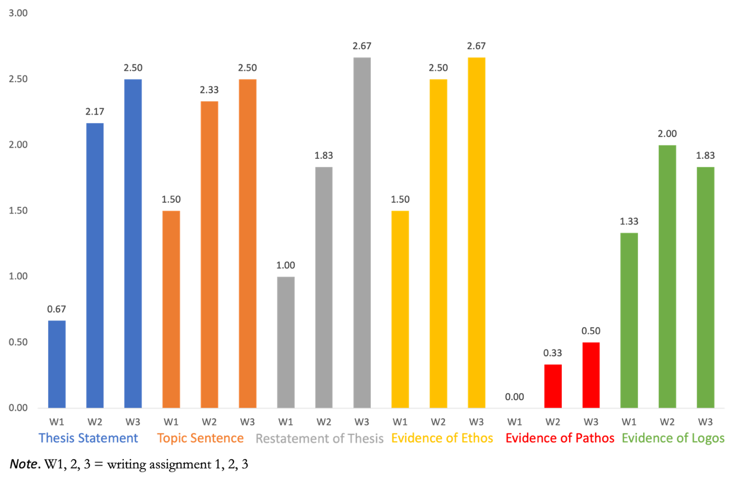
Specifically, out of the four discourse features on which students made observable progress, learners made the most improvement on the Thesis Statement from the first to the third writing assignment (from point 0.7 to point 2.5). Three students’ (Sukarno, Qin, and Sophia) first essays did not include thesis statements, but sense-making thesis statements were found in their second essays. In the third assignment, half of the students were able to produce qualified thesis statements.
The average scores of Topic Sentence and Restatement of Thesis improved by 1 point and 1.7 points from the first to the final writing assignment. For the topic sentences, most of the first essays showed evidence of topic sentences and gradually improved across the following essays. In the end, half of the students produced well-structured topic sentences in their final essays. For example, in the first essay, Kuram started a body paragraph by “I can learning how to improve myself on the movie because you cannot understand everything.” The sentence shows no clear transition from the previous paragraph and less direct relevance to the thesis statement. In the third essay, he wrote a topic sentence, “Secondly, it is faster, comfortable and most convenient way of travelling for human being.”, which is more cohesively connected and concise than the counterpart in the first essay.
Students’ essays also showed pronounced progress on the Restatement of Thesis. Four students had insufficient or no thesis restatements in their first drafts, but all students included thesis restatements in their final essays, and four of them (students who received point 3) were able to produce well-structured ones. The observable improvements in the thesis statement, thesis restatement, and topic sentence suggest that students developed a certain level of understanding about the SCOBAs for the paragraph structure and overall organization of the FPE. It makes sense since the concepts of thesis statement and topic sentence in the TOEFL independent writing task are intrinsically formulaic and less prone to the influence of other factors such as the possession of linguistic resources or awareness of context.
For the three aspects of modes of persuasion, the average score of Ethos was found to increase from the first to the last writing assignment (point 1.5 for the first, 2.5 for the second, and 2.7 for the third). Logos improved in the second writing assignment (point 1.2 for the first assignment, and point 2 for the second), but dropped slightly in the third assignment (point 1.8 for the third assignment). In the students’ first essays, Qin, Hanqin, and Sophia, who scored point 1 for the Evidence of Ethos, had poorly supported arguments with non-credible evidence. In the third writing assignment, they used more comprehensible and more credible examples or personal experiences to support their opinions. For instance, Hanqin’s second writing assignment presented Ethos and wrote:

In my life, I have learned a lot of things from movies, like family is really important whatever where you are they always support you. I believe the movie will teach you more things however, there is a bad or good.

While the precision of his language use is still developing, as evidenced by typos and grammar errors, the personal experiences present in this stretch of text are one type of Ethos strategy that Hanqin chose to enhance the credibility of the writer’s argument.
Pathos was the aspect of the modes of persuasion that progressed the least. No evidence of Pathos was found in the first assignments. Only two out of six students tried to appeal to readers’ emotions in the second assignment but failed to contribute to the persuasion of arguments. In the final assignment, only one student (Sophia) produced qualified evidence of Pathos. However, no evidence of Pathos, such as personal stories, anecdotes, or use of figurative language to appeal to readers’ emotions, was found in other students’ essays. Across the three writing assignments, only three entries were found demonstrating the rhetorical strategy of Pathos. One of them (in Sophia’s second writing assignment) utilized an inspirational quote to evoke readers’ emotions. The lack of Pathos in the students’ writing may be related to their limited linguistic and cultural knowledge of English accumulated in the process of interacting with authentic English discourse. For instance, in the final tutoring session with Hanqin when I asked him to think of ways that he could involve Pathos to evoke readers’ empathy, he said:

I find it really tricky to put emotions into my writing. Some of my feelings are hard to translate into English. The words I would use at home sometimes there are no a [sic] good word in English. Also, I worry if I can use the word or not, if I'm being too emotional or not emotional enough. I was thinking to show my emotion but I worry if they understand the emotion the same way I do.

In short, C-BLI instruction seemed to contribute to positive changes in students’ FPEs rhetorical instantiations, even though the changes in some features, such as Pathos, were minimal. The overall score increases in each focal discourse feature in the FPEs, suggesting learners applied the target concepts in their FPE writing. The following section details the two focal students’ conceptual development of the target concepts.

Student Conceptual Understanding of the Target Concepts

Qin’s Data

Qin possessed a relatively high level of English proficiency compared with the other students (she received the highest average score for the three writing assignments). She had TOEFL preparation experiences for three months prior to the current TOEFL writing course. In the class, Qin was always actively engaged in activities and group discussions. She demonstrated self-confidence in expressing and defending her thoughts when she discussed the meaning of the SCOBAs and used them to analyze the writing sample and plan her own writing. She demonstrated a basic understanding of the FPE format in the pre-interview. She was able to define the overall structure and general purposes of each paragraph. She held an overall positive attitude toward the FPE because, as she noted, “It’s clear and easy to learn, and it helps me to logically order my thoughts while I am planning for an essay.” However, when I asked what she usually did to establish a solid argument in an FPE, Qin expressed her uncertainty about the essential features of a solid argument:

I get confused about how to organize my argument. I know the essay should have one main argument, but my ideas usually mix up. You know what I mean? I worry about whether my ideas are logical or if they are related closely to my main argument. I guess I don’t know what is a good argument in English. What should I include? How to arrange them so my readers can understand.

Qin’s response conveyed several challenges she faced while trying to construct a coherent argument in English academic writing, including uncertainty about how to structure her argument effectively (“confused about how to organize my argument”), difficulty in maintaining a tight connection between supporting ideas and the central thesis of the essay ("I worry about whether my ideas are logical or if they are related closely to my main argument.”), and anxiety about whether her argument will be comprehensible to audiences (“How to arrange them so my readers can understand.”). The struggles suggest that Qin lacked a systematic understanding of Logos and writing in a unified and coherent manner. After learning about the SCOBAs, Qin used the SCOBA for Modes of Persuasion and the SCOBA for Regressive Mode of Reasoning for the analysis of the FPE sample. Qin discussed the key components of an argument in the FPE sample through the SCOBA for Regressive Mode of Reasoning. In the FPE sample analytic essay, she wrote:

The second paragraph makes me remember the claim, accounting, and warrant in the regressive mode of reasoning model we learned this week. The author connected his or her opinion and evidence with clear support. There are supports before and after the evidence.

Qin’s observations showed her understanding of the meaning of the three argumentative components. She actively used the SCOBA to explain how the writer organizes the three components. Though mentioning her understanding of the SCOBA of the Regressive Mode Reasoning in the text above, Qin chose to modify the SCOBA of Modes of Persuasion to assist in her interpretation of the writing sample (see Figure 5).

Figure 5
Qin’s Student-annotated SCOBAs

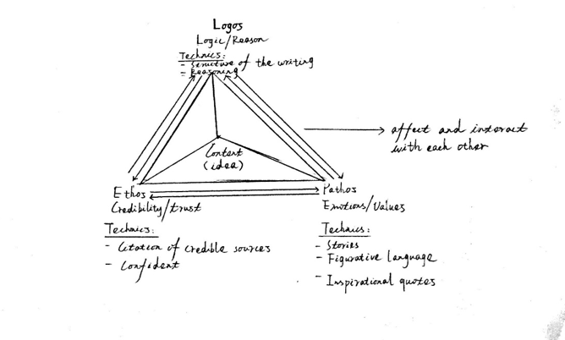

The rematerialization of the concept, namely, the adaptations or a redesign of the SCOBA by the learner, has been extensively documented in C-BLI studies (Fernández & Donato, 2020; Wang & He, 2021) and has been viewed as evidence that learners actively and innovatively use SCOBAs as mediational tools in the internalization process of the target concepts. The creative use of the SCOBA is seen in Qin’s SCOBA. Qin added bidirectional arrows to indicate that the relationship between the three strategies is mutually influenced. Qin explained that she found this relationship based on the supporting evidence in the writing sample. She wrote in her essay on the FPE sample analysis:

This sentence let me realize that ethos, logos and pathos are related. One sentence can be both logos and ethos. I have to keep the three aspects in mind when I write a body paragraph. I will also consider these when I revise. A sentence should play at least one of these functions.

She pointed out that a single sentence can serve both Logos's and Ethos’s purposes. Then, she concluded that the three aspects of the mode of persuasion interplay with each other to contribute to the effect of persuasion. Qin’s student-annotated SCOBA visualized her understanding of the SCOBA for the mode of persuasion. Her analysis of the writing sample showed her conceptual understanding of the three rhetorical appeals in the SCOBA.
Qin’s SCOBA also included her understanding of the SCOBA for the organization of the FPE. She added the word “content” at the center of the triangle to illustrate that all strategies for persuasion should serve to establish the ideas and content of the essay. She wrote in her reflective essay that she was aware of this connection when she reflected on the three elements (topic sentence, evidence, and rebuttal) of a body paragraph in the sample of FPE. She realized that a writer should bear Ethos in mind to involve evidence to support their ideas and skillfully use Logos to establish a credible rebuttal in a concession paragraph. The word “content” at the center of Figure 5 indicated that Qin connected the concept of the modes of persuasion and the concept of the organization of the FPE while she was internalizing the rhetorical concepts of the FPE.
In the tutoring session, Qin’s reflective comments also showed her ability to perform her understanding of the target concepts while she was asked to reexamine her essays in terms of the modes of persuasion. The tutor-tutee interaction in Excerpt 1 (the “TE” stands for my turn-at-talk as the tutor across all excerpts) demonstrates how Qin consciously used the concept of Logos to point out a potential weakness in her writing.

Excerpt 1
I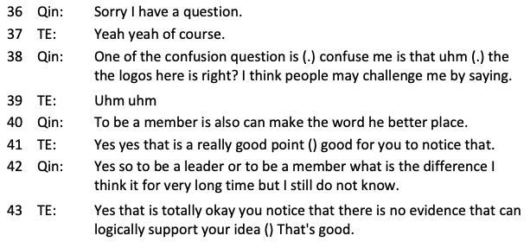

Prior to this snippet of conversation, I asked Qin to identify rhetorical skills in one body paragraph, and she referred to a sentence, “Being a leader is better than being a group member because the leader can make the world a better place.” as evidence of Ethos and Logos in the paragraph. Before I continued my probing questions, Qin interjected and asked if a logical fallacy exists in the argument. In turn 38, Qin asked, “the logos here is right?” and worried that the argument might be challenged by readers because of the untenable logic. Qin’s question here seems to be a gesture of asking for confirmation, given her continuation. In turn 40, she continued and brought up a potential counterargument that being a member can also make the world a better place. I was surprised that Qin noticed the logical fallacy and then confirmed her noticing. In turn 42, Qin said, “So to be a leader or to be a member, what is the difference?”, which externalized her private speech as she grappled with the validity of the argument. Even though the transcript did not document Qin’s solution to the untenable argument, her verbalization demonstrated that she understood the conceptual meaning of Logos and was aware of the significance of Logos in an FPE.
Though Qin’s SCOBA and comments in the tutoring session indicated her conceptual development of the target concepts, her reflective comments on the language use of her writing (such as lexical and syntactic choices) nevertheless showed that the conceptual understanding did not automatically lead to improvements in writing quality due to the limitations of linguistic resources. Before the conversation presented below, I tried to encourage her to further externalize her understanding of the concepts by asking “If you are allowed to ask one more question about the SCOBA of the modes of persuasion, what would you want to ask?”, Qin pinpointed the conundrum of language use that she encountered.

Excerpt 2

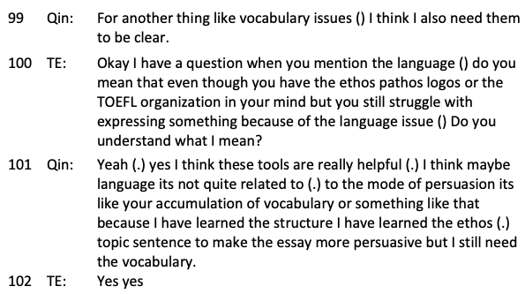

In turn 101, Qin acknowledged that the SCOBA was helpful as a general guide for her writing. However, the conceptual understanding did not directly translate to sense-making in her writing. As Qin said, “I have learned the structure, the ethos, and the topic sentence, but I still need the vocabulary.” Qin’s confidence in her conceptual understanding and concern about her vocabulary knowledge demonstrated a gap between knowing the definition of the concept and the internalization of the concept. Qin developed a conscious awareness of the rhetorical aspects that can be improved but was not able to perform the rhetorical skills independently.

Sukarno’s Data

Unlike Qin, Sukarno came to the course with a lower level of proficiency and no previous preparation experience for TOEFL writing tests. However, the average score for his FPEs improved the most of all the students (from 1.1 to 2.4). In the pre-interview, Sukarno stated his unfamiliarity with the FPE format but said he had experience with the “PIE” structure (Point, Illustration, and Explanation) in his previous learning experience. When I asked him to think aloud about how he usually organized an argumentative essay, he showed difficulties in transferring his knowledge about the PIE structure to planning a whole essay. Sukarno also struggled with the concepts of thesis statement and topic sentence when he responded to my follow-up questions, eliciting his understanding of the argumentative components. After learning the SCOBA, Sukarno’s student-annotated SCOBA (see Figure 6) and verbalization in the tutoring session substantiated his conceptual development in using the target concepts in the FPE sample analysis and his own FPE writing.

Figure 6
Sukarno's Student-annotated SCOBAs

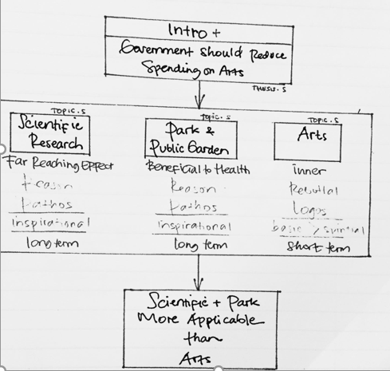

While writing the essay of FPE sample analysis, Sukarno chose the SCOBA for the organization of the FPE and annotated the SCOBA with the information (the thesis, topic sentences, and reasoning) that he summarized from the writing sample to illustrate his understanding of the structure and key points of the writing sample. Sukarno also incorporated the three modes of persuasion into his SCOBA (Pathos and Logos in the box at the center) to specify the rhetorical skill in each body paragraph. This indicated his ability to integrate the two concepts into a systematic network rather than understanding them in an isolated way. Sukarno’s annotation on the SCOBA suggested that he used it as a mediational tool to interpret and analyze the writing sample. However, Sukarno mostly copied the organization SCOBA without making changes to the structure or commenting on the affordances of the SCOBA as Qin did in her student-annotated SCOBA.
In addition, Sukarno’s ability to apply his conceptual understanding to his own writing was evident in the final tutoring session.

Excerpt 3

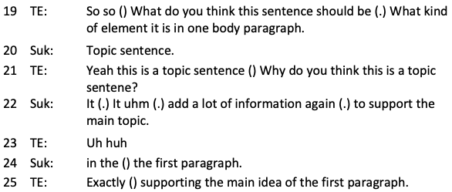

In Except 3, Sukarno and I were talking about the first sentence of one body paragraph. I was trying to elicit an explanation regarding the topic sentence. In lines 22 to 24, Sukarno explained that the topic sentence provides more detailed information to support the main idea in the introduction paragraph. Sukarno’s comments suggest that Sukarno understood the topic sentence as a concept with regard to the organization of the FPE. Moreover, based on the examination of his writing assignments, Sukarno’s thesis statements and topic sentences improved across the drafts, suggesting that he was internalizing the SCOBA.

Excerpt 4

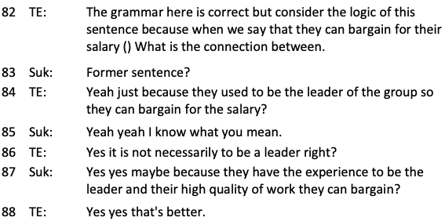

However, Sukarno struggled with applying the concept of Logos in his essay (see Excerpt 4). In turn 82, I pointed out the logical fallacy in Sukarno’s writing. At the end of the turn, I paused, and Sukarno immediately picked up the turn and referred to the previous sentence in his writing to check whether we were still on the same page. Then, in turn 85, he responded, “Yeah, I know what you mean,” to my clarification request in turn 84, demonstrating his possible realization of the logical fallacy. The prompt response to the instructor’s mediation also suggests his conceptual understanding of Logos instantiated in his writing. Though Sukarno was not able to independently identify the weaknesses of Logos in his essay, after noticing the problem, he was able to resolve it. Sukarno proposed alternative evidence that leaders’ “high quality of work” enables them to negotiate the salary with employers in turn 87. Sukarno’s solution showed that he was able to notice the logical weakness and make improvements to the Logos of his argument with the instructor’s mediation.
In sum, the two students presented in this section demonstrated that they understood the target concepts and consciously capitalized on the SCOBAs to guide their analysis, planning, and writing of the FPE. However, they still encountered difficulties enacting rhetorical skills, such as Logos, in their writing due to the developing linguistic repertoire. The gap between students’ comprehension of the concepts and their actual writing performance demonstrates that they were still internalizing the concepts, even if they had developed certain levels of conceptual understanding.

DISCUSSION & CONCLUSION

The present study examined an alternative approach to teaching the FPE by implementing C-BLI in a 12-week-long TOEFL independent writing course. The investigation sought to answer two research questions: 1) Does the C-BLI approach to teaching rhetorical skills in the five-paragraph essay change the writing quality of the FPE? 2) How do the SCOBAs influence the conceptual development of ESL writers?
In response to the first research question, the students applied a number of target concepts (modes of persuasion, regressive mode of reasoning, and organization of the FPE) to create arguments and organize their essays. In particular, the students made observable progress in generating effective topic sentences, thesis statements, and thesis restatements and utilizing rhetorical strategies of Ethos in their essays. Compared to the first draft, learners presented more logical and credible arguments in their second and third drafts. The improvement in the later drafts corroborated the effectiveness of the C-BLI intervention. However, students improved more from writing assignments 1 to 2 than assignments 2 to 3. Most of the focal discourse features (e.g., Topic Sentence, Evidence of Ethos, and Evidence of Logos) did not improve from drafts 2 to 3. In addition, the learners made less obvious progress on Pathos and Logos in their FPE writing. They either did not incorporate the rhetorical strategy in their writing (e.g., no evidence of Pathos was found in five out of six students’ final essays) or performed the rhetorical strategy ineffectively (e.g., the logical fallacies that were found in Qin and Sukarno’s final essays). Combining the qualitative analysis of learners’ responses to the written sample analysis essays and the final tutoring sessions, the limited quality improvement seems to be connected to the learners’ developing linguistic repertoires and familiarity with the writing contexts that matter in the internalization of the target concepts.
As L2 writing researchers have contended, L2 writing is a complex socially constructed activity that requires sophisticated linguistic knowledge, metacognitive strategies (e.g., planning, monitoring), sociocultural awareness (e.g., awareness of genre expectations), and a high level of motivation and self-efficacy (de Larios et al., 2016). The limited improvement in the final essay, especially on Pathos and Logos, suggested that the learners did not develop sufficient linguistic and cultural knowledge to enact the conceptual understanding of the rhetorical and organizational strategies developed in the process of discussing and using the SCOBAs. For example, in the final tutoring sessions, Tianyun pointed out how the limited linguistic repertoires constrain her ability to keep the story-telling concise and purposeful. Tianyun said she knew that her storytelling was wordy and a little bit off-topic, but she did not know how to revise it. In this sense, a C-BLI for L2 writing instruction, in addition to well-designed SCOBAs and appropriate mediation (e.g., mediating artifacts, meaningful interactions with the teacher and peers, and purposeful practical activities), might concurrently need to address the diverse linguistic backgrounds and specific language needs of students to help them apply and internalize the conceptual knowledge they are developing. As van Compernolle (2012) argued, the relationship between conceptual knowledge and performance is dialectical. They influence each other in development, and conceptual knowledge may accelerate performance but cannot fully control it.
To address the second research question, the student-annotated SCOBAs and student responses in tutoring sessions illuminated the students’ conceptual development of the rhetorical skills of the five-paragraph essay. Qin demonstrated an understanding of FPE structure and argumentation elements but struggled with organizing arguments logically. Her student-annotated SCOBA showed creativity in using SCOBAs as tools for internalizing concepts, indicating an understanding of modes of persuasion and their interrelationships. Sukarno made significant progress in the writing quality of his FPEs. His student-annotated SCOBA, while less creative and abstract than Qin's, indicated an emerging understanding of essay structure and the integration of rhetorical skills. Both students showed conceptual understanding of specific SCOBAs but faced challenges applying rhetorical skills like Logos and Pathos in their writings. Qin’s and Sukarno’s student-annotated SCOBAs and reflections in tutoring sessions also showed idiosyncratic trajectories of each student's concept development. Their creative usage of the SCOBAs demonstrated that productive materialization and instruction of SCOBAs is not accomplished through a unidirectional transmission of knowledge from the instructor to students, but through a dialectical approach where the instructor strives to not only facilitate students’ understanding but also encourage them to exert their agency throughout the learning and teaching process (Lantolf & Poehner, 2014). Thus, the student-annotated SCOBAs are not merely a strategy to stimulate verbalization and facilitate the internalization of the concepts. An instructor can enhance their instructional approach by adopting ideas from student-annotated SCOBAs to improve the SCOBA design. In fact, I used Qin’s student-annotated SCOBA to modify the original SCOBA for Modes of Persuasion and presented it in class in the tenth week of the intervention. The participating students found that the modified version made more sense than the original one.
Therefore, one key implication of this study is the recognition that while the design of SCOBAs should be established with rigor and based on scientific evidence to ensure a complete and systematic representation of concepts, the dynamic nature of C-BLI implementation also requires, and indeed benefits from, thoughtful adaptations. These adaptations to the SCOBAs are not arbitrary but are responsive to students' cognitive development, as evidenced by their engagement with mediational tools and the verbalization of conceptual understanding. While Materialization, Verbalization, and Internalization (Arievitch & Haenen, 2005) form the procedural core, they should not be perceived as static; instead, they may adapt to the context and learners’ evolving processes (Lantolf et al., 2021). Importantly, modifying SCOBAs is a deliberate process that happens through the collaborative effort of teachers and students, ensuring that the materialization of scientific concepts reflects the learners' current understanding while striving for accuracy and completeness. As such, a collaborative revision of SCOBAs with multilingual learners or learners’ independent adaptations of SCOBAs (as shown in Qin and Sukarno’s annotated SCOBA) should be encouraged and mediated to facilitate their conceptual understanding of the target concepts.
In addition, based on the dialectical relationship between conceptual understanding and learners’ writing competence revealed in this study, I suggest a linguistically responsive approach to writing instruction that provides abundant linguistic support and acknowledges and leverages learners’ linguistic diversity. This study advocates for the pedagogical discussion that calls for renewed attention to language support in L2 writing and tutoring contexts for academic purposes, which are currently dominated by a philosophy that focuses on higher-order concerns (e.g., content, organization, purpose) over the lower-order concerns (various levels of language, mechanics, and punctuation) in L2 writing (Ferris & Eckstein, 2020; Liu & Harwood, 2022).
This study has a number of limitations. First, a small number of participants (six in total) in this study limits the generalizability of results to other ESL teaching contexts. It remains unknown whether the effectiveness of the C-BLI design can be replicated in a beginner-level or advanced-level TOEFL preparation course or other ESL writing courses for academic purposes. In addition, the comparison of observations in the pre-interviews and the final tutoring sessions cannot fully capture the complete trajectories of conceptual development. According to Vygotsky (1997), psychological development should be interpreted longitudinally by tracing its origin and genesis in intensive observations of learners’ speech and actions on a moment-by-moment basis. Therefore, investigating observations of learners’ verbalization in activities such as classroom discussion and freewriting think-aloud by a fine-grained qualitative analysis can identify and depict the critical moments in the learners’ emerging conceptual understanding and potential internalization. Future studies are suggested to observe and assess learners’ conceptual development and writing performance longitudinally within and beyond classroom contexts.
In conclusion, this study documents an initial study of applying C-BLI to the FPE instruction. It shows that teaching the rhetorical and organizational skills in the FPE, not merely as a formulaic template, can lead to higher-quality FPEs and awareness and conceptual understanding of persuasion and argumentation in English writing. The students in the study demonstrated their ability to agentively use and reflect on the SCOBAs as part of their cognitive development in analyzing and writing solid arguments. The positive influence of C-BLI indicates its potential to teach rhetorical and organizational techniques in other academic writing genres. The interdependent relationship between the learners’ conceptual understanding and linguistic repertoires also suggests further exploring better ways to balance the two aspects of academic writing in standardized test preparation and L2 writing teaching and tutoring contexts.

REFERENCES

Arievitch, I. M. and Haenen, J. P. P. (2005). Connecting sociocultural theory and educational practice: Gal’perin’s approach. Educational Psychologist, 40(3), 155–165. https://doi.org/10.1207/s15326985ep4003_2
Bacha, N. N. (2010). Teaching the academic argument in a university EFL environment. Journal of English for Academic Purposes, 9(3), 229-241. https://doi.org/10.1016/j.jeap.2010.05.001
Caplan, N. A., & Johns, A. M. (2019). Changing practices for the L2 writing classroom: Moving beyond the five-paragraph essay. University of Michigan Press. https://doi.org/10.3998/mpub.10000663
Connor, U. M., & Ene, E. (2019). Does Everyone Write the Five-Paragraph Essay? In Caplan, N. A., & Johns, A. M. (Eds.), Changing Practices for the L2 Writing Classroom: Moving Beyond the Five-Paragraph Essay (pp. 42-63). University of Michigan Press. https://doi.org/10.3998/mpub.10000663
Creswell, J. W., & Poth, C. N. (2016). Qualitative inquiry and research design: Choosing among five approaches. Thousand Oaks, CA: Sage.
Crowley, S., & Hawhee, D. (1999). Ancient rhetorics for contemporary students. Boston, MA: Pearson Education, Inc. https://doi.org/10.2307/358304
Crusan, D. & Ruecker, T. (2019). Standardized testing pressures and the temptation of the five-paragraph essay. In Caplan, N. A., & Johns, A. M. (Eds.), Changing Practices for the L2 Writing Classroom: Moving Beyond the Five-Paragraph Essay (pp. 201-220). University of Michigan Press. https://doi.org/10.3998/mpub.10000663
de Larios, J. R., Nicolás-Conesa, F., & Coyle, Y. (2016). Focus on writers: Processes and strategies. In Manchón R. M., & Matsuda P. K. (Eds). Handbook of second and foreign language writing (pp. 267-286). De Gruyter, Inc. https://doi.org/10.1515/9781614511335-015
Eckstein, G., Chariton, J., & McCollum, R. M. (2011). Multi-draft composing: An iterative model for academic argument writing. Journal of English for academic purposes, 10(3), 162-172. https://doi.org/10.1016/j.jeap.2011.05.004
Educational Testing Service. (2019). TOEFL iBT Independent writing rubrics. Retrieved March 22, 2020, from https://www.ets.org/s/toefl/pdf/toefl_writing_rubrics.pdf
Fernández, L., & Donato, R. (2020). Interacting with SCOBAs in a Genre-based Approach to Italian as FL. Language and Sociocultural Theory, 7(1), 33-59. https://doi.org/10.1558/lst.31180
Ferreira, M. M. (2005). A concept-based approach to writing instruction: From the abstract to the concrete performance. [Unpublished doctoral dissertation]. The Pennsylvania State University. https://etda.libraries.psu.edu/catalog/6699
Ferris, D., & Eckstein, G. (2020). Language matters: Examining the language-related needs and wants of writers in a first-year university writing course. Journal of Writing Research, 12(2), 321-364. https://doi.org/10.17239/jowr-2020.12.02.02
Ferris, D. R., & Hedgcock, J. (2013). Teaching L2 composition: Purpose, process, and practice. Routledge. https://doi.org/10.4324/9781410611505-12
Fogal, G. G. (2015). Pedagogical stylistics and concept-based instruction: An investigation into the development of voice in the academic writing of Japanese university students of English. [Unpublished doctoral dissertation]. University of Toronto (Canada). https://tspace.library.utoronto.ca/handle/1807/69299
Gal'perin, P. Y. (1989). Organization of mental activity and the effectiveness of learning. Soviet Psychology, 27(3), 65-82. https://doi.org/10.2753/rpo1061-0405270365
Gal'perin, P. I. (1992). Stage-by-stage formation as a method of psychological investigation. Journal of Russian & East European Psychology, 30(4), 60-80. https://doi.org/10.2753/rpo1061-0405300460
Gregory, A. E., & Lunn, P. (2012). A Concept-based Approach to the Subjunctive. Hispania, 95(2), 333-343. https://www.jstor.org/stable/23266216
Hadidi, A. (2021). Application of a SCOBA in Educational Praxis of L2 Written Argumentative Discourse. Language and Sociocultural Theory, 8(1), 68–96. https://doi.org/10.1558/lst.19037
Hyland, K., & Hyland, F. (2019). Feedback in second language writing: Contexts and issues. Cambridge University Press.
https://doi.org/10.1017/CBO9781139524742
Johnson, R. B., & Christensen, L. (2019). Educational research: Quantitative, qualitative, and mixed approaches. Sage publications. https://us.sagepub.com/en-us/nam/educational-research/book259335
Kim, J. (2013). Developing conceptual understanding of sarcasm in a second language through concept-based instruction. [Unpublished doctoral dissertation]. The Pennsylvania State University. https://etda.libraries.psu.edu/catalog/18649
Kim, Y., & Emeliyanova, L. (2021). The effects of written corrective feedback on the accuracy of L2 writing: Comparing collaborative and individual revision behavior. Language Teaching Research, 25(2), 234-255. https://doi.org/10.1177/1362168819831406
Kurtz, L.M. (2017). ‘I don’t know why. I just make comparisons.’: Concept-based instruction to promote development of a second legal languaculture in international LL.M. students. [Unpublished doctoral dissertation]. The Pennsylvania State University. https://etda.libraries.psu.edu/catalog/14767lmk299
Lantolf, J. P. (2011). The sociocultural approach to second language acquisition: Sociocultural theory, second language acquisition, and artificial L2 development. In D. Atkinson (Eds.), Alternative approaches to second language acquisition, (1st ed., pp. 24-47) Abingdon: Routledge. https://www.routledge.com/Alternative-Approaches-to-Second-Language-Acquisition/Atkinson/p/book/9780415549257
Lantolf, J. P., Xi, J., & Minakova, V. (2021). Sociocultural theory and concept-based language instruction. Language Teaching, 54(3), 327-342. https://doi.org/10.1017/s0261444820000348
Lantolf, J. P., Poehner, M. E., & Thorne, S. L. (2020). Sociocultural theory and L2 development. In VanPatten, B., Keating G. D., & Wulff, S. (Eds.) Theories in second language acquisition (pp. 223-247). Routledge.
Lantolf, J. P., & Tsai, M.-H. (2018). Chapter 2. L2 developmental education and systemic theoretical instruction. Usage-Inspired L2 Instruction, 29–53. Portico. https://doi.org/10.1075/lllt.49.02lan
Lantolf, J. P., & Poehner, M. E. (2014). Sociocultural theory and the pedagogical imperative in L2 education: Vygotskian praxis and the research/practice divide. Routledge. https://doi.org/10.4324/9780203813850-2
Lantolf, J. P., & Thorne, S.L, (2006). Sociocultural Theory and the genesis of second language development. Oxford: Oxford University Press. https://doi.org/10.1093/applin/amm027
Liu, C., & Harwood, N. (2022). Understandings of the role of the one-to-one writing tutor in a UK university writing centre: Multiple perspectives. Written Communication, 39(2), 228-275. https://doi.org/10.1177/07410883211069057
Ma, J., & Cheng, L. (2015). Chinese Students’ Perceptions of the Value of Test Preparation Courses for the TOEFL iBT: Merit, Worth, and Significance. TESL Canada Journal, 33(1), 58-79. https://doi.org/10.18806/tesl.v33i1.1227
Ngo, X. M. (2018). A sociocultural perspective on second language writing teacher cognition: A Vietnamese teacher's narrative. System, 78, 79-90. https://doi.org/10.1016/j.system.2018.08.002
Negueruela, E. (2003). A sociocultural approach to teaching and researching second languages: Systematic-theoretical instruction and second language development. [Unpublished doctoral dissertation]. The Pennsylvania State University. https://www.proquest.com/docview/288332887?pq-origsite=gscholar&fromopenview=true&sourcetype=Dissertations%20&%20Theses
Nicholas, A. (2015). A concept-based approach to teaching speech acts in the EFL classroom. ELT Journal 69(4), 383-394. https://doi.org/10.1093/elt/ccv034
Nunes, M. J. (2013). The five-paragraph essay: Its evolution and roots in theme-writing. Rhetoric Review, 32(3), 295-313. https://doi.org/10.1080/07350198.2013.797877
Pham, T. N., & Bui, L. T. P. (2019). An exploration of students’ voices on the English graduation benchmark policy across Northern, Central and Southern Vietnam. Language Testing in Asia, 9(1), 1-20. https://doi.org/10.1186/s40468-019-0091-x
Qin, L., Ouyang, X., & Ren, W. (2023). Decoding EFL learners’ internalization of English modal verbs in concept‐based language instruction: Integrating SCOBAs with languaging. The Modern Language Journal, 107(S1), 24-45. https://doi.org/10.1111/modl.12821
Riazi, A. M. (2016). The Routledge encyclopedia of research methods in applied linguistics. Routledge. https://doi.org/10.4324/9781315656762
Richards, J. (2007). Rhetoric. Routledge. https://doi.org/10.4324/9780203932759
Schlesinger, I. M., Keren-Portnoy, T., & Parush, T. (2001). Structure of Arguments. John Benjamins Publishing Company, ProQuest Ebook Central. https://www.torrossa.com/en/resources/an/5016118
Seo, B. I. (2007). Defending the five-paragraph essay. English Journal, 97(2), 15. https://www.proquest.com/openview/0e28e912093141f316e698826bed9005/1?pq-origsite=gscholar&cbl=42045
Smagorinsky, P. (2018). Deconflating the ZPD and instructional scaffolding: Retranslating and reconceiving the zone of proximal development as the zone of next development. Learning, Culture and Social Interaction, 16, 70–75. https://doi.org/10.1016/j.lcsi.2017.10.009
Smart, J. (2019). Affordances of TOEFL writing tasks beyond university admissions. Assessing Writing, 41, 80-83. https://doi.org/10.1016/j.asw.2019.06.006
Tardy, C.M. (2019). Is the five-paragraph essay a genre? In Caplan, N. A., & Johns, A. M. (Eds.), Changing Practices for the L2 Writing Classroom: Moving Beyond the Five-Paragraph Essay (pp. 24-41). University of Michigan Press.
Thorne, S. L., Reinhardt, J., & Golombek, P. (2008). Mediation as Objectification in the Development of Professional Discourse: A Corpus-Informed Curricular Innovation. In J. P. Lantolf & M. Poehner (eds.), Sociocultural Theory and the Teaching of Second Languages (pp. 256-284). London: Equinox. https://www.equinoxpub.com/home/sociocultural-theory-teaching-second-languages/
Toulmin, S. E. (2003). The uses of argument. Cambridge university press.
https://doi.org/10.1017/CBO9780511840005
Warner, J. (2018). Why they can't write: Killing the five-paragraph essay and other necessities. JHU Press. https://www.press.jhu.edu/books/title/12025/why-they-cant-write
Wang, T., & He, Y. (2021). Teaching Domain-Based Figurative Expressions: Designing and Implementing CL-informed SCOBAs. Language and Sociocultural Theory, 8(1), 120-151. https://doi.org/10.1558/lst.19040
Wingate, U. (2012). ‘Argument!’ helping students understand what essay writing is about. Journal of English for academic purposes, 11(2), 145-154. https://doi.org/10.1016/j.jeap.2011.11.001
van Compernolle, A. R. (2012). Developing sociopragmatic capacity in a second language through concept-based instruction. [Unpublished doctoral dissertation.] The Pennsylvania State University. https://etda.libraries.psu.edu/catalog/13752
Yáñez Prieto, M. D. C. (2010). Authentic instruction in literary worlds: Learning the stylistics of concept-based grammar. Language and Literature, 19(1), 59-75. https://doi.org/10.1177/0963947009356723
Vygotsky, L. S. (1997). The collected works of LS Vygotsky: The history of the development of higher mental functions (Vol. 4). Springer Science & Business Media. https://doi.org/10.1007/978-1-4615-5939-9
Wesley, K. (2000). The ill effects of the five paragraph theme. The English Journal, 90(1), 57-60. https://doi.org/10.58680/ej2000659
West, G. B., & Thiruchelvam, B. (2018). Impacts and responses to a university high-stakes writing test. In Ruecker, T. C., & Crusan (Eds.), The Politics of English Second Language Writing Assessment in Global Contexts (pp.
138-150). Routledge. https://doi.org/10.4324/9781315106069

Appendix A
Pre-Interview Protocol
Welcome, and thank you so much for agreeing to participate in this interview. Today, we’ll be discussing your thoughts on English writing, focusing particularly on your experiences with and attitudes toward the Five-Paragraph Essay.
The purpose of this interview is not to evaluate your writing skills, but rather to gather your personal reflections on the writing process, your understanding of essay structures, and the ways in which you approach this common format. There are no right or wrong answers here. I’m looking for honest, reflective thoughts that will help me explore the diverse experiences of essay writers. Your responses will contribute to a broader understanding of writing instruction and practice. Please feel comfortable to share openly, and if at any point you have questions or need clarification, don't hesitate to ask. Let’s get started!
Self-evaluation of English writing competence
  - Can you describe your experience with writing essays? What aspects do you find most challenging or rewarding?
  - How do you assess your own writing skills, and what criteria do you use to determine if an essay you've written is successful?
Understanding of the Five-Paragraph Essay
  - What is your understanding of the Five-Paragraph Essay structure? Can you outline the main components?
  - In what ways do you think the Five-Paragraph Essay format aids in organizing your thoughts? How do you like the format? Do you find it helpful for your writing？
Attitudes Towards the Five-Paragraph Essay
  - How do you like the format? Do you find it helpful for your writing？
  - Do you believe that the Five-Paragraph Essay format prepares you well for other forms of writing? Why or why not? Have you ever felt restricted by the Five-Paragraph Essay structure?

Appendix B

Prompts for the Three Writing Assignments

Writing Assignment 1: Movies are worth watching only if they teach something in real life

Writing Assignment 2: Do you agree or disagree with the following statement? All students should be required to study art and music in secondary school. Use specific reasons to support your answer.

Writing Assignment 3: Choose one of the following transportation vehicles and explain why you think it has changed people's lives.
- Automobiles
- bicycles
- Airplanes

Appendix C

Trait-Based Rubric For The Five-Paragraph Essay

 | 3 | 2 | 1 | 0
Organization | The progression and unity of the overall organization is logically presented. The coherence is easily identified. | The progression and unity of the overall organization is logically presented. Transition words are used but sometimes not appropriate. | Inadequate organization of the essay. Transition words are rarely used. | Severe disorganization. No use of transition words.
Thesis statement | The thesis statement is well-written, clear and concise, states the author's major argument on the prompt. The reader knows exactly what the essay will be discussed. | The statement clearly describes the reader's major argument. The statement does not clearly indicate how the essay will be discussed. | The statement merely gives an answer to the prompt. The author's idea is not stated at all. | The statement does not give information about what will be discussed or the author's opinion on the prompt.
Topic sentence | The topic sentences are well-written, clear and concise, states the author's minor points of each body paragraph. The reader knows exactly what the paragraph will be discussed. | The topic sentences clearly describe the reader's minor points of body paragraphs. The statement does not clearly indicate how the essay will be discussed. | The statement merely gives an answer to the prompt. The author's idea is not stated at all. | The topic sentences do not give information about what will be discussed or the author's opinion of the body paragraphs.
Evidence of Ethos | The credible and persuasive evidence such as personal experiences, facts, statistics, and research, etc. are detailed and well-written with minor grammatical errors, syntactic variety, and proper word choices. | The evidence is clearly and detailedly presented, but insufficient to support the ideas or opinions of the writer. | The personal stories, facts, statistics, or research, etc. are offered, but fails to make sense to readers. Or, the evidence is not credible or persuasive. | No credible evidence to support opinions.
Evidence of Pathos | The appealing and eye-catching evidence such as personal stories, anecdotes and uses of figurative language, etc. are detailed and well-written with minor grammatical errors, syntactic variety, and proper word choices. | The appealing and eye-catching evidence is presented but not expressed in an effective way. | The evidence of pathos fails to appeal to readers, or hard to understand. | No evidence of pathos.
Evidence of Logos | The arguments are clearly, persuasively and logically expressed. The evidence tightly connects to and perfectly supports the minor point of each body paragraph. | The arguments are clearly expressed. The connection between the opinions and evidence is easy to be recognized. The evidence partially supports the minor point of each body paragraph. | There are arguments and evidence but not connected very well to each other. The evidence does not support the minor point of each body paragraph. | No arguments or evidence found in the essay.
Restatement of thesis | The thesis restatement is well-written, clear and concise, and precisely paraphrases the main points of the essay and the main supportive reasons in the essay. | The thesis restatement is clear and concise, but merely copies the main points of the essay and the main supportive reasons with the same words. | The statement merely repeats the attitudes of the writer without reiterating the main reasons offered in the essay. | There is no thesis restatement in the conclusion paragraph.

Appendix D
Transcription Conventions
. full stop marks falling intonation
, slightly rising intonation
? raised intonation (not necessarily a question)
(XXX) unable to transcribe
((comment)) double parentheses contain transcriber’s comments or descriptions
- abrupt cutoff with level pitch
underline underlining indicates stress through pitch or amplitude

