TEACHERS’ FORUM

Reframing the Language Classroom through Discovery-Based Frameworks

RABINDRA HAYASHI

University of California, Berkeley

E-mail: rhayashi@berkeley.edu

MINSOOK KIM

University of California, Berkeley

E-mail: minskim@berkeley.edu

The past four years have seen radical upheaval in language pedagogy due to restrictions imposed by the outbreak of COVID-19 and the advent of generative AI. Increasing evidence that remote learning options can be just as effective as in-person ones has additionally forced educators to re-evaluate and re-articulate the methods and purpose of in-person classroom instruction. This report suggests that a discovery-based framework can help transform classrooms into spaces in which students go beyond simple skill acquisition to become a community of learners through an increased focus on first-hand experiences. These experiences furthermore promote curiosity and ownership over projects in the target language, extending learning beyond the confines of the classroom. With discussion of a successful example conducted in Korean language classes, the article explores how discovery-based frameworks reinforce acquisition of the target language as a tool for cultivating students’ relationships with a broader community of speakers in a personally meaningful way. This report therefore underscores the efficacy, ethicality, and endurance of discovery-based frameworks in classroom instruction as a holistic pedagogical approach.
_______________

INTRODUCTION¹

The abrupt transition to remote teaching during the COVID-19 pandemic was both difficult and disruptive to language educators. The unprecedented transformations in the transition led many educators to reevaluate fundamental principles of teaching and learning, including the value of in-person classroom teaching. Contrary to popular belief, much research suggests that the efficacy of online language learning is not inferior to in-person learning in any statistically significant manner (Adair-Hauck, Willingham-McLain, & Earnest-Youngs, 1999; Chenoweth & Murday, 2003; Chenoweth et al., 2006; Scida & Saury, 2006; Blake & Delforge 2007; Blake, Wilson, Cetto, & Pardo-Ballester, 2008; Senior 2010, Moneypenny & Aldrich, 2016). Moreover, the recent emergence of generative Artificial Intelligence, interpretation apps, and ubiquitous individualized language learning platforms have placed world language education under even greater strain. While these changes are challenging, they also provide opportunities for educators to re-articulate the value of the in-person classroom as a community with unique learning opportunities.

¹ Part of this report was initially drafted by Author 1 as part of his pedagogical training as a graduate student and was its own discovery-based learning project in Author 2’s class. All future iterations were co-written.

As online spaces may prove effective for skill-based learning, we ask what sorts of transformations for in-person classrooms might offer students entirely distinct learning opportunities, thus supplementing rather than competing with the online learning domain.

Background

As we returned to the classroom after the pandemic in the Fall of 2021, Author 2 grappled with this question: how can we make the transition from online to in-person more than just a return, but an opportunity to address the needs of students whose education was impacted by the pandemic? Remote learning during the pandemic revealed a need for a sense of belonging, collaborative learning, firsthand experience, socialization, and face-to-face engagement, all of which need to be addressed in the post-pandemic classroom.
We believe that we should optimize the benefits of in-person learning while integrating the merits of online learning. As hybrid modes of instruction gain more attention as increasingly viable new directions in education, it is essential to design curriculums by discerning what computers do better than human instructors, and vice versa. We are in an era where online learning is increasingly prevalent in the realm of education and thus the role of classroom teaching needs to be redefined to adequately meet the needs of students—specifically, that which necessitates in-person interaction.
In the fall of 2021, Author 2 was awarded a three-year fellowship through the Berkeley Discovery program at UC Berkeley. The phrase “Transforming your skill-based course into a discovery-based course” in the fellowship application caught Author 2’s attention. The goal of the Discovery Innovation program was to create undergraduate experiences that support students’ creative exploration and self-actualization through inquiry-driven learning. Students would apply their knowledge and passion during personalized discovery experiences.
Before joining the Discovery Program, Author 2’s courses relied heavily on secondhand experiences including readings, films, and media. The class format was student-led and discussion-based. However, it lacked firsthand experiences that could ignite students’ curiosity and turn them into researchers who work with primary sources and engage with the community beyond the classroom. Therefore, a major change in the new curriculum was the incorporation of firsthand experiences to stimulate students’ intellectual curiosity and empower them on their journey of discovery. To achieve these goals, Author 2 introduced field trips with specific objectives: 1) to create a sense of belonging within the class, campus, and community through shared experiences and 2) to transform book knowledge into lived knowledge through projects inspired by field trips. These trips, combined with class materials, were intended to provide a foundation for students to engage in discovery learning, encouraging them to inquire, research, and produce new knowledge.

Rationale

Drawing from the principles of the constructive theory of learning outlined by Jean Piaget, Jerome Bruner, and Lev Vygotsky, discovery-based learning within language pedagogy encourages student inquiry and gives space for students to construct their understandings of language through practice (Reagan, 1999). At its core, constructivist education favors an approach that centers an individualized student’s long-term knowledge retention through experiential learning activities designed to foster critical thinking skills, problem-solving capacities, and teamwork—all while bolstering motivation by allowing the pursuit of topics which interest students (Juvova et al., 2015). Rather than thinking of the classroom as a space through which knowledge flows unilaterally from the instructor as in traditional guided pedagogical approaches, discovery-based learning invites students to be both collaborators and researchers by asking them to pursue interests invoked by instructor-provided sources (Juvova et al., 2015; Reagan, 1999). In its original conception, discovery-based learning might be understood as a series of puzzle pieces for students to put together—one whose full shape is prepared in advance by the instructor. Our theory of discovery-based learning, however, is further inspired by Berkeley’s framework of discovery which imagines learning as an open-ended process co-produced by the instructor and the student as described on Berkeley’s website (About the Initiative). Thus, students are asked to wrestle with texts and topics within a community of inquisitive scholars in order to pursue projects they find meaningful, thereby encouraging identification and, consequently, knowledge retention (Hasenova, 2015). In this context, the process of knowledge construction extends beyond guiding students to the right answers to instead help them ask productive questions that produce new knowledge for their classmates—thereby transforming research into its own form of pedagogy. This sort of engagement empowers students to reach beyond the classroom, encouraging wider community engagement which persists long after the formal class has ended. At the university level, discovery-based learning imagines the classroom as a working lab where students share their findings with a cohort of supportive scholars to foster some of the most powerful pillars of constructivist education. This should not be mistaken as a partisan attempt to excise traditional guided learning; the courses we detail below contain some elements of guided learning. Different tasks require different methodologies, and mixing inquiry-based lessons with more traditional tactics shows promising effectivity (Dellatoia et al., 2020). However, interaction and communication are key to language acquisition, and inquiry-based learning has been demonstrated to show greater long-term cognitive and metacognitive effects for students (Lee, 2014). Thus, the long-term benefits of including constructivist approaches offer compelling reasons for pursuit beyond differentiating the collective in-person classroom from the individual guided lessons common in online instruction.
To us, the premise of discovery-based learning is to encourage student autonomy, with the instructor assuming the role of facilitator. Students consult with the instructor on the problems they face throughout their projects to jointly produce solutions, a process that simultaneously allows instructors to monitor the progress of the individual student projects. In this role, Author 2 additionally employed Crook’s nine principles of language critical pedagogy (1978, 1981, 1982) to more fully realize the type of guidance given. The roles of instructors and students in Critical Language Pedagogy (CLP) align well with discovery-framework’s emphasis on learner autonomy and are summarized below:

- the purpose of education is to develop critical thinking by presenting [a] situation to [students] as a problem so that they can perceive, reflect and act on it
- the content of the curriculum derives from the life situation of the learners as expressed in the themes of their reality
- the learners produce their own learning materials
- the task of planning is first to organize generative themes and second to organize subject matter as it relates to those themes
- the teacher participates as a learner among learners
- the teacher contributes his/her ideas, experiences, opinions, and perceptions to the dialogical process [of the course]
- the teacher’s function is one of posing problems
- the students possess the right to and power of decision-making. (Crooks, 2012, p. 3)

In this capacity, the role of the teacher is described as one who poses problems for students to resolve. However, the instructor and students jointly identified problems or research topics—thereby combining discovery-based approaches with Crooks’s CLP principles. This gives students numerous opportunities to improve the affective and volitional factors that may impact language pedagogy (Hasenova 2015). Importantly, in both discovery-based frameworks and CLP, instructors invite students to be researchers and collaborators in the class as their projects and inquiries become components of the course they are taking, but CLP crucially posits that the materials students produce also add educative value for other students. In our case, this was accomplished through the sharing of student projects both within cohorts and across them. Paired with prescient social topics, this furthermore encouraged students to ameliorate social injustices by motivating them to approach otherwise abstract topics as tangible problems to be resolved through cooperative teamwork. We detail several successful implementations of discovery-based learning in Elementary and Advanced Korean courses.

IMPLEMENTATION

Critical Action Projects in Advanced Korean

The principles of discovery-based curriculums were integrated into teaching an advanced-level content-based Korean language course, K111: Korean History and Culture. The focus of this course was on historical shifts across the 20th and early 21st centuries in South Korea. More specifically, there were four lessons, Liberation and divided Korea (1945-1960), Regime of Chung-hee Park (1961-1979), Democratization (1980-1996), and Korean society after IMF (1997-2021). These lessons were adapted based on the main reading from the Korean-language textbook, Korean Modern History Read through Debates, by Hogi Kim and Taegyn Park (2019). Most students who take this course are Korean heritage students who attended elementary school in Korea and immigrated to the U.S. These students enroll in this course hoping to improve their knowledge of Korean history and enhance their Korean language skills beyond the elementary level. In this particular semester, there were two non-Korean Ph.D. students whose dissertation topics were Korea-related. The class retained the traditional methods of reading history textbooks, presenting on specific issues, and watching topical films. Additionally, online sessions called “media days” were held where relevant media clips from the past few years were selected by the instructor to emphasize how historical topics could be better understood as ongoing issues. The course also included two field trips to local sites related to topics covered in class. Both media days and field trips were designed to encourage curiosity in students and empower them to form their own opinions based on their contemporary experiences. These ideas were reflected in their final projects, which could be analytical essays on historical topics or ‘Critical Action’ projects.
The key to ‘Critical Action’ projects was engagement with both topics covered in class and wider linguistic communities. Students were encouraged to learn from history and culture in class to understand the types of actions that individuals and groups have used to promote social change. Thus, students were encouraged from the outset of their projects to understand themselves as undertaking direct attempts to ameliorate injustices around them related to course topics. The course’s emphasis on ongoing transformations in Korean history meant that there was no shortage of ways students could approach the topic—even in the United States. Students were therefore forced to think critically about the semester’s content to help them better articulate to a wider community both the need for intervention and the tactics through which they sought change. Rather than posing historical controversies as academic subjects to be memorized for accreditation, students actively reconsidered the social structures in their lives as parts of these ongoing historical narratives that they, too, played a part in. The forms these projects took were highly varied, and some examples include petitions to change the name of the university library’s Korean collection from a Japanese one to a Korean one; investigating and publicizing offensive iconography near local memorials in honor of “comfort women” to both campus media and Korean newspapers; petitions to remove this offensive iconography; publicizing the social changes made by students in the course; and informing the student body about “comfort women” through publicity campaigns which mimicked job listings.
Students were divided into groups of three to four and started their final projects early in the semester. The course was a total of 16 weeks with 15 weeks of instruction, and groups began forming after the field trips in week 5. The Critical Action projects had two separate submission requirements: a project proposal due in week 8 and a project report due in week 16. The project proposal included a detailed timeline, project goals, and rationale for the topic selection. The instructor then provided feedback to each group. Students also had the opportunity to share their project ideas in the classroom to receive suggestions and comments from their classmates. This sharing time transformed the classroom space into a laboratory for thinking through potential critical action in the linguistic community. The final report detailed the process undertaken by students throughout the semester and contained reflections by each group member articulating what they learned through their critical actions as well as engaging with potential critiques of their work. While the critical actions themselves might have been conducted in multiple languages, all proposals, reports, meetings, and classroom interactions were conducted in Korean. This approach not only made Critical Action projects manageable but also gave students experience in collaborative group work as well as in identifying and solving problems through the target language.

Fall 2022: A Red Circle at the Memorial

In Fall 2022, the class of K111 took a field trip to the Column of Strength memorial statue in San Francisco, California. The statue, erected to memorialize the victims of sexual slavery or “comfort women” who suffered at the hands of Imperial Japan, is located just outside of San Francisco’s Chinatown in a park overlooking a busy intersection on a hill (Figure 1). Surrounded by financial institutions, art universities, and small businesses, the memorial is a powerful public statement of presence and solidarity.

Figure 1
San Francisco “Comfort Women” Column of Strength Memorial (Angle 1); taken October 2023 by Author 1

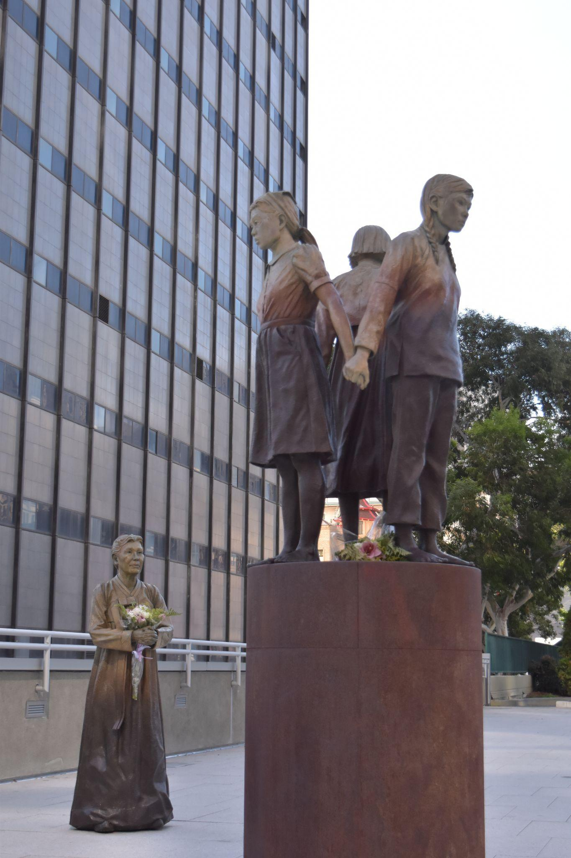

Yet students noticed an intrusive design on a building just across the street: a black square with a large red circle in its center, evoking Japan’s rising sun (Figure 2).

Figure 2
San Francisco “Comfort Women” Column of Strength Memorial (Angle 2); taken October 2021by Author 2.

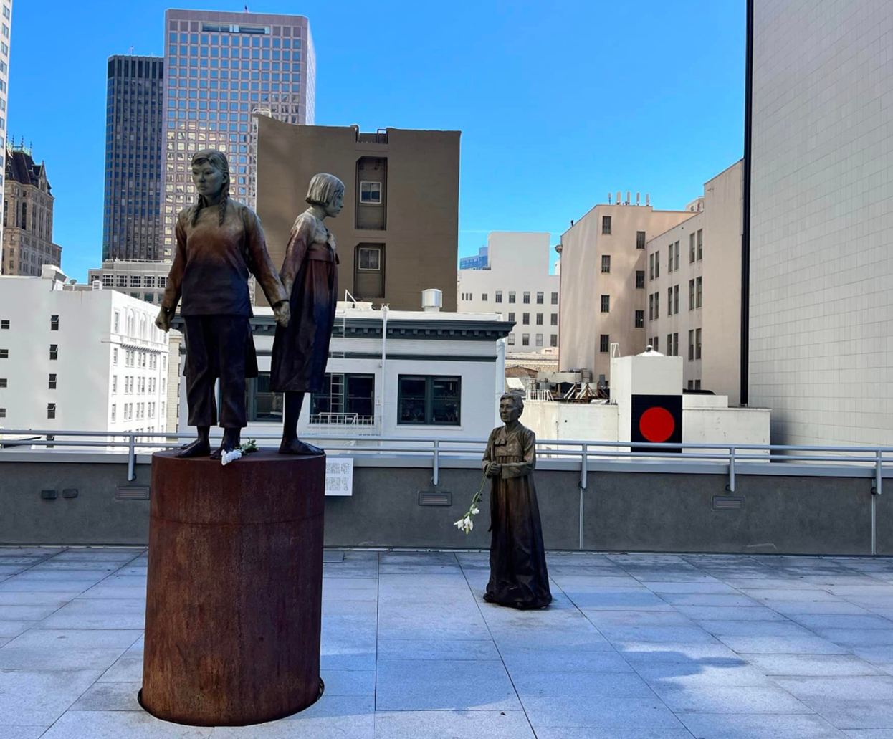

Without purporting deliberate malice, the instructor encouraged interested students to seek more information about the juxtaposed red circle as part of their final critical action project. Multiple groups of three turned in project proposals (written in Korean) for a multi-lingual pursuit to gain more information and, hopefully, have the red circle removed. While different groups adopted different strategies, the group we focus on engaged in a concerted fact-finding effort and local pressure campaign to have the symbol removed. After meeting with the instructor, three goals were jointly specified: raising awareness among students supportive of change, determining the affiliation of the building with the red circle, and contacting those who might be able to exert pressure toward its removal.
As part of building popular support, the group began with a social media campaign on KakaoTalk and Instagram (Appendix A). A short introductory post explained the campaign and its relation to the class before asking users to complete a survey designed by the students. The survey (written in both Korean and English) was a total of three pages. The first included the historical background of “comfort women” generally, which was accompanied by the second page’s brief history of the San Francisco statue specifically. The end of the second page featured a photo taken by the students of the memorial juxtaposed with the red circle and asked respondents to identify what the red circle represented. Finally, the last page of the survey asked for students to support the removal of the circle from the adjacent building by signing an online petition. While students had only expected 50 responses, they totaled 119 responses. In analyzing the survey results, the students noted that fewer than 7% of respondents called the design a “red circle,” “sun,” or “red circle with a black background,” with nearly all other responses calling it a Japanese flag. Responding to comments garnered from the survey, the students noted in their final report that respondents argued that even if similarities had been coincidental, its placement was insensitive:

It could be argued that the mural that looks like a Japanese flag is a mere coincidence. However, even if this juxtaposition is a coincidence, under no circumstances should the Statue of Peace be compared next to a symbol that could draw false assumptions from the unknowing viewers of the statue. For the case in which the Japanese flag was placed intentionally, it is unforgivable to tarnish a symbol that honors an unjustly oppressed community, by the very symbol that oppressed the community. Therefore, it is only right to remove the mural and allow the audience to view the Statue of Peace as it is, regardless of the intentions behind the mural. (Survey Respondent)

Motivated by this support, students proceeded to identify the building's owner. This was done through a combination of photo evidence and Google Maps, leading students to identify it as the Academy of Art University. Further investigation demonstrated that the red circle was likely the institution’s logo missing its final stylized “A” in its center. Armed with this knowledge, students proceeded to contact the university as well as the Korean consulate in San Francisco. Writing in English to the university and Korean to the consulate, the students presented a case for the logo’s removal which cited the historical context, survey responses, and support they had received. While the campaign led to no tangible results during the instruction period, the group did receive an apologetic response from the Academy of Art University’s chief of staff after the semester ended. The note specified that the remainder of the paint job would be completed at its earliest convenience and that they had not known about the memorial nor its historical significance.
While students were thrilled, the timing of the response meant that students had written their final reports before any indication of resolution. Despite lacking any tangible results from their campaign, students reported in their final project that they nonetheless felt empowered by their choices and more connected to a wider Korean-language community. One student noted in her language final reflection that it was the “most meaningful project she had ever done” and that conducting social media campaigns had connected her to a community of Korean speakers in the United States who supported her actions at other universities. Additionally, she had even received guidance from a prominent historian. Another student noted feeling empowered to resolve historical issues based on his efforts on the project, noting that even a little effort could have lasting impacts. The students also noted that the materials they produced helped educate non-Koreans about historical injustices related to Japanese colonialism and sexual slavery, thereby transforming students into teachers as well. The project, combined with the materials students produced, would end up being relevant for the next cohort of students who visited the memorial.

Fall 2023: Vanished Red Circle

The following year, students were briefed about the previous projects conducted by their peers before the field trip to the memorial. Students were interested in confirming the logo’s completion. However, during the field trip, it became evident that the logo had not been finished but instead removed entirely (Figure 3). Many students were inspired by the change; what might have otherwise been a mundane paint job had been transformed into a symbol of enduring commitment to a Korean language community that memorialized historical traumas.

Figure 3
San Francisco “Comfort Women” Column of Strength Memorial, taken October 2023 by Author 2

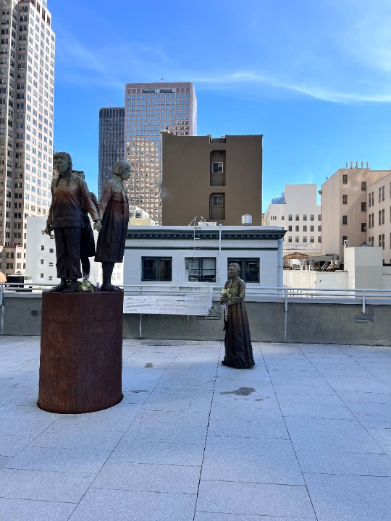
Since there was no communication between the Academy of Art University and the previous cohort of students outside of the apologetic note, students were left perplexed by the sudden change in direction. Subsequently, a group of students from this second cohort embarked on a new project with three objectives: 1) expressing gratitude to the Academy of Art University, 2) investigating the reasons behind the decision to erase the logo rather than complete it, and 3) promoting the success of the previous project.
While the group attempted to expand upon the project from the cohort before them, they found that the former chief of staff was no longer listed on the Academy of Art’s webpage and were therefore unable to determine the motivations for removing the logo. Nonetheless, they found alternative means of using the previous cohort’s work in productive ways. They publicized the success of the previous student project by writing and creating news videos in both English and Korean to promote the case, even going so far as to get an article published in a local newspaper. The students even contacted the Comfort Women Justice Coalition, the original organization which erected the statue. They informed students that they had always disliked the red circle and were very pleased with the students’ efforts. In their final reports, students noted the difficulty in contacting media and getting their articles published but nonetheless recognized the importance of publicizing the success of the student project and expressed continued interest in engaging in social justice.
Although this report focuses on an exemplary case in an upper-level course, discovery-based learning can also be applied at the elementary level. Author provides two examples used in her elementary heritage and non-heritage courses.

CULTURE LESSONS IN ELEMENTARY KOREAN

In her elementary Korean courses, Author 2 utilized the inquiry-based discovery framework in teaching cultural lessons to restructure the elementary course into a more student-centered one promoting autonomy while maintaining students’ interest in learning Korean. Although traditional culture lessons are often marginalized in language classes, it has become imperative for Korean courses to integrate more culture lessons because many students take Korean courses to fulfill their interest in Korean culture, especially K-pop, TV shows, movies, K-beauty, and food. To note, there are separate courses for heritage and non-heritage students at the elementary levels at the institution. The following culture lesson is used for both heritage and non-heritage courses.
Before adopting the discovery framework, the culture lesson was delivered by an instructor, with few images or video clips to supplement a paragraph of factual information printed in English in the textbook. An inquiry-based discovery framework aims to encourage students to investigate cultural topics, providing opportunities for them to share their findings so that students might contribute to building collective knowledge as a cohort that includes the instructor. To accomplish this, Author 2 used a Discussion Board and an Asset Library in the Learning Management System (LMS). The process involved three steps: inquiry, research, and sharing. First, after reading cultural notes in the textbook, Author 2 prompted students to share one thought-provoking question that a cultural topic had sparked for them on the class’s Discussion Board (Appendix B). Once students posted their inquiries, they read their classmates’ questions as well and chose their two favorites by using the “like” button. They were then required to research their inquiries and post their findings using the Asset Library in the LMS by putting a link and summarizing at least three resources they discovered using hashtags to identify keywords (Appendix C). Resources could include articles, media, and academic papers. On the day of the culture lesson, a group of students prepared a presentation introducing the cultural aspect discussed in the textbook. They also presented the three most liked inquiries and the resources found by their classmates. Additionally, the culture presentation began with warm-up questions and concluded with true or false questions to assess comprehension.
This cultural activity provided opportunities for students to prepare before coming to class by reading the textbook, reflecting on their inquiries related to cultural practices, researching, and learning what kinds of questions their classmates were drawn to. Since these questions are often overlooked in the language classroom, creating space for questions, discussions, and research among peers with similar interests helps students feel like they are part of a larger linguistic community. This is particularly true in classes for heritage speakers whose cultural knowledge is radically different from that of non-heritage speakers.
By repeating this inquiry modality in each lesson throughout the semester eight times, students learned good research practices such as productive questioning and finding meaningful answers. Additionally, students reported that it was a valuable experience for students to build a class Asset Library through the culture lessons, leading to a deeper understanding of the target culture collectively. Regardless of how cultural instruction is delivered in one’s class, priming students for culture invites students to gain perspectives on the target culture through their own inquiries and research.
Another example involves field trips to locations available on the university campus such as the Art Museum and East Asian Library. Both field trips were planned with activities that allowed students to use the target language in an authentic situation dealing with primary sources as a shared firsthand experience with their classmates, all while also fostering a sense of community. Instructors may find themselves limited by needing to locate events and exhibitions on campus that are representative of the target language community, but any field trip can be used as a primary source for a discovery-based framework. For instance, the non-heritage course visited an exhibition without direct connections to Korea or the Korean language. Using the exhibition as a primary source, students can practice key grammatical expressions and vocabulary they have learned. Activities using numbers, colors, and nationalities can be created for students to engage with these concepts based on their direct experience with the exhibition. Even a few of these activities within a semester offer students clear and memorable cornerstones to the course, providing opportunities for them to apply comprehensive linguistic knowledge obtained in the class.
Depending on the learner group, field trips can offer different experiences. For example, in the elementary heritage course, Author 2 took students to the East Asian library on campus. Prior to the visit, students prepared questions about the library and the librarian using the formal speech style, which is often challenging for heritage speakers whose primary exposure to the Korean language is at home. After formulating the questions, they shared them with classmates and practiced in class.
During the visit, the Korean librarian organized a class in a seminar room showcasing Korean treasures archived in the library, while Author 2 played the role of facilitator. The displayed artifacts inspired students to learn about their history and acquisition process. Students asked their prepared questions, recorded answers, took pictures, and noted things they learned. Following the visit, students shared their questions, answers, and thoughts in class, focusing on what they learned and felt during their first-hand experiences. All sharing was encouraged to be in Korean with limited use of English. As part of their assignment, students submitted worksheets with three sections: inquiries before the visit, observations during the visit, and thoughts after their visit. In addition, they were required to share their reflections about the field trip in English, along with pictures they took, using the LMS discussion board. This sharing in English helped them fully express some of their deeper feelings that were otherwise difficult for them to convey at an elementary level and provided students with the space to articulate their sense of identity as heritage speakers in relation to the target language community. Below are some of the reflections:

Going to the East Asian Library and seeing the Korean artifacts was a moving experience, as I was able to see some of the cornerstones that helped create the culture that I can be proud to call myself [Korean]…. learning of the role that Cal had in pushing the study of the Korean language made me feel really connected to my culture and even excited to be Korean…. as these trivial artifacts would one day give our class a look into the rich history of our culture. (Student reflection)

During this field trip I learned about the complex relationship that UC Berkeley had to the US Military, Japan’s occupation of Korea, and international politics in order to acquire the collection of Korean books it has today. I have mixed feelings towards the Japanese name the Korean collection has. (Student reflection)

At the end of the semester, students produced digital storytelling videos to celebrate their linguistic achievements. These videos featured narratives that included their experiences from field trips taken throughout the semester. The digital stories were presented in class and shared with their families, as well as with fellow Korean American students on campus. Students from this class expressed that the experience of encountering their rich history as part of a cultural and linguistic community is something that digitized materials cannot replace. Particularly at an elementary level, there is no skill-based drill exercise that can produce experiences that are as profound and lasting for language learners.

CLOSING REMARKS

As demonstrated, the discovery framework promotes active learning, critical thinking skills, and a deeper understanding of the subject through hands-on projects. However, it is also true that discovery-based learning is a time-consuming process, and requires considerable effort to organize and implement thought-provoking activities that invite student inquiry. It also requires a supportive environment to encourage collaboration. Discovery-based learning, especially, requires flexibility from both students and instructors to jointly structure learning opportunities while embracing the emergence of unpredictable projects as potential learning materials. One way to handle the uncertainty in this regard is to give students options on assignments that also promote further equity and inclusion. In the advanced Korean course, students were given options of writing a paper or conducting critical action projects so that students more interested in individual reflection and research on course topics had an equal opportunity to fulfill their learning goals. For example, one of the PhD students worked on a paper related to her focus of study that was covered in the course while practicing academic writing in Korean. Another undergraduate student wrote a paper on one of the historical debates he presented in class, further investigating the debate and adding personal reflection concerning contemporary Korean culture. In this way, students with varying needs and interests are able explore course-related projects in ways which meaningfully adapt to their current learning styles.
Commitment to discovery-based frameworks affirms the classroom as a space for critical growth in addition to language acquisition. At an individual level, students reinforce their commitments to a wider language community in a meaningful way. At a wider social level, however, the constructivist approach we have outlined allows students to use the classroom to realize their own identities as members of these communities, thereby providing more positive volitional and affective factors to their study. Yet perhaps even more meaningful is the capacity for students to work towards the amelioration of injustice, a process which as we have seen empowers many students to begin to realize their capacity to enact change upon the world, thereby tying their language usage to their identities as individuals. Our approach therefore combines discovery-based frameworks with CLP to offer a substantive enrichment to traditional classroom instruction with lasting power. In an age of a pedagogical shift towards digital platforms, this approach offers a valuable transformative experience for both students and instructors typically unavailable in either the traditional or online classroom. This reframing of the language classroom underscores it as an effective, ethical, and enduring space of learning that exceeds skill acquisition.

REFERENCES

“About the Initiative | Berkeley Discovery.” n.d. Accessed August 16, 2024. https://discovery.berkeley.edu/about-initiative.
Adair-Hauck, B., Willingham-McLain, L., and Earnest-Youngs, B. (1999). Evaluating the integration of technology and second language learning. CALICO Journal 17.2: 269–306.
Behzadan, Amir H., and Vineet R. Kamat. (2013). Enabling Discovery‐based Learning in Construction Using Telepresent Augmented Reality. Automation in Construction, Augmented Reality in Architecture, Engineering, and Construction, 33 (August):3–10. https://doi.org/10.1016/j.autcon.2012.09.003
Blake, R., and Delforge, A. (2007). Online language learning: The case of Spanish without walls. In B. Lafford and R. Salaberry (eds.), The art of teaching Spanish: second language acquisition from research to praxis. Washington, DC: Georgetown University Press. 127–47.
Blake, R., Wilson, NL., Cetto, M, and Pardo-Ballester, C. (2008). Measuring oral proficiency in distance, face-to-face, and blended classrooms. Language Learning and Technology 12.3: 114–27.
Chenoweth, N., and Murday, K. (2003). Measuring student learning in an online French course. CALICO Journal 20.2: 284–315.
Chenoweth, N.A., Ushida, E., & Murday, K. (2006). Students learning in hybrid French and Spanish courses: An overview of language online. CALICO Journal Electronic Journal 24.1:115-146.
Crawford, L. M. (1978). Paulo Freire’s philosophy: derivation of curricular principles and their application to second language curriculum design. PhD dissertation, University of Minnesota.
Crawford-Lange, L. M. (1981). Redirecting foreign language curricula: Paulo Freire’s contribution. Foreign Language Annals, 14, 257-273.
Crawford-Lange, L. M. (1982). Curricular alternatives for second language learning. In T. V. Higgs (ed.), Curriculum competence, and the foreign language teacher (pp. 81-113). Skokie, IL: National Textbook Co. Reprinted in J. C. Richards and M. H. Crookes, Graham. (2020) Critical Pedagogy in Language Teaching, The Encyclopedia of Applied Linguistics, 1–5
Dellatola, Eirini, Thanasis Daradoumis, and Yannis Dimitriadis. 2020. ““Exploring Students’ Engagement Within a Collaborative Inquiry-Based Language Learning Activity in a Blended Environment”.” In Emerging Technologies and Pedagogies in the Curriculum, edited by Shengquan Yu, Mohamed Ally, and Avgoustos Tsinakos, 355–75. Singapore: Springer. https://doi.org/10.1007/978-981-15-0618-5_21.
Dönük, Dönercan. 2016. “Revisiting Language Learning Through the Self: Discovery Learning in the 21st Century.” Turkish Online Journal of English Language Teaching 1 (2): 66–74. https://doi.org/10.32959/tojelt.229319.
Hanesova, Dana. 2015. “A Move toward Learner-Centred Foreign Language Pedagogy: Focusing on Factors Fostering Language Intake.” XLinguae 8 (4): 46–59. https://doi.org/10.18355/XL.2015.08.04.46-59.
Juvova, Alena, Stefan Chudy, Pavel Neumeister, Jitka Plischke, and Jana Kvintova. 2015. “Reflection of Constructivist Theories in Current Educational Practice.” Universal Journal of Educational Research 3 (5): 345–49. https://doi.org/10.13189/ujer.2015.030506.
Lee, Horng-Yi. 2014. “Inquiry-Based Teaching in Second and Foreign Language Pedagogy.” Journal of Language Teaching and Research 5 (6): 1236–44. https://doi.org/10.4304/jltr.5.6.1236-1244.
Moneypenny, D. B., & Aldrich, R. S. (2016). Online and Face-to-Face Language Learning: A Comparative analysis of Oral Proficiency in Introductory Spanish. the Journal of Educators Online, 13(2). https://doi.org/10.9743/jeo.2016.2.2
Reagan, Timothy. 1999. “Constructivist Epistemology and Second/Foreign Language Pedagogy.” Foreign Language Annals 32 (4): 413–25.
Scida, EE. and Saury, RE. (2006). Hybrid courses and their impact on student and classroom performance: a case at the University of Virginia. CALICO Journal 23.3: 517–31.
Senior, R. (2010). Connectivity: A framework for understanding effective language teaching in face-to-face and online learning communities. RELC Journal 41.2:137-147.

Appendix A: Online Survey for the Red Circle
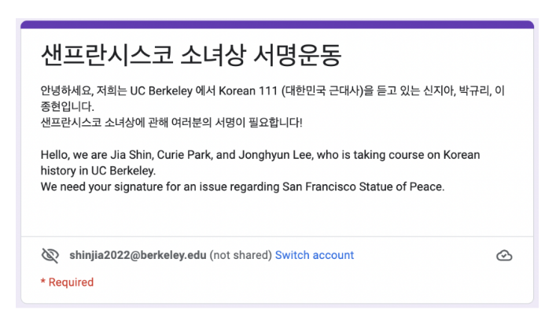
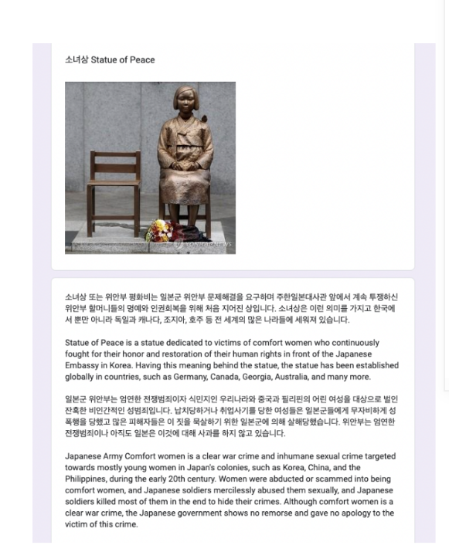
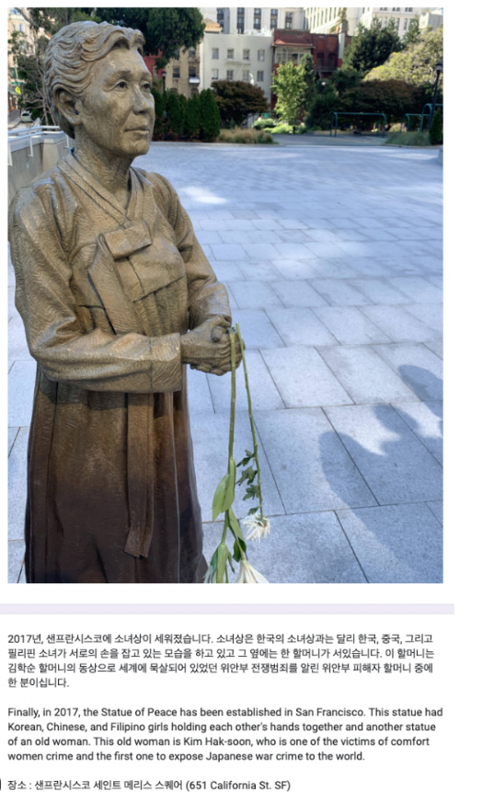
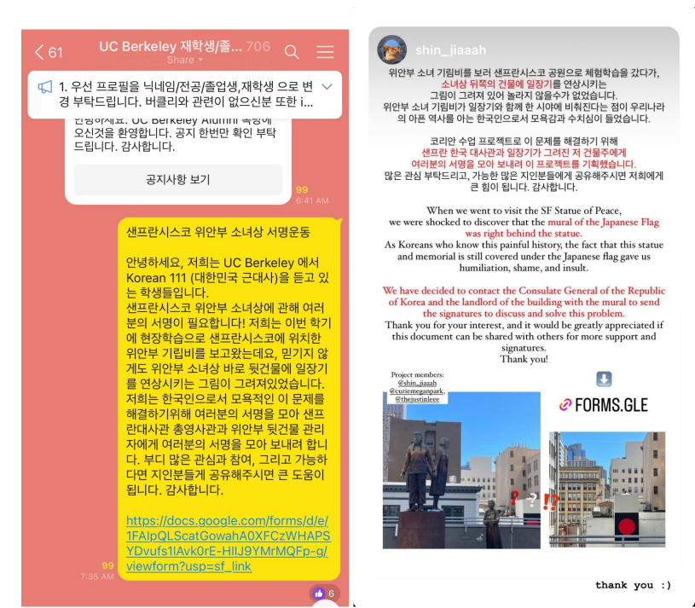

Appendix B. Discussion Board for Cultural Inquiries

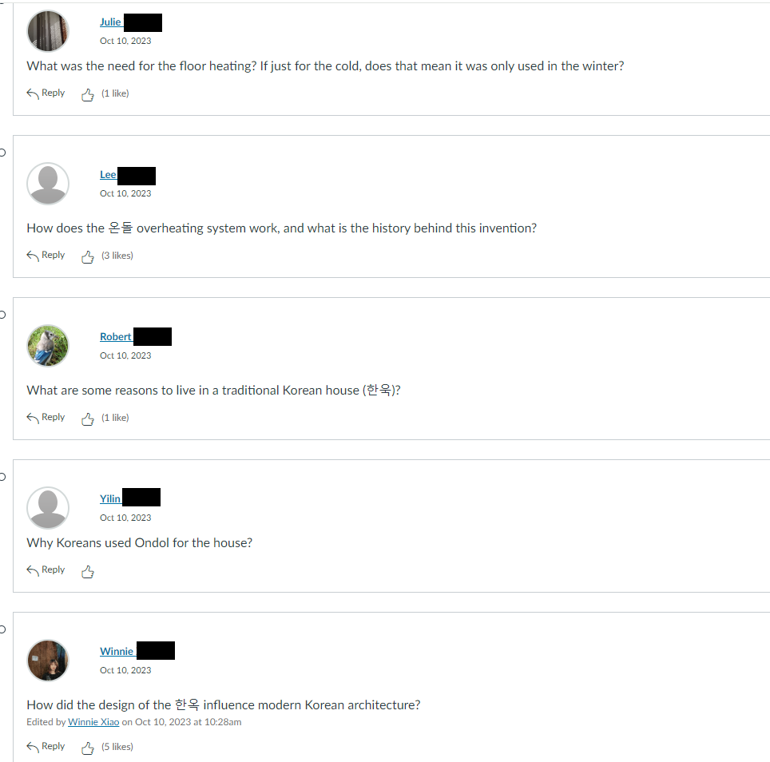

Appendix C. Asset Library for Research Source Posting 

