TEACHERS’ FORUM

Teaching Intercultural Competence in Higher Education Language Classrooms Using Virtual Reality

ESTHER OMONIGHO AIREMIONKHALE

Carnegie Mellon University
E-mail: eairemio@andrew.cmu.edu

In this globalized world, technology has created opportunities for cultural learning within virtual reality (VR) environments, facilitating second language acquisition (SLA). Recent studies have reported that VR-assisted language learning reduces learners’ anxiety and influences learners’ positive affective factors in and beyond the classroom. However, little attention is given to VR’s potential in promoting cultural learning in language classrooms. In this article, I present VR’s potential for cultural learning and its practical application for language learning in higher education through a series of practical task-based and semi-structured activities using language-focused VR applications such as Immerse and Mondly. As a starting point for cultural learning in the classroom, these activities are designed to simultaneously develop learners' intercultural, pragmatic, and symbolic competence by simulating authentic interaction in the target environment. These activities not only prepare learners for real-life interactions but also serve as a valuable precursor to study abroad programs by integrating cultural immersion into classroom learning. While I acknowledge the technical challenges of using VR in the classroom, I provide educators with a step-by-step process to transform the classroom into an immersive language learning site.
_______________

INTRODUCTION

Higher institutions prepare students for globalization and internationalization through cultural immersion (Shiri, 2015). Immersion in second language acquisition (SLA) supports learners' interaction within the target culture and language. Traditionally, immersion is facilitated through immersion villages, study abroad, and exchange programs (Isabelli-García et al., 2018). However, the benefits of these mediums of cultural immersion are inconsistent due to various moderating variables, such as the learner’s depth of awareness and knowledge of the host culture (Kinginger, 2008). The cultural unpreparedness of learners sometimes leads to initial unpalatable experiences that learners are not equipped to work through, consequently negatively impacting their investment and motivation in the target language (Isabelli-García et al., 2018).
In recent times, language learners have autonomously leaned into tandem learning apps such as HelloTalk!, HiNative, and Tandem to support their immersion in the target environment without leaving their own (Sadeghi & Chalak, 2023). Tandem learning, as defined by Cziko (2004), is a language-based exchange between native speakers of different languages who are also learning each other’s languages (pp. 26-27).
With more capacity for immersion than tandem apps, virtual reality (VR) offers multiple affordances that influence learners’ development of autonomy, engagement, and communicative competence (Dooly et al.,2023). Nonetheless, very few studies have developed pedagogical models for integrating VR in the classroom to address and teach intercultural competence (IC), which encompasses cultural awareness and learning (Berti, 2021). Thus, this pedagogical report addresses the question: How can language teachers leverage the affordances of immersive VR environments to promote cultural learning and immersion in the classroom? To support educators, I propose activities that provide a practical understanding of VR, its affordances, and implications for cultural learning in language education.
In the following sections, I discuss the theoretical underpinnings of VR in IC development in higher education language classrooms and its implications for language learners. I then present task-based activities that could guide learners in developing their intercultural and pragmatic competence by simulating authentic interactions in the target context.

THEORETICAL BACKGROUND

Constructivism

On a broader scale, VR is a digital environment powered by technology that simulates real-life experiences, environments, and interactions to create an immersive experience (Lin & Lan, 2015; Dooly et al., 2023). In proposing VR for cultural learning, this paper draws upon two constructivist approaches: Piaget’s (1964) cognitive constructivism and Vygotskian (1978) social constructivism. According to Schcolnik, Kol, and Abarbanel (2006), constructivism posits that individuals actively construct knowledge through experience and reflection. Piaget's theory emphasizes that learning is an active process where individuals cognitively construct knowledge through experience and interaction with their environment.
Within the scope of the Vygotskian sociocultural theory is the constructivist approach to language learning. Scott and Palincsar (2013) emphasize that sociocultural theory views learning as a process of enculturation. Sociocultural theory helps to understand the role and importance of social interactions in developing competence. As von Glasersfeld (1989) highlighted, “knowledge cannot simply be transferred by means of words … [and] ‘learning' is the product of self-organization.” (p.136). For language learning, intercultural and pragmatic competence are thus co-constructed, self-organized, and acquired through experience. Moreover, the Douglas Fir Group (2016) noted that language learning is mediated “through cultural resources and tools that individuals use to move through, respond to, and make sense of their social worlds” (p.11). Following their view, task design in this article situates learners within social, cultural, and ideological contexts that require negotiated meaning-making, collaboration, and active participation, helping them develop the capacity to navigate culturally diverse situations by drawing on the totality of their semiotic resources.
Drawing on the Vygotskian paradigm, VR’s interactive environments can scaffold learners’ progress within the zone of proximal development (ZPD) through peer collaboration, guided dialogue, and real-time support from instructors, peers, or digital agents. Additionally, presenting students with authentic cultural dilemmas in VR settings enables learners to devise strategies for assimilating and accommodating new cultural understanding, positioning Piagetian cognitive conflict mechanisms as central to developing intercultural competence within VR environments. These paradigms informed how the tasks were conceptualized and framed.

Task-Based Learning

Researchers have conceptualized task-based language teaching (TBLT) in technology-enhanced environments as a process-oriented approach that places communicative language teaching at the core of instructional design and goals. But first, what constitutes a task? Branden (2010, p. 4) defines a task as “an activity in which a person engages to attain an objective, and which necessitates the use of language.” Task-based language teaching (TBLT) stresses the importance of using authentic language to achieve real-life non-linguistic outcomes such as socializing and resolving conflicts, while meeting linguistic challenges and promoting language learning through process or product (Lai & Li, 2011; Thomas & Reinders, 2012). For instance, cultural comparison tasks, facilitated by VR’s immersive socializing scenarios, prompt learners to critically reflect on their own and others’ cultural norms, creating room for intercultural awareness and adaptability.

Intercultural Competence (IC) in Language Learning

The communicative approach to language learning posits that communication and social interaction are the foci of language (Canale & Swain, 1980; Mitchell et al., 2019). Canale and Swain’s (1980) model of communicative competence acknowledges that the ability to use a language is as important as the knowledge of its rules. However, in its endeavor to enhance communication and language use, it forgoes the link between culture and language (Crozet & Liddicoat, 1999). Consequently, Byram’s (1997) model of intercultural communicative competence (ICC), which I also refer to as intercultural competence (IC) in this article, is employed for its value in holistically capturing the dimensions of culture and communication. IC focuses on the learner’s ability to understand and communicate within the target culture(s). In a multicultural world where a target language represents multiple cultures and identities, IC becomes a crucial component of communicative competence and an invaluable skill for language learners.
Much like understanding culture itself, defining IC is a complex task. In Deardorff's (2006a) study on evaluating the possible definition and appropriate assessment procedures of IC, Deardorff (2006a) found that many IC scholars regard this definition as the most representative of IC: “the ability to communicate effectively and appropriately in intercultural situations based on one’s intercultural knowledge, skills, and attitudes” (Deardorff, 2006a, p.247). Similarly, IC has been defined by ​​Meyer (1991) as the capacity of an individual to respond appropriately and “flexibly” when faced with the manners, attitudes, and expectations of individuals from different cultures (as cited in Atay, 2009, p. 123).
Furthermore, the Douglas Fir Group (2016) emphasizes that communities define language norms; thus, learners should possess “flexible competencies” to know what to say and when to say it (p. 26). Intercultural learning aims to place learners in contexts that encourage them to reflect on their culture and develop agency in the target language. I extrapolate this stance to argue that the culture and norms of a target language are as significant as the language itself, especially in a globalized world where one language does not necessarily equate to one culture. For instance, different varieties of the French language exist, each with distinct cultural norms. It is, therefore, important that language instructors expose their students to the diverse cultural identities of a language. Hence, a learner who has developed IC in a target language can effectively and pragmatically communicate and interact with people from different cultural backgrounds of the target language.
According to Byram’s (1997) model, learners must develop four components of IC: knowledge, skills, attitude, and awareness. VR’s affordances facilitate the development of each element in the immersive learning process. VR’s embodied simulation of cultural scenarios enables learners to gain knowledge as they explore social groups and practices within authentic virtual settings. Materials tailored to a VR environment and task-based activities provide contextual interactions that promote the development of skills, allowing learners to interpret cultural documents and engage in real-time communication. The sense of presence in VR contributes to learners’ engagement and attitude.
Additionally, VR’s capacity for reflective tasks within diverse cultural environments facilitates awareness, supporting the critical evaluation of cultural perspectives and practices and allowing for the possibility of experiencing and comparing across cultures in real-time. These affordances illustrate how VR technology encourages the holistic development of IC components in language learning.
While study-abroad programs offer immersive experiences, they expose learners to a limited portion of diverse target cultures. VR addresses this gap by providing arguably low-cost, simultaneous access to multiple cultural contexts within the same language. For example, a French learner can virtually experience cultural norms from France, Canada, Cameroon, or the Congo, broadening intercultural competence through multisite immersion. Although VR’s immersive and interactive features support authentic cultural engagement and personalized activities, making it an effective complement to traditional immersion (Berti, 2021; Shadiev et al., 2020), it also presents challenges such as potential technology accessibility issues and discomfort from prolonged exposure to VR tools, which may affect the depth of cultural immersion. Yet considering the logistics and unpredictability of study-abroad programs, VR-assisted immersive language learning remains a valuable complementary approach to support learners while these limitations are addressed.

Virtual Reality (VR) for Cultural Learning

There are two factors, immersion and presence, that educators should consider before introducing VR in their classrooms to transform cultural learning in language acquisition. These two distinguishing characteristics of VR environments impact its benefits and drawbacks.
Berti (2021) defined immersion as the reality of the virtual world based on the technology used, whereas presence is the psychological sense of being in a virtual space (see also Slater & Wilbur, 1997). Here, I consider two types of immersive environments: low-immersive (LiVR) and highly immersive (HiVR) environments. According to Kaplan-Rakowski and Gruber (2019), the LiVR is a computer-generated 3D virtual space that uses standard audio-visual technologies, such as smartphones, desktops, or basic 3D graphics, to provide limited engagement and interactivity. A HiVR is equipped with a 360° experience, often rendered through a head-mounted display (HMD) or VR headset that actively engages the learner's senses.
Examples of LiVR include Google Cardboard, YouTube VR, and Immerse Desktop. This hardware is relatively affordable, and although it has a lower immersive capacity, it has been reported to be more effective for linguistic gains. Chen et al. (2022), in their meta-analysis of 21 quantitative studies, found that low-immersive VR environments benefited learners’ linguistic gains, which may be related to the technology’s lower cognitive load—the mental effort required to manage the VR tool, environment, and learning content (Frazier et al., 2021, p. 134). Learners may benefit more from LiVR for vocabulary-focused tasks, such as learning pragmalinguistic elements like slang, where reduced cognitive demands help students concentrate on linguistic features without becoming overwhelmed.
However, these effects are highly context-dependent, as high-immersive VR environments, when combined with appropriate scaffolding and thoughtfully designed tasks, can also enhance both linguistic and affective outcomes through more immersive interaction opportunities. Therefore, cognitive load is moderated not only by immersion level but also by instructional design and task complexity, which together determine learners’ capacity to benefit from different VR modalities. Further research is required to understand how these benefits can enhance cultural learning.
Numerous studies have reported that high-immersive environments facilitate interaction and collaboration to enhance performance, engagement, and retention (Berti, 2021; Dooly et al., 2023; Yang et al., 2020). These benefits are closely linked to the immersive capacity and sense of presence the environment creates, making learners feel as though they are part of that setting in that moment (Frazier et al., 2021; Berti et al., 2020). Evidently, both LiVR and HiVR environments can contribute to learners' development of key components of IC. To that end, the sample lessons are designed for LiVR environments for two reasons: accessibility of VR equipment and manageability of cognitive load during VR sessions.
One of the affordances of VR is its potential to simulate naturalistic, authentic language situations and interactions through a sense of being in an authentic space. Here, authenticity is operationalized as the use of language to complete tasks and develop skills transferable to real-life situations where learners may find themselves in the future (Lai & Li, 2011). Drawing on the literature, I designed a set of task-based VR activities. Although these specific activities have not yet been implemented in my classes, evidence from prior research on VR for second language learning suggests such approaches can facilitate cultural immersion and prepare students for real-world intercultural experiences. Thus, I argue for the positioning of VR as a valuable precursor to study abroad programs in higher education by integrating cultural immersion into the classroom learning experience. This approach has the potential to reduce the adverse affective impacts of inevitable culture shocks in the study abroad context.

DESIGNING EFFECTIVE VR EXPERIENCES FOR CULTURAL LEARNING

The rationale informing the lesson design is that increased cultural awareness within the classroom will support learners’ construction of meaning, learning extramurally, and socialization. These sample lessons are designed for Portuguese and/or French language instructors and learners in higher education who participate in online or hybrid language courses. The lessons are particularly beneficial for speaking programs, such as conversation groups, and can be used complementarily or supplementally at different points during the program. While the activities were developed for the low-immersive environment provided by Immerse, they can be adapted for use with other VR language-learning platforms, such as Mondly and WondaVR. Due to the potential for more comfortable and natural social interaction, these activities are designed for learners to role-play with their classmates or virtual exchange peers, where available. When peer participation is limited, such as in smaller classes or resource-constrained situations, these interactions can also take place with AI agents or instructor avatars.
Some challenges learners and instructors might encounter during implementation include:
- Technical issues with the computer or VR platforms (e.g., connectivity, compatibility, audio).
- Students' levels of comfort with technology.
- Vocabulary may hinder students' engagement during the VR activity.

To address potential challenges, it is recommended that instructors hold a separate session to introduce students to the tools and platforms they will be using. Additionally, instructors may provide students with subject matter-related vocabulary before class.
While the lessons are not designed for formal assessments, observation, discussion, and reflective writing serve as authentic modes of formative assessment throughout the VR sample lessons. Teacher observation occurs both during and immediately after each VR activity, using annotations to document evidence of intercultural competence. For example, this could include teachers noting observable demonstrations of cultural awareness, discussing strategies with learners for handling cultural differences, and the ability to relate new experiences to learners’ own cultural backgrounds. However, this approach may be less practical in larger classes.
After each VR task, peer and whole class debriefing and discussions as well as individual student reflections give further opportunities to assess development across Byram’s (1997) IC components. Table 1 below summarizes how these formative tasks align with specific IC components and the expected outcomes. For example, students’ reflection pieces are evaluated for signs of awareness (e.g., identifying cultural perspectives or reflecting on stereotypes); discussions are used to appraise attitudes (e.g., openness, empathy); and teacher observations target interaction skills and practical application. This approach ensures that the impact of VR on intercultural learning outcomes is tracked.

Table 1

Summary of Observable Outcomes of IC Components

Component | Outcome
Knowledge | Constructive noticing | Reflections on stereotypes
Skill | Strategic competence | Pragmatic competence
Attitude | Openness | Empathy
Awareness | Perspective taking | Dialoguing

The formative assessment recommendations presented in this section apply to all tasks in the three sample lessons presented below.

Sample Lesson 1: Raising Concerns with a Brazilian Host Family

Task

You have just returned from an outing with your host family. The family appears to be very friendly, and they want to talk about everything. After returning from a long outing, it is time to eat dinner, and your host parents want to hear all about your experience during the day. They think you should love it because it was exciting for them, and they have planned more outings for the next day. Still, you thought it was too much for you and feel you would rather stay home the next day. Discuss your experience and preferences with your host parents, focusing on cultural differences and similarities in daily life.

Lesson Plan 1

Duration: 60 minutes |  | Level: Intermediate/upper-intermediate Portuguese learners (A2-B2)
Theme: Raising Concerns with a Brazilian Host Family
Lesson objectives: Learners will exhibit the following IC components:
- Knowledge → employ the appropriate formality needed while conversing in a Portuguese family setting.
- Skill → understand the level of detail and topics considered appropriate when sharing about one's day,
- Attitude/Awareness → identify and reflect on attitudes towards work, education, leisure, and family time in Portuguese culture.
Resources:
Personal computer, Immerse account, PowerPoint
Procedures:
Time | Activities |  | Environment
15 mins  20 mins  10 mins  15 mins | Pre-task:  - Review the lesson on Brazilian family and work culture  - Review vocabulary related to daily routines, leisure activities, and expressing preferences in Portuguese.  - Watch a short video demonstrating typical Brazilian family interactions during dinner time.  Main task:  Using Immerse’s “Create a room” feature (see Figure 1), the teacher can assign students into groups of four:  - Engage in a conversation with your virtual Brazilian host parents, sharing 3-4 main activities from your day's outing.  - Express your feelings about the outing, balancing politeness with honesty about your preferences.  - Listen to your host parents' perspectives and plans for the next day.  - Consider your needs and your hosts' enthusiasm to negotiate a compromise for future activities.  Post Task:  Discussion: Learners discuss their approach to the issue. Invite students to share the strategies they used and explain how they determine whether a strategy is culturally appropriate.  Reflection Task - Video or Written:  Students share their knowledge of cultural differences or interesting points about familial interactions in Brazil.  Formative Assessment Indicators (optional)  - Did the student politely express their feelings about their day during the activity?  - Did the student reflect on and compare their own culture with that of their host family?  - Did the student use an appropriate level of formality when conversing in the Portuguese family setting? |  | Classroom  VR environment  Classroom  Homework

Figure 1

Community Area in Immerse Where Teachers Can Create a Room

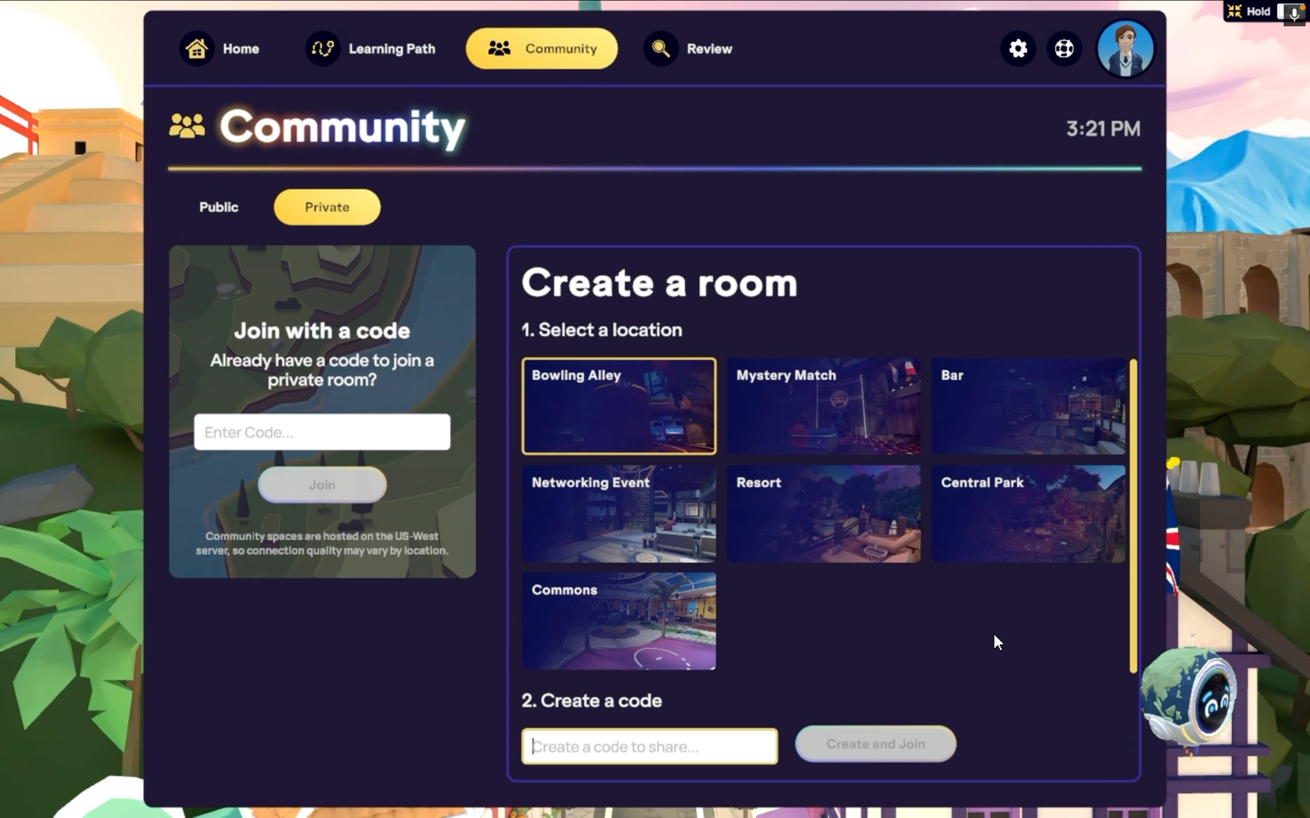
Lesson 2: Creating a Social Network at a French University in France

Task

You are attending a potluck with your French peers. As this is a casual gathering, you expect the discussions to be very casual and relaxing. As the event progresses, you notice your new friends are comfortable expressing their views on political discourse. This was culturally shocking for you, and you are interested in learning more about their expressiveness regarding political events. Your objective is to understand this culture better using informal yet polite language.

Lesson Plan 2
Duration: 60 minutes |  | Level: Intermediate/upper-intermediate French learners (B1-B2)
Theme: Socializing with University Peers
Lesson objectives: Learners will exhibit the following IC components:
- Knowledge → understand typical French social behaviors.
- Skills → demonstrate socializing with French peers using colloquial expressions.
- Awareness/Attitude → Reflect on the view of political discourses in France.
Resources:
Personal computer, Immerse account, PowerPoint
Procedures:
Time | Activities |  | Environment
15 mins  20 mins  10 mins  15 mins | Pre-task:  - Review lesson on social behaviors in France  - Review a list of common French slang terms and their meanings.  - Watch a video of a French social gathering focusing on informal language and slang.  Main task:  Students are assigned to the common room area in Immerse:  - Individually, students engage in conversations with virtual peers, using colloquial terms.  - Ask virtual friends questions to understand their cultural viewpoint about open political discourses.  Post-task:  Discussion: Learners discuss their understanding of the culture. Invite students to share similarities or differences with their social culture.  Reflection Task (Video or Written):  Students share their knowledge of cultural differences or interesting points about social culture in France, especially about openly sharing political views.  Formative Assessment Indicators  - Did the student use more than five colloquial terms correctly?  - Did the student demonstrate awareness of cultural norms in the discussion?  - How open to and/or critical of new cultural perspectives is the student in their reflection? |  | Classroom  VR environment  Classroom  Homework

Figure 2

The Common Area in Immerse Where All Students Can Gather.

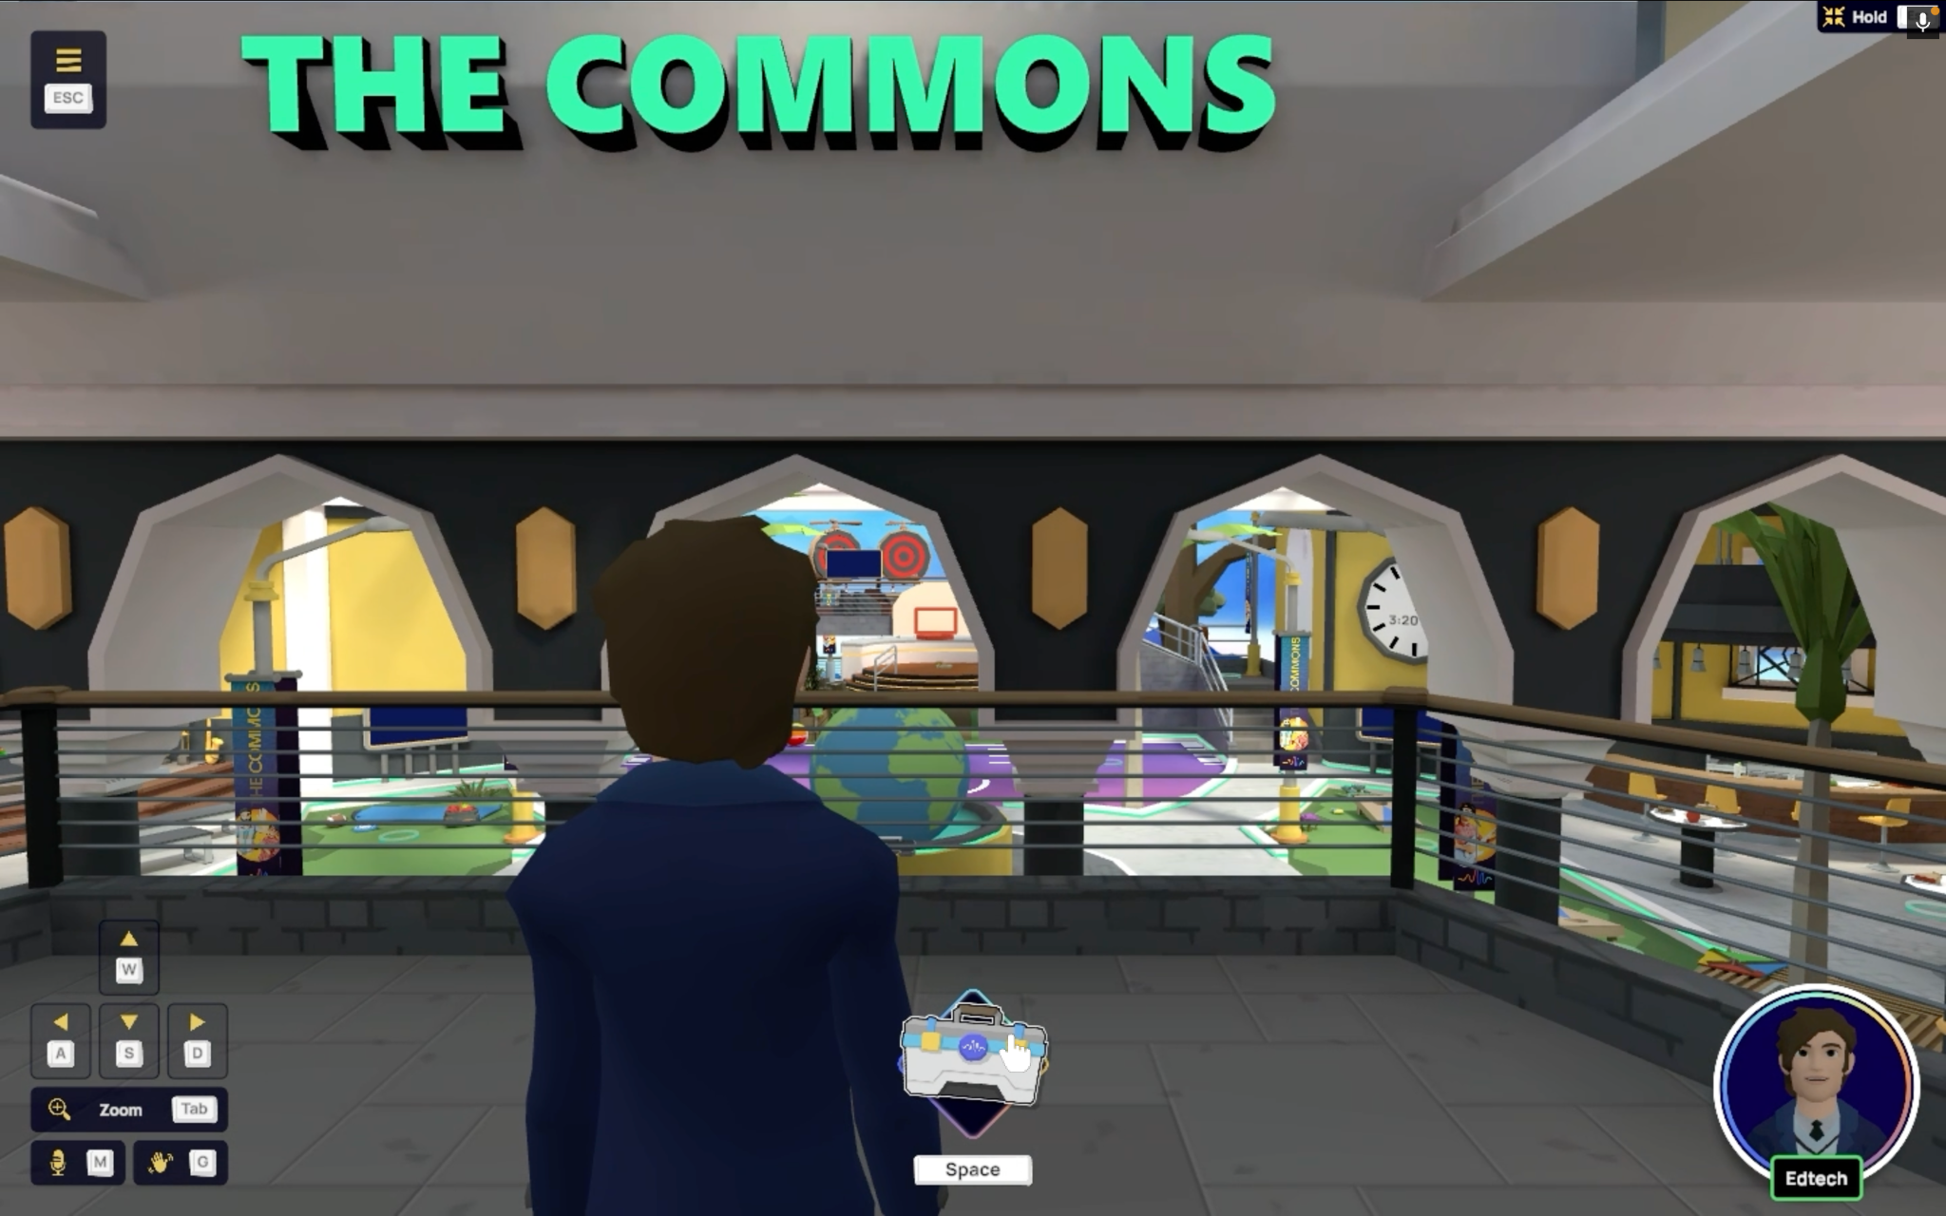

Lesson 3: Adapting to French Social Norms

Task

You are a student studying abroad in France and have decided to visit a new friend having a small get-together. You did not want to go empty-handed, so you stopped by the bakery to get a baguette because you believed that French people love baguettes. As you enter the apartment, you see three people, but you go straight to your friend. You offer the baguette and immediately ask for a coffee. Your friend and everyone in the room give you a look—they are surprised at the baguette and slightly offended. Your friend responds to your request with “Bonjour.” You suddenly realize your mistake; you've committed a cultural faux pas but are unsure which. Now, you must try to salvage the interaction. Your goal is to figure out the error, apologize, and engage in small talk to avoid any awkwardness going forward. How you handle this situation may impact your interaction and future experiences with that friend.

Lesson Plan

Duration: 60 minutes |  | Level: Beginner to Intermediate learners (A1-B1)
Theme: Socializing with University Peers
Lesson objectives: Learners will exhibit the following IC components:

- Knowledge → notice French social etiquette and salutation culture
- Skill → practice apologizing and making small talk in French
- Awareness → recognize subtle cultural cues in social interactions
- Attitude → learn to strategically and politely deal with a specific cultural faux pas gracefully

Resources:
VR headset, Immerse platform
Procedures:
Time | Activities |  | Environment
10 mins  10 mins  15 mins  15 mins | Pre-task:  - Review French vocabulary related to social etiquette, social interactions, and apologies.  - Discuss common social norms in French gatherings.  Main task:  - Students individually observe an interaction in a VR environment featuring Non-Player Characters (NPCs) within the Immerse platform. In this scenario, an NPC customer commits a cultural faux pas by entering the café and immediately ordering without first greeting the staff with "Bonjour."  - Learners observe:  - The reactions of the virtual café staff and patrons (animated NPCs) to this oversight.  - How the individual apologizes and corrects the mistake in French.  - To guide observation and support constructive noticing, learners complete a brief worksheet prompting them to note:  - What was the faux pas?  - How did staff and patrons react?  - How was the situation resolved?  Post-VR Interactive Roleplay:  - Create a get-together scene in groups of 3-4 with rotating roles (friend, other attendees).  - Students must figure out the issue, apologize, engage in small talk, and recover from the cultural misunderstanding.  Post-task:  - Discussion: Learners share strategies for recovering from this and similar cultural misunderstandings.  Reflection Task (Video or Written):  Learners reflect on how this experience or similar might apply to other social situations in France and the learner’s culture.  Formative Assessment Indicators  - Did learners notice when a misunderstanding or cultural faux pas occurred during interaction?  - Did learners employ suitable strategies to clarify meaning or accommodate cultural expectations?  - Did learners show flexibility in adjusting their communication style based on interlocutor feedback or contextual cues? |  | Classroom  VR environment  Classroom  Homework

IMPLICATIONS FOR TEACHING AND FUTURE DIRECTION

As teachers support learners in developing communicative competence, the proposed approach actively immerses learners in both language and culture, positioning them as agents in constructing knowledge about the target language(s) and culture(s). To prepare learners for potential cultural misunderstandings during immersive VR experiences, instructors should explicitly introduce that misunderstandings are valuable opportunities for reflection and learning. Additionally, teachers can scaffold learners’ responses to ambiguities by modeling strategies such as asking clarifying questions and reflecting on cultural assumptions.
Teachers must be recognized as central stakeholders in learners’ IC development, which calls for specific training in both VR technology and intercultural pedagogy. Professional development efforts could focus on how to facilitate VR-based interactions effectively, interpret learners’ responses from intercultural lenses, and guide meaningful discussions that deepen cultural awareness and promote critical reflection. While the activities presented here focus on two languages and limited contexts, expanding VR lesson designs to other languages, proficiency levels, and age groups is a promising future direction. Importantly, the effectiveness of VR in developing intercultural competence requires empirical evaluation; therefore, future research should prioritize classroom-based studies that measure VR’s impact on IC development.

REFERENCES

Atay, D., Kurt, G., Çamlıbel, Z., & Ersın, P. (2009). The role of intercultural competence in foreign language teaching. İnönü Üniversitesi Eğitim Fakültesi Dergisi, 10(3), 123–135. https://dergipark.org.tr/en/download/article-file/92286
Berti, M. (2021). The unexplored potential of virtual reality for cultural learning. The EUROCALL Review, 29(1), 60–67. https://www.proquest.com/scholarly-journals/unexplored-potential-virtual-reality-cultural/docview/2580805024/se-2
Berti, M., Maranzana, S., & Monzingo, J. (2020). Fostering cultural understanding with virtual reality: A look at students’ stereotypes and beliefs. International Journal of Computer-Assisted Language Learning and Teaching, 10(1), 47–59. https://doi.org/10.4018/IJCALLT.2020010104
van den Branden, K. (2006). Introduction: Task-based language teaching in a nutshell. In K. van den Branden (Ed.), Task-based language education: From theory to practice (pp. 1–16). Cambridge University Press.
Byram, M., & Masuhara, H. (2013). Intercultural competence. In B. Tomlinson & H. Masuhara (Eds.), Applied linguistics and materials development (pp. 143–160). Bloomsbury Publishing Plc. https://ebookcentral.proquest.com/lib/cm/detail.action?docID=1080344
Chen, B., Wang, Y., & Wang, L. (2022). The effects of virtual reality-assisted language learning: A meta-analysis. Sustainability, 14(6), Article 3147. https://doi.org/10.3390/su14063147
Crozet, C., & Liddicoat, A. J. (1999). The challenge of intercultural language teaching: Engaging with culture in the classroom. In J. Lo Bianco, A. J. Liddicoat, & C. Crozet (Eds.), Striving for the third place: Intercultural competence through language education (pp. 113–125). https://www.semanticscholar.org/paper/The-challenge-of-intercultural-language-teaching%3A-Crozet-Liddicoat/0f488d0e968572d181d769c7b5c74536a4c25f74
Cziko, G. A. (2004). Electronic tandem language learning (eTandem): A third approach to second language learning for the 21st century. CALICO Journal, 22(1), 25–39. http://www.jstor.org/stable/24149442
Deardorff, D. K. (2006a). Identification and assessment of intercultural competence as a student outcome of internationalization. Journal of Studies in International Education, 10(3), 241–266. https://doi.org/10.1177/1028315306287002
Deardorff, D. K. (2006b). Assessing intercultural competence in study abroad students. In M. Byram & A. Feng (Eds.), Living and studying abroad: Research and practice (pp. 232–256). Multilingual Matters. https://doi.org/10.21832/9781853599125-013
Frazier, E., Lege, R., & Bonner, E. (2021). Making virtual reality accessible for language learning: Applying the VR application analysis framework. Teaching English with Technology, 21(1), 131–143. https://www.proquest.com/scholarly-journals/making-virtual-reality-accessible-language/docview/2526914806/se-2
Isabelli-García, C., Bown, J., Plews, J. L., & Dewey, D. P. (2018). Language learning and study abroad. Language Teaching, 51(4), 439–484. https://doi.org/10.1017/S026144481800023X
Kaplan-Rakowski, R., & Gruber, A. (2019, November). Low-immersion versus high-immersion virtual reality: Definitions, classification, and examples with a foreign language focus. In Conference proceedings. Innovation in Language Learning 2019.
Kinginger, C. (2008). Language learning in study abroad: Case studies of Americans in France. The Modern Language Journal, 92(s1), i–131. http://www.jstor.org/stable/25173139
Lai, C., & Li, G. (2011). Technology and task-based language teaching: A critical review. CALICO Journal, 28(2), 498–521. http://www.jstor.org/stable/calicojournal.28.2.498
Lin, T. J., & Lan, Y. J. (2015). Language learning in virtual reality environments: Past, present, and future. Educational Technology & Society, 18(4), 486–497. http://www.jstor.org/stable/jeductechsoci.18.4.486
Lloyd, A., Rogerson, S., & Stead, G. (2017). Imagining the potential for using virtual reality technologies in language learning. In M. Carrier, R. M. Damerow, & K. M. Bailey (Eds.), Digital language learning and teaching: Research, theory, and practice (pp. 222–234). Routledge. https://doi.org/10.4324/9781315523293
Sadeghi, A., & Chalak, A. (2023). Iranian EFL learners’ attitudes toward autonomous English learning through the HelloTalk mobile application. Journal of Language, Culture, and Translation, 5(2), 107–136. https://doi.org/10.30495/lct.2023.1990574.1093
Schcolnik, M., Kol, S., & Abarbanel, J. (2006). Constructivism in theory and in practice. English Teaching Forum, 44(4), 12–20. https://americanenglish.state.gov/files/ae/resource_files/06-44-4-c.pdf
Scott, S., & Palincsar, A. (2013). Sociocultural theory. https://www.dr-hatfield.com/theorists/resources/sociocultural_theory.pdf
Shadiev, R., Wang, X., & Huang, Y. M. (2020). Promoting intercultural competence in a learning activity supported by virtual reality technology. International Review of Research in Open and Distance Learning, 21(3), 157–174. https://doi.org/10.19173/irrodl.v21i3.4752
Shih, Y. C. (2013). A virtual walk through London: Culture learning through a cultural immersion experience. Computer Assisted Language Learning, 28(5), 407–428. https://doi.org/10.1080/09588221.2013.851703
Shiri, S. (2015). The homestay in intensive language study abroad: Social networks, language socialization, and developing intercultural competence. Foreign Language Annals, 48(1), 5–25. https://doi.org/10.1111/flan.12127
Slater, M., & Wilbur, S. (1997). A framework for immersive virtual environments (FIVE): Speculations on the role of presence in virtual environments. Presence: Teleoperators and Virtual Environments, 6(6), 603–616. https://doi.org/10.1162/pres.1997.6.6.603
Tafazoli, D. (2024). From virtual reality to cultural reality: Integration of virtual reality into teaching culture in foreign language education. Journal for Multicultural Education, 18(1–2), 6–24. https://doi.org/10.1108/JME-12-2023-0135
Thomas, M., & Reinders, H. (Eds.). (2010). Task-based language learning and teaching with technology (1st ed.). Continuum. https://doi.org/10.5040/9781474212366
von Glasersfeld, E. (1989). Cognition, construction of knowledge, and teaching. Synthese, 80, 121–140. https://link.springer.com/content/pdf/10.1007/BF00869951.pdf
Yang, F. O., Lo, F. R., Hsieh, J. C., & Wu, W. V. (2020). Facilitating communicative ability of EFL learners via high-immersion virtual reality. Journal of Educational Technology & Society, 23(1), 30–49. http://www.jstor.org/stable/26915405

The default state would be for students to roleplay with classmates but depending on the classroom size and resources available, AI agents or instructor avatars could also serve as “peers.”
As this is a beginner-level task, observation is central. For this reason, the activity is first approached individually, allowing learners to focus on noticing cultural cues before moving into group roleplay.

