ARTICLE

Rethinking “Action” in Critical Language Pedagogy: A Snapshot of Multimodal Resistance and Pedagogical Possibilities in China

WONGUK CHO

University of Massachusetts, Boston
E-mail: wonguk.cho001@umb.edu

This study explored the application of Critical Pedagogy (CP) frameworks at a Chinese university, focusing on a persuasive speech task in an English as a Foreign Language (EFL) speaking class. Situated within the theoretical foundations of Critical Language Pedagogy (CLP), the study investigated how first-year EFL students in China engaged with CLP-inspired materials and curriculum. The analysis of student-generated presentation slides revealed that the students adeptly undertook the CLP-inspired task, identifying issues, formulating solutions, and enacting local changes, albeit within the constraints of their challenging environment. The students’ strategic utilization of multimodal resources, such as personal anecdotes, metaphoric expressions, and visual aids, played a significant role in enhancing the persuasiveness and criticality of their arguments. The findings underscore the importance of considering contextual and situational factors when implementing CLP principles, as the efficacy of this approach cannot be assumed to be universally applicable, especially across diverse groups of Chinese students. Factors like the students’ educational background, institutional dynamics, and socio-political climate shape their willingness and capacity to engage in transformative praxis. Future research should explore the impact of teacher-student dialogue on the production of CLP-inspired tasks within relatively oppressive and hierarchical structures.
_______________

INTRODUCTION

Critical Pedagogy (CP) is an educational theory that gained prominence in the 1970s, inspired by Paulo Freire’s seminal work, Pedagogy of the Oppressed (2000; originally published in 1970 in English). Its primary aim is to empower students and develop their critical awareness by encouraging them to question societal, political, and cultural norms and engage in transforming oppressive systems (Shor & Freire, 1987). In doing so, it challenges conventional teaching methods, promoting dialogue, social justice, and democratic engagement (Crookes & Abednia, 2022; Freire, 2000).
The foundational principles of CP, which encompass democratic purposes of education, have been explored by scholars such as Henry Giroux, Michael Apple, and Peter McLaren. These scholars agree that schooling is an institution that reproduces social order, cultural values and inequalities (Apple, 2013; Giroux, 2018; McLaren, 1999; Gounari, 2020). McLaren (1999), through his ethnographic research in Canadian Catholic schools, demonstrated that schools reproduce inequalities almost in a ritualistic way through cultural reproduction, hidden curricula, and strict discipline. In such an environment, learners rarely take ownership of their education, and schools seldom offer opportunities for inquiry. CP, however, seeks to transform students from passive recipients of knowledge—empty vessels, into active participants. It fosters “conscientization,” or critical consciousness, enabling students to challenge societal inequalities and power structures to bring about change, making education relevant to their lives (Freire, 2000).
Despite extensive discussions about CP frameworks in various contexts (Britton & Austin, 2022; Cannizzo, 2021; Chun, 2020; McMahill, 2001; Quan, 2020; Shin & Crookes, 2005), China has seen relatively few studies on the subject. While some research exists (Ku, Yuan-Tsang & Liu, 2009; Liang & Yu, 2023; Lu & Ares, 2015; Yang, 2020; Zhao, 2010), the scarcity of recent studies in this particular geographic area is notable. It may be challenging to document what is going on in the Chinese context without articulating a critique to the status quo or engaging in a political discussion, since CP necessarily involves inquiring about what is ethical often involving critical assessments of prevailing powerful groups (Giroux, 1991).
In considering the expansion of CP within the EFL context in China, it has been noted that CP may not be readily welcomed in classrooms where grammar-translation and audiolingual methods still hold significant influence as dominant approaches to English instruction (Wen, 2016). While these traditional methods may support students’ performance on standardized exams, they often hinder the development of dialogical thinking and problem-posing skills, which are key components of CP.
This study explores applying a CP framework at a Chinese university as a junior, foreign-contract researcher and instructor. My unique position, distinct from Chinese faculty in administrative roles, allowed me to question CP’s applicability in a rigid EFL context. I collected and analyzed student-generated presentation slides from a persuasive speech task to see if my first-year students could identify daily challenges and express resistance to hierarchical structures in their community.

Critical Language Pedagogy: From Theoretical Foundations to Empowering Practices

Critical Language Pedagogy (CLP) is an approach to teaching second, additional, heritage, or other languages that emphasizes social justice values (Crookes, 2021). This pedagogical approach has long been recognized as creating an educational environment where discussions on social justice can take place, and where community members are trained to become active citizens capable of effecting change through language use. The early history of CLP involved the application of Freirean concepts by Shor (1980) in post-secondary English classrooms, which provided guidance to practitioners and theorists of CLP through sharing narratives, lesson plans, and personal reflection. Additionally, Moriarty and Wallerstein (1979) established a strong connection between CLP and English as a second language (ESL) education in the United States, particularly for immigrant populations. From this effort, CLP was situated and employed to cultivate active citizens who could identify problems, seek solutions, and take action in a sequential manner in a language learning environment (Crookes, 2013). With this approach and pedagogical foundation, language was not considered solely as a medium of communication but also a practice that shaped how learners perceive themselves and their society (Norton & Toohey, 2004).
Dialogue, according to Freire, is the means by which educators can identify learners’ concerns and learning objectives, making it a vital aspect of education and human liberation (Shor & Freire, 1987). Freire acknowledged the dialectical relationship between individuals and society via dialogue, emphasizing the importance of educators guiding students to confront the social, political, and cultural conditions that shape their lives. Through this process, students are encouraged not only to recognize systems of oppression and inequality but also to question and challenge them as part of their educational journey. Through dialogue, a democratic and participatory learning environment can be fostered, enabling learners to critically reflect on their experiences and challenge dominant power structures (Freire, 2000). In practice, this entails sharing historical values, ideas, and relevant topics for discussion, thereby increasing students’ awareness of their surroundings and empowering them to take transformative action (Crookes & Abednia, 2022). However, the dominant educational system often discourages questioning and instead encourages conformity (along the lines of what Freire terms the banking model of education). In contrast, dialogue fosters active participation, ongoing critical examination of the status quo, and the pursuit of social justice by encouraging students to reflect on and discuss the realities of their everyday lives. This aligns with the problem-posing approach, which acknowledges the human capacity to question what is right and wrong (Freire, 2000).
The problem-posing approach is acknowledged as an alternative to the traditional banking method of education (Freire, 2000). In the traditional classroom setting, knowledge is transferred from the teacher to the learners, establishing an environment where the teacher holds expertise and control while students lack agency and ownership of their learning. Conversely, the problem-posing approach encourages teachers to act as facilitators and learners themselves, reshaping the teacher-student relationship. This approach is closely aligned with student-centered and dialogical models, as it leverages personal experiences to foster social connectedness and shared responsibility for change (Wallerstein & Auerbach, 2004). Thus, learners are afforded the opportunity to situate their lives and recognize the broader historical, political, and social contexts that shape their experiences by adopting the problem-posing approach.

Navigating Challenges in Global CLP Applications

Because CLP centers on naming oppression, challenging structural hierarchies, and empowering learners, its uptake is uneven across educational systems. Hierarchical pedagogical traditions, reinforced by high-stakes testing, centralized curricula, and top-down accountability, persist in many schools worldwide and can constrain dialogic, problem-posing practice. These limits stem less from any single nation than from the interaction of institutional risk cultures, political sensitivities, and local political economies. As a result, educators and researchers often engage in self-censorship or avoid ostensibly contentious topics, which helps to explain CLP’s limited visibility in certain settings.
Hayik in her 2020 study observed that EFL writing students in Israel hesitated to share the results of their community projects. These students had gathered data on the linguistic landscape in their neighborhood, which exposed instances where Arabic language was displayed with less attention to detail, often characterized by misspellings and mistranslations on multilingual banners, boards, and signs; when compared to Hebrew and English, Arabic appeared to receive less careful treatment. Hayik (2020) interpreted the students’ reluctance to share their findings with others in their community, noting that:

Being part of an often silenced minority group and on the threshold of graduating as English teachers, they felt intimidated and preferred to refrain from critiquing the authorities and sabotaging their chances of being hired in the Israeli Arab school system that promotes conformity and obedience over audacity and activism. (p. 218)

Hayik provided further clarification on the potential apprehension felt by the students, suggesting that they might fear that openly critiquing their community could potentially put them at a disadvantage in the future due to their active participation in class activities.
Another notable study that instantiated a teaching practice in a challenging environment is an EFL writing class in Iran (Ghahremani-Ghajar & Mirhosseini, 2005). Through a meticulous analysis of dialogue journals in the EFL classroom, the researchers discovered that this particular task facilitated students’ expression of their ideas in written form. Moreover, it provided a means for learners to gain empowerment asynchronously in a society that was relatively oppressive and hierarchical, especially when they hesitated to actively participate in class discussions.

Voices of Resistance in Educational Contexts

Gounari (2018a) critiqued the current global educational system, emphasizing how capitalist and conservative forces have shaped it into a competitive and controlled environment. She highlighted a shift toward a rigid, dystopian model that promotes conformity and obedience, disproportionately affecting working-class students and students of color, who are often marginalized and deprived of opportunities to express themselves or engage in acts of resistance. Giroux (1983, 2001, 2013, 2014) saw resistance as a crucial critique of schooling, illustrating its political and cultural dimensions. He advocated for a pedagogy of resistance accessible to all, aimed at building a society rooted in justice, equality, and freedom (2001). Similarly and aligning with Giroux, Apple (2012) stressed that students could challenge the status quo when faced with structural inequalities.
Freire (2000) viewed resistance as a way for students to reclaim their agency, using their experiences to challenge the dominant culture imposed by the education system. He argued that teachers should facilitate this process rather than control it, although he acknowledged that students often hesitate to resist due to a “magical belief in the invulnerability and power of the oppressor” (2000, p. 64), which can psychologically hinder their pedagogical engagement.
West (2014) explored forms of student resistance in South Korea, focusing on profit-driven educational institutions. He collected verbal and non-verbal data, including test papers and graffiti, uncovering instances of implicit and explicit resistance toward schools, teachers, and students themselves. West emphasized that behaviors such as vandalism and refusal to complete homework should be recognized as legitimate forms of resistance, rather than being dismissed as poor behavior or laziness.
Rowe et al. (2020) studied resistance among Chinese college students in dance education, revealing oppressive practices like peer pressure from standardized exams, collective punishment, public humiliation of teachers, and pervasive surveillance. Using Foucault’s (1977) framework, they showed how surveillance became a form of self-censorship, affecting students’ and teachers’ behavior. Ha & Li (2014) argued that one notable form of Chinese student resistance is silence. Silence, often mistaken for passivity or obedience, was found to be a strategic choice used to resist ineffective classroom management or undervaluation of their voices. Ultimately, silence is understood as “right, choice, resistance, and strategy” (Ha & Li, 2014, p. 233).
In my study, resistance does not manifest as overt acts of rebellion or large-scale protests, as often emphasized in traditional discussions of oppositional behavior (Giroux, 2001), but rather as subtle, context-specific practices such as strategic silences, humor, metaphors, or shifting discursive positions within students’ presentations. Drawing on Giroux’s framework (2001; see also Gounari 2018b), I understand resistance here as a form of human agency embedded within everyday interactions, where power is negotiated not only through domination but also through small acts of critique and repositioning, often carrying elements of hope and the possibility of change. While not every oppositional behavior can be classified as resistance, many of these acts, though modest, are interpreted as meaningful forms of challenging normative expectations, making resistance a nuanced and contextually embedded practice in this setting.

Research Questions

By examining the elements of CLP—dialogue, problem-posing, and action, alongside various forms of resistance observed in previous studies (e.g., narrative and silence)—this research aims to investigate how first-year EFL students in China engage with CLP-inspired materials and curriculum. Through an analysis of the students’ output, particularly their presentation slides, this study assesses the applicability and potential of CLP in the Chinese educational context. Additionally, addressing the following questions is essential for gaining a comprehensive understanding of the topic:

- How do Chinese college students engage with CLP-inspired speaking tasks?
- How are the fundamental elements of CLP, such as resistance and action, manifested in speaking tasks within the Chinese EFL context through multimodal resources?
- In what ways do multimodal resources enhance the effectiveness of persuasive speech tasks by incorporating criticality?

Researcher’s Positionality

As a language teacher and junior-level researcher born and raised in South Korea and trained in the United States, I specialize in second language education. Later, I moved to China to teach English at a prestigious university affiliated with the 985 Project—a central government-led initiative aimed at fostering world-class universities. During my years in this role, I encountered significant challenges in introducing CLP into a traditionally teacher-centered educational structure. Teachers usually occupied the front of the classroom, often speaking through microphones to passive students who either slept or showed little interest. Students, particularly those in engineering fields, frequently questioned the relevance of fluency in English. Observing this rigid and passive environment, I recognized an opportunity (and responsibility) to implement a pedagogical shift towards a more dialogical and democratic classroom.
Drawing from my own educational experiences in another East Asian country dominated by cram-schools and test-oriented practices, I believed that Freirean praxis could be transformative for my students. My goal was to return ownership of the learning space to students, allowing them to voice their own experiences, opinions, and critiques. Realizing Freire’s vision of liberatory education within such a restrictive environment might have been challenging, I intentionally created what I perceived as a “safe” pedagogical space, one where students could freely engage in discourse without fear of serious repercussions. Although the classroom still operated within certain boundaries and constraints, these critical engagements left lasting impressions. Students and I, as participants and witnesses, carried with us the experiences and critical insights gained from this pedagogical approach.
It is essential to emphasize that CLP is not solely about promoting classroom-level dialogue or fostering individual empowerment; it also entails interrogating and challenging the structural conditions that reproduce inequality (Crookes, 2013; Kubota & Miller, 2017). In this study, CLP served as both a pedagogical and ideological framework through which I and my students could explore how institutionalized expectations—such as silence or compliance—are linked to broader systems of stratification. Although systemic change was beyond the immediate reach of the classroom, the pedagogical choices made in this context were not neutral. By encouraging students to raise questions, identify problems, and consider alternative perspectives, this project aimed to make visible the conditions that often remain unquestioned, potentially opening up a discursive space where small acts of resistance could take root.
While introducing CLP in such a setting required careful navigation, I was familiar enough with the institutional culture to establish boundaries that protected students while still pushing pedagogical norms. Earning students’ and administrators’ trust was crucial. It ensured that the democratic design of the course was not perceived as a lack of structure or authority, but rather as a deliberate, informed approach to language teaching (Crookes & Abednia, 2022). This foundation allowed me to authentically position myself as a practitioner of CLP, working within, but not fully bound by, the constraints of the Chinese university classroom.

METHODOLOGY

Context and Participants

The research takes place at a university in southwestern China, an area considered less industrialized compared to regions like Shanghai or Guangzhou in the east and south. This regional disparity may contribute to the lower presence of English speakers, affecting their recruitment. In recent years, however, pressures to internationalize and expand English-medium programming have prompted public schools and private academies in the southwest to intensify outreach, issuing frequent recruitment notices with competitive salaries and benefits to attract qualified teachers.
Amidst this enthusiasm for globalization, joint dual-degree programs have emerged as an intriguing trend. These programs, often established in collaboration with universities from the United States, Canada, or the United Kingdom, offer courses and degrees taught in English. As noted by Feng (2013), they are often marketed and perceived as comparatively accessible routes to internationally recognized credentials, which carry substantial signaling value in local labor markets.
I worked at a school offering a dual-degree program in partnership with a U.S. institution. Each fall semester, approximately 100 students enrolled in the program, which offered two engineering-related majors. Students were required to take 20–30 credits per semester, including 12 credits of mandatory English courses in their first year, covering listening, reading, lab report writing, and speaking skills.
I was responsible for teaching the speaking course, which had two components: both structured and unstructured conversations reflecting real-life scenarios. The structured conversations included presentations and public speaking focused on developing presentation skills, delivery techniques, topic organization, and brainstorming strategies. The unstructured speech component involved various conversations such as team discussions, professor interactions, and interviews. Although both modes were well-planned, the department requested a slight emphasis on academic presentation training.
In the Fall semester of 2021, I taught four sections of a speaking class, totaling 101 first-year students who had recently completed the Chinese college entrance exam. Having learned English since the third grade through both formal education and after-school programs, these students were bilingual in Mandarin Chinese and English, with proficiency levels ranging from high-beginner to advanced.

Procedure

The data was collected from a persuasive speech task assigned within the structured component of my college-level speaking course, which focused on academic presentation training. This structured mode, distinct from the unstructured, conversational segments of the course, was designed to help students develop formal speaking skills, such as organizing content, using evidence, and practicing delivery techniques. The persuasive speech was not only aligned with the institution’s broader emphasis on preparing students for academic and professional communication but also served as a critical entry point for introducing the principles of CLP into the curriculum. More specifically, I employed two scaffolding stages inspired by Auerbach’s (1992) simplified problem-posing model: (1) identifying potential improvements to everyday gadgets or digital tools, and (2) engaging in teacher-led discussions about common social issues, such as line-cutting or recycling.
These preparatory stages encouraged students to analyze mundane aspects of daily life through critical reflection and group dialogue. According to de Certeau (1984), everyday practices function through “an ensemble of procedures” (p. 43), or the repeated operations that structure how people interact with their environment. By foregrounding familiar yet often overlooked experiences, the task allowed students to reframe ordinary observations as meaningful topics for critique and persuasion. Through small-group discussions, conducted in both their first language and English, students began to articulate problems, explore causes, and suggest possible actions. This grounded, dialogic preparation not only supported their language development but also positioned them to speak with increased confidence and critical awareness during the formal speech assignment.
In the subsequent week, discussions turned to common issues students faced daily, such as recycling and cutting in line. For example, students analyzed slides depicting scenarios of someone cutting in line and participated in guided dialogues about appropriate social responses. Through these conversations, students strategically employed everyday language to subtly question and challenge accepted behaviors and norms. Here, de Certeau’s insight becomes particularly relevant: the phrase “it is always so; people see it every day” illustrates how injustices become normalized, appearing ordinary and unavoidable, yet seldom directly contested (1984, p. 16). However, within these seemingly passive acknowledgments of everyday problems, students found space to covertly resist, exposing deeper injustices and implicitly challenging the accepted social order. After these guided activities, students further reflected on their experiences, discussing a chosen issue with their peers to foster greater agency and awareness.
Following the scaffolded activities, I introduced a persuasive speech assignment based on guidelines and rubrics adapted from the textbook The Art of Public Speaking (Lucas, 2012). Students created outlines for their speeches, submitted them for my feedback on coherence and organization, and delivered a five-minute persuasive speech the following week. Feedback focused on speech content, language use, and presentation skills. Thus, through structured yet open-ended tasks, students’ everyday linguistic practices were transformed into meaningful pedagogical acts that implicitly addressed resistance and challenged prevailing norms within their constrained educational context.

Critical Discourse Studies for Data Analysis

Critical Discourse Studies (CDS) is best understood as both a theoretical perspective and a methodological approach to analyzing discourse in relation to broader social contexts (Fairclough, 2013; Flowerdew, 2018). Rather than simply a method for qualitative analysis, CDS provides frameworks to critically explore how language and other semiotic modes (e.g., images, gestures, or sounds) reflect, shape, and reproduce societal ideologies, power dynamics, and social inequalities (Fairclough, 2013; van Dijk, 1997). Central to CDS is the recognition that discourse both constitutes and is constituted by the social world; discourse and social context interact dialectically, meaning one influences the other continually (Fairclough, 2013; Flowerdew, 2018).
In particular, Fairclough’s (2013) perspective on CDS underscores how language use in contemporary societies is deeply embedded within ideological frameworks and social structures. His analytical approach integrates micro-level textual analysis with macro-level exploration of social contexts, focusing explicitly on power relations and ideological effects. Complementing this, van Dijk (1997, 2009) highlights three interconnected domains in discourse analysis: language use, cognitive representations (beliefs and ideologies), and interactions within specific social situations. According to van Dijk (2009), critical discourse analysis must engage not only in textual interpretation but also with critical theory, explicitly addressing issues of social injustice, inequality, and power imbalances.
Moreover, contemporary CDS emphasizes multimodality, recognizing that meanings are communicated through various semiotic resources beyond language alone, such as visuals, typography, gestures, and design elements (Machin, 2013; van Leeuwen, 2012; see also Parba & Morikawa, 2024). As van Leeuwen (2012) argues, understanding modern communication demands attending to non-linguistic resources because spoken and written discourse seldom occur in isolation from other semiotic forms. Thus, multimodal critical discourse studies (MCDS) provide an analytical framework that helps researchers examine how images, texts, and other semiotic resources collectively produce social meanings, attitudes, identities, and power dynamics (Machin, 2013; Chen & Eriksson, 2019; Ma & Stahl, 2017; Machin & Suleiman, 2006). In line with this approach, my research leverages MCDS to analyze multimodal data—specifically student-produced PowerPoint slides—enabling an extensive understanding of how these semiotic forms mediate students’ critical engagement with their sociopolitical realities.

Agency

When approaching student-produced data, agency became a key aspect for understanding how students constructed their arguments without risking accusations of being “whistleblowers.” According to Ahearn (2001), agency should not be viewed simply as individual free will; rather, it emerges as a socioculturally mediated ability to act within the complex layers of power relations, social norms, and discourse. This aligns with Karp’s definition (1986), emphasizing that “[t]he agent refers to persons engaged in the exercise of power in its primary sense of the bringing about of effects, that is engaged in action that is constitutive” (p. 137, emphasis in original). Thus, in sociocultural and discourse studies, agency can be seen as individuals’ capacity to act independently, make choices, and strategically position themselves in particular contexts. Within CLP, agency specifically relates to learners’ ability to critically assess and influence their sociopolitical realities. Norton (2013) further elaborates on this idea by highlighting how agency arises from learners’ negotiation of identities, determining how they position themselves as capable or incapable, legitimate or illegitimate speakers. Thus, individuals strategically position themselves in discourse to maximize their legitimacy, credibility, and influence within social interactions (Davies & Harré, 1990).
From a methodological perspective, agency is intricately connected to the linguistic and semiotic choices individuals make to situate themselves, their listeners, and external entities within a discursive event. In this case, the concept and theoretical aspects of agency provide a useful analytical framework for discourse analysts to investigate how speakers use language to assign roles, responsibilities, and identities. Speakers position themselves and others through linguistic forms such as personal pronouns, modality, passive constructions, and evaluative language, actively shaping the relationships among participants (Fairclough, 2013). In this way, discourse actively constructs social relations, thereby enabling or restricting speakers’ agency (Fairclough, 2013; van Dijk, 2008).
Applying this theoretical framing of agency to CLP highlights the potential for students’ discourse to serve both as a site of ideological struggle and as a means of exerting transformative influence. Students engaging in CLP-inspired tasks, therefore, exercise their agency not only by explicitly challenging or resisting social structures, but also by subtly repositioning themselves and others through discourse choices, shaping how certain issues are viewed or prioritized (Kubota & Miller, 2017). Particularly relevant to this study, students’ use of multimodal resources can be interpreted as strategic discursive moves through which students claim agency, highlight or mitigate power imbalances, and construct persuasive arguments (Kress & van Leeuwen, 2006). Thus, investigating agency through multimodal discourse provides nuanced insights into how learners actively negotiate meaning and resistance within constrained educational and sociopolitical environments.

FINDINGS
Overview of the Data

A total of 101 PowerPoint presentation slides were collected, reflecting the types of issues students aimed to address: (1) personal or family-related, (2) school or campus-related, (3) domestic or municipal, and (4) international issues. From this dataset, two distinctive thematic categories emerged, agency and humorous adaptation, each encompassing several subthemes that reflected how students chose to present and frame their topics. The presentation slides, along with students’ verbal commentary, comprised a small yet rich multimodal dataset that was analyzed to address the research questions. In the following findings section, I highlight several student projects in which learners effectively identified and presented problems using multimodal elements. These examples illustrate how students either claimed agency in subtle or explicit ways or used humor and metaphor as rhetorical strategies to critique everyday realities. All personal names are pseudonyms, and participants provided informed consent for the collection, analysis, and dissemination of their classroom productions for this project.

Table 1

Thematic Categories of Findings

Targeted agents |  | N
 | Students themselves | 49
 | Citizens in community | 21
 | Government/policy makers | 17
Humorous adaptation
 | Metaphor | 7
 | Cynical self-criticism | 4
Non-applicableª |  | 12
Note. Some postings fell into more than one category.
ª These were mostly off-topic (introducing a topic e.g., E-Sports; comparison & contrast)

Agency: Calling Action for Students Regarding a Campus Issue

The school’s mandatory independent study session at 7 AM, lasting 90 minutes, received criticism, especially from students with late evening classes ending at 10 PM. Attendance affects credit, influencing eligibility for scholarships, major declarations or change, and student leadership positions. Students, managing over 25 credits per semester, struggle with late-night homework and projects, leading to sleep deprivation. This has made the program unpopular and seen as coercive. A first-year student, Wang, criticized the policy, focusing on its detrimental effects on young adults’ health. Wang’s speech included an overview of the program, problem identification, and suggestions, using a personal story to underline the negative impact on physical and mental health (Figure 1).
After stating the problem, Wang proceeded to share a few suggestions, including efficient time management and getting enough sleep. However, these suggestions were not directed towards the main entity responsible for organizing and implementing the program, the school. Instead, Wang advised fellow students on how to overcome the difficulties and manage overwhelm. In other words, he focused more on offering peer-oriented strategies rather than proposing institutional-level changes, such as revising or retracting the mandatory program. This approach could be seen as conforming to the dominant position held by the school within the hierarchical structure, as it is easier and less risky to suggest actions to peers than to challenge institutional authority. Regarding this agency issue, Yang (2020), building on Norton’s concept (2000, 2013), posited that agency is shaped by an individual’s personal narrative and their envisioned identities. This influence is reflected in the ways individuals navigate power structures, often adhering to conventional norms even when raising critiques. In Wang’s case, his rhetorical choices reveal a form of negotiated agency: one that resists through redirection rather than confrontation, subtly maintaining safety while still acknowledging systemic strain.

Figure 1

Wang’s Framing of the Problem Through Personal Anecdote

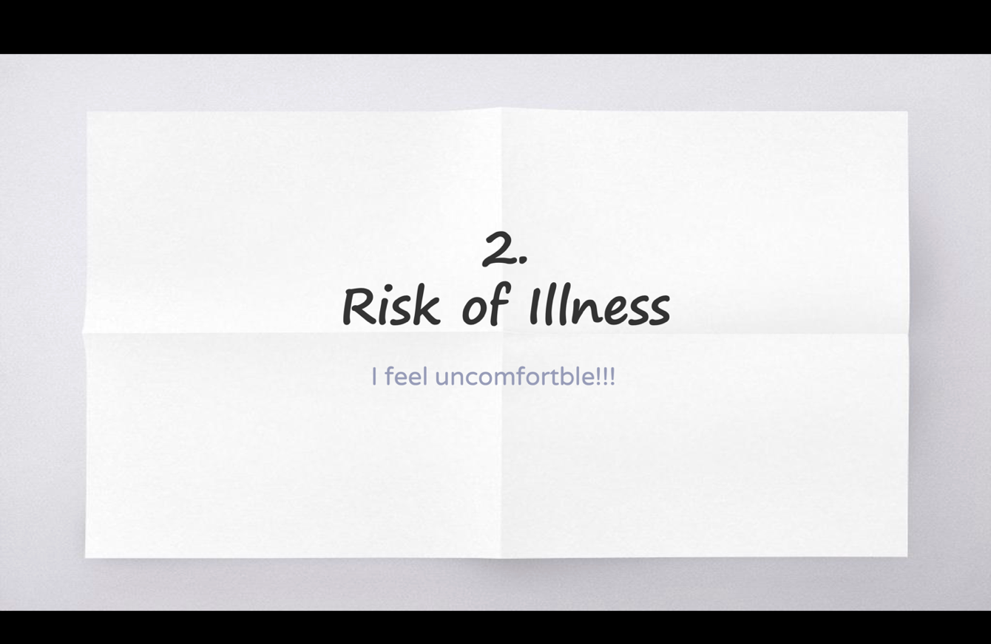

Moreover, I observed that Wang displayed a shift in his position by taking a relatively favorable stance towards the program. He positioned himself as a “moderator” by making comments and suggestions to the students who were unhappy with the program, including himself. This alignment with the school’s position puts him in an unclear role, somewhere between the school and the students, and somewhere between a critiquing position and a stance towards conformity to the school. This ideological tension exhibits contradiction; he expressed discomfort by leaving the remark, “I feel uncomfortable!!!,” on the slide (Figure 1), while also arguing that students should find ways themselves to survive. Therefore, although Wang successfully identified the problem, he did not directly propose solutions by addressing the main agent of the issue, the school.

Agency: Calls to Action for Students regarding a Community Issue

For this persuasive speech task, many students have taken a strong stance on a social issue and are actively seeking justice by addressing problems within their community. One student, Zhang chose to focus her speech on the challenges faced by the blind in Chinese society and how the societal structure unfairly affects this population. In her persuasive speech, Zhang began by quoting statistics from the World Health Organization (WHO) indicating that there are between 40 and 45 million blind individuals worldwide, with six million residing in China. She then posed a simple question: if the numbers are so large, why do we rarely see blind people in public spaces? Using this to highlight the community’s invisibility, Zhang identified two root problems: inadequate infrastructure that restricts mobility and widespread social discrimination. To illustrate her points, she presented a picture how Braille blocks intended for the visually impaired were being neglected and misused, such as being obstructed by trash cans, concrete structures, drainage systems, fire hydrants, streetlights, and even bicycles (Figure 2).

Figure 2

An Example of How the Infrastructure in the Society is Wrongly Designed for the Blind

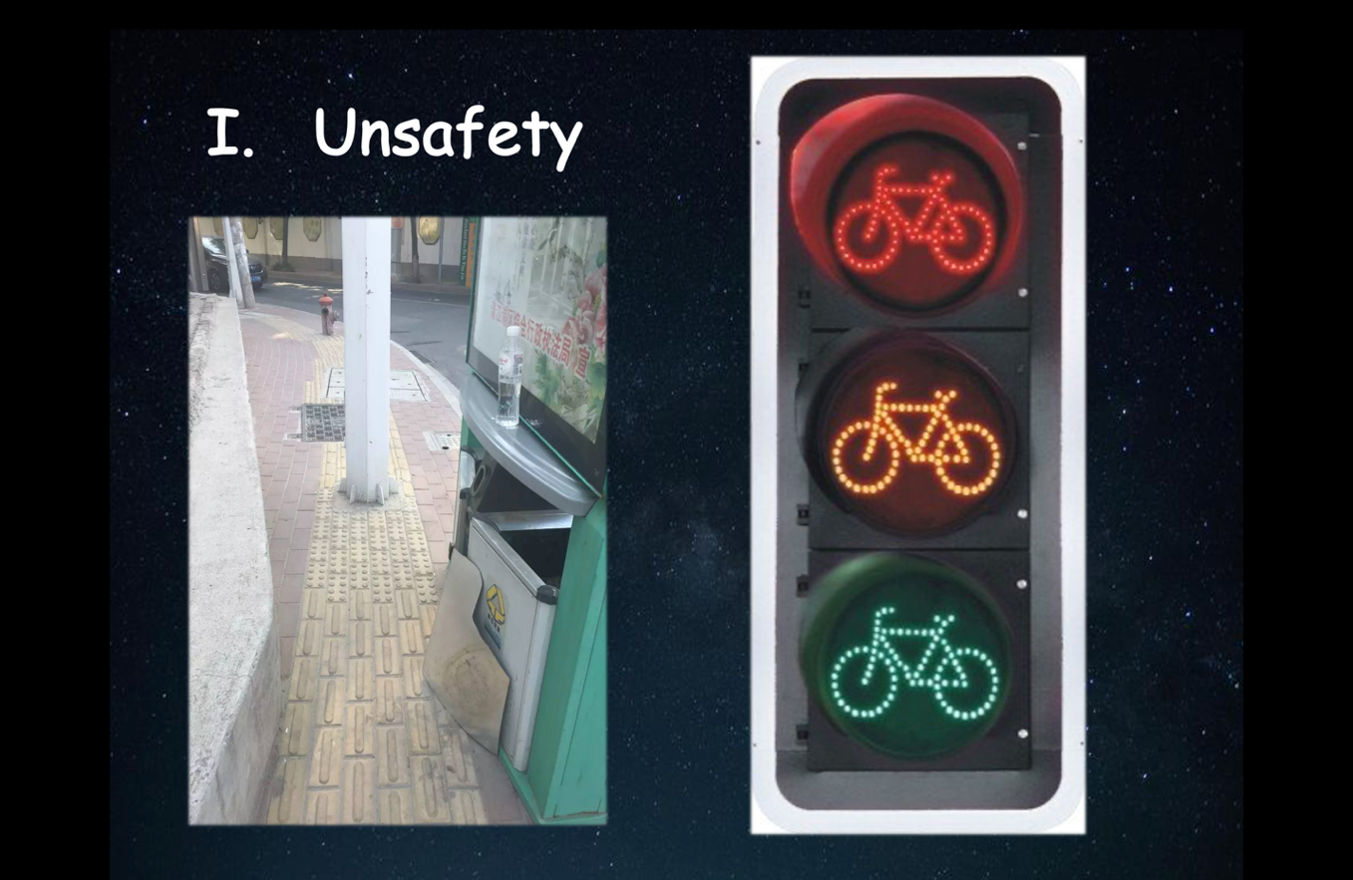

In addition, she shared another slide displaying two titles that she collected from local news websites about how the blind population have been discriminated against by the service sectors and educational policy (Figure 3).
Zhang presented solutions grouped into two categories: treating the blind population with dignity and respect and taking actions to enhance their safety in everyday environments. In her first argument, she emphasized the importance of treating them equally and encouraged the audience to offer their assistance. Regarding assistance, she highlighted the role of everyday citizens as active agents capable of making meaningful, grassroots-level contributions. Within the framework of CLP, this positioning of regular individuals as change-makers reflects a key aspect of agency, recognizing and responding to social inequities in daily life (Wallerstein & Auerbach, 2004). Furthermore, she suggested two specific actions to improve safety: cleaning up obstacles on the Braille blocks (if any are observed) and alerting blind individuals when crossing roads. These suggestions provided practical, accessible ways for students to participate in creating a more inclusive and just environment.

Figure 3

An Example of Recent News Report about Discrimination in Nationwide China with Personal Anecdote, “Unfairnss[Unfairness]!”

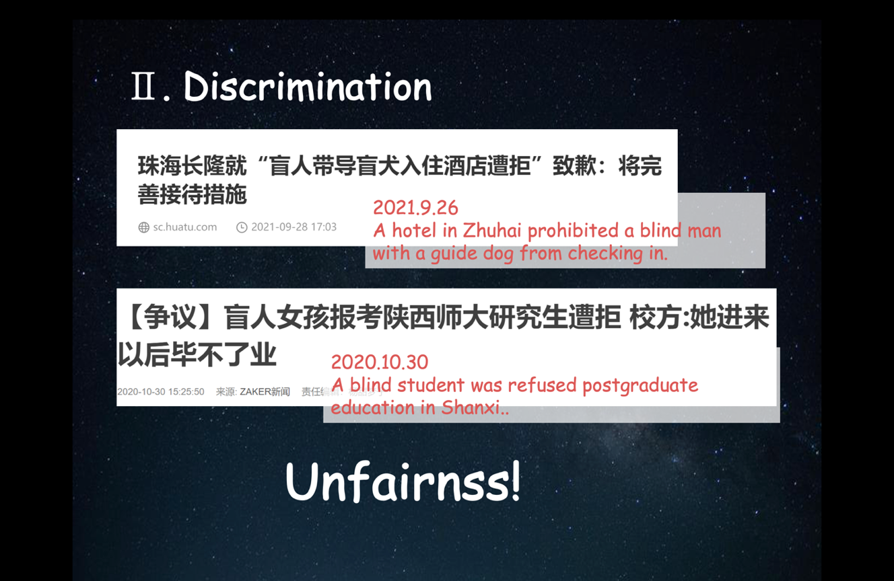

Though Zhang effectively made her point on the challenges faced by the blind population through the use of supportive images, she fell short of exploring potential strategies for instigating change and neglected to mention key stakeholders, like municipal governments, which hold overarching responsibilities. As was discussed previously regarding Wang’s speech, her focus instead centered predominantly on actions that fellow students and community members can undertake to tackle the issue. While this grassroots approach is still encouraging, it may not comprehensively respond to the root problem or present robust solutions, such as rectifying poorly positioned infrastructure and city design that perpetuate the difficulties encountered by the blind community. Addressing these matters could have involved outreach to policy makers to advocate for more extensive and systemic transformations.

Agency: Calls to Action for Students and Stakeholders

Since door-to-door delivery service is often unavailable for student dormitories in China, many college students opt to have their online purchases shipped to local package stores. Small third-party businesses act as intermediaries between delivery companies and recipients serving as centralized pickup points where students retrieve their parcels. These stores, which have become widespread with the boom of online shopping, often operate under cramped and disorganized conditions. I frequently heard accounts not only of stolen or missing packages, but also of overcrowded pickup areas, long wait times, and the physical burden of carrying multiple parcels alongside backpacks or school supplies. Against this backdrop of logistical and physical strain, Lee raised her concerns and proposed solutions aimed at three key stakeholders: students, package store owners, and the school administration.
To clarify issues, Lee prepared a slide featuring two pictures that she took on campus and drew herself (Figure 4).

Figure 4

A Suggestion and Two Pictures Portraying the Problem and Self-Portrait

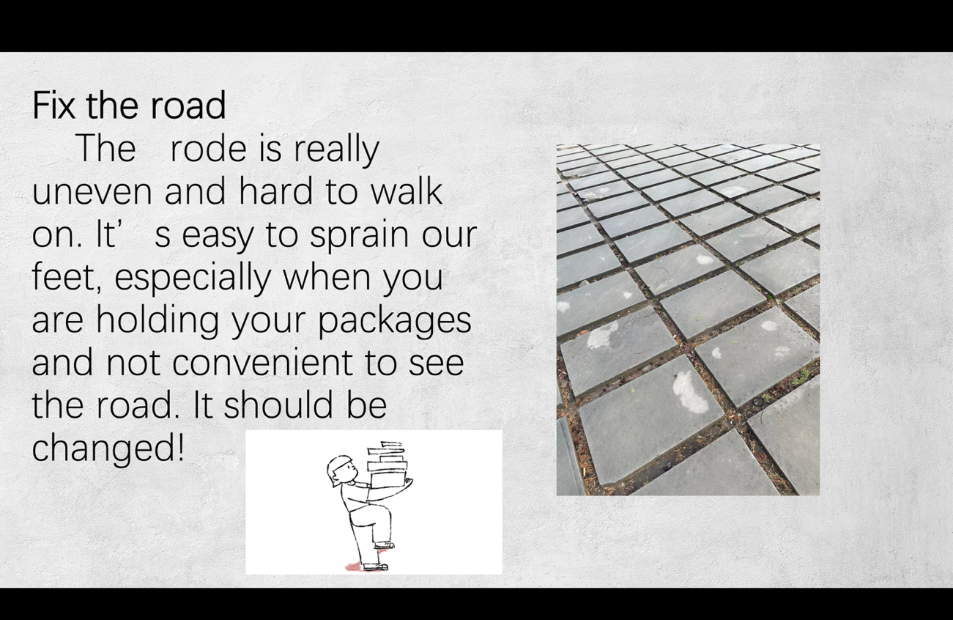

The first photo on the right side serves as evidence of the hazardous condition of the pavement tiles, emphasizing the risks involved when walking. The picture on the left side is Lee’s self-portrait, displaying the inconvenience of carrying packages while dealing with chewing gum stuck to her shoes.
During her speech, Lee effectively utilized imperative sentences to make her points explicit, which strengthened the level of certainty of the argument. Throughout the speech, she consistently employed the subject “people” when describing a logistical issue with the label-scanning machine inside the package store. Specifically, she noted that the scanner was placed within the already cramped shop, forcing people to queue indoors and further crowd an already chaotic environment. This detail was not incidental; it highlighted a specific infrastructural flaw in how the package store—a key service point for thousands of students—was organized. Lee argued that relocating the scanner outside would help reduce congestion and improve the user experience for all students.
What became particularly powerful in her speech was the discursive shift from “people” to “we” when she transitioned to another related issue: the uneven and hazardous pavement tiles leading to the package store. By using “we,” Lee reframed the problem as one that not only affected others but directly implicated herself and her classmates. This shift illustrates how agency can be enacted through pronoun use and positioning, as speakers realign themselves with the affected community to legitimize their claims and reallocate responsibility (Fairclough, 2013; van Dijk, 2008). This discursive move deepened the persuasive impact of her speech by aligning her personal experience with that of the audience, establishing a sense of solidarity and shared vulnerability. At the same time, it strengthened her critique of the institution by underscoring the school’s responsibility to ensure student safety. By situating herself as both speaker and subject of the issue, she elevated her call for action, suggesting that negligence on the school’s part could result in real harm for students, herself included. This rhetorical positioning transformed a context-specific inconvenience into a broader argument about accountability and student well-being.
Another notable aspect of Lee’s expression was her shift in grammatical voice. In the final sentence of her slide (Figure 4), she wrote, “it should be changed.” This move into the passive voice is discursively significant. As Machin and Mayr (2012) explain, transitivity analysis allows us to examine how grammatical choices shape the relationships between subjects, actions, and responsibility. By omitting the agent responsible for the change, whether the school administration, the package store, or another institutional actor, Lee effectively distanced herself from directly assigning blame. This rhetorical strategy allowed her to propose a necessary course of action while avoiding direct confrontation with institutional authority.
In contexts where hierarchy is strongly maintained and critique may be discouraged, such passive constructions function as a subtle way to raise concerns without overtly challenging those in power. While the use of the modal verb “should” adds a strong degree of certainty to her argument, the passive voice simultaneously softens its force by leaving the actor unnamed (Machin & Mayr, 2012). This dual strategy reveals how speakers negotiate agency and accountability in complex institutional environments: the issue is clearly framed as urgent, but the responsibility for action is left ambiguous. In doing so, Lee’s slide demonstrates how discursive choices, like switching to passive voice, can become pragmatic tools for expressing critique within constrained rhetorical and sociopolitical spaces.

Humorous Adaptation: Metaphor and Cynical Expressions

Taking into account evident distinctions in rhetoric between the English and Chinese languages (Liu, 2005), there has been research conducted to unveil the frequency with which Chinese EFL learners incorporate rhetorical devices, including metaphors/similes, amplification, and hyperbole, into diverse skill-focused academic English courses (Ji, 2011; Yeung, 2019, see also Gao & Meng, 2010; Jin et al., 2014). Of particular note, metaphor stands out as a frequently employed device among Chinese speakers, extending to academic, political, and professional engagements. While I was working in China as a teacher, I observed this rhetorical use as well among my students, particularly in classes centered around productive skills, and it is especially pronounced in specific genres like college essays and presentation courses. However, scant attention has been paid to exploring the link between critical language education and the rhetorical norms among English L2 learners in China.
This underscores the need for further exploration in this area, specifically examining how EFL learners employ metaphorical expressions to formulate questions or provide critiques when they are reluctant to share their opinions in public. In this specific case, Lai’s speech brought to light her use of metaphorical expressions that convey a sense of cynicism and humor, projecting a particular group of tourists into a specific situation.
Lai raised a pertinent nationwide issue concerning public order and virtue through metaphoric expressions. Easily accessible through media and social networking platforms, videos depicting instances of social order breaches, such as line-cutting at tourist spots and criminal activities in public places, have become common. Most of these videos are captured by individuals and lead to extensive online discussions among internet users. For her persuasive speech task, Lai pointedly highlighted an instance where citizens resorted to physical violence in a zoo, a place where adherence to public order and common sense is expected. She attached a screenshot from a video onto the slides—though censored, it was evident that people were involved in a brawl. The backdrop to this incident involved a person cutting in line, which led to several families responding (Figure 5).

Figure 5

Metaphorical Expressions and Cynical Implications of a Given Situation

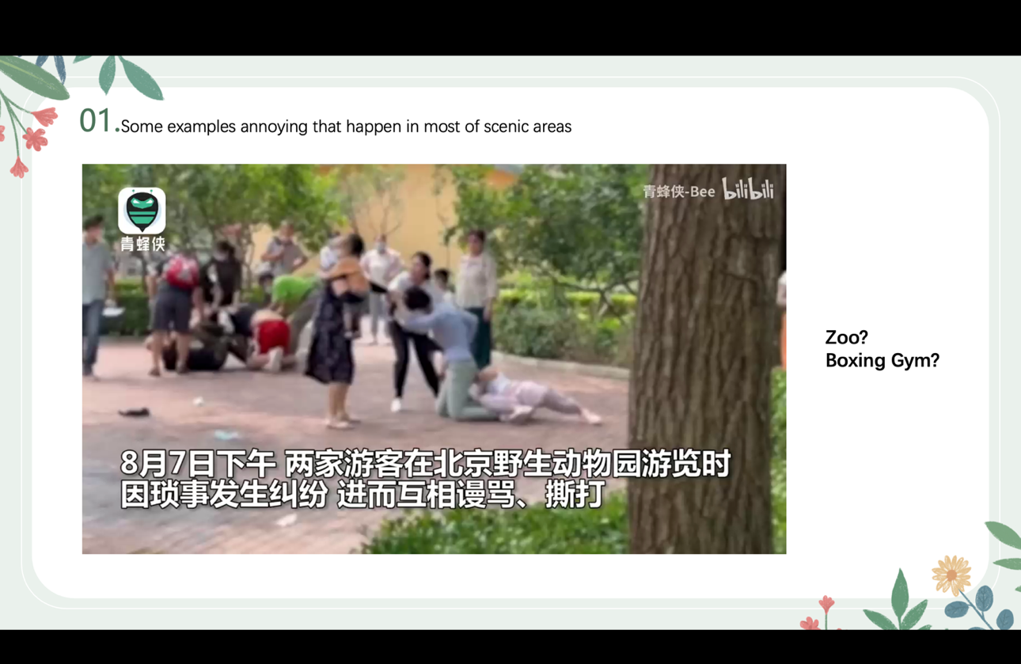

On the slide, Lai succinctly presented two words: “zoo” and “boxing gym.” These humorous metaphorical expressions evoked laughter from the audience. The incident took place in a zoo, a place where visitors anticipate observing animals engaging in activities like eating, sleeping, and even chasing each other. From this context, Lai highlighted the potential for this scenario to be another “zoo” for animals—observing humans fighting could be akin to a spectacle for them. She also emphasized that such incidents of violent and irrational behavior are commonly witnessed among groups of animals. By flipping the scenario and perspectives within the scene, Lai critiqued the behavior of tourists. She also labeled the situation as a “boxing gym,” highlighting how out of place the actions were in the context of social norms.
In the realm of metaphor application within an EFL context, Cho (2023) explored how South Korean students employed metaphors to present arguments concerning the overexploitation of part-time workers within their system. The study revealed that these metaphors acted as supplements to compensate for the students’ limited English proficiency. On the contrary, Lai’s story was a bit different. Despite its focus on critiquing a specific group—tourists who disregard public order—the use of metaphors generated laughter among the audience. This contrast emerged because the metaphors functioned as sources of humor, aiming to convey cynicism and facilitate satirical expression, rather than delivering a severe critique of the subject matter.
Moreover, Lai raised a question through her speech that local propaganda frequently addresses and campaigns about—whether citizens possess a law-abiding attitude and community spirit. In tackling a point that everyone is aware of can be challenging, as it may risk sounding mundane and repetitive due to the adoption of widely recognized topics or campaign slogans, Lai’s decision to use metaphor and inject humor into her points was strategic.

DISCUSSION

This research seeks to investigate how college-level EFL students in China express resistance and critique specific issues within their classroom environment using persuasive speech tasks. By analyzing students’ presentation slides, distinct categories emerged that answer the research questions and offer insights into approaching this context for future scholarly investigation.
In response to the research questions, my EFL students in China effectively undertook the CLP-inspired task: identifying issues, formulating solutions, and enacting local changes. This raises the question of whether the actions taken align with what is considered transformative action (Gounari, 2020; Kubota, 2022; Kubota & Miller, 2017). In challenging environments where resistance and transformative action are unwelcome, understanding and interpreting students’ actions may vary. Protest or vocal resistance carry risks, and the key question is how to interpret these students’ work as a manifestation of CLP.
In this context, individual efforts during the preparation of the presentation task can be seen as instances of both resistance and action. Students took initiative by capturing photos and illustrations of their surroundings, annotating these multimodal resources, and presenting them in class. While it was still difficult for students to openly critique aspects of their lives, institutions, and communities, these small acts became meaningful interventions. Drawing on de Certeau (2002), we can see these efforts not as grand acts of defiance, but as everyday ways of operating—tactics that allow students to navigate and subtly push back against the institutional strategies shaping their educational environment (p. 30). Though not openly revolutionary, these “arts of doing” carry quiet political weight, offering students a way to reappropriate and reshape the space they inhabit.
Students actively searched for topics, reflecting critically on their lives and communities in preparation for the task. Although not explicitly required, they recognized the power of visual aids in making their speeches more persuasive. A notable strategy involved combining personal anecdotes with images, using punctuation to add emotional weight and amplify their voices. Students also incorporated metaphorical expressions and humor to address social issues through their presentations.
The inquiry shifts to how these multimodal resources were used to resist and strengthen arguments, thereby enhancing the persuasiveness of their presentations. Visual aids played a dual role: they supported spoken delivery and acted as catalysts for critique. Additionally, the strategic use of visuals over explicit verbal criticism allowed students to convey their arguments clearly without identifying specific parties responsible for the problems they highlighted.
The contextual nature of this approach to CLP is crucial, particularly given the unique characteristics of the dual degree program and the student cohort, who come from an upper-middle-class background and have access to private tutoring and international schooling. These conditions shape their educational experiences and expectations, distinguishing them from other student groups. Their linguistic proficiency and nuanced understanding of topics allow them to navigate discussions on sensitive subjects securely, though understanding their limitations in expressing dissent remains vital.

CONCLUSION

As CLP has been applied across various contexts over the past decades, it is now an important moment to reflect on how its theoretical frameworks can be adapted to challenging environments in which displays of resistance and problem-posing around social issues are often discouraged or unwelcome. What I sought to trace throughout this study was how students who are considered living in relatively oppressive environment raise their voice and formulate critiques, presenting their own solutions, and how multimodal resources could assist in the task.
For future research, it is necessary to examine how dialogue between teachers and students could impact the production of CLP-inspired tasks, particularly considering that the current task separated scaffolding activities and my feedback about students’ performance due to administrative constraints and the course’s design. This situation left no room for intervention in their engagement and performance. This necessitates an alternative approach to implementing the CLP framework within a relatively oppressive and hierarchical pedagogical structure.

REFERENCES

Ahearn, L. M. (2001). Language and agency. Annual Review of Anthropology, 30(1), 109-137.
Apple, M. W. (2012). Education and power (3rd ed.). Routledge.
Apple, M. W. (2013). Knowledge, power, and education: The selected works of Michael W. Apple. Routledge.
Britton, E. R., & Austin, T. Y. (2022). Critical and dominant language learner ideologies: A case study of two Chinese writers’ experiences with a critical language writing pedagogy. TESOL Quarterly. 56(2), 629-655.
Cannizzo, H. A. (2021). Implementing feminist language pedagogy: Development of students’ critical consciousness and L2 writing. Education Sciences, 11(8), 393.
Chen, A., & Eriksson, G. (2019). The mythologization of protein: a Multimodal Critical Discourse Analysis of snacks packaging. Food, Culture & Society, 22(4), 423-445.
Cho, W. (2023). Critical Language Pedagogy in a Neoliberal Space (Hagwǒn) in Korea: Student Awareness and Engagement in Critical Dialogue. Critical Education, 14(3), 37-57.
Chun, C. W. (2020). Representations of anorexia in an EAP classroom: critically engaging with the body and its discourses. Classroom Discourse, 11(2), 164-180.
Crookes, G. V. (2013). Critical ELT in action: Foundations, promises, praxis. Routledge.
Crookes, G. V. (2021). Critical language pedagogy: An introduction to principles and values. ELT Journal, 75(3), 247-255.
Crookes, G. V., & Abednia, A. (2022). Starting points in critical language pedagogy. Information Age Publishing.
Davies, B., & Harré, R. (1990). Positioning: The discursive production of selves. Journal for the Theory of Social Behaviour, 20(1), 43-63.
De Certeau, M. (1988). The practice of everyday life. University of California Press.
Fairclough, N. (2013). Critical discourse analysis: The critical study of language. Routledge.
Feng, Y. (2013). University of Nottingham Ningbo China and Xi’an Jiaotong-Liverpool University: globalization of higher education in China. Higher Education, 65(4), 471-485.
Flowerdew, J. (2018). Critical discourse studies and context. In J. Flowerdew & J. Richardson (Eds.), The Routledge handbook of critical discourse studies (pp. 165-178). Routledge.
Foucault, M. (1977). Language, countermemory, practice: Selected essays and interviews by Michel Foucault. Basil Blackwall.
Freire, P. (1998). Cultural action and conscientization. Harvard Educational Review, 68(4), 499-521.
Freire, P. [1970] (2000). Pedagogy of the oppressed. Continuum.
Ghahremani-Ghajar, S. S., & Mirhosseini, S. A. (2005). English class or speaking about everything class? Dialogue journal writing as a critical EFL literacy practice in an Iranian high school. Language, Culture and Curriculum, 18(3), 286-299.
Gao, L., & Meng, G. (2010). A study on the effect of metaphor awareness raising on Chinese EFL learners’ vocabulary acquisition and retention. Canadian Social Science, 6(2), 110-124.
Giroux, H. A. (1983). Theories of reproduction and resistance in the new sociology of education: A critical analysis. Harvard Educational Review, 53(3), 257-293.
Giroux, H. A. (1991). Modernism, postmodernism and feminism: rethinking the boundaries of educational discourse. In H. Giroux (Ed.), Postmodernism, feminism, and cultural politics: Redrawing education boundaries (pp. 1-59). Suny Press.
Giroux, H. A. (2001). Theory and resistance in education: Towards a pedagogy for the opposition and expanded edition (2nd ed.). Praeger.
Giroux, H. A. (2013). The Quebec student protest movement in the age of neoliberal terror. Social Identities, 19(5), 515-535.
Giroux, H. A. (2014). Neoliberalism’s war on higher education. Haymarket Books.
Giroux, H. A. (2018). Pedagogy and the politics of hope: Theory, culture, and schooling: A critical reader. Routledge.
Gounari, P. (2018a). Authoritarianism, discourse and social media: Trump as the “American Agitator.” In J. Morelock (Ed.), Critical theory and authoritarian populism (pp. 207-228). University of Westminster Press.
Gounari, P. (2018b). Discourses of opposition and resistance in education. In P. Trifonas & S. Jagger (Eds.), Handbook of cultural studies and education (pp. 29-41). Routledge.
Gounari, P. (2020). Introduction to the special issue on critical pedagogies. L2 Journal, 12(2), 3-20.
Ha, P. L., & Li, B. (2014). Silence as right, choice, resistance and strategy among Chinese ‘Me Generation’students: Implications for pedagogy. Discourse: Studies in the Cultural Politics of Education, 35(2), 233-248.
Hayik, R. (2020). Using linguistic landscapes as stimuli for relevant EFL Writing. In D. Malinowski, H. Maxim, & S. Dubreil (Eds.), Language teaching in the linguistic landscape. Educational linguistics, (pp. 205-221). Springer, Cham.
Hu, G. (2002). Potential cultural resistance to pedagogical imports: The case of communicative language teaching in China. Language, Culture and Curriculum, 15(2), 93-105.
Huang, J., & Cowden, P. (2009). Are Chinese students really quiet, passive and surface learners?–A Cultural studies perspective. Comparative and International Education, 38(2), 75-88.
Ji, K. I. (2011). The influence of Chinese rhetorical patterns on EFL writing: Learner attitudes towards this influence. Chinese Journal of Applied Linguistics, 34(1), 77-92.
Jin, L., Liang, X., Jiang, C., Zhang, J., Yuan, Y., & Xie, Q. (2014). Studying the motivations of Chinese young EFL learners through metaphor analysis. ELT Journal, 68(3), 286-298.
Karp, I. (1986). Agency and social theory: A review of Anthony Giddens. American Ethnologists, 13(1), 131-137.
Kress, G., & van Leeuwen, T. (2020). Reading images: The grammar of visual design (3rd ed.). Routledge.
Ku, H. B., Yuan-Tsang, A. W., & Liu, H. C. (2009). Triple capacity building as critical pedagogy: A rural social work practicum in China. Journal of Transformative Education, 7(2), 146-163.
Kubota, R. (2016). Critical Content-Based Instruction in the Foreign Language Classroom. In L. Cammarata (Ed.), Content-based Language Teaching: Curriculum and Pedagogy for Developing Advanced Thinking and Literacy Skills (pp. 192-212). Routledge.
Kubota, R. (2023). Linking Research to transforming the real world: critical language studies for the next 20 years. Critical Inquiry in Language Studies, 20(1), 4-19.
Kubota, R., & Miller, E. R. (2017). Re-examining and re-envisioning criticality in language studies: Theories and praxis. Critical Inquiry in Language Studies, 14(2–3), 129–157. https:// doi.org/10.1080/15427587.2017.1290500
Liang, C., & Yu, S. (2023). Investigating critical language awareness pedagogy in China: A case study of a Chinese university EFL teacher. Language Awareness, 1-19.
Liu, L. (2005). Rhetorical education through writing instruction across cultures: A comparative analysis of select online instructional materials on argumentative writing. Journal of Second Language Writing, 14(1), 1-18.
Lu, S., & Ares, N. (2015). Liberation or oppression?—Western TESOL pedagogies in China. Educational Studies, 51(2), 112-128.
Lucas, S. (2019). The art of public speaking. McGraw-Hill Education.
Ma, J., & Stahl, L. (2017). A multimodal critical discourse analysis of anti-vaccination information on Facebook. Library & Information Science Research, 39(4), 303-310.
Machin, D. (2013). What is multimodal critical discourse studies?. Critical Discourse Studies, 10(4), 347-355.
Machin, D. & Mayr, A. (2012). How to do critical discourse analysis. Sage.
Machin, D., & Suleiman, U. (2006). Arab and American computer war games: The influence of a global technology on discourse. Critical Discourse Studies, 3(01), 1-22.
McLaren, P. (1999). Schooling as a ritual performance: Toward a political economy of educational symbols and gestures. Rowman & Littlefield.
McMahill, C. (2001). Self-expression, gender, and community: A Japanese feminist English class. In A. Pavlenko & A. Blackledge (Eds.), Multilingualism, second language learning, and gender (pp. 307-344). Mouton de Gruyter.
Moriarty, P., & Wallerstein, N. (1979). Student/teacher/learner: A Freire approach to ABE/ESL. Adult Literacy and Basic Education, 3(3), 193-200.
Norton, B. (2000). Identity and language learning: Gender, ethnicity and educational change. Edinburgh: Pearson Education.
Norton, B. (2013). Identity and language learning: Extending the conversation (2nd ed.). Multilingual Matters.
Norton, B., & Toohey, K. (2004). Critical pedagogies and language learning: An introduction. In B. Norton & K. Toohey (Eds.), Critical Pedagogies and Language Learning (pp. 1-17). Cambridge University Press.
Parba, J., & Morikawa, T. (2024). Unequal Englishes in multimodal texts. In R. Tupas (Ed.), Investigating Unequal Englsihes: Understanding, Researching Analysing Inequalities of the Englishes of the World (pp. 120-134). Taylor & Francis Group.
Qi, W., & Hu, Y. (2022). A multimodal ecological discourse analysis of presentation PowerPointslides in business English class. Journal of Language Teaching and Research, 13(6), 1441-1350.
Quan, T. (2020). Critical language awareness and L2 learners of Spanish: An action‐research study. Foreign Language Annals, 53(4), 897-919.
Rowe, N., Xiong, X., & Tuomeiciren, H. (2020). Dancing from policy to pedagogy in China: Transgressions, surveillance and resistance from students, teachers and institutional leaders. Policy Futures in Education, 18(8), 995-1010.
Shin, H., & Crookes, G. (2005). Exploring the possibilities for EFL critical pedagogy in Korea: A two-part case study. Critical Inquiry in Language Studies: An International Journal, 2(2), 113-136.
Shor, I. (1980). Critical teaching and everyday life. Bergin & Garvey.
Shor, I., & Freire, P. (1987). What is the “dialogical method” of teaching?. Journal of education, 169(3), 11-31.
van Dijk, T. A. (1997). The study of discourse. In T. van Dijk (Ed.), Discourse as Structure and Process (pp. 1-34). Sage.
van Dijk, T. A. (2008). Discourse and power. Bloomsbury Publishing.
van Dijk, T. A. (2009). Critical discourse studies: A socio-cognitive approach. In R. Wodak & M. Meyer (Eds.), Methods of critical discourse analysis (2nd ed., pp. 62–85). Sage.
van Leeuwen, T. (2012). Critical analysis of multimodal discourse. In C. Chapelle (Ed.), The encyclopedia of applied linguistics (pp. 1-6). Blackwell Publishing.
Wallerstein, N., & Auerbach, E. (2004). Problem-posing at work: Popular educator’s guide. Grass Roots Press.
Wen, Q. (2016). The production-oriented approach to teaching university students English in China. Language Teaching, 51(4), 526-540.
West, G. B. (2014). Doing critical language pedagogy in neoliberal spaces: a materialist narrative of teaching young(er) learners of English in a Korean hagwon. [Master's thesis, University of Hawaiʻi at Mānoa]. https://scholarspace.manoa.hawaii.edu/bitstream/handle/10125/101229/West_Gordon_r.pdf?sequence=1
Yang, S. (2020). Critical pedagogy for foreign-language writing. L2 Journal, 12(2), 110-127.
Yeung, L. (2019). Dialectics versus polemics in Chinese rhetoric: A study of indirection in Chinese and Chinese ESL argumentative writing as compared with English argumentative writing. Chinese as a Second Language Research, 8(1), 29-55.
Zhao, S. (2010). Critical Pedagogy of EFL Teaching in China. International Journal of the Humanities, 8(2).

