Shabtis
الأوشابتي (الشوابتي)
Henk Milde

Editors

Willeke Wendrich
Editor-in-Chief
Area Editor Material Culture
University of California, Los Angeles

Jacco Dieleman
Editor
University of California, Los Angeles

Elizabeth Frood
Editor
University of Oxford

John Baines
Senior Editorial Consultant
University of Oxford

Short Citation:
Milde, 2012, Shabtis. UEE.

Full Citation:
Milde, Henk, 2012, Shabtis. In Willeke Wendrich (ed.), UCLA Encyclopedia of Egyptology, Los Angeles. http://digital2.library.ucla.edu/viewItem.do?ark=21198/zz002bwv0z
8339 Version 1, April 2012
http://digital2.library.ucla.edu/viewItem.do?ark=21198/zz002bwv0z
Shabtis
الأوشابتي (الشوابتي)
Henk Milde
Uschebtis
Chaouabtis
A shabti is a funerary figure that is usually mummiform in shape and originally represented the deceased in his dignified status. Some New Kingdom shabtis, however, are clad in the dress of daily life. Background of the shabti-concept was the need for food that had to be produced in the realm of the dead as well as on earth. There was an ambiguity in function: a shabti represented the deceased and a shabti substituted the deceased. On the one hand it was a means for the deceased to benefit from the food production, on the other hand it created a possibility to escape from the burdensome labor required for the food production. Whenever the deceased was summoned to cultivate the fields in the hereafter, a shabti was supposed to present itself on his/her behalf saying, “I shall do it, here I am.” The substitution was secured by an incantation that—after the Middle Kingdom—used to be written on the shabtis themselves. The spell is also known from the Coffin Texts and the Book of the Dead. Towards the end of the New Kingdom, the number of shabtis per burial grew considerably. A total of c. 400 was not uncommon in the Late Period. By then shabtis had become mere slaves.
الأوشابتي هو تمثال جنائزي في الغالب يكون على هيئة المومياء ، وهو في الأصل يمثل المتوفي بمكانتة ووضعه المبجل ، بعض الأوشابتي من عصر الدولة الحديثة ظهرت مرتديه ملابس الحياة اليومية. نشأت فكرة هذه التماثيل الصغيرة من إحتياج المتوفي للطعام الذي يستوجب إنتاجه في عالم الموتى كما هوالحال في عالم الأحياء. هناك إلتباس وغموض حول الغرض من تلك التماثيل: فيمثل الشابتي المتوفي وفي نفس الوقت يقوم بمقام المتوفى. حيث اعتبر كوسيلة للمتوفي للاستفادة من إنتاج الغذاء، ومن جانب آخر فقد كان وسيلة للتهرب من العمل الشاق الذي يتطلبه إنتاج الغذاء، فكلما تم استدعاء المتوفي للعمل في حقول العالم الآخر، كان على أحد الشوابتي التقدم والإنابة عنه قائلاً »سوف أفعل، فأنا هنا«. وبعد إنتهاء الدولة الوسطى، بدأت كتابة تعويذة تضمن أداء هذه الوظيفة على تماثيل الأوشابتي نفسها. عرفت تلك التعويذة أيضا في نصوص التوابيت وكتاب الموتى. وبنهاية الدولة الحديثة زاد عدد الشوابتي ، ان وصول المجموع أربعمائة تمثال جنائزي في كل دفنة كان أمرا معتادا في العصر المتأخر. وحينئذ كان الأوشابتي ليس إلاعبدا للمتوفي.
A

shabti is a funerary figure. If confined to statuettes belonging to the tomb equipment (Schlögl 1985: 896), Osirian statuettes buried elsewhere are not to be classified as shabtis (Hayes 1959: 230). But it is difficult to deny, as a rule, votive figurines from various other sacred places the status of sha(wa)btis, several of them being designated as such (see, for example, fig. 1 right). Pumpenmeier (1998) called attention to extrasepulchral shabti-
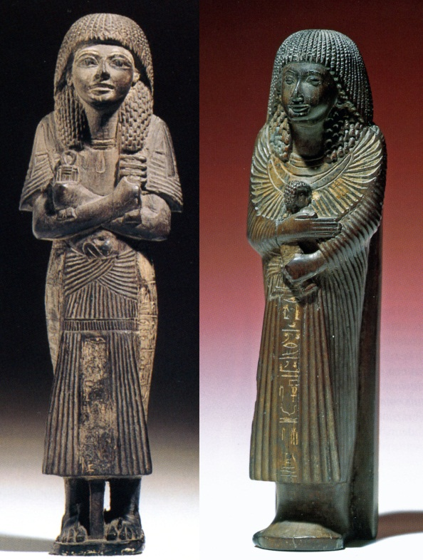
Figure 1. Left: Shabti of Hesyef-shemsu-nesu in dress of daily life, carrying hoes and holding djed and tit amulets. Wood. Height 19.4 cm. Provenance unknown. Dynasty 19 (early). Leiden, National Museum of Antiquities CI 3. Typology 3.1.5.5. Right: Shabti of Wepwautmes in dress of daily life, holding ba-bird. Stela on the back inscribed with shabti spell. Wood (ebony). Height 25 cm. From Saqqara (?). Dynasty 19 (early). Leiden, National Museum of Antiquities AH 117. Typology 3.1.5.3.
depositories. The oldest occurrence of the word so far dates from an 11th Dynasty tomb, where SAbty is a designation for a member of the household bringing fowl (Budge 1911: pl. 51). On coffins of the Middle Kingdom, the spelling SAbtyw is found, seemingly a plural (de Buck CT VI: 1a and 2a), but constructed as a singular (Schneider 1977, Vol. 1: 136 - 137). The etymology of the word has been much discussed. There might be a connection with words for food, like SAbw, SAbt, Sbw, Sbt (Erman and Grapow WB IV: 410, 2.4, 437, 6.10 - 11). An interpretation based upon SAbt, “corvée” (Speleers 1923: 88 - 93), turned out to be untenable (Erman and Grapow Belegstellen WB IV: 410, 4). Schneider (1977, Vol. 1: 136 - 137) argues for a derivation from Sbd, a Semitic loanword meaning “stick,” “staff” (Erman and Grapow WB IV: 442, 13).
In the 17th Dynasty, the variant spelling shawabti turned up (SAwAbty or Swbty, in case of group-writing). This designation has been connected with the word shawab, “persea tree” (Hayes 1953: 326). A shawabti, therefore, would be a “statuette made of persea wood.” However, shabtis of persea wood are virtually absent, as Petrie (1935: 5) already observed. What is more, the rubric of CT Spell 472 stipulates: “to be recited over a statue of the master as he was on earth, made of tamarisk (jsr) or zizyphus wood (nbs) and placed <in> the chapel of the glorified spirit” (de Buck CT VI: 2i - k). Here, too, shawabti may be derived from Sbd (Schneider 1977, Vol. 1: 138).
During the late New Kingdom, the word shebti (Sbty) is found, apparently a derivation of the verb Sbj, “to replace” (Erman and Grapow WB IV: 436, 12: “eine Person ersetzen = an deren Stelle treten”). A shebti, therefore, is a “substitute” for the deceased.
Whereas shabti remained in use, the word shawabti gave way to another spelling. From the 21st Dynasty onwards, we usually read ushebti. The new expression is obviously a folk-etymology: an ushebti (wSbty) was understood as an “answerer” (wSb). In the 21st Dynasty, the word occasionally occurred with an extension: ter-ushebti. The prefix “tr-” (allegedly from Tnr, Erman and Grapow WB V: 382 - 383; Schneider 1977, Vol. I: 328) qualifies the ushebti as being “diligent.”
Meaning
Shabtis originated from the tomb imagery of the Old Kingdom (Morenz 1975). Their meaning is ambiguous. A shabti represented the deceased, functioning as a vehicle for the ka-soul in order to receive offerings. And a shabti substituted the deceased, functioning as a servant involved in food production. Dedication of shabtis by relatives or servants was not unusual in the 2nd millennium BCE. In the 18th Dynasty, these statuettes could also be granted “as a favor by the king.” Since the
1. |  | SAbty | BM 614b: jamb from the tomb of Tjetji  Budge 1911: pl. 51, no. 102
2. |  | SAbtyw | de Buck CT VI: 2a (B1P)
3. |  | SAwAbty  Swbty | BD Spell 6 in P. Nu  Lapp 1997: pl. 62
4. |  | wSbty.w | Bill of sale for a set of ushabtis  Edwards 1971: pl. XXXII
5. |  | tr-wSbty | Rare, not on statuettes  Oracular Decree on behalf of Neskhons  Černỳ 1942: 107 - 109
Table 1. The word shabti and some variant readings in hieroglyphs.
end of the New Kingdom, the ambiguity was solved in that the individual shabti disappeared in gangs of slaves, supervised by overseer (reis) shabtis.
Background of the shabti-concept was the need for food that had to be produced in the realm of the dead as well as on earth. Just as the pharaoh imposed conscripted agricultural labor, so did the gods in the hereafter. High officials tried to escape these obligations by a king’s decree (wD nsw). In a similar way, dignified deceased persons resorted to an exonerative text, an incantation that was not only recited but, since the Middle Kingdom, written down as well. The purpose of these texts was to avert the burden of menial labor in the hereafter from the deceased to a personal substitute, eventually to masses of slaves. Activities, however, like plowing, sowing, and reaping were commonly accepted in the iconographical repertoire (Spell 110 of the Book of the Dead in tombs or on papyri). But the issue here was not menial labor that the deceased was obliged to do. Here it was about an aspect of the blissful life in the Field of Offerings to which the deceased willingly committed himself. Therefore, no shabtis appear in this context (Gesellensetter 2002:

129 note 333 and 148); for the same reason these substitutes were not wanted for eating, drinking, and having sex.
The ancient idea of a ka-statue representing the owner survived in the dedication of so-called “stick”-shabtis by relatives on the occasion of funerary celebrations in or near tomb-chapels (Whelan 2007: 45 - 47; Willems 2009: 518) and in the votive use of shabtis put in sacred places (Stewart 1995: 10 - 12). In this way the deceased remained present to relatives and stayed in the vicinity of important divine rulers like Osiris (Abydos), Sokar (Saqqara, Giza), and Apis (Serapeum) in whose offering rituals he could partake.
Development
Precursors of the shabtis date from the First Intermediate Period: tiny figures of wax or clay showing the human body as on earth, with legs together and arms by their side. Wrapped in linen, they were placed in little rectangular coffins (Hayes 1953: 326 - 327). The first mummiform statuettes appeared in the 12th and 13th Dynasties (Bourriau 1988). Name and titles occurred occasionally, a (simple) shabti text just in a few cases. Although the rubric of the shabti spell refers
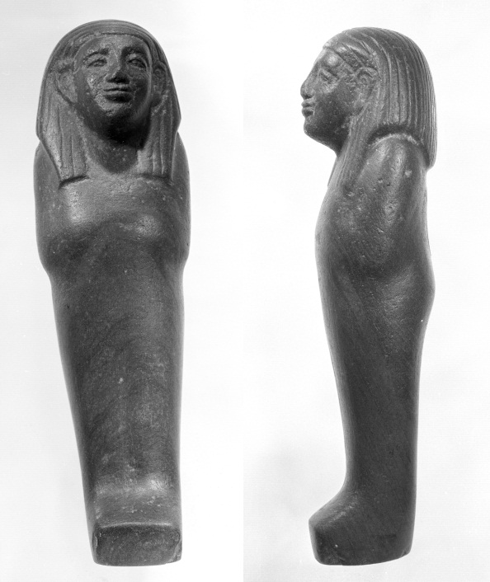
Figure 2. Uninscribed mummiform shabti. Green schist. Height 12.5 cm. Allegedly from Gebelein. Dynasty 12/13. Leiden, National Museum of Antiquities F 1971/7.2. Typology 1.2.4.1.
to a statue of the master “as he was on earth,” we see the deceased in a sah-status (fig. 2), a dignity acquired after mummification. Originally these figurines seemed to represent the deceased person, although the idea of substitution by a servant existed already.
After the Middle Kingdom, the shabti phenomenon faded into the background, but it recurred in the 17th Dynasty at Thebes. Most of these shabtis are crudely cut wooden statuettes, so-called “stick”-shabtis (Whelan 2007), placed in little coffins and often inscribed with a short text (fig. 3 left). They have usually been found outside the tomb-chamber.
From the New Kingdom onwards, shabtis generally show an inarticulate body, from which only the head (with wig) protrudes. Often the hands are visible, especially when they hold tools or other attributes. In general, the size varies between a few centimeters and c. 50 cm. One of the largest known statuettes is the shabti of Khebeny (fig. 4), measuring 58.5 cm. Shabtis of Amenhotep III in the Louvre Museum even surpass this giant, one
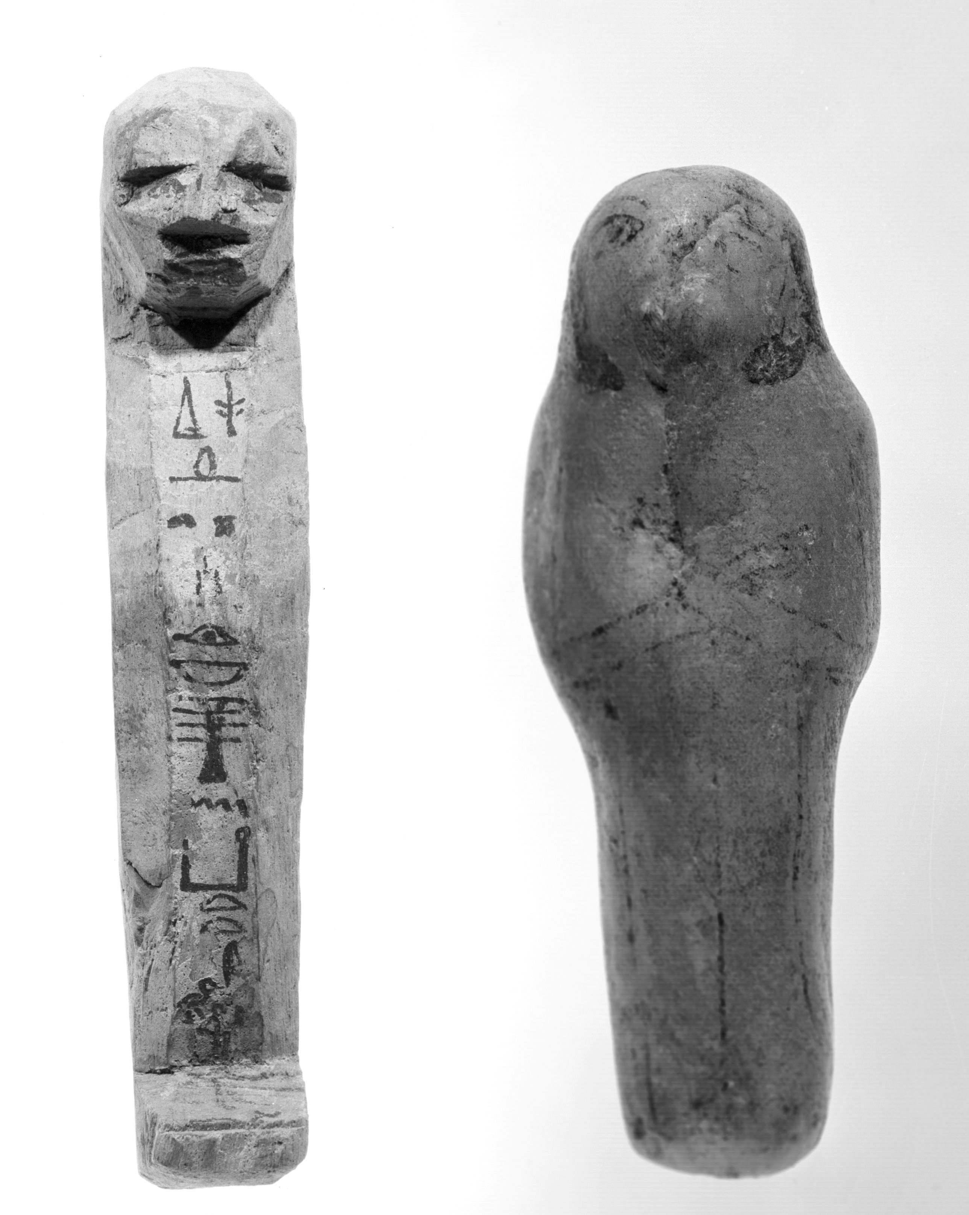
Figure 3. Left: “Stick”-shabti of Teti-sa-Intef with hetep di nesut formula. Wood. Height 16 cm. From Dra Abu el-Naga. Dynasty 17. Leiden, National Museum of Antiquities F 1971/2.4. Typology 2.1.1.4. Right: Uninscribed “peg”-shabti. Alabaster. Height 15 cm. Provenance unknown. Dynasty 20. Leiden, National Museum of Antiquities F 1961/12.1. Typology 3.2.4.10.
of them measuring 67 cm (Ziegler and Bovot 2006: 102). Royal shabtis are generally marked by regalia like crowns and nemes-headdresses. An iconographical novelty that came into being in the New Kingdom gave shabtis their characteristic appearance: the statuettes were carved or painted with agricultural tools like hoes, picks, and bags, but also yokes with waterpots and brick molds (fig. 5 right). Such implements were occasionally added separately as models (fig. 6 inset). Shabtis also grasp attributes like ankh-signs, djed- and tit-amulets (fig. 1 left), hes-vases (Moje 2008), scepters, and pieces of cloth. Occasionally they even embrace a ba-bird (fig. 1 right), an image recalling the vignette of Spell 89 of the Book of the Dead (Loeben 1987). Special figures have been found, such as animal-headed shabtis (especially from Apis burials at Saqqara), pairs of shabtis, shabtis reclining on biers, and kneeling shabtis grinding corn.
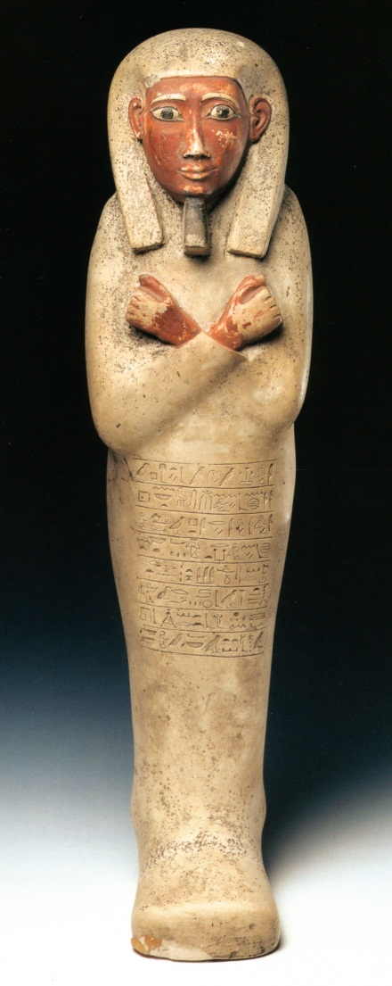
Figure 4. Shabti of the mayor (HAty-a) Khebeny. Painted limestone. Height 58.5 cm. From Abydos (?). Dynasty 17 (late) or 18 (early). Leiden, National Museum of Antiquities AST 43. Typology 2.2.1.3.
After Amarna, a new type appeared, showing the deceased not as a mummy but in the then fashionable clothing (fig. 1). Towards the end of the New Kingdom, the number of shabtis per burial grew considerably, whereas their size decreased proportionally. The so-called “peg”-shabtis (à contours perdus) also date from this period (fig. 3 right). The increase in number caused mass production in molds. On the conceptual side, the development was even more drastic, which is reflected in terminology. A ushebti is no longer a familiar servant, but an indifferent slave (Hm) who has “to answer” (wSb) to summons. A slight metathesis in spelling (Swbty > wSbty) reflects a
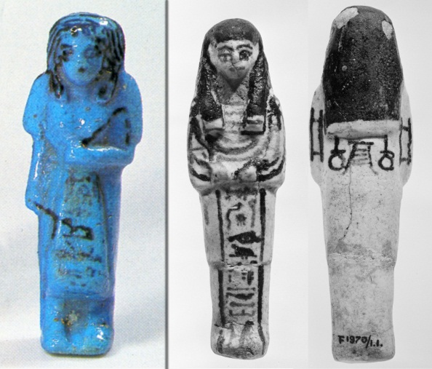
Figure 5. Left: Shabti of the overseer Gautseshnu in dress of daily life holding whips. Faience, Deir el-Bahri blue glaze. From Deir el-Bahri (Cache II). Height 11.2 cm. Dynasty 21. Leiden, National Museum of Antiquities F 93/10.81. Typology 4.3.5.5. Right: Shabti of Hori, viceroy of Nubia, carrying hoes (front), brick molds, a yoke with waterpots, and a basket (back). Faience. Height 11 cm. From Tell Basta. Dynasty 20. Leiden, National Museum of Antiquities F 1970/1.1. Typology 3.3.0.5.
considerable change in status. When personal ties fade, responsibility wanes. This may have led to the creation of overseer (reis) shabtis from Dynasties 20 - 25, clad in daily dress and carrying whips to stress their authority (fig. 5 left). The rare expression tr-wSbty from the 21st Dynasty may confirm this development. For shabtis, being diligent was no longer a matter of course. In an oracular decree, Amun declares that he will see to it that the ter-ushebtis perform their duties for Neskhons. Because it is for her exemption that they were bought (Černỳ 1942, Part 1: 105 - 118). A receipt from the 22nd Dynasty mentions the delivery of no less than 401 ushebtis, “male and female slaves” (Hmw, Hmwt), 365 workers (one for each day), and 36 overseers (Edwards 1971). It has been suggested that the payment not only compensated the manufacturer but also covered the “wages” of the ushebtis (Taylor 2001: 116; Warburton 1984 – 1985: 345 – 355, 2007: 175 – 179). This view has persistently been contested by Poole (2005: 165 – 170, 2010: 83 – 87). Male and female ushebti-slaves also figure in Spell 166 of the
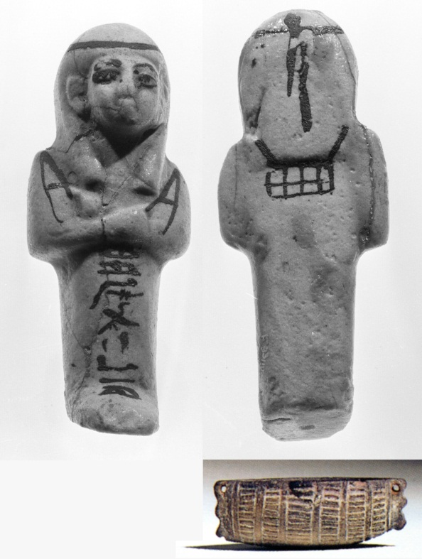
Figure 6. Shabti of Nesypaheran with a seshed-band around the wig, carrying hoes and a basket. Faience. Height 10.6 cm. From Deir el-Bahri (Cache II). Dynasty 21. Leiden, National Museum of Antiquities, Inv. no. F 93/10.56. Typology 4.3.1.48. Inset: Model of a shabti basket. Faience. Height 2.1 cm, length 6 cm, and width 2.9 cm. New Kingdom. Leiden, National Museum of Antiquities L.XIII.22.
Chapitres Supplémentaires (Pleyte 1881, Vol. 2: 58 - 59, Vol. 3: pls. 121 - 123). Since they were bought, they should perform their duties at the right time instead of the deceased whenever he is remembered (Černỳ 1942, Part 2: 118 - 133). Shabtis of this (Third Intermediate) period generally wear a seshed-band around their head (fig. 6).
The general decline in craftsmanship was countered by the rulers of the 25th Dynasty. Kushite statuettes are rather thickset figures (fig. 7). Large stone shabtis even recurred.
In the Saite renaissance, a new standard was developed displaying a characteristic feature of ancient statuary: the dorsal pillar (fig. 8), which could be inscribed with the so-called “Saitic formula” (see below). Overseer shabtis cannot be distinguished any longer. Text-
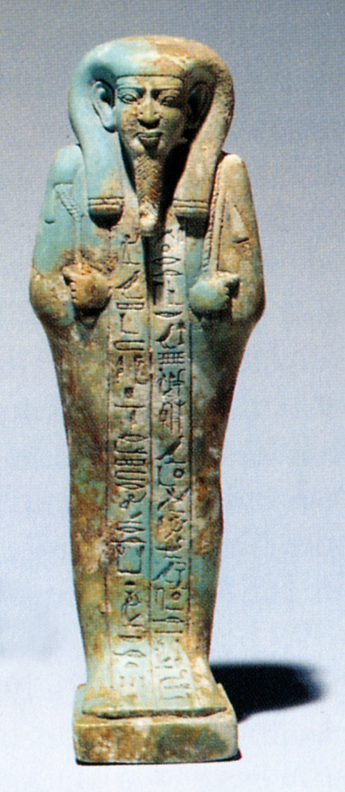
Figure 7. Shabti of the king’s scribe Horkhebi. Faience. Height 16.8 cm. From Thebes (?). Dynasty 25/26. Leiden, National Museum of Antiquities AF 55. Typology 5.3.1.189.
versions, too, recalled the past. They resumed the structure of the Middle Kingdom Coffin Texts (Schneider 1977, Vol. 1: 78, 154 - 155). The shabti stands on a pedestal (sometimes maat-shaped). The hands grasp two hoes or a hoe and a pick, as well as the rope of a basket hung over the left shoulder (fig. 8). The face displays a “Greek” smile and is adorned with the long Osirian beard, even in the case of women. Individual shabtis can be male or female (mainly marked by the wig, sometimes also by dress or breasts), according to the persons in question. Sexual differentiation among the depersonalized shabtis of the Late
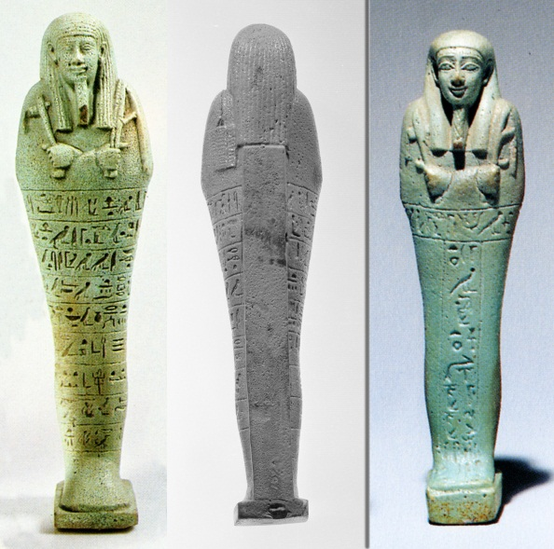
Figure 8. Left: Shabti of Imhotep, standing on a pedestal supported by a dorsal pillar, grasping hoe and pick and carrying a basket over his left shoulder. Faience. Height 20.5 cm. From Saqqara (?). Dynasty 30. Leiden, National Museum of Antiquities AF 38a. Typology 5.3.1.9. Right: Shabti of Nesbanebdjed with text in T-shape. Faience. Height 16.5 cm. From Tell el-Ruba (Mendes). Dynasty 30. Leiden, National Museum of Antiquities F 1970/1.4. Typology 5.3.1.164.
Period reflects the general composition of personnel. From the Persian Period onwards, texts also appeared in a T-shaped arrangement (fig. 8 right: horizontal line over a vertical column).
Formulae
Schneider (1977, Vol. I: 81 - 82) distinguishes between seven versions of the spell, each with several variants. The oldest version, CT Spell 472, has been found on two coffins from Deir el-Bersha. The text is a compilation of two variants, concluded by a single rubric (cited above) and introduced (at least in B2L) by a single title, “Spell for causing a shabti to do work for his master in the realm of the dead” (de Buck CT VI: 1a). The first variant fell into disuse, the second underwent several adaptations, but had a comeback in the Late Period due to renaissancistic tendencies. In the Book of the Dead, the spell occurs occasionally, either separately (Spell 6 of the Book of the Dead) or as part of the captions concerning the burial chamber (Spell 151 Ai of the Book of the Dead). In the papyrus of Nu, we read:
Spell for causing a shawabti to do work in the realm of the dead. To be recited by N: “O these shawabtis, if one counts off the Osiris N to do any work that should be done there in the realm of the dead, and he, indeed, is to obey there in order to act like a man at his duties, then one is counting off in respect of you, at any time on which one should serve, be it tilling the fields, irrigating the riparian lands, transporting by boat the sand of the West (and) of the East, ‘I shall do it, here I am,’ you shall say.” (Spell 6 of the Book of the Dead; Lapp 1997: pl. 62).
The idiomatic use of Hwj sDb, “to obey” (instead of the usual translation “to implant an obstacle”), has been suggested by Heerma van Voss in a Dutch translation of the text on a shabti in a museum in Leeuwarden (Heerma van Voss 1987: 4; further references in Van der Molen 2000: 592). The interpretation of “sand” is quite mysterious (Heerma van Voss 1963). It might be sand from the desert blown over the arable fields that should be removed (Petrie 1935: 10), or material for building dykes around the fields (Schneider 1977, Vol. 1: 59), or some type of fertilizer (Hornung 1979: 48) comparable to the sebakh (Barguet 1967: 42) used by present-day fellahin.
The wording of the spell illustrates that the owner is not playing the part of a landlord demanding statute labor, but that he himself is subject to conscription, for which he is seeking substitution (Bonnet 1952: 849 - 850).
From the 17th Dynasty onwards, the spell appeared more regularly on shabtis themselves (e.g., fig. 4). Only a few simple versions are found earlier. During the Middle Kingdom, the inscriptions, if any, were limited to the name (and titles) of the deceased, sometimes introduced by a hetep di nesut formula. This offering formula gave way to the introduction sHD (Osiris) N, “illuminating (the Osiris) N” or “the illuminated (Osiris) N,” found on most statuettes (Schneider 1977, Vol. 1: 128).
A variant text has been found on statuettes from Abydos: the “Amenhotep III formula.” Characteristic is the address to the gods at the side of Osiris. They should pronounce the owner’s name in order to secure his share of the evening meals and the offerings at the Wag-festival.
Principal object of the so-called “Khamuas formula” is the wish to see the sun disk and adore the sun in life. This recalls older formulae under Akhenaten (Martin 1986). Most private shabtis of this period, however, provide the conventional wording.
In the “town-god formula” the divinity in question is implored to stand behind the deceased. This is represented iconographically by a dorsal pillar, the benben or sun pillar being a manifestation of the town-god. The formula already occurred in the 18th Dynasty, but is often found on the dorsal pillar of Saitic shabtis. That is why the “town-god formula” is also known as “Saitic formula.”
On the whole, most shabtis display a very short text, often no more than sHD plus name.
Material and Manufacture
From the 12th Dynasty to the end of the New Kingdom, statuettes were made of wood, but not exclusively. With the exception of the Second Intermediate Period, there were also stone and faience shabtis. Stone shabtis recurred under the Kushite rulers, whereas the ever popular faience remained in use into the Ptolemaic Period. Other materials were pottery, clay, glass, and bronze.
Stone and wooden shabtis were individually cut and carved. Faience figurines were made in molds, after which further details were applied. The finishing touch determined most of the quality. Typical for faience statuettes is their glaze. The shabtis found by thousands in the Deir el-Bahri Caches (Aubert 1998; Janes 2002: xxii - xxv) are renowned for their deep blue glaze. The majority of the Late Period shabtis is green (fig. 8).
The value of shabtis was dependent on
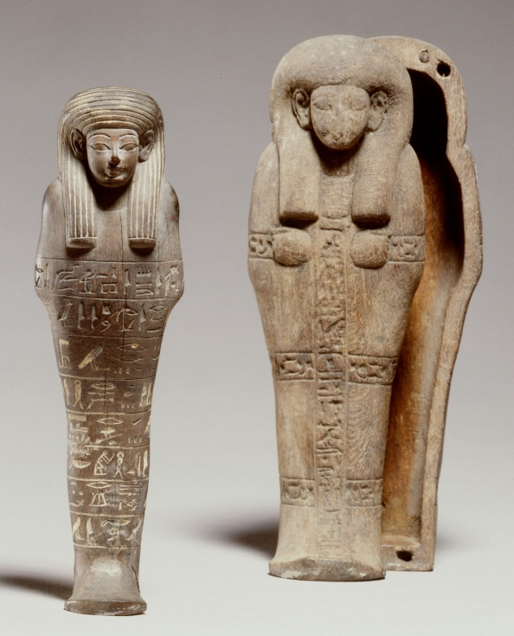
Figure 9. Shabti of Amenemope/Ipuy next to anthropoid model coffin with inscribed mummy bandages (Nut spell). Wood. Height 18 cm (shabti) and 21 cm (coffin). From Thebes (?). Dynasty 18/19. Leiden, National Museum of Antiquities L.IX.10. Typology 3.1.1.5.
material and quality. According to ostracon IFAO 764, the price for 40 shabtis was one deben (Janssen 1975: 243). The low price might be an argument for the obtainability of shabtis even for the poor (Poole 1999: 109; contra Schneider 1977, Vol. 1: 9: “Shabtis for the poor never existed”). However, the entire ostracon deals with decoration prices only (Cooney 2007: 32). The “bill of sale for a set of ushabtis” (Edwards 1971) does not mention a price, unfortunately.
Storage
Mass production also influenced the storage of shabtis. In the Middle and New Kingdom, individual shabtis were placed, like mummies, in miniature coffins (fig. 9) or, like divine images, in little shrines with vaulted lids. Originally the coffins were rectangular, later rishi-shaped and anthropoid. In the Ramesside Period, shabtis were also stored in pottery jars locked with jackal-headed lids (to be distinguished from Duamutef canopic jars).
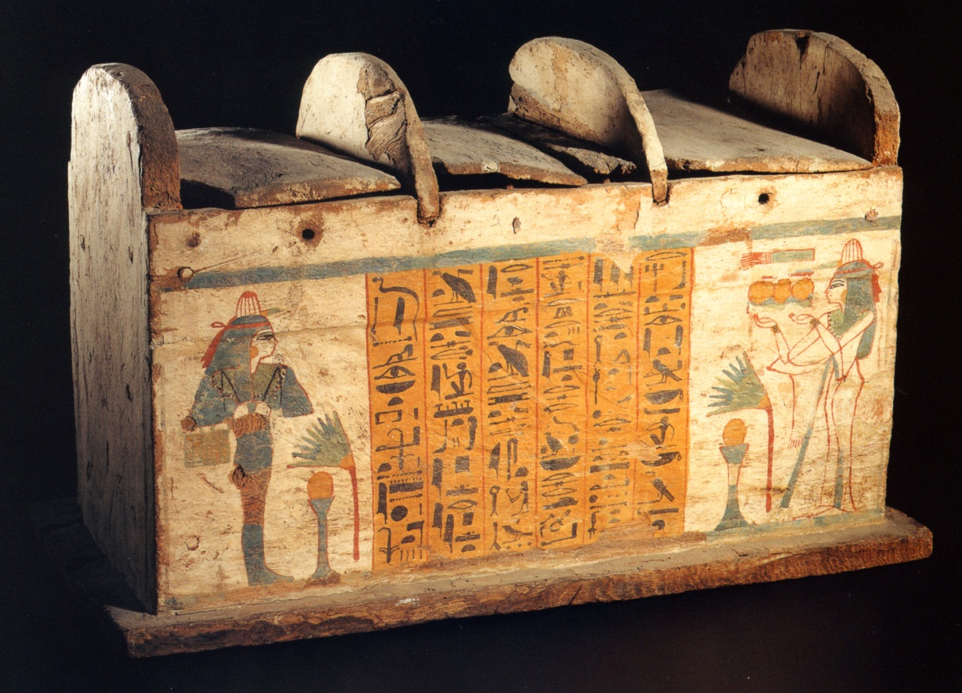

Figure 10. Shabti-box of the lady Mutemmertes who is facing her own shabti carrying hoes and a basket. Shabti spell in between. Wood. Height 34.5 cm, length 56 cm, and width 32 cm. Dynasty 22. Leiden, National Museum of Antiquities AH 186.

With the increase in number of shabtis per burial, they were stored in multiple shrines and eventually stacked in painted boxes (fig. 10; Aston 1994). Shabtis have also been found freestanding near the mummy, in holes, or arrayed elsewhere in or in the vicinity of the tomb. They have also been dug out from depositories at other sacrosanct places (Pumpenmeier 1998). From ostracon Turin 57387 may be inferred that shabti box and shabtis were bought together (Cooney 2007: 32).
Typology
In his study on the Leiden shabtis, Schneider (1977, Vol. II: Chapter IV, pp. 22 - 24: Arrangement of the Catalogue) established a general typology starting with an indication of period, material, and iconography (see table 2), followed by a sequence number of the Leiden Collection.

Further information is classified in section and type codes, such as class (Cl.), wigs (W), hand positions (H), implements (I), bags and baskets (B), attributes (A), text position (Tp), and version of the shabti spell (V). Finally, specific data about the object are given.
In view of digitalization, a new typology is being developed (see Bibliographic Notes).

Period | Material | Iconography
1 Middle Kingdom | 1 wood | 0 royal persons
2 Second Intermediate Period | 2 stone | 1 private persons, mummiform, name mentioned
3 New Kingdom | 3 faience | 2 private persons, mummiform, name illegible
4 Third Intermediate Period | 4 glass | 3 private persons, mummiform, anonymous
5 Late - Ptolemaic Period | 5 pottery | 4 private persons, mummiform, uninscribed
 | 6 mud | 5 private persons, dress of daily life, name mentioned
 | 7 bronze | 6 private persons, dress of daily life, name illegible
 | 8 others | 7 private persons, dress of daily life, anonymous
Table 2. Main lines of a general typology of shabtis as developed by Schneider (1977).

Bibliographic Notes
So many shabtis, so many shabti publications! In 1952 Hans Bonnet gave an outstanding summary of the previous and current theories. An update appeared in the Lexikon der Ägyptologie (Schlögl 1985). In the meantime, Jacques and Liliane Aubert had published an extensive book on shabtis (Aubert and Aubert 1974). Fundamental, though, is the study by Hans Schneider (1977). Apart from substantial historical and religio-historical research, he developed a typology (Schneider 1977, Vol. 1: chapter IV) in order to make elaborate and repetitive descriptions of the abundant material superfluous. He submitted the collection of the National Museum of Antiquities in Leiden to this procedure (Schneider 1977, Vol. 2: passim) and made it manageable by means of key pages with outlines of the various types (Schneider 1977, Vol. 3; adopted in Janes 2002: 227 - 249). The building of databases and the use of the Internet required an adaptive approach. An international working-group developed a new typology (“grille de saisie”) and established a shabti-database: Base Internationale des Shaouabtis (BIS). From 1987 to 2007, Jean-Luc Chappaz, member of the working-group, published a very useful Annual Index of shabti figures in the Genevan Bulletin de la Société d’Egyptologie. The digital continuation of this work (la base sehedj) as well as the shabti database just mentioned can be found at the website of the Société d’Egyptologie, Genève. In the series Corpus Antiquitatum Aegyptiacarum, several shabti collections were made accessible, e.g., the shabti collections in the Allard Pierson Museum in Amsterdam (Van Haarlem 1990), the Etnografisk Museum in Oslo (Naguib 1985), the Kunsthistorisches Museum in Vienna (Reiser-Haslauer 1990, 1992), and museums in the Rhine-Main region (Schlick-Nolte and von Droste zu Hülshoff 1984). Schlögl (2000) published the collections in Kraków. The collection of the Bibliothèque Nationale in Paris has been described by Aubert and Aubert (2005). Apart from the collection of the Musée d’Art et d’Histoire in Geneva, Chappaz (1984) also brought specimens from private collections to light. So did Janes (2002), Schlögl and Brodbeck (1990), as well as Schlögl and Meves-Schlögl (1993). Shabtis have been studied from different angles: stick shabtis (Whelan 2007; Willems 2009), royal shabtis (Bovot 2003, Clayton 1972), shabtis from the world of Amenhotep III (Kozloff and Bryan 1992, Chapter X: 305 - 330), shabtis from the Amarna Period (Martin 1986), shabtis from Deir el-Medina (Valbelle 1972), and shabtis from the Caches of Deir el-Bahri (Aubert 1998). Excellent overviews appeared in the Shire Egyptology series (Stewart 1995) and in a chapter devoted to “Funerary Figurines” in Death and the Afterlife in Ancient Egypt by John Taylor (2001).
References
Aston, David
1994 The shabti box: A typological study. Oudheidkundige Mededelingen uit het Rijksmuseum van Oudheden te Leiden 74, pp. 21 - 54.
Aubert, Jacques, and Liliane Aubert
1974 Statuettes égyptiennes: Chaouabtis, ouchebtis. Paris: Librairie d'Amérique et d'Orient Adrien Maisonneuve.
2005 Statuettes funéraires égyptiennes du département des Monnaies, Médailles et Antiques. Paris: Bibliothèque Nationale de France. (Exhibition catalog.)
Aubert, Liliane
1998 Les statuettes funéraires de la Deuxième Cachette à Deir el-Bahari. Paris: Cybele.
Barguet, Paul
1967 Le Livre des Morts des anciens Egyptiens. Paris: Éditions du Cerf.
Bonnet, Hans
1952 Reallexikon der ägyptischen Religionsgeschichte. Berlin and New York: Walter De Gruyter. (Reprint 2000.)
Bourriau, Janine
1988 Pharaohs and mortals: Egyptian art in the Middle Kingdom. Cambridge and New York: Cambridge University Press.
Bovot, Jean-Luc
2003 Les serviteurs funéraires royaux et princiers de l’Ancienne Égypte. Musée du Louvre: Département des antiquités égyptiennes. Paris: Réunion des Musées Nationaux.
Buck, Adriaan de
1935- The Egyptian Coffin Texts (CT). 7 volumes (1935 - 1961). Chicago: The University of Chicago Press.
Budge, E. A. Wallis
1911 Hieroglyphic texts from Egyptian stelae &c. in the British Museum. Part I. London: British Museum.
Černỳ, Jaroslav
1942 Le caractère des oushebtis d’après les idées du Nouvel Empire. Part 1 and 2. Bulletin de l’Institut français d’archéologie orientale 41, pp. 105 - 133.
Chappaz, Jean-Luc
1984 Les figurines funéraires égyptiennes du Musée d’art et d’histoire et de quelques collections privées. Aegyptiaca Helvetica 10. Geneva: Le Musée.
1987- Répertoire annuel des figurines funéraires. Part 1 - 16. Bulletin de la Société d’égyptologie Genève 11, 12, 14 - 27 (1987 - 2007).
Clayton, Peter
1972 Royal bronze shawabti figures. Journal of Egyptian Archaeology 58, pp. 167 - 175.
Cooney, Kathlyn
2007 The cost of death: The social and economic value of ancient Egyptian funerary art in the Ramesside Period. Leiden: Nederlands Instituut voor het Nabije Oosten.
Edwards, I. E. S.
1971 Bill of sale for a set of ushabtis. Journal of Egyptian Archaeology 57, pp. 120 - 124.
Erman, Adolf, and Hermann Grapow (eds.)
1926- Wörterbuch der aegyptischen Sprache (WB). 7 volumes (1926 - 1963). Leipzig: J. C. Hinrichs.
Gesellensetter, Judith
2002 Das Sechet-Iaru: Untersuchungen zur Vignette des Kapitels 110 im Ägyptischen Totenbuch. PhD thesis: Würzburg University. (Internet resource: http://opus.bibliothek.uni-wuerzburg.de/volltexte/2002/375/. Accession date: January 2012.)
Haarlem, Willem van
1990 Shabtis. Vol. I and II. Corpus Antiquitatum Aegyptiacarum, Allard Pierson Museum, Amsterdam 2. Mainz: Philipp von Zabern.
Hayes, William Christopher
1953 The scepter of Egypt: A background for the study of the Egyptian antiquities in the Metropolitan Museum of Art I: From the earliest times to the end of the Middle Kingdom. Cambridge, Mass.: Harvard University Press.
1959 The scepter of Egypt: A background for the study of the Egyptian antiquities in the Metropolitan Museum of Art II: The Hyksos Period and the New Kingdom (1675 - 1080 B.C.). Cambridge, Mass.: Harvard University Press.
Heerma van Voss, Matthieu
1963 De sjawabti’s en het zandmysterie. Phoenix 9, pp. 53 - 57.
1987 Oud Egypte in het Princessehof. Leeuwarden: Museum het Princessehof.
Hornung, Erik
1979 Das Totenbuch der Ägypter. Zurich and Munich: Artemis.
Janes, Glenn
2002 Shabtis: A private view: Ancient Egyptian funerary statuettes in European private collections. Paris: Cybele.
Janssen, Jac. J.
1975 Commodity prices from the Ramessid Period: An economic study of the village of necropolis workmen at Thebes. Leiden: Brill.
Kozloff, Arielle, and Betsy Bryan
1992 Egypt's dazzling sun: Amenhotep III and his world. Cleveland: Cleveland Museum of Art. (With contributions by Lawrence Berman and Elisabeth Delange.)
Lapp, Günther
1997 The Papyrus of Nu (BM EA 10477). London: British Museum Press.
Loeben, Christian
1987 Ein Rundbild als Textillustration. In Form und Mass: Festschrift für Gerhard Fecht zum 65. Geburtstag am 6. Februar 1987, Ägypten und Altes Testament 12, ed. Jürgen Osing, and Günter Dreyer, pp. 286 - 306. Wiesbaden: Otto Harrassowitz.
Martin, Geoffrey
1986 Shabtis of private persons in the Amarna Period. Mitteilungen des Deutschen Archäologischen Instituts, Abteilung Kairo 42, pp. 109 - 129.
Moje, Jan
2008 Uschebtis mit hz-Vasen: Zeugnisse sich wandelnder Bedeutung altägyptischer Totenstatuetten. Chronique d’Égypte 83, pp. 5 - 19.

Molen, Rami van der
2000 A hieroglyphic dictionary of Egyptian Coffin Texts. Probleme der Ägyptologie 15. Leiden, Boston, and Cologne: Brill.
Morenz, Siegfried
1975 Die Herkunft der Uschebti. In Religion und Geschichte des alten Ägypten: Gesammelte Aufsätze, ed. Elke Blumenthal, and Siegfried Herrmann, pp. 295 - 303. Weimar: Hermann Böhlaus Nachfolger.
Naguib, Saphinaz-Amal
1985 Funerary Statuettes. Corpus Antiquitatum Aegyptiacarum, Etnografisk Museum, Oslo 1. Mainz: Philipp von Zabern.
Petrie, William Matthew Flinders
1935 Shabtis. London: British School of Egyptian Archaeology. (Reprinted Warminster 1974.)
Pleyte, Willem
1881 Chapitres supplémentaires du Livre des Morts, 162 à 174: Traduction et commentaire. Vol. 1 - 3. Leiden: Brill.
Poole, Federico
1999 Social implications of the shabti custom in the New Kingdom. In Egyptological studies for Claudio Barocas, Serie Egittologica 1, ed. Rosanna Pirelli, pp. 95 - 111. Naples: Instituto Universitario Orientale.
2005 All that has been done to the shabtis: Some considerations on the Decree for the Shabtis of Neskhons and P. BM 10800. Journal of Egyptian Archaeology 91, pp. 165 - 170.
2010 R-DbA and pronoun reference in the decree for the shabtis of Neskhons and P.BM EA 10800. Göttinger Miszellen 225, pp. 83 - 87.
Pumpenmeier, Frauke
1998 Eine Gunstgabe von seiten des Königs: Ein extrasepulkrales Schabtidepot Qen-Amuns in Abydos. Studien zur Archäologie und Geschichte Altägyptens 19. Heidelberg: Heidelberger Orientverlag.
Reiser-Haslauer, Elfriede
1990 Uschebti. Vol. I. Corpus Antiquitatum Aegyptiacarum, Kunsthistorisches Museum, Wien 5. Mainz: Philipp von Zabern.
1992 Uschebti. Vol. II. Corpus Antiquitatum Aegyptiacarum, Kunsthistorisches Museum, Wien 8. Mainz: Philipp von Zabern.
Schlick-Nolte, Birgit, and Vera von Droste zu Hülshoff
1984 Uschebtis. Corpus Antiquitatum Aegyptiacarum, Museen der Rhein-Main-Region 2. Mainz: Philipp von Zabern.
Schlögl, Hermann
1985 Uschebti. In Lexikon der Ägyptologie, Vol. 6 (columns 896 - 899), ed. Wolfgang Helck, and Wolfhart Westendorf. Wiesbaden: Otto Harrassowitz.
2000 Corpus der ägyptischen Totenfiguren der öffentlichen Sammlungen Krakaus. Krakow: Jagiellonian University; and Freiburg: Freiburg University, Switzerland.
Schlögl, Hermann, and Andreas Brodbeck
1990 Ägyptische Totenfiguren aus öffentlichen und privaten Sammlungen der Schweiz. Orbis Biblicus et Orientalis: Series Archaeologica 7. Freiburg: Academic Press; and Göttigen: Vandenhoeck & Ruprecht.
Schlögl, Hermann, and Christa Meves-Schlögl
1993 Uschebti: Arbeiter im ägyptischen Totenreich. Wiesbaden: Harrassowitz.
Schneider, Hans
1977 Shabtis: An introduction to the history of ancient Egyptian funerary statuettes with a catalogue of the collection of shabtis in the National Museum of Antiquities at Leiden. 3 volumes. Leiden: National Museum of Antiquities.

Speleers, Louis
1923 Les figurines funéraires égyptiennes. Brussels: Fondation universitaire de Belgique.
Stewart, Harry
1995 Egyptian shabtis. Shire Egyptology 23. Princes Risborough: Shire Publications Ltd.
Taylor, John
2001 Funerary figurines: Servants for the afterlife. In Death and the afterlife in ancient Egypt, pp. 112 - 135. London: British Museum Press.
Valbelle, Dominique
1972 Ouchebtis de Deir el-Médineh. Documents de fouilles 15. Cairo: Institut français d’archéologie orientale.
Warburton, David
1984- Some remarks on the manufacture and sale of shabtis. Bulletin de la Société d’égyptologie Genève 9 - 10 (1984 - 1985), pp. 345 - 355.
2007 Work and compensation in ancient Egypt. Journal of Egyptian Archaeology 93, pp. 175 - 194.
Whelan, Paul
2007 Mere scraps of rough wood?: 17th - 18th Dynasty stick shabtis in the Petrie Museum and other collections. London: Golden House Publications.
Willems, Harco
2009 Carpe diem: Remarks on the cultural background of Herodotus II.78. In Elkab and beyond: Studies in honour of Luc Limme, Orientalia Lovaniensia Analecta 191, ed. Wouter Claes, Herman de Meulenaere, and Stan Hendrickx, pp. 511 - 520. Leuven, Paris, and Walpole, Mass.: Peeters.
Ziegler, Christiane, and Jean-Luc Bovot
2006 L' art égyptien. Paris: Larousse.
External Links
Société d’égyptologie Genève
La base sehedj. (Internet resource: http://www.segweb.ch/. Accession date: August 2011.)
Image Credits
I am greatly indebted to Dr. Maarten J. Raven, curator of the Egyptian Department of the National Museum of Antiquities in Leiden (Netherlands), who kindly permitted me to illustrate the article with artifacts from the Leiden Museum. The reader should realize that some objects have been composed in one figure disregarding real sizes. Measures can be found in the list below.
Figure 1. Left: Shabti of Hesyef-shemsu-nesu in dress of daily life, carrying hoes and holding djed and tit amulets. Wood. Height 19.4 cm. Provenance unknown. Dynasty 19 (early). Inv. no. CI 3. Typology 3.1.5.5. © Photography National Museum of Antiquities, Leiden.
Right: Shabti of Wepwautmes in dress of daily life, holding ba-bird. Stela on the back inscribed with shabti spell. Wood (ebony). Height 25 cm. From Saqqara (?). Dynasty 19 (early). Inv. no. AH 117. Typology 3.1.5.3. © Photography National Museum of Antiquities, Leiden.
Figure 2. Uninscribed mummiform shabti. Green schist. Height 12.5 cm. Allegedly from Gebelein. Dynasty 12/13. Inv. no. F 1971/7.2. Typology 1.2.4.1. © Photography National Museum of Antiquities, Leiden.
Figure 3. Left: “Stick”-shabti of Teti-sa-Intef with hetep di nesut formula. Wood. Height 16 cm. From Dra Abu el-Naga. Dynasty 17. Inv. no. F 1971/2.4. Typology 2.1.1.4. © Photography National Museum of Antiquities, Leiden.
Right: Uninscribed “peg”-shabti. Alabaster. Height 15 cm. Provenance unknown. Dynasty 20. Inv. no. F 1961/12.1. Typology 3.2.4.10. © Photography National Museum of Antiquities, Leiden.
Figure 4. Shabti of the mayor (HAty-a) Khebeny. Painted limestone. Height 58.5 cm. From Abydos (?). Dynasty 17 (late) or 18 (early). Inv. no. AST 43. Typology 2.2.1.3. © Photography National Museum of Antiquities, Leiden.
Figure 5. Left: Shabti of the overseer Gautseshnu in dress of daily life holding whips. Faience, Deir el-Bahri blue glaze. From Deir el-Bahri (Cache II). Height 11.2 cm. Dynasty 21. Inv. no. F 93/10.81. Typology 4.3.5.5. © Photography National Museum of Antiquities, Leiden.
Right: Shabti of Hori, viceroy of Nubia, carrying hoes (front), brick molds, a yoke with waterpots, and a basket (back). Faience. Height 11 cm. From Tell Basta. Dynasty 20. Inv. no. F 1970/1.1. Typology 3.3.0.5. © Photography National Museum of Antiquities, Leiden.
Figure 6. Shabti of Nesypaheran with a seshed-band around the wig, carrying hoes and a basket. Faience. Height 10.6 cm. From Deir el-Bahri (Cache II). Dynasty 21. Inv. no. F 93/10.56. Typology 4.3.1.48. © Photography National Museum of Antiquities, Leiden.
Inset: Model of a shabti basket. Faience. Height 2.1 cm, length 6 cm, and width 2.9 cm. New Kingdom. Inv. no. L.XIII.22. © Photography National Museum of Antiquities, Leiden.
Figure 7. Shabti of the king’s scribe Horkhebi. Faience. Height 16.8 cm. From Thebes (?). Dynasty 25/26. Inv. no. AF 55. Typology 5.3.1.189. © Photography National Museum of Antiquities, Leiden.
Figure 8. Left: Shabti of Imhotep, standing on a pedestal supported by a dorsal pillar, grasping hoe and pick and carrying a basket over his left shoulder. Faience. Height 20.5 cm. From Saqqara (?). Dynasty 30. Inv. no. AF 38a. Typology 5.3.1.9. © Photography National Museum of Antiquities, Leiden.
Right: Shabti of Nesbanebdjed with text in T-shape. Faience. Height 16.5 cm. From Tell el-Ruba (Mendes). Dynasty 30. Inv. no. F 1970/1.4. Typology 5.3.1.164. © Photography National Museum of Antiquities, Leiden.
Figure 9. Shabti of Amenemope/Ipuy next to anthropoid model coffin with inscribed mummy bandages (Nut spell). Wood. Height 18 cm (shabti) and 21 cm (coffin). From Thebes (?). Dynasty 18/19. Inv. no. L.IX.10. Typology 3.1.1.5. © Photography National Museum of Antiquities, Leiden.
Figure 10. Shabti-box of the lady Mutemmertes who is facing her own shabti carrying hoes and a basket. Shabti spell in between. Wood. Height 34.5 cm, length 56 cm, and width 32 cm. Dynasty 22. Inv. no. AH 186. © Photography National Museum of Antiquities, Leiden.

