Do Belugas Send Sound Cues?
Experimental Verification of Blindfolded Imitation among Beluga

Yoshiaki Maeda¹, Yukimi Otomo², Hiroshi Katsumata¹, Kazutoshi Arai¹, & Tsukasa Murayama²

¹ Kamogawa Sea World

² Tokai University, School of Marine Science and Technology

Dolphins can successfully coordinate their behavior using audio signals. Therefore, the current study tested whether or not belugas can use sound to exchange information in a cooperative task and verified the mechanisms of the transmission of information during trials. The subjects are two male belugas, Nack and Duke. Nack was trained to rotate his body when the experimenter turned a hand in a circular motion (rotation cue) or to take a vertical position on the spot of the pool when the experimenter turned on a light toward the subject (headstand cue). Duke was required to do the same behavior as Nack but was blindfolded. During the test trials, the experimenter presented both cues toward Nack in random order. The result indicated that Nack responded correctly to both cues, and Duke behaved similarly to Nack. Moreover, Nack emitted different sounds in response to the cues, which indicates that Nack spontaneously transmitted information to Duke by emitting sounds, which led Duke to provide correct responses. Although Duke displayed the same behaviors as Nack did despite the lack of training to do so, Duke’s performance was due to learning by hearing sounds instead of training.

イルカ類は音を用いて行動を調整することができる．そこで本研究では，シロイルカが音を使って協調的な行動のために情報交換ができるかを調べ，情報伝達のメカニズムを検証した．被験体は2個体のオスのベルーガ，「ナック」と「デューク」である．ナックは，実験者が円を描くように手を回す（回転合図）と体を回転させ，また，ライトを向ける（逆立ち合図）と水槽の1点で垂直に立つように訓練された．目隠しをしたデュークにはナックと同じ行動をさせた．テストでは，実験者はナックに向かって両方の合図をランダムに呈示した．その結果，ナックは両方の合図に正しく反応し，目隠しをされたデュークもナックと同様の行動をとった．さらに，ナックはそれぞれの合図に応じて異なる鳴音を発したが，これはナックが自発的に音を発することでデュークに情報を伝達し，デュークが正しい反応を示したことを示している．デュークは模倣の訓練を受けていないにもかかわらず，ナックと同じ行動を示した．これは，デュークは事前の訓練ではなく，ナックからの音を聞いて学習したことによるものである．

Los delfines poseen la habilidad de coordinar exitosamente su comportamiento mediante señales de audio. Por lo tanto, el presente estudio evaluó si las belugas pueden usar sonidos para intercambiar información en una tarea cooperativa y exploró los mecanismos de transmisión de información durante las pruebas. Los sujetos fueron dos belugas macho, Nack y Duke. Nack fue entrenado para rotar su cuerpo cuando el experimentador giraba una mano en un movimiento circular (señal de rotación) o para tomar una posición vertical cuando el experimentador encendía una luz hacia el sujeto (señal de parada de cabeza). A Duke se le pidió que hiciera los mismos comportamientos que Nack, pero hizo el procedimiento con los ojos vendados. Durante las pruebas, el experimentador presentó ambas señales hacía Nack en orden aleatorio. Los resultados indicaron que Nack respondió correctamente a ambas señales y Duke se comportó de manera similar a Nack. Además, Nack emitió diferentes sonidos en respuesta a las señales, lo que indica que transmitió información espontáneamente a Duke mediante la emisión de sonidos y lo llevó a presentar respuestas correctas. A pesar de la falta de entrenamiento directo, Duke mostró los mismos comportamientos que Nack y su desempeño correspondió a un aprendizaje basado en la escucha de sonidos y no a un entrenamiento.

Keywords: beluga, communication, imitation, sound cue

Animals communicate using various means, one of which is sound. They use sound to provide information to other animals for different purposes, such as vigilance, reproduction, and foraging. Previous studies demonstrated a link between animal sociality and sound communication, in which animals with complex sociality use sound to communicate in complex ways, as illustrated in primates, and other animals (Freeberg, 2006; Krams et al., 2012; Lima et al., 2018). Group size is well known to be related to sound diversity (McComb & Semple, 2005), and the complex sociality of animals facilitates complex vocal communication (Freeberg et al., 2012).

Dolphins, which are highly adapted to underwater life, form groups and lead complex social lives. Social cetaceans produce various sounds (Herman & Tavolga, 1980; Jones et al., 2019). Scholars propose that sound plays an important function in their society. For example, discrete calls by killer whales (Orcinus orca) (Ford, 1989) and coda by sperm whales (Physeter macrocephalus) (Watkins & Schevill, 1977; Weilgart & Whitehead, 1993) are considered to be used for communication between individuals or within groups. In addition, the signature whistle, a unique sound of the bottlenose dolphins (Tursiops spp.) (Caldwell & Caldwell, 1968), functions as an individually unique label for the bottlenose dolphin (Janik, 2013), which they use to call out to other individuals and maintain cohesion within the group (Janik & Slater, 1998). May-Collado et al. (2007) found that sociality influenced the diversity of complex dolphin sounds. The type of sound produced by dolphins differs according to the presence or absence of other individuals (Terada et al., 2022), which indicates that they use different sounds for different situations. These findings suggest that sounds produced by dolphins contain certain types of information or have particular functions.

Previous studies reported that chimpanzees (Pan troglodytes) (Melis & Tomasello, 2019) and orangutans (Pongo pygmaeus) (Botting & Bastian, 2019) could facilitate task success by communicating through visual signals. Cooperative behavioral experiments were also conducted to elucidate the function of sound. In the case of bottlenose dolphins (King et al., 2021), for example, two individuals simultaneously pressed buttons in a task, in which the whistle of one individual was found to increase the success rate by coordinating the behavior between the two individuals. These findings clarified that dolphins successfully coordinate their behavior through audio signals. However, the type of information transmitted using sounds by individuals in these cases remains unclear.

Belugas (Delphinapterus leucas) produce a wide variety of sounds (Tyack & Clark, 2000) and are colloquially called the canary of the sea. Mishima et al. (2015) suggested that pulsed signals of belugas, which are termed creaking calls, are used as contact calls. In addition, scholars demonstrate that belugas have the ability to learn ringing sounds (Vergara & Barrett-Lennard, 2008), imitate human voices and synthetic sounds (Murayama et al., 2014; Ridgway et al., 2012), and use sounds for object labeling (Murayama et al., 2012), which suggests that a possibility exists that belugas may integrate these abilities into information using the emitted sounds. Therefore, the current study experimentally tested whether or not captive beluga whales use sound to exchange information in a cooperative task and verified the mechanism for transmission of information by sound.

Method

Subject

The subjects were two male belugas named Nack (body weight: 879 kg, total length: 384 cm, age: 28 years old) and Duke (body weight: 1470 kg, total length: 480 cm, age: 31 years old), which were kept in Kamogawa Sea World in Chiba Prefecture in Japan. Nack had previously undergone several types of cognitive experiments on the sounds emitted by Nack (Murayama et al., 2012; 2014; 2017) unrelated to the present study; however, neither subject has previously participated in any investigation involving blindfolded imitation.

Procedure

The experiments were performed at an indoor pool (depth: 3.5 m, width: 18 m, water temperature: 17.0°C) in Kamogawa Sea World. There is a clockwise water current in the pool.

In the training conducted before the experiment, each subject was trained to rotate his body when an experimenter turns a hand in a circular motion (i.e., a rotation cue) or to take a vertical position in a particular spot of the pool when an experimenter turns on the light toward a subject (i.e., headstand cue). Duke had never been trained to perform in imitation with or without being blindfolded. However, because Duke received reinforcement when blindfolded to imitate Nack’s behavior, Duke spontaneously came to perform the same behavior as Nack without being specifically trained to do so. In addition, when Nack makes any sounds, bubbles appear from the respiratory hole of Nack. Since we could also see the bubbles when we heard the sounds, we concluded that Nack emitted those sounds.

Two experimenters conducted the experiments. One was outside the pool to present cues to Nack (Figure 1). The other was inside the pool to set the eyecups to Duke and to give the subjects their rewards but stayed far from them during each trial to avoid influencing the experiment. The experimenters were randomly switched in their roles.

The study recorded the behavior of each subject for each trial using a video camera (HDR CX-470, SONY). The sounds emitted for each trial were recorded using a hydrophone (SH 200K, System Intech), which has a high sensitivity ranging from 20 Hz to 200 kHz. The hydrophone was placed in the middle of both individuals at a depth of 0.5 m (Figure 1). The emitted sounds were recorded into a data recorder (R-09HR, Roland) at a 16-bit, 500 kHz sampling rate.

The two subjects were located 10 m apart from each other with their head turned in different directions in the pool (Figure 1), such that one would not perceive the echolocation sounds of the other. Duke was blindfolded using eyecups during the trials but they were taken off between trials.

All sounds that were emitted during the experiment were then analog-bandpass filtered from 1kHz with a 70dB gain using a preamplifier (Aqua-feeler IV, Aquasound Inc). Moreover, we generated sound spectrograms (sonagrams) using Audition 3 (Adobe Co.).

Figure 1

Schematic diagram of experiment

hydrophone
Duke
Nack
eyecup
water current
Experimenter
10 m

The authors confirm that all experiments were performed in accordance with the relevant following guidelines and regulations. That is, all the research activities adhered to the Ethical Guidelines for the Conduct of Research Animals by Zoo and Aquariums issued by the World Association on Zoos and Aquariums (WAZA), the Code of Ethics issued by the Japanese Association of Zoos and Aquariums (JAZA), and the Japanese Act on Welfare and Management of Animals.

(a) Pre-test phase

Before the test trials, an experimenter stood in front of Duke and presented the rotation cue or headstand cue to only Duke (blindfolded) to confirm if Duke could see those cue signs and to determine if Duke would emit any sounds.

(b) Test phase

Control trial session

The experimenter stood in front of Nack outside the pool without movement for 10 s.

Test trial sessions

The experimenter stood in front of Nack outside the pool (Figure 1) and presented the rotation or headstand cue toward Nack for 3 s. A trial involved one cue signal, which was randomly ordered. Over one month, two to three trials including the training session took place a day. When not only Nack but also Duke responded correctly to each cue, then the experimenter inside the pool rewarded them one of fish each. If Nack, Duke, or both produced an incorrect response, then no rewards were given. The study analyzed the responses of the subjects after the presentation of each cue. All experiments were performed in water, therefore, both subjects were submerged below the water during all of the trials.

Statistics

Two independent t-tests were conducted to determine whether the mean duration time and the mean interval time of pulses/signals were statistically significant.

Results

(a) Pre-test phase

First, five trials were performed in each cue sign. Duke did not respond to any of the trials. Since Duke was trained to respond in response to the cue when he saw the cue, it was found that Duke could not see the experimenter's cue due to being blindfolded by eyecups. Furthermore, Duke produced no sound during the trials, which indicated that Duke did not spontaneously or arbitrarily emit any sound while being blindfolded, even in the presence of Nack.

(b) Test phase

Control trial

This phase is composed of five trials. Although no cue was presented for 10 s, both subjects produced no movement or sound. In other words, they did not arbitrarily respond without a cue from the experimenter.

Test trial

In the rotation cue trials, a total of 15 trials were performed. When the experimenter presented the cue toward Nack, not only Nack but also Duke rotated his body. It was successful in 14 out of 15 trials. The only incorrect response was that Duke conducted a headstand for the rotation cue in which Nack gave the correct response. In the headstand cue trials, a total of 16 trials were performed. For all trials, Nack and Duke performed correctly. Both subjects responded correctly to the majority of trials for both cues, thus, the percentages of correct responses were very high (Table 1).

Table 1

Correct responses of each individual in each cue trial

 | Nack | Duke
 | correct trials/total trials  (percentage of correct responses) | correct trials/total trials  (percentage of correct responses)
Rotation cue  trial | 15/15 (100%) | 14/15 (93.3%)
Headstand cue trial | 16/16 (100%) | 16/16 (100%)

We analyzed pictures from the video recording and observed that Nack responded within 2 s after a cue was presented. Therefore, we analyzed the sounds emitted up to 2 s after the cue presentation.
Many sounds were emitted and recorded during the trials. During the pre-test phase, Duke did not spontaneously emit any sound while being blindfolded, even in the presence of Nack. In addition, as mentioned above, since it has been confirmed that bubbles are emitted from the respiratory holes of Nack when Nack makes such sounds, we considered that the sounds recorded in the test phase were thought to be emitted only by Nack.

While intermittent tonal signals were recorded in the rotation cue trials, clicks were recorded in the headstand cue trials. Figure 2 shows a few sonograms in the successful trials for each cue. The study observed many tonal signals or pulses in the sonograms of the trials for both cues, however, distinctive differences existed between these cue trials on duration time (Figure 3a) and interval time between signals or pulses (Figure 3b).

Figure 2

A few sonograms in the successful trials. The dashed lines represent the analysis range (2 s)
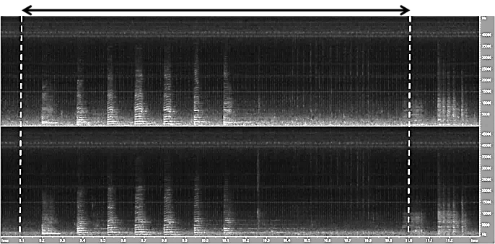
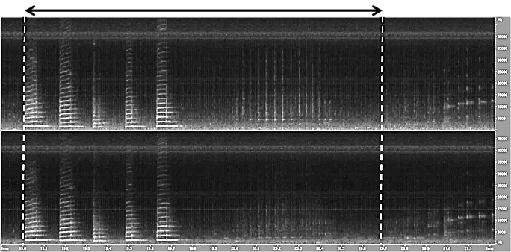
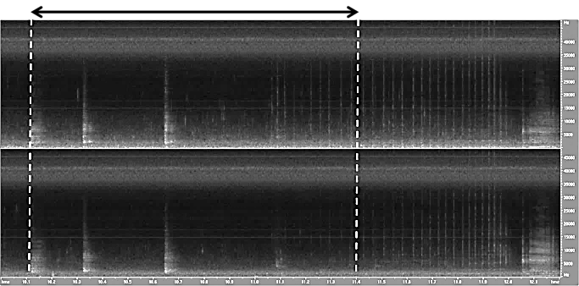
40
20
0
Frequency (kHz)
Time (sec)
0
2
1
0
2
1
0
2
1
Time (sec)
Time (sec)
a

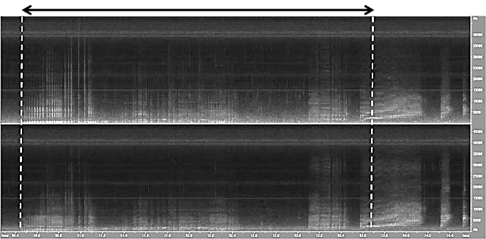
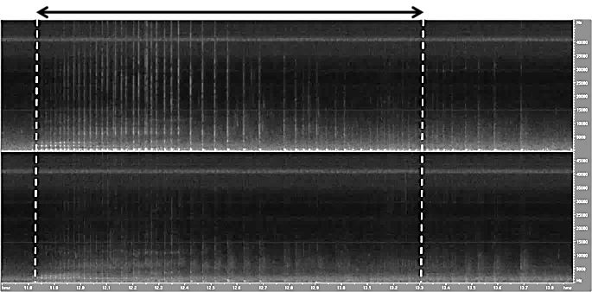
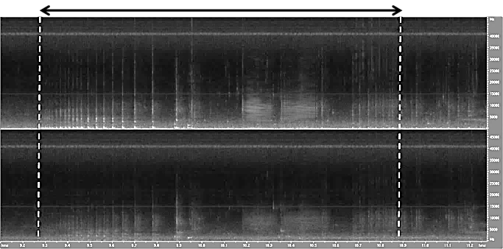
0
2
1
0
2
1
0
2
1
Time (sec)
Time (sec)
Time (sec)
40
20
0
Frequency (kHz)
b

Note. a: rotation cue trials, b: headstand cue trial.

Figure 3

Legends of duration time (a) and interval time between pulses (b)

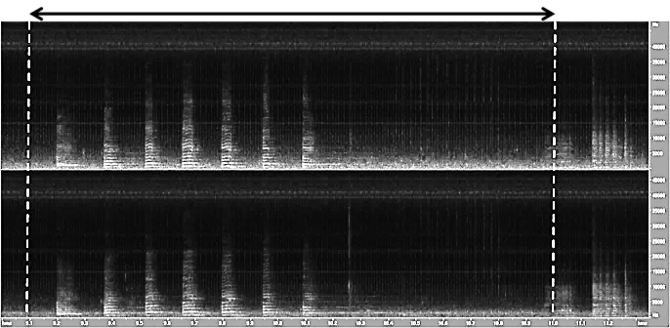
a
b

For the rotation cue, two types of sounds were observed in the sonagrams (Figure 2a); one is a tonal signal with short duration time, and the other is a click. The tonal signals were always included which were evident during the first half of the sonagrams. In addition, the interval between signals was relatively long. Alternatively, in the sonagrams for the trials for the headstand cue, only clicks but not tonal signals with long duration time were observed (Figure 2b). The interval between pulses was relatively short.

We then compared the mean duration time of signals/pulses and the mean interval time between signals/pulses for the first 2 - 5 pulses per trial for each cue (Table 2). The mean duration time of the trial for the rotation cue (M = 83.9, SD = 39.3) was significantly longer than the trials for the headstand cue (M = 8.9, SD = 3.5) (t-test, t(113) = 10.0, d = 1.49, p = .007), and the mean interval time of the trials for the rotation cue (M = 185.4, SD = 69.5) was significantly longer than the trials for the headstand cue (M = 26.2, SD = 11.6) (t-test, t(100) = 8.73, d = 1.73, p = .013).

Table 2

Comparison of mean duration time and mean interval time.

 |  |  | mean duration time (ms)  (M ± SD) |  | mean interval time (ms)  (M ± SD)
Rotation cue trial |  |  | 83.9 ± 39.3 (N = 41) |  | 185.4 ± 69.5 (N = 31)
Headstand cue trial |  |  | 8.9 ± 3.5 (N = 74) |  | 26.2 ± 11.6 (N = 71)

Note. ms: millisecond, M: mean, SD: standard deviation.

Discussion

Cetaceans are speculated to communicate through sound. Certain species of cetaceans use pulsed sounds as contact calls, such as the coda of sperm whales (Weilgart & Whitehead, 1993) and the discrete call of killer whales (Ford, 1989). It has also elucidated that sound is used differently according to the situation between individuals. In the wild, bottlenose dolphins form alliances and engage in various behaviors to protect themselves from rival alliances (Connor & Krützen, 2015; Owen et al., 2002). During these behaviors, sound plays an important role in collective behavioral coordination (King et al., 2019; Moore et al., 2020). Captive dolphins produce different sounds depending on the number of individuals in the vicinity and their behaviors, and it is demonstrated that these sounds have some function as contact calls or are involved in friendly behaviors (Terada et al., 2022). Eskelinen et al. (2016) reported high sound production rates during cooperative successes in a cooperative task. This suggested that acoustic signals play an important role in cooperative tasks and functions as vital communication tool.

The objectives of these sound emissions in cetaceans are postulated to be associated with reproduction or maintenance of groups (Janik & Slater, 1998; Tyack & Clark, 2000), which are essential for their life. For example, the packet tone of dolphins functions as a contact call to convey information about their location, and the burst pulse is used for various forms of intraspecific communication such as threats and prey capture (Nakahara, 2002). The signature whistle of bottlenose dolphins is hypothesized to function as an interaction with a specific individual/partner (Caldwell & Caldwell, 1968; Janik et al., 2006). In this manner, the possibility exists that sound is used to transmit various information among cetaceans, however the meaning of each emitted sound remains unclear.

Duke produced correct responses although he could not see the cue as he was blindfolded, and his responses corresponded to those of Nack. Jaakkola et al. (2013) demonstrated in the blindfolded imitation study that an Atlantic bottlenose dolphin (T. truncatus) switched strategies when mimicking model behaviors, recognizing behaviors by the characteristic sounds of model behaviors and by echolocation for more novel sound behaviors. As in Jaakkola et al. (2013), passive acoustics played a role in the outcome also in the current study. However, in the current study, the pool has a clockwise water current, and Duke is positioned upstream of the current and both subjects were positioned far enough apart (10 m apart), thus, Duke could not perceive Nack's movements according to the experimenter’s cue. Moreover, the experiments were carried out in water, so no splashing occurred even if Nack acted underwater. In addition, the beamwidth of echolocation for a beluga is approximately 6.5° in the horizontal plane (Au et al., 1987), and the subjects are positioned with their heads turned in different directions (Figure 1), so, the echolocation direction of each subject was also different. Moreover, Duke had never been trained to imitate behavior and was not ordered to imitate Nack’s behavior in the current study. Therefore, we propose that Duke responded neither by sensing the movements of Nack nor by echolocation, that is, Duke based his movements on the sounds emitted by Nack. The results demonstrate that the two belugas used vocal signals to accomplish cooperative actions.

Nack emitted different sounds in response to the experimenter’s cue, such that Duke was able to provide correct responses to the cues. However, Nack was not trained to emit sounds. Therefore, we considered that Nack spontaneously transmitted information to Duke by sound. Since Duke was not trained to perform the same behavior as Nack, the results were not due to training but rather from learning. In contrast, the rotation and headstand behaviors imposed by the current study are not essential for the subjects. Nack used his emitted sounds to transmit certain information to Duke, thus, the study concludes that belugas can use sound and transmit information, even regarding aspects that are not particularly ecologically necessary for living. In addition, they spontaneously used different sounds according to particular purposes. In the cooperative tasks for captive dolphins, a few individuals used vocal signals to facilitate the successful execution of cooperative actions. This result indicates that they use vocal communication to actively coordinate in a cooperative context (King et al., 2021). The current results suggest that belugas also communicate with other individuals by emitting sounds to accomplish cooperative tasks.

Acknowledgments

The authors would like to express our gratitude to the staff of Kamogawa Sea World for their excellent cooperation in conducting this research. We thank Dr. F. Nakahara for useful comments on the manuscripts and anonymous reviewers for important suggestions and information for this study.

References

Au, W. W. L., Penner, R. H., & Turl, C. W. (1987). Propagation of beluga echolocation signals. The Journal of the
Acoustical Society of America, 82, 807–813. https:/doi.org/10.1121/1.395278
Botting, J., & Bastian, M. (2019). Orangutans (Pongo pygmaeus and Hybrid) and gorillas (Gorilla gorilla gorilla) modify
their visual, but not auditory, communicative behaviors, depending on the attentional state of a human experimenter. International Journal of Primatology, 40, 244–262. https:/doi.org/10.1007/s10764-019-00083-0
Caldwell, M. C., & Caldwell, D. K. (1968). Vocalization of naive captive dolphins in small groups. Science, 159, 1121–
1123. https:/doi.org/10.1126/science.159.3819.1121
Connor, R. C., & Krützen, M. (2015). Male dolphin alliances in Shark Bay: Changing perspectives in a 30-year study.
Animal Behaviour, 103, 223–235. https:/doi.org/10.1016/j.anbehav.2015.02.019
Eskelinen, H. C., Winship, K. A., Jones, B. L., Ames, A. E. M., & Kuczaj, S. A. (2016). Acoustic behavior associated
with cooperative task success in bottlenose dolphins (Tursiops truncatus). Animal Cognition, 19, 789–797. https://doi.org/10.1007/s10071-016-0978-1

Ford, J. K. B. (1989). Acoustic behaviour of resident killer whales (Orcinus orca) off Vancouver Island, British Columbia.
Canadian Journal of Zoology, 67, 727–745. https://doi.org/10.1139/z89-105
Freeberg, T. M. (2006). Social complexity can drive vocal complexity: Group size influences vocal information in
Carolina chickadees. Psychological Science, 17, 557–561. https://doi.org/10.1111/j.1467-9280.2006.01743.x
Freeberg, T. M., Dunbar, R. I., & Ord, T. J. (2012). Social complexity as a proximate and ultimate factor in communicative
complexity. Philosophical Transactions of the Royal Society B: Biological Sciences, 367, 1785–1801.
https:/doi.org/10.1098/rstb.2011.0213
Herman, L. M., & Tavolga, W. (1980). The communication system of cetaceans. In L.M. Herman (Ed.), Cetacean
Behavior (pp.149–209). John Wiley & Sons.
Jaakkola, K., Guarino, E., Rodriguez, M., & Hecksher, J. (2013). Switching strategies: A dolphin’s use of passive and
active acoustics to imitate motor actions. Animal Cognition, 16, 701–709.
https:/doi.org/10.1007/s10071-013-0605-3
Janik, V. M. (2013). Cognitive skills in bottlenose dolphin communication. Trends in Cognitive Sciences, 17, 157–159.
https:/doi.org/10.1016/j.tics.2013.02.005
Janik, V. M., Sayigh, L. S., & and Wells, R. S. (2006). Signature whistle shape conveys identity information to bottlenose
dolphins. Proceedings of the National Academy of Sciences of USA, 103, 8293–8297. https:/doi.org/10.1073/pnas.0509918103
Janik, V. M., & Slater, P. J. B. (1998). Context-specific use suggests that bottlenose dolphin signature whistles are
cohesion calls. Animal Behaviour, 56, 829–838.
Jones, B., Zapetis, M., Samuelson, M. M., & Ridgway, S. (2019). Sounds produced by bottlenose dolphins
(Tursiops): A review of the defining characteristics and acoustic criteria of the dolphin vocal repertoire.
Bioacoustics, 29, 399–440. https:/doi.org/10.1080/09524622.2019.1613265
King. S., Allen. S., Krützen, M., & Connor, R. (2019). Vocal behaviour of allied male dolphins during cooperative mate
guarding. Animal Cognition, 22, 991–1000. https:/doi.org/10.1007/s10071-019-01290-1
King, S. L., Guarino, E., Donegan, K., McMullen, C., & Jaakkola, K. (2021). Evidence that bottlenose dolphins can
communicate with vocal signals to solve a cooperative task. Royal Society. Open Science, 8, 202073. https:/doi.org/10.1098/rsos.202073
Krams, I., Krama, T., Freeberg, T.M., Kullberg, C., & Lucas, J.R. (2012). Linking social complexity and vocal
complexity: A parid perspective. Philosophical Transactions of the Royal Society B: Biological Sciences, 367, 1879–1891. https://doi.org/10.1098/rstb.2011.0222
Lima, S. G. C., Sousa-Lima, R. S., Tokumaru, R. S. Nogueira-Filho, S. L. G., & Nogueira, S. S. C. (2018). Vocal
complexity and sociality in spotted paca (Cuniculus paca). PLoS ONE, 13(1), e0190961.
https:/doi.org/10.1371/journal.pone.0190961
May-Collado, L. J., Agnarsson, I., & Wartzok, D. (2007). Phylogenetic review of tonal sound production in whales in
relation to sociality. BMC Evolutionary Biology, 7, 1–20. https:/doi.org/10.1186/1471-2148-
7-136
McComb, K., & Semple, S. (2005). Coevolution of vocal communication and sociality in primates. Biological Letters, 1,
381–385. https://doi.org/10.1098/rsbl.2005.0366
Melis, A. P. & Tomasello, M. (2019). Chimpanzees (Pan troglodytes) coordinate by communicating in a collaborative
problem-solving task. Proceedings of the Royal Society B, 286, 20190408.
https:/doi.org/10.1098/rspb.2019.0408
Mishima, Y., Morisaka, T., Itoh, M., Matsuo, I., & Sakaguchi, A. (2015). Individuality embedded in the isolation calls of
captive beluga whales (Delphinapterus leucas). Zoological Letters, 1, 1–13. https://doi.org/10.1186/s40851-015-0028-x
Moore, B. M., Connor, R. C., Allen, S. J., Krützen, M. & King, S. L. (2020). Acoustic coordination by allied male dolphins in a cooperative context. Proceedings of the Royal Society B, 287, 20192944.
https:/doi.org/10.1098/rspb.2019.2944
Murayama, T., Iijima, S., Katsumata, H., & Arai, K. (2014). Vocal imitation of human speech, synthetic sounds and
beluga sounds, by a beluga (Delphinapterus leucas). International Journal of Comparative Psychology, 27, 369–84. https://doi.org/10.46867/ijcp.2014.27.03.10
Murayama, T., Suzuki, R., Kondo, Y., Koshikawa, M., Katsumata, H., Arai, K. (2017). Spontaneous establishing of cross-modal stimulus equivalence in a beluga whale. Scientific Reports, 7, 9914. https:/doi.org/10.1038/s41598-017-09925-4
Murayama, T., Fujii, Y., Hashimoto, T., Shimoda, A., Iijima, S., Hayasaka, K., Shiroma, N., Koshikawa, M., Katsumata, H., Soichi, M., Arai, K. (2012). Preliminary study of object labeling using sound production in a beluga. International Journal of Comparative Psychology, 25, 195–207. https://doi.org/10.46867/ijcp.2012.25.03.04
Nakahara, F. (2002). Social functions of cetacean acoustic communication. Fisheries Science, 68 (Suppl.), S298–301. https://doi.org/10.2331/fishsci.68.sup1_298
Owen, E. C. G., Wells, R. S., & Hofmann, S. (2002). Ranging and association patterns of paired and unpaired adult male
Atlantic bottlenose dolphins, Tursiops truncatus, in Sarasota, Florida, provide no evidence for alternative male strategies. Canadian Journal of Zoology, 80, 2072–2089. https:/doi.org/10.1139/z02-195
Ridgway, S., Carder, D., Jeffries, M., & Todd, M. (2012). Spontaneous human speech mimicry by a cetacean. Current
Biology, 22, 860–861.
Terada, T., Morisaka, T., Wakabayashi, I., & Yoshioka, M. (2022). Communication sounds produced by captive narrow-
ridged finless porpoises (Neophocaena asiaeorientalis). Journal of Ethology, 40, 245–256. https://doi.org/10.1007/s10164-022-00755-0
Tyack, P. L., & Clark, C. W. (2000). Communication and Acoustic Behavior of Dolphins and Whales. In Au, W. W. L.,
Fay, R. R. & Popper, A. N. (Eds.), Hearing by Whales and Dolphins (pp. 156–224). Springer.
Vergara, V., & Barrett-Lennard, L. G. (2008). Vocal development in a beluga calf (Delphinapterus leucas). Aquatic
Mammals, 34, 123–143. https://doi.org10.1578/AM.34.1.2008.123
Watkins, W.A., & Schevill, W. E. (1977). Sperm whale codas. The Journal of the Acoustical Society of America, 62,
1485–1490. https://doi.org/10.1121/1.381678
Weilgart, L., & Whitehead, H. (1993). Coda communication by sperm whales (Physeter macrocephalus) off the
Galápagos Islands. Canadian Journal of Zoology, 71, 744–752. doi.org/10.1139/z93-098

Financial conflict of interest: No stated conflicts.
Conflict of interest: No stated conflicts.
Submitted: April 24th, 2023
Resubmitted: September 30th, 2023
Accepted: October 23rd, 2023

