Effortful Foraging Activity for Uncertain Food in Pigeons

Patrick Anselme, Fatma Oeksuez, Nurdem Okur, Roland Pusch, and Onur Güntürkün

Department of Biopsychology, Ruhr-University Bochum, Germany

When well-known food resources are running out, animals extinguish their foraging behavior in that food patch and increasingly work for reward-related information to decrease outcome uncertainty. In the absence of such information, a potentially successful strategy consists of spending more time and effort searching for profitable locations—a phenomenon known from extinction learning experiments conducted in conventional conditioning chambers. Here, we tested this hypothesis by means of a semi-natural “foraging board” allowing pigeons to move and look for food items inside perforated holes. The holes could be covered with a slit plastic tape, hiding the food items they contained while making them accessible to pigeons. Our goal was to determine how pigeons forage on hidden food items in an area associated with uncertainty (one in three holes baited, on average) when visible or hidden food items were available in an adjacent area associated with certainty (each hole baited). The number of food items was equivalent in both areas. We expected longer time spent and more pecks given in the uncertain versus certain area with the food items visible in the certain area, as well as longer time spent and more pecks given per visit in the uncertain versus. certain area with the food items either visible or hidden in the certain area. Our results confirm these predictions.

ハトにおける不確かな餌に対する努力的な採餌活動

なじみの食物資源が枯渇すると、動物はその食物パッチでの採食行動を止め、結果の不確実性を減らすために報酬に関連する情報を探す行動を増やす。そのような情報がない場合、成功する可能性のある戦略は、より多くの時間と労力を費やして有益な場所を探すことである（この現象は、従来の条件付け実験室で行われた消失学習実験から知られている）。ここでは、ハトが動いて有孔穴の中の餌を探すことができる半自然的な「採餌板」を用いて、この仮説を検証した。穴は切れ目の入ったビニールテープで覆うことができ、入っている餌を隠しつつ、ハトがアクセスできるようにすることができる。我々の目的は、隣接した「確実性のある区画（各穴に餌がある）」で目に見える餌や隠れた餌が得られたとき、ハトが「不確かな区画（平均して3穴に1穴の割合で餌がある）」で隠れた餌をどのように採餌するかを明らかにすることであった。餌の数はどちらの区画でも同じだった。私たちは、「確実性のある区画」において餌が目に見える形で配置されている場合、「確実性のある区画」対して、「不確かな区画」においてより長い時間を費やし、つつき回数が多くなると予想した。同様に、「確実性のある区画」において餌が見えているもしくは隠されている場合においても、「確実性のある区画」より「不確かな区画」において1訪問あたりに長い時間を費やし、つつき回数が多くなると予想した。我々の結果は、これらの予測を裏付けるものである。

Actividad de Forrajeo con Esfuerzo para Comida Incierta en Palomas

Cuando los recursos alimentarios conocidos se están agotando, los animales extinguen su comportamiento de forrajeo en esa zona de alimentación y comienza a trabajar más para adquirir información relacionada con la recompensa y disminuir la incertidumbre para encontrarla. En ausencia de dicha información, una estrategia potencialmente exitosa consiste en dedicar más tiempo y esfuerzo a buscar ubicaciones productivas, un fenómeno descrito desde experimentos de aprendizaje de extinción realizados en cámaras de condicionamiento convencionales. En este artículo, evaluamos esta hipótesis por medio de una "tabla de forrajeo" seminatural que permite a las palomas moverse y buscar alimentos dentro de los agujeros perforados. Los agujeros pueden cubrirse con una cinta plástica, ocultando los alimentos o haciéndolos accesibles a las palomas. Nuestro objetivo fue determinar cómo las palomas forrajean por alimentos ocultos en un área asociada con incertidumbre (uno de cada tres hoyos cebados, en promedio) cuando los alimentos visibles u ocultos estaban disponibles en un área adyacente asociada con certeza (cada hoyo cebado). El número de alimentos fue equivalente en ambas zonas. Se esperaba que las palomas pasarán más tiempo y picotearan más en el área de incertidumbre versus la de certeza con los alimentos visibles en el área de certeza, así como más tiempo y más picoteos por visita en el área incierta versus el área determinada con los alimentos visibles u ocultos en el área de certeza. Nuestros resultados confirmaron estas predicciones.

Keywords: effort, matching, motivation, pecking, unpredictability

Procurement of primary reward—such as food—is a major driver of animal and human behaviors. Organisms are able to detect food items or to make some predictions about profitable locations they can approach. When those expectations are limited, because of reward uncertainty in the environment, searching for reliable information or just profitable locations should temporarily be favored over trying to obtain primary reward. Information seeking has repeatedly been found to motivate behavior to the detriment of primary reward procurement in various situations. For example, studies on extinction of operant behavior have indeed shown that, parallel to a decrease in a previously reinforced behavior, new, previously non-reinforced behaviors are observed that could indicate attempts to identify new information on alternative operant strategies (Donoso et al., 2021; Lattal & Lattal, 2012; Tinsley et al., 2002). Also, in the suboptimal choice task, pigeons (Columba livia), starlings (Sturnus vulgaris), and other species, may strongly prefer a rare cue consistently predictive of food to a more frequent cue inconsistently predictive of larger food amounts—such that their preference is suboptimal in terms of the reward rates to be obtained (Cunningham & Shahan, 2019; Fortes et al., 2016; Vasconcelos et al., 2015). Finally, human and nonhuman animals will work for non-instrumental information—which does not change the outcome to be delivered (FitzGibbon et al., 2020; Rodriguez Cabrero et al., 2019; Wang & Hayden, 2019).

By contrast, if limited information is available in an uncertain environment, a relevant strategy that may lead to reward procurement is to spend more time (i.e., scrutinize a place longer) and effort (e.g., peck or dig around more often) searching the location of the profitable resource. For example, Stahlman and Blaisdell (2011) tested rats (Rattus norvegicus) on a foraging board with 16 cups containing sand and one of these cups was associated with a high-food landmark (i.e., a food item was buried in sand with a 100% probability) or a low-food landmark (i.e., a food item was buried in sand with only a 20% probability). These authors did not measure time and effort spent, but they found a higher variability in total number of cups inspected before the rats searched in the cued cup, in the low-food than in the high-food trials. In the present study, we investigated the time and effort spent searching for food on a foraging board with pigeons. We used a “foraging board” allowing pigeons to move and look for food items inside perforated holes. The holes could be covered with a slit plastic tape, hiding the food items they contained while making them accessible to pigeons. Our goal was to determine how pigeons forage on hidden food items in an area associated with uncertainty (one in three holes baited, on average) when an equivalent number of visible or hidden food items were available in an adjacent area associated with certainty (each hole baited), at the beginning of a training session. The food depletion status in the certain area is easier to assess by pigeons when the food items are visible rather than hidden, and this should have an impact on behavior in the uncertain area. Indeed, both the matching law (Herrnstein, 1961) and optimal foraging theory (Stephens & Krebs, 1986) predict a primary focus of animals on reward, and there is evidence that foraging activity is more intense for visible than hidden food items in pigeons (Anselme et al., 2018). Depletion of the certain area should be faster when the food items are visible, leading possibly to longer and stronger foraging activity in the uncertain area.

In a previous study with our foraging board (in which all the holes were covered) and noticeable differences in the situations tested, we found that more foraging time and effort per visit were observed in the uncertain area than expected based on reinforcement rates (Anselme et al., 2022). The pigeons had to choose between 30 cued covered holes consistently baited with one food item per hole (with 60 cued covered empty holes) on one side of the board and 30 cued covered holes randomly baited out of 90 holes on the other side. Although the pigeons spent more time and gave more pecks in the 30 holes associated with certainty, they spent more time and effort per visit in the uncertain area. Given that they consumed similar amounts of food in both areas, we argued that the additional investment was necessary to optimize food procurement in the uncertain area. We could not determine whether behavior rates reflected the decrease in reinforcement rates in the certain and uncertain areas, so that the matching law could not be used in the strict sense (Baum, 1974; Herrnstein, 1961). But our pigeons constantly traveled between the two areas and food depletion was similar in both areas at the end of each session, suggesting overmatching in time and effort per visit in the uncertain area. Given that organisms do not typically prefer uncertainty to certainty (pigs, Sus scrofa: de Jonge et al., 2008; macaques, Macaca mulatta: Eisenreich et al., 2019; humans: Gneezy et al., 2006; fish, Carassius auratus: Purdy & Peel, 1988; pigeons: Wilton & Clements, 1971), these findings indicate that uncertainty is able to boost their investment in the task of obtaining more food items (Anselme & Güntürkün, 2019).

Replicating the behavioral effects shown in our previous study, despite significant configurational and methodological changes, would indicate that deviations from strict matching in a foraging context is a robust phenomenon. First, we expected longer time spent and more pecks given in the uncertain versus certain area with the food items visible in the certain area (Experiment 1), as explained above, but perhaps not with the food items hidden in the certain area (Experiment 2). In this second scenario, the certain area becomes more uncertain after a few pecks and quickly equivalent in terms of reward rate to the (initially) uncertain area. Differential behaviors in both areas would possibly be indicative of a motivational/cognitive bias induced by differential reward density when a session starts, as shown in Anselme et al. (2022). Here, we introduced significant variations relative to this study to determine whether the behavioral effects (biases) are replicable. Second, we expected longer time spent and more pecks given per visit in the uncertain versus certain area both with the food items visible (Experiment 1) and the food items hidden (Experiment 2) in the certain area. Although we saw that uncertainty is often avoided, when possible, in the absence of a better alternative due to quick depletion of the certain area, uncertainty tends to stimulate behavioral investment and should therefore favor foraging persistence when food per hole is not guaranteed (e.g., Bateson et al., 2021; Crawford et al., 1985; Glueck et al., 2018; Robinson et al., 2014). Again, an absence of major alteration in the behavioral effects despite important variations in design would indicate robustness of the results.

Experiment 1: Method

The goal of this experiment was to determine the extent to which pigeons can favor food items both hidden and randomly distributed (33.3% probability per hole) in an area when the same resource is visible and in maximal density (100% probability per hole) in another area at the beginning of a session.

Animals and Housing Conditions

Nine adult homing pigeons (5 females; average age of all pigeons: 5.42 ± 1.15 years) obtained from local breeders had already been used in a related experiment several months beforehand. They were maintained at 85-90% of their free-feeding body weight for the duration of the experiment. Water was accessible ad libitum in their home cage and the pigeons did not receive additional food supply to the amounts consumed during a training session. Four pigeons were individually housed, while the other five individuals were housed in an aviary under a 12 hr light/dark cycle (lights on at 7:30 a.m.). Housing conditions were independent of sex. All procedures were approved by the ethics commission of the State of North Rhine-Westphalia, Germany, and followed the European Communities Council Directive 86/609/EEC concerning the care and use of animals for experimentation.

Apparatus

Pigeons were tested in a rectangular wooden box with a net on top to prevent them from flying away. The floor consisted of a horizontally removable brown plate of wood (120 cm length × 70 cm width × 2 cm height), perforated with 180 holes (1.5 cm diameter and < 2 cm depth). The holes were organized as nine rows of 20 holes regularly spaced and could be baited with one dried grain or seed (i.e., corn, green pea, yellow pea, or sunflower). As the board was heavy and difficult to manipulate, it was divided in two equal parts, and these two parts were placed next to each other during a session to form the complete board. A small entrance compartment (28.7 cm long × 20.4 cm width × 36 cm height) with two vertical doors allowed the experimenter to introduce the pigeon in the compartment (external door) and to give the pigeon access to the foraging board (internal door). The entrance compartment was located in the middle of one long side of the box, which was as the same height.

The foraging board was divided into three areas by means of blue-white strips (Figure 1A). One strip separated the board into two equal parts of 90 holes, split on either side from the entrance compartment. Another strip separated one of these two parts into two areas of 30 and 60 holes, perpendicularly to the first one. For these latter two areas, the holes were not covered; the pigeons could directly see whether a hole was baited or empty, even from a distance. The adjacent 90-holes area was covered with a black plastic tape, with a cross cut above each hole to create an opening. The openings allowed the pigeons to access the food items while minimizing the risk that they can detect their presence visually, even when located nearby. Specific stimuli (blue and yellow triangles; basis: 25.5 cm; height: 12.1 cm) were used to signal the consistent presence or absence of food per hole (see below) in the 30- and 60-holes areas, respectively. A blue-yellow stimulus (composed of the two triangles joined by their basis to form a rectangle) signaled the inconsistency of the hole-food associations (see below). These stimuli were placed on the walls, 2-4 cm above the floor level and only one per wall in each area. Each session was recorded with an external camera (GoPro – Hero7), placed above the apparatus.

Figure 1

Food consumption in the uncovered R area versus covered U area.

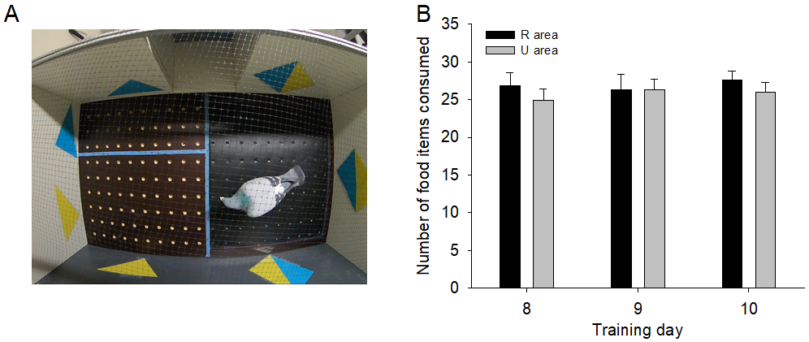
Note: Experiment 1. (A) Board 180 with three areas: 30 uncovered holes (R area) and 60 uncovered holes (NR area) on one side, and 90 covered holes (U area) on the other side. (B) Number of food items consumed during days 8-10 in the R and U areas. R: Consistently rewarded area; NR: Consistently non-rewarded area; U: Inconsistently rewarded area.

Before testing the pigeons in the configuration reported above, each individual was exposed to the stimuli for a few sessions. For that, we used another board of identical size with only 60 holes (six rows of 10 holes, regularly spaced). The holes were all covered, and a blue-white strip separated the board in two equal sides of 30 holes relative to the entrance compartment. The same blue and yellow triangles were used to differentiate a consistently rewarded area (each hole was baited) from a consistently non-rewarded area (each hole was empty). There was one triangle per wall on each side, and no blue-yellow combination was used at training.

Procedure

Both for training and test sessions, the meaning of each stimulus for food availability was counterbalanced across pigeons, and the location of the blue and yellow stimuli was also counterbalanced within the same individuals to reduce possible side preference maximally. Of note, these stimuli aimed to help the pigeons locate the different areas but their conditioned value in the absence of food was not tested. The food items consumed were manually counted after each session and the board was cleaned and prepared for the next pigeon. Once the pigeons were able to eat at least 80% of the food items available at training, they started the experimental (test) phase with the 180-hole board. To avoid confusion, the two boards will be referred to as Board 60 and Board 180 hereafter.

The pigeons were weighed and tested individually each day. For each daily session, one pigeon was placed in the entrance compartment via the external vertical door, which remained closed during the session. The internal vertical door giving the pigeon access to the board was then immediately removed and the entrance compartment remained open during the session. The pigeon could move and consume food items in the board’s holes or spend time in the entrance compartment for 10 min daily, and this treatment was repeated for 10 days.

On one side of Board 180, each hole was baited with one food item in the 30-hole area (rewarded [R] area, consistently rewarded) and each hole was empty in the 60-hole area (non-rewarded [NR] area, consistently non-rewarded). On the other side, which also contained 90 holes, 30 holes were randomly baited with one food item and the remaining 60 holes were empty (uncertain [U] area, inconsistently rewarded). Thus, a pigeon entering Board 180 had a choice between 30 food items consistently signaled and visible in the R area (blue or yellow triangle) and 30 food items inconsistently signaled and hidden in the U area (blue-yellow rectangle). For a given pigeon, the meaning of the stimuli had not changed from the training phase and the sides were counterbalanced in such a way that the U area could appear left or right and the R area close to or far from the entrance compartment during a session.

After a session, the pigeon was picked up using a fishing net from the entrance compartment and the number of food items consumed in the R and the U areas was manually counted. The board was cleaned and prepared for the next pigeon. The placement of the food items in the board’s holes of the U area followed a pre-established plan that changed every day and was counterbalanced for left-right and back-front preferences. After placing the food items, the corners of the crosscut plastic tape above the holes were realigned using a manual tweezer. No experimental work was conducted during the weekends.

Data Extraction and Statistical Analyses

Some data were obtained directly (i.e., body weight, food items consumed), while others were extracted from the video recordings (i.e., time spent per area, number of pecks per area, and number of visits per area). We collected video data from the last three test sessions, when behavior had become stable. In addition to processing the daily data, for each variable of interest, the average values for the three days were used to reduce random daily variations in performance and obtain more robust behavioral effects. Of note, determining whether a peck at a hole was successful (food item grasped) or not was mostly impossible from the videos, so that peck is not a synonym of item consumed. A peck simply meant vertical downshift of the pigeon’s head above a hole.

A pigeon was assumed to be present in an area if its head was in this area—because its body could be in one area while giving pecks in the adjacent one. No transition between two areas was counted if the pigeon came from one area, had a quick look of a few seconds above another area, and then went back to the first one. A peck given outside of a hole, even to get a food item that rolled on the board after an unsuccessful attempt to grasp it from a hole, was not counted. A pigeon might flap its wings while on the board, often traveling from one area to another. No crossing was counted if the pigeon stopped flapping its wings in the same area before executing this behavior. A single, well-trained rater—highly reliable compared to another rater in another experiment—collected the video data.

As we used a within-subject design, the statistical analyses were carried out by means of two-tailed repeated measures analysis of variance (ANOVAs) tests (Statistica 13). All the p-values were corrected for multiple comparisons using the Tukey post-hoc test, and statistical significance was accepted at p < .05. Effects sizes are reported. Means and standard errors were used for all calculations.

Experiment 1: Results

After up to 7 days of training with Board 60 (4.3 ± 0.6 days; 30 signaled holes baited with one food item each on one side and 30 signaled empty holes on the other side), the pigeons had learned the meaning of the blue and yellow triangles. During their last training day, their body weight was 414.5 ± 7.1 g and they ate almost all food items available (26.2 ± 1.5). They also gave a number of pecks significantly higher in the rewarded than in the non-rewarded area (R: 240.5 ± 21.9; NR: 54.8 ± 12.7), F(1, 8) = 45.70, p = .0001, η_{p}² = .85.

The pigeons were then daily exposed to a free choice between a consistent side with two areas (R and NR) and an inconsistent side consisting of a single area (U) for 10 days, on Board 180. During the last three days, their body weight remained relatively stable (day 8: 423.9 ± 6.4 g; day 9: 429 ± 6.2 g; day 10: 430 ± 6.4 g). Nevertheless, the overall comparison was significant, F(2, 16) = 14.89, p = .0002, η_{p}² = .65, because the pigeons’ body weight was lower on day 8 versus days 9 and 10 (ps ≤ .002). The pigeons ate a similar number of food items in the uncovered R and the covered U areas, F(5, 40) = 1.33, p = .27, η_{p}² = .14, and they consumed almost all the food items present in these two areas (Figure 1B).

To study how the pigeons used the different areas while foraging, we equalized their size to 60 holes regarding the time spent, the number of pecks given, and the number of visits per area. A significant overall effect was shown across the last three days and areas for the time spent per area (Figure 2A; days 8-10), F(8, 64) = 46.52, p < .001, η_{p}² = .85. Post-hoc analysis revealed similar durations in the R and the NR areas on each day (ps ≥ .082), although the durations were higher in the R area, on average. By contrast, the time spent in the U area was significantly higher than in any other area each day (all ps = 0.0001). No other comparisons were significant. A comparison of the totals (three days combined) showed an overall significant effect, totals: F(2, 16) = 119.94, p < .001, η_{p}² = .94. Specifically, a longer time spent in the R versus NR area (p = .011) and in the U versus R and U versus NR areas were found (all ps = .0002).

The number of pecks per area displayed quite a similar pattern, with an overall significant effect (Figure 2B; days 8-10), F(8, 64) = 84.53, p < .001, η_{p}² = .91. Post-hoc analysis indicated that the pigeons pecked more in the R than the NR area on day 8 (p = .01) but the differences were not significant on days 9 and 10 (ps ≥ .088). The pigeons showed a significantly higher number of pecks in the U area relative to the other two areas on each day (all ps = .0001). A significant decrease in pecking activity occurred in the U area between days 8 and 9 (p = .027) and persisted between days 8 and 10 (p = .0001). No other comparisons were significant. Regarding the totals, an overall effect occurred, totals: F(2, 16) = 156.43, p < .001, η_{p}² = .95. The pecks were more numerous in the R versus NR area (p = .004) and more numerous in the U versus R and U versus NR areas (all ps = .0002).

Overall, the number of visits differed significantly across days and areas (Figure 2C; days 8-10), F(8, 64) = 10.31, p < .001, η_{p}² = .56). Post-hoc analysis showed that the pigeons visited the R area more often than the NR area on day 9 (p = .0002) but not on days 8 and 10 (ps ≥ .423). However, the R area was visited more often each day than the U area (ps ≤ .004). The U and the NR areas did not statistically differ on any day (ps ≥ .370). No other comparisons were significant. The totals indicated an overall significant effect, totals: F(2, 16) = 49.26, p < .001, η_{p}² = .86. A significantly higher number of visits occurred in the R versus NR and R versus U areas (all ps = .0002) and in the NR versus U area (p = .008).

Based on the data presented above, we calculated the time spent per visit in the different areas, and an overall significant effect emerged (Figure 2D; days 8-10), F(8, 64) = 16.88, p < .001, η_{p}² = .68. Post-hoc analysis identified similar responding between the R and the NR areas (all ps = 1.0), while the time per visit was significantly higher in the U area than in any of these two areas (ps ≤ .0003). No other comparisons were significant. Regarding the totals, an overall significant effect was found, totals: F(2, 16) = 58.87, p < .001, η_{p}² = .88. The difference in time per visit was non-significant between the R versus NR area (p = .91) and it was significantly higher in the U versus R and U versus NR areas (all ps = .0002).

We also did the same analysis for the number of pecks per visit in the different areas (Figure 2E; days 8-10), F(8, 64) = 19.40, p < .001, η_{p}² = .71. Post-hoc analysis revealed no significant difference between the R and NR areas on any days (ps ≥ .99), while a higher number of pecks per visit was shown in the U area relative to the other two areas each day (ps ≤ .0005). No other comparisons were significant. An overall significant effect was found with respect to the totals, totals: F(2, 16) = 53.48, p < .001, η_{p}² = .87). The R and NR areas generated a statistically similar number of pecks per visit (p = .55) and this number was significantly higher in the U versus R and U versus NR areas (all ps = .0002).

Figure 2

Use of the Board.

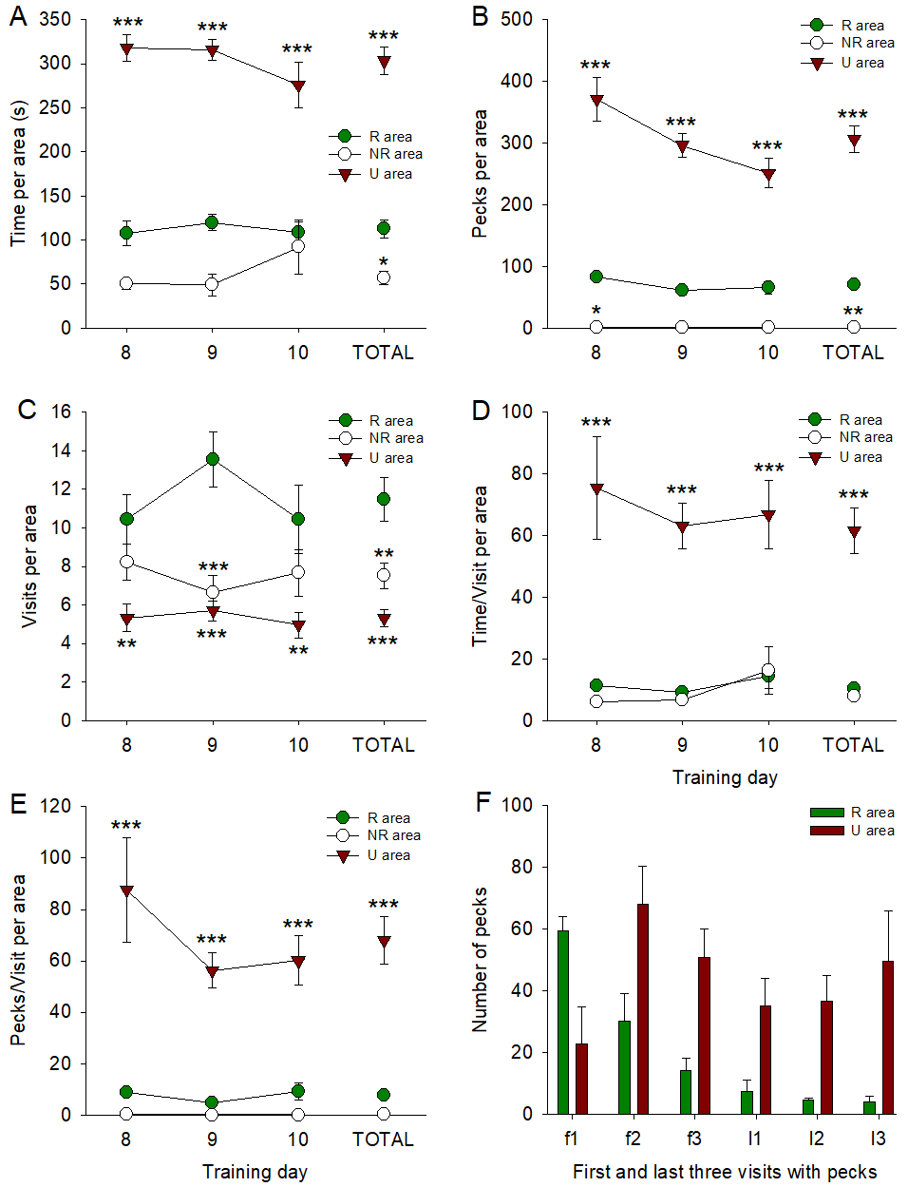
Note: Experiment 1: (A) Time spent per area. (B) Number of pecks per area. (C) Number of visits per area. (D) Time-per-visit ratio per area. (E) Pecks-per-visit ratio per area. (F) Number of pecks during the first three and the last three visits that included pecks across days 8-10. Legends: *p < 0.05, **p < 0.01, ***p < 0.001. The asterisks denote the significant differences with the R area only. More details in the text.
To have a better idea of how the pecks were distributed between the R and the U areas over time, we reported what happened during the first three and the last three visits that contained pecks (considering more visits was not possible due to the differences across pigeons in this respect). We aimed to determine whether the pigeons ate the easily accessible food first (R area) and then switched to the harder-to-access one (U area) or whether their pecks gradually decreased in the R area while remaining relatively constant in the U area. The second hypothesis was correct (Figure 2F). During the first three visits of the R area, the number of pecks decreased and it remained low during the last three visits, F(1, 2) = 42.41, p = .02. On average, the pigeons pecked more in the R area than necessary, given the number of uncovered food items available. The U area was selected three times less than the R area on the very first visit, which makes sense in terms of the probability of reward per hole. But, pecking behavior remained higher on average and relatively constant over time in the U area, F(1, 2) = 7.91, p = .106.

Above, we reported evidence that the pigeons spent more time and gave more pecks in a covered U area than in an uncovered R area. They also visited the covered U area less often than the uncovered R area, leading to higher time-per-visit and pecks-per-visit ratios in the U than in the R area. As the R area emptied, the pigeons persisted in investing effort in the U area. To quantify the pigeons’ investment in the U area, we compared the values of the observed ratios in the U area with their expected values, assuming that the food items decreased at the same rate in the R and U areas. Specifically, the U-observed ratios were the real ratio values (time per visit, pecks per visit, and consumption per visit), calculated for 60 holes with the average values of the last three training days. They were unrelated to the values in the R area. By contrast, the U-expected ratios were the values in the R area divided by 3 since food density was three times lower in the U area. For example, the U-expected value of time per visit for pigeon x was calculated as follows: ((time value of x in R)/3)/((number of visits of x in R)/3). Only the values per visit were analyzed because, contrary to the values per area, they violated the expectations from the matching law. Here, our goal was to determine the extent of such violations.

Given our calculations, a perfect positive correlation and equivalent ratios existed between the R and the U-expected responses, so we determined how the observed responses in the U area deviated from the U-expected responses (i.e., from what they should be if behavior strictly matched reinforcement rate). Spearman’s r correlation between the observed and expected time-per-visit ratios for each pigeon in the U area was positive and significant (Figure 3A), r = .76, p = .018. A repeated-measures ANOVA showed that the observed duration per visit was significantly longer than expected in the U area, F(1, 8) = 58.48, p < .001, η_{p}² = .88. A similar tendency was found regarding the pecks-per-visit ratios, with a positive and significant correlation between the observed and expected values for each pigeon in the U area (Figure 3B), r = .76, p = .019. The observed number of pecks per visit was significantly higher than expected in the U area, F(1, 8) = 52.43, p < .001, η_{p}² = .87. Applied to food consumption, these analyses also indicated a positive and significant correlation between the observed and expected consumption-per-visit ratios (Figure 3C), r = .92, p < .001, but the repeated-measures ANOVA revealed an observed consumption per visit lower than expected, F(1, 8) = 18.35, p = .003, η_{p}² = .70.

Figure 3

Correlational analysis between the expected and the observed performance in the U area.

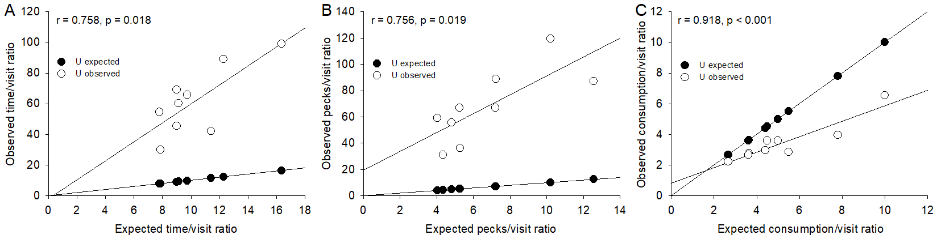
Note: Experiment 1: (A) Time per visit. (B) Pecks per visit. (C) Consumption per visit. The two regression lines show how the observed individual responses (open circles) in the U area deviate from their expected values (black circles), predicted by the pigeons’ responses in the R area.

Experiment 2: Method

In Experiment 1, the pigeons had to choose between visible food items (R area) and the same number of harder-to-access food items (i.e., hidden behind a cover and omitted in 2/3 of the possible locations [U area]). Each area was cued differently, including a NR area. This configuration let the pigeons deplete the R area while maintaining seeking behavior in the U area at a relatively constant, high rate. The time-per-visit and the pecks-per-visit ratios showed a clear-cut higher investment in the U area—as discussed further, similar findings were also found when all the areas were covered (Anselme et al., 2022). Experiment 2 introduced some variations in this design. Its aim was to amplify the degree of uncertainty and hence, to determine whether the pigeons were still willing to work harder, at least per visit, in the U area. First, the NR area was removed, as it was poorly attractive in Experiment 1. Second, the R area was covered, so the pigeons could not detect food without hole inspection. Third, no wall cues were used, as we do not know whether they had any influence on performance and preference in Experiment 1. Fourth, the number of food items available in the U area was changed daily (not just changed in their distribution, as previously), although this number was in total equivalent to that of the R area across days.

Animals and Apparatus

The same nine pigeons were housed as in Experiment 1. A board with 180 holes was also used, although the general configuration in the apparatus differed in several respects (Figure 4A). As reported above, the NR area and the cues were no longer used, and the holes were all covered in the R and the U areas, with a cross cut in the plastic tape to create an opening above each hole. The R and the U areas were delimited using blue-white strips, glued on the board’s cover. Specifically, a rectangle of 40 holes (8 holes × 5 holes) was delimited at the center of the board, symmetric relative to each lateral side of the apparatus. The area around this central rectangle therefore contained 140 holes. It must be noted that Experiments 1 and 2 were not counterbalanced. However, a 2-month interval separated both experiments, there was not much to learn on the board apart from the hole-food association required to do the task, and the easiest condition was tested first.

Figure 4

Food consumption in the covered R and U areas.

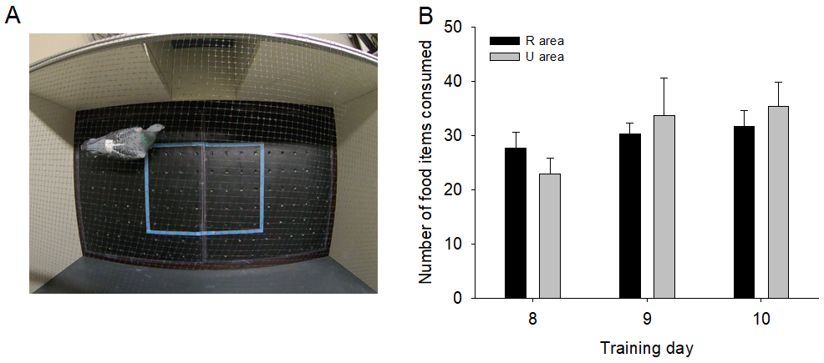
Note: Experiment 2. (A) Board 180 with two areas: 40 covered holes (R area, central rectangle) and 140 covered holes (U area). (B) Number of food items consumed during days 8-10 in the R and the U areas.

Procedure

The procedure was the same as in Experiment 1. However, the distribution of the food items was different. At the beginning of a session (10 min a day), each of the 40 holes in the central rectangle contained one food item, characterizing the R area. The remaining 140 holes around the central rectangle represented the U area, some holes being baited and the others empty. To amplify the feeling of uncertainty, the number of food items in the U area changed from day to day for 10 days. For one half of the pigeons, the number of food items per session in the U area followed this sequence: 40 – 54 – 26 – 10 – 70 – 40 – 50 – 60 – 20 – 30. Thus, the percentage of baited holes varied between 7.1% and 50%, with an average of 40 food items across the 10 sessions (i.e., the number of food items found each day in the R area). The other half of the pigeons were exposed to the reverse sequence to counterbalance for possible positive or negative contrast effects. The proportion of holes in the R and the U areas (40 vs. 140) was similar to that of Experiment 1 (30 vs. 90). The two areas were arranged differently due to the absence of a NR area and the need to respect lateral symmetry in the apparatus.

Experiment 2: Results

The pigeons’ body weight remained stable over the last three days (day 8: 430.8 ± 10.8 g; day 9: 424.4 ± 10.8 g; day 10: 426.5 ± 9.7 g, F(2, 16) = 2.81, p = .09, η_{p}² = .26, and they ate a statistically similar number of food items in the R and the U areas (Figure 4B), F(5, 40) = 1.96, p = .106, η_{p}² = .20.

The use of the board was analyzed after equalizing both areas regarding the number of holes; the values reported in Figures 5 and 6 refer to 60 holes. Across days, the pigeons spent significantly more time in the R than in the U area (Figure 5A; days 8-10), F(5, 40) = 23.97, p < .001, η_{p}² = .75, and post-hoc analysis showed that the difference was significant on each day (ps = .0001). The durations remained stable in both areas (all ps ≥ .998). Accordingly, the totals for the three days combined in each area indicated a significantly higher time spent in the R than in the U area, totals: F(1, 8) = 116.22, p < .001, η_{p}² = .93.

The number of pecks per area displayed a similar pattern. The pigeons gave significantly more pecks in the R than in the U area across days (Figure 5B; days 8-10), F(5, 40) = 23.48, p < .001, η_{p}² = .74, and the effect occurred each day (ps = .0001). In each area, pecking behavior did not statistically differ over the three days (all ps ≥ .938). The totals revealed a higher number of pecks in the R as opposed to the U area, totals: F(1, 8) = 139.83, p < .001, η_{p}² = .94.

The number of visits per area was significantly higher in the R than in the U area across days (Fig5C; days 8-10), F(5, 40) = 86.47, p < .001, η_{p}² = .91, as well as for each day (ps = .0001). Post-hoc analysis showed that, in the R area, a significant increase in the number of visits occurred between days 8 and 10 (p = .0005), although the apparent increase from one day to the next remained non-significant (ps ≥ .180). In the U area, no significant changes were found (ps ≥ .650). In totals, the R area was visited a significantly higher number of times compared to the U area, F(1, 8) = 291.22, p < .001, η_{p}² = .97.

Figure 5

Use of the board.

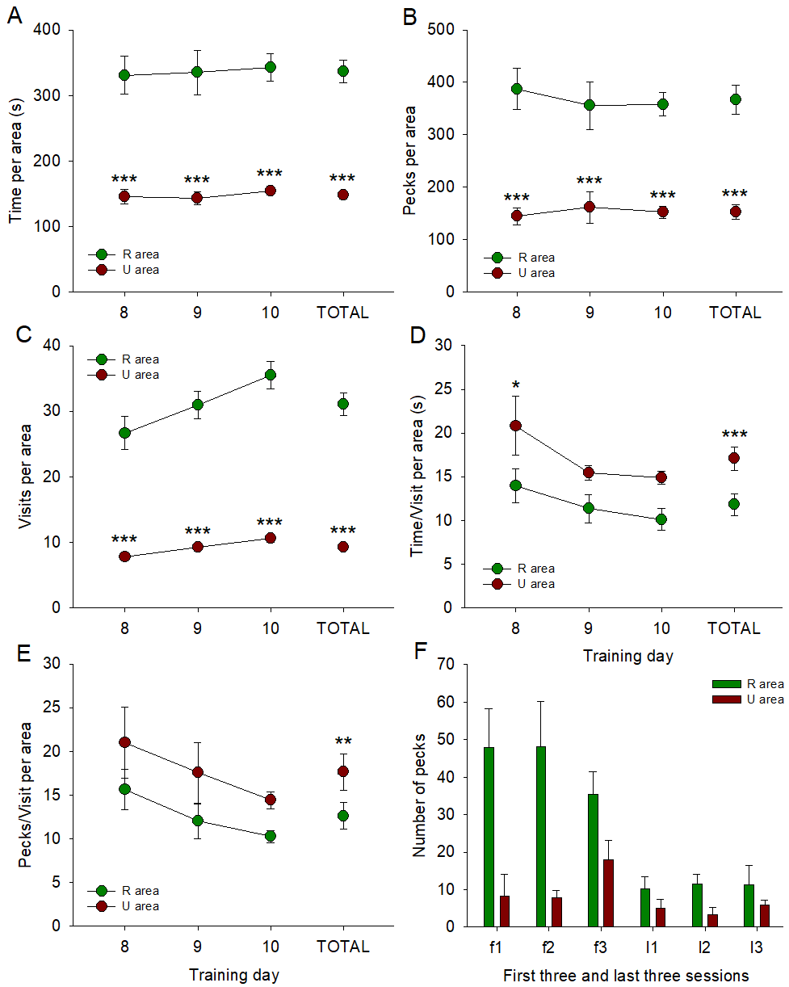
Note: Experiment 2: (A) Time spent per area. (B) Number of pecks per area. (C) Number of visits per area. (D) Time-per-visit ratio per area. (E) Pecks-per-visit ratio per area. (F) Number of pecks during the first three and the last three visits that included pecks across days 8-10.
The findings of longer durations, more pecks, and more visits in the R area as opposed to the U area with covered holes are not surprising and are consistent with a central prediction of the matching law. In case of strict matching, the law predicts that the time-per-visit and the pecks-per-visit ratios should be equivalent in the R and the U areas (i.e., an investment in each area proportional to the expected reward rate). However, the time-per-visit ratio (for 60 holes) was significantly higher in the U area relative to the R area across the three days (Figure 5D; days 8-10), F(5, 40) = 6.16, p < .001, η_{p}² = .43, a difference that was only significant on day 8 (p = .029). No significant decreases in performance were shown in any area. The totals indicated a significantly higher time-per-visit in the U than in the R area, F(1, 8) = 67.20, p < .001, η_{p}² = .89. With respect to the pecks-per-visit ratio, the overall comparison across the three days was significantly higher in the U than in the R area (Figure 5E; days 8-10), F(5, 40) = 3.55, p = .009, η_{p}² = .31. But none of the daily comparisons was significant (ps ≥ .410). The totals showed a higher pecking activity per visit in the U than the R area, F(1, 8) = 26.07, p = .001, η_{p}² = .76. Figure 5F illustrates how the pigeons pecked during the first three and the last three visits that included pecks. In the R area, there was a non-significant trend for a decrease in responding between the first three and the last three visits including peck, F(1, 2) = 18.12, p = .051. In the U area, pecking behavior remained constant over time, F(1, 2) = 3.14, p = .218.

We correlated the expected and the observed ratio values (time, pecks, and consumption per visit) in the U area. A positive and significant Spearman’s r correlation was found between the observed and the expected time-per-visit ratios (Figure 6A), r = .76, p = .018. A repeated-measures ANOVA between those ratios for each pigeon showed an observed duration per visit significantly longer than expected in the U area, F(1, 8) = 45.72, p < .001, η_{p}² = .85. The observed number of pecks per visit was also positively and significantly correlated with the expected values (Figure 6B), r = .83, p = .005, and the observed values were significantly higher than the expected ones in the U area, F(1, 8) = 25.17, p = .001, η_{p}² = .76. Applied to food consumption per visit, the correlation was positive and significant (Figure 6C), r = .93, p < .001, and the observed consumption per visit was higher than expected, F(1, 8) = 48.45, p < .001, η_{p}² = .86.

Figure 6

Correlational analysis between the expected and the observed performance in the U area.

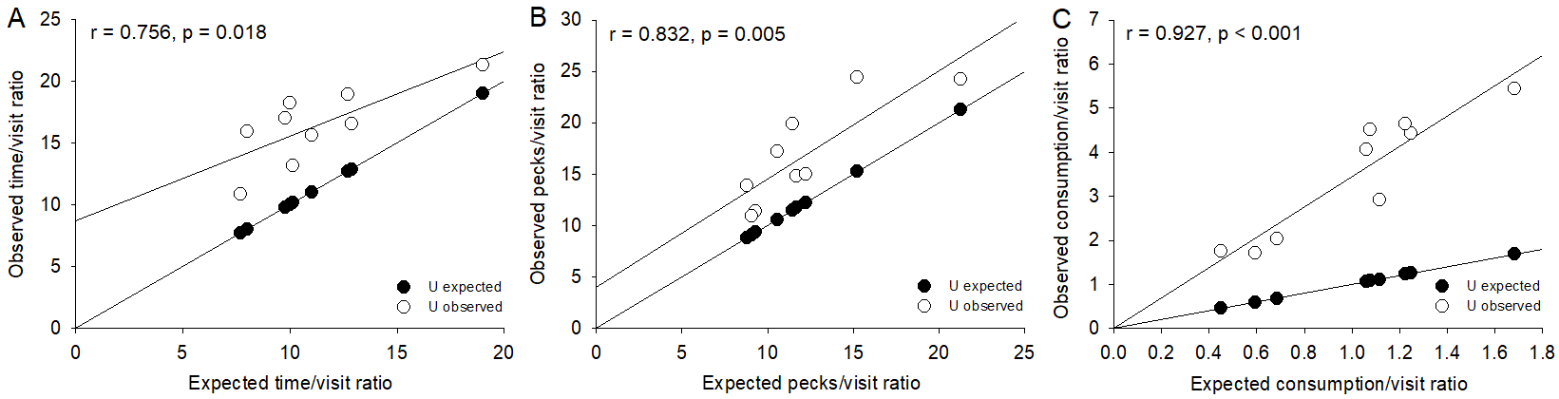
Note: Experiment 2: (A) Time per visit. (B) Pecks per visit. (C) Consumption per visit. The two regression lines show how the observed individual responses (open circles) in the U area deviate from their expected values (black circles), predicted by the pigeons’ responses in the R area.

General Discussion

We demonstrated that pigeons have a propensity to invest more time and effort in the task of seeking locally unguaranteed food items (i.e., U area), but also that the vigorousness of seeking behavior depends on the information available about the depletion status of initially guaranteed food items (i.e., R area). In Experiment 1, pigeons had to choose between exploring a U area in which 30 food items were cued, hidden, and randomly distributed in 90 holes and exploiting a R area in which 30 food items were also cued but visible and predictable in each of the 30 holes at the beginning of a session. More time and more pecks, but fewer visits, were found in the U area as opposed to the R area. Accordingly, the time- and pecks-per-visit ratios were higher in the U area, and higher than expected if foraging activity was under strict control of reinforcement rate. Nevertheless, the pigeons ate less than expected.

In Experiment 2, pigeons had to choose between exploring a U area in which 40 food items (on average) were hidden, randomly distributed in 140 holes, subject to daily variation in amount, and not cued, and exploiting a R area in which 40 food items were also hidden and not cued but predictable in each of the 40 holes at the beginning of a session. As previously, the number of visits per area was lower in the U than the R area, the time- and pecks-per-visit ratios were higher in the U area (at least, with the three days combined), and these ratios were higher than expected by reinforcement rate alone. However, the pigeons spent more time and gave more pecks in the R than the U area and ate more food than expected if consumption was under strict control of reinforcement rate. Thus, in both experiments, the pigeons showed some willingness to invest more foraging time and effort per visit in the U area, and this was particularly obvious when the food items in the R area were directly visible. They ate statistically similar amounts of food in both experiments.

Let us begin with the two major differences that emerge between the results of both experiments. First, the time spent, and the number of pecks given per area were higher in the U area when the food items were visible in the R area (Experiment 1) but lower in the U area when the food items were not visible in the R area (Experiment 2). Because the U and the R areas were adjacent to each other in both experiments, no penalty can be invoked to explain the observed differences in foraging time and effort. In Experiment 1, the U area became quickly more inspected than the R area, probably because the pigeons could estimate by sight the food depletion status in the non-covered R area. Once totally emptied, the R area was no longer a profitable option, and the pigeons invested all their time and effort trying to obtain a maximal number of food items in the U area. This situation represented a forced rather than free choice, and we saw an inversion of preference from the R to the U area as soon as the second visit. Put simply, after a time, choosing the covered U area was the only opportunity for the pigeons to continue eating. By contrast, in Experiment 2, the R area was covered, so its depletion status after multiple pecks could not easily be assessed—and became as uncertain as in the U area. One possible explanation for the multiple revisits in the R area is that pigeons failed to remember the locations they inspected previously (Roberts, 1988; Spetch & Edwards, 1986; Wittek et al., 2022). In this case, the pigeons showed a motivational/cognitive bias for more investment in the R area, which was the most profitable option at the beginning of a session. If the number of visits in an area is indicative of a preferred place, we can argue that the R area was preferred over the U area when both were covered.

The second major difference between Experiments 1 and 2 is the lower food consumption per visit than expected from reinforcement theory in the U area in Experiment 1 and the higher food consumption per visit than expected in the U area in Experiment 2. The correlational results shown in Figures 3C and 6C capture the origin of this difference. Once equalized for 60 holes, consumption in the R area was higher in Experiment 1 (53.9 ± 3.1 items)—food items not covered—than in Experiment 2 (29.9 ± 2.5 items)—food items covered. Given that the U-expected consumption values were calculated based on consumption in the R area, the range of those values were therefore higher in Experiment 1 (2.7 – 10) than in Experiment 2 (0.4 – 1.7), for quite similar ranges with respect to U-observed consumption values (2.2 – 6.5 and 1.7 – 5.4, respectively). The high expected consumption values relative to the observed consumption values in the U area in Experiment 1 explain why the pigeons ate less than expected.

By contrast, the low expected consumption values relative to the observed consumption values in the U area in Experiment 2 explain why the pigeons ate more than expected. Interestingly, however, the pigeons ate the same amounts of food in the R and U areas in both experiments. This indicates that an overinvestment in time and effort (at least per visit) in the U area was necessary to collect a number of food items statistically equivalent to that found in the R area. This conclusion is based on correlational rather than causal analysis, which would have been required to determine whether successful pecks were preceded by longer inspection times. But—at least in Experiment 2—a downward adjustment of foraging activity to reward rate in the U area, predicted by the matching law, would not have allowed the pigeons to extract as many food items as possible in the U area. Food uncertainty per hole forced the pigeons to work harder (overmatching) than expected from reinforcement theory in order to exploit the U area maximally (i.e., as efficiently as the R area). A similar result had also been obtained with the holes covered in both the R and U areas, using the design of Experiment 1 (Anselme et al., 2022).

In many choice situations, behavior deviates from what the matching law predicts (McDowell, 2013; Strand et al., 2022), and the indiscriminate use of this principle—in other words, ignoring the ecological conditions in which organisms operate or the psychological processes at stake—is problematic (Houston et al., 2021; Kacelnik & Todd, 1992). However, our experimental design did not allow us to determine the rate at which reinforcement decreased over a session. The matching law is therefore not applicable in the strict sense. Instead of reinforcement rate, we used the outcome (food consumption) for the comparison. Nevertheless, the absence of significant difference in the number of food items consumed in the U and the R areas strongly suggests that the additional time and effort spent scrutinizing and pecking at the holes in the U area is responsible for the pigeons’ foraging success in this area.

According to the marginal value theorem (Charnov, 1976), an area should be left earlier if depleted more quickly. This is what clearly happened in Experiment 1 with respect to the non-covered R area since the food items were visible. However, when performance was analyzed per visit, Experiments 1 and 2 showed a higher investment in the U area compared to R area of equivalent size (60 holes). Thus, the accessibility of predictable food items at start (covered vs. not covered) has no strong influence on foraging investment per visit in a covered area containing unpredictable food items. The U area was not more profitable in the absolute, but the animal may somehow perceive failure to eat under uncertainty as the consequence of a lack of investment in foraging—while failure to eat under initial certainty is a consequence of food depletion in the environment.

One possible limitation of this study is that we reused pigeons from a related experiment. However, as mentioned earlier, there was a gap of several months between the experiments. Also, despite similar preferential investment per visit in the U area, we saw that the pigeons adjusted their behavior to the experienced situations rather than showing inflexible response patterns across experiments. So, there is no clear evidence that previous training had significant effects here.

Another possible limitation is that Experiment 2 differed from Experiment 1 in several respects: no NR area, no cues on the walls, R area covered, and daily variation in food amounts in the U area. However, the results of Experiment 2 appear very similar to those of an already published study in which the design of Experiment 1 was used with covered holes in the R and NR areas (Anselme et al., 2022). In both cases, the pigeons spent more time and gave more pecks in the R area but showed higher time-per-visit and pecks-per-visit ratios in the U area—with a tendency to eat more food items per visit than expected. Perhaps the absence of a NR area and of wall cues explains why the pigeons alternated choice between the R and the U areas very often, causing more visits than in the previous study. But this did not change the behavioral patterns of interest. A perfect control would consist of replicating Experiment 1 (uncovered R area) using the layout of Experiment 2, that is, a central R area representing 1/3 of the total surface available—instead of 1/3 of one half of the board. However, given the similar results obtained in Experiment 2 and the Experiment 2 reported in Anselme et al. (2022), we think that most of the differences in design between Experiments 1 and 2 in the present paper have no real impact on the pigeons’ foraging behaviors. The only difference that appears to matter is the presence or the absence of a hole cover in the R area.

The evidence that pigeons work harder in an uncertain environment is in line with findings collected by means of various experimental procedures. Mammals and birds increase their response rates to a cue randomly followed by food or nothing (Anselme et al., 2013; Bateson et al., 2021; Crawford et al., 1985; Gottlieb, 2004; Rauwolf et al., 2021; Robinson et al., 2019) or in situations of unpredictable food shortage (Dickins & Schalz, 2020; Srivastava et al., 2015), compared to their safer counterparts. Also, the responses to a low probability of food are more variable in their expression than when food probability is higher (Blaisdell et al., 2016). Donoso et al. (2021) developed a simple neural associative computational model to identify the mechanisms that drive the emergence of new, previously non or less reinforced behaviors after a decrease in reward of a previously established behavior (Packheiser et al., 2019; 2021). They discovered that mere associative learning, combined with a decision-making process that rests on winner-takes-all, gives rise to exploratory behaviors and persistence on previously unrewarded or less rewarded responses. This is not to say that animals develop motivational attraction for uncertain rewards, like they do for highly expected foods and drugs (Berridge, 2007), in which case they should prefer a reward-related cue predictive of uncertainty compared to certainty (Anselme, 2021; Anselme & Güntürkün, 2019). As noted earlier, they do not typically exhibit such a preference (pigs: de Jonge et al., 2008; macaques: Eisenreich et al., 2019; humans: Gneezy et al., 2006; fish: Purdy & Peel, 1988; pigeons: Wilton & Clements, 1971). If we assume that the number of visits per area is a good proxy of preference, our present data are compatible with this fact, since the R area received more visits than the U area in both experiments.

However, reward uncertainty represents a major environmental challenge that organisms must overcome or resolve to improve their survival and/or reproductive success. The widespread stimulating effects of reward uncertainty on behavior are difficult to understand without suggesting that they have an evolutionary function, which might be to respond to challenging situations involving unguaranteed reward (Anselme, 2023). Abrams (1991) showed that foraging effort should increase in the aim of minimizing mortality, in case food density is too low or its increase too temporary. Overmatching under reward uncertainty on the board could be the consequence of a motivation to put more (rather than less, as traditionally predicted) time and effort in the task because countering/resolving uncertainty matters. Current evidence indeed suggests that pigeons are excellent information seekers (Herbranson, 2012; Wilton & Clements, 1971) and strongly intolerant to delayed outcomes (Mazur & Biondi, 2009), especially if non-signaled. Accordingly, they prefer to receive less food from an option in which two cues are consistently predictive of food or no food, respectively, over receiving more food when the possible cues are both inconsistent (e.g., Fortes et al., 2016; Smith & Zentall, 2016). Our findings provide further evidence that pigeons prefer consistent cue-reward pairings (hole-food pairings in the R area) but invest more time and effort when those pairings are inconsistent (U area).

Acknowledgments

This work was supported by the Deutsche Forschungsgemeinschaft (DFG) through An1067/3-1 (PA) and project number 316803389 – SFB 1280, subproject A1.

References

Abrams, P. A. (1991). Life history and the relationship between food availability and foraging effort. Ecology, 72(4),
1242–1252. https://doi.org/10.2307/1941098
Anselme, P. (2021). Effort-motivated behavior resolves paradoxes in appetitive conditioning. Behavioural Processes, 193, 104525. https://doi.org/10.1016/j.beproc.2021.104525
Anselme, P. (2023). Exploratory search: Information matters more than primary reward. Animal Behavior and Cognition, 10(4), 366–383. https://doi.org/10.26451/abc.10.04.05.2023
Anselme, P. & Güntürkün, O. (2019). How foraging works: Uncertainty magnifies food seeking motivation. Behavioral and Brain Sciences, 42(e35), 1–59. https://doi.org/10.1017/S0140525X18000948
Anselme, P., Dreher, T., & Güntürkün, O. (2018). Pigeons consistently prefer easy over harder access to food: No reversal after direct dopaminergic stimulation. Behavioral Neuroscience, 132(4), 293–301.
http://dx.doi.org/10.1037/bne0000249
Anselme, P., Robinson, M. J. F., & Berridge, K. C. (2013). Reward uncertainty enhances incentive salience attribution as sign-tracking. Behavioural Brain Research, 238, 53–61. https://doi.org/10.1016/j.bbr.2012.10.006
Anselme, P., Wittek, N., Oeksuez, F., & Güntürkün, O. (2022). Overmatching under food uncertainty in foraging pigeons. Behavioural Processes, 201, 104728. https://doi.org/10.1016/j.beproc.2022.104728
Bateson, M., Andrews, C., Dunn, J., Egger, C. B. C. M., Gray, F., Mchugh, M., & Nettle, D. (2021). Food insecurity increases energetic efficiency, not food consumption: An exploratory study in European starlings. Peer J, 9, e11541. https://doi.org/10.7717/peerj.11541
Baum, W. M. (1974). On two types of deviation from the matching law: Bias and undermatching. Journal of the Experimental Analysis of Behavior, 22(1), 231–242. https://doi.org/10.1901/jeab.1974.22-231
Blaisdell, A. P., Stolyarova, A., & Stahlman, W. D. (2016). The law of expect or a modified law of effect? Outcome expectation and variation in learned behavior. Conductal, 4(2), 61–90. https://doi.org/10.59792/VEEC8896
Charnov, E. L. (1976). Optimal foraging, the marginal value theorem. Theoretical Population Biology, 9(2), 129–136. https://doi.org/10.1016/0040-5809(76)90040-X
Crawford, L. L., Steirn, J. N., & Pavlik, W. B. (1985). Within- and between-subjects partial reinforcement effects with an autoshaped response using Japanese quail (Coturnix coturnix japonica). Animal Learning and Behavior, 13, 85–92. https://doi.org/10.3758/BF03213369
de Jonge, F. H., Ooms, M., Kuurman, W. W., Maes, J. H. R., & Spruijt, B. M. (2008). Are pigs sensitive to variability in food rewards? Applied Animal Behaviour Science, 114(1-2), 93–104.
https://doi.org/10.1016/j.applanim.2008.01.004
Dickins, T. E., & Schalz, S. (2020). Food shopping under risk and uncertainty. Learning and Motivation, 72, 101681. https://doi.org/10.1016/j.lmot.2020.101681
Donoso, J. R., Packheiser, J., Pusch, R., Lederer, Z., Walther, T., Uengoer, M., Lachnit, M., Güntürkün, O., & Cheng, S. (2021). Emergence of complex dynamics of choice due to repeated exposures to extinction learning, Animal Cognition, 6, 1279–1297. https://doi.org/10.1007/s10071-021-01521-4
Eisenreich, B. R., Hayden, B. Y., & Zimmermann, J. (2019). Macaques are risk-averse in a freely moving foraging task. Scientific Reports, 9, 15091. https://doi.org/10.1038/s41598-019-51442-z
FitzGibbon, L., Lau, J. K. L., & Murayama, K. (2020). The seductive lure of curiosity: Information as a motivationally
salient reward. Current Opinion in Behavioral Sciences, 35, 21–27.
https://doi.org/10.1016/j.cobeha.2020.05.014
Fortes, I., Vasconcelos, M., & Machado, A. (2016). Testing the boundaries of “paradoxical” predictions: Pigeons do disregard bad news. Journal of Experimental Psychology: Animal Learning and Cognition, 42(4), 336–346. https://doi.org/10.1037/xan0000114
Glueck, A. C., Torres, C., & Papini, M. R. (2018). Transfer between anticipatory and consummatory tasks involving reward loss. Learning and Motivation, 63, 105–125. https://doi.org/10.1016/j.lmot.2018.05.001

Gneezy, U., List, J. A., & Wu, G. (2006). The uncertainty effect: When a risky prospect is valued less than its worst
possible outcome. The Quarterly Journal of Economics, 121(4), 1283–1309. https://doi.org/10.1093/qje/121.4.1283
Gottlieb, D. A. (2004). Acquisition with partial and continuous reinforcement in pigeon autoshaping. Learning and Behavior, 32, 321–334. https://doi.org/10.3758/BF03196031
Herbranson, W. T. (2012). Pigeons, humans, and the Monty Hall dilemma. Current Directions in Psychological Science, 21(5), 297–301. https://doi.org/10.1177/0963721412453585
Herrnstein, R. J. (1961). Relative and absolute strength of response as a function of frequency of reinforcement. Journal of the Experimental Analysis of Behavior, 4(3), 267–272. https://doi.org/10.1901/jeab.1961.4-267
Houston, A. I., Trimmer, P. C., & McNamara, J. M. (2021). Matching behaviours and rewards. Trends in Cognitive Sciences, 25(5), 403–415. https://doi.org/10.1016/j.tics.2021.01.011
Kacelnik, A., & Todd, I. A. (1992). Psychological mechanisms and the marginal value theorem: Effect of variability in travel time on patch exploitation. Animal Behaviour, 43(2), 313–322.
https://doi.org/10.1016/S0003-3472(05)80226-X
Lattal, M. K., & Lattal, K. A. (2012). Facets of Pavlovian and operant extinction. Behavioural Processes, 90(1), 1–8. https://doi.org/10.1016/j.beproc.2012.03.009
Mazur, J. E., & Biondi, D. R. (2009). Delay-amount tradeoffs in choices by pigeons and rats: Hyperbolic versus exponential discounting. Journal of the Experimental Analysis of Behavior, 91(2), 197–211.
http://dx.doi.org/10.1901/jeab.2009.91-197
McDowell, J. J. (2013). On the theoretical and empirical status of the matching law and matching theory. Psychological Bulletin, 139(5), 1000–1028. https://doi.org/10.1037/a0029924
Packheiser, J, Güntürkün, O. & Pusch, R. (2019). Renewal of extinguished behavior in pigeons (Columba livia) does not require memory consolidation of acquisition or extinction in one-day free-operant appetitive conditioning paradigms. Behavioural Brain Research, 370, 111947. https://doi.org/10.1016/j.bbr.2019.111947
Packheiser, J., Donoso, J. R., Cheng, S., Güntürkün, O., & Pusch, R. (2021). Trial-by-trial dynamics of reward prediction errors during extinction learning and renewal. Progress in Neurobiology, 197, 101901.
https://doi.org/10.1016/j.pneurobio.2020.101901
Purdy, J. E., & Peel, J. L. (1988). Observing response in goldfish (Carassius uratus). Journal of Comparative Psychology, 102(2), 160–168. https://doi.org/10.1037/0735-7036.102.2.160
Rauwolf, P., Millard, S. K., Wong, N., Witt, A., Davies, T. J., Cahill, A. M., Madden, G. J., Parkinson, J. A., & Rogers, R. D. (2021). “Just not knowing” can make life sweeter (and saltier): Reward uncertainty alters the sensory experience and consumption of palatable food and drinks. Journal of Experimental Psychology: General, 150(10), 2015–2035. https://doi.org/10.1037/xge0001029
Roberts, W. A. (1988). Foraging and spatial memory in pigeons (Columba livia). Journal of Comparative Psychology, 102(2), 108–117. https://doi.org/10.1037/0735-7036.102.2.108
Robinson, M. J. F., Anselme, P., Fischer, A. M., & Berridge, K. C. (2014). Initial uncertainty in Pavlovian reward prediction persistently elevates incentive salience and extends sign-tracking to normally unattractive cues. Behavioural Brain Research, 266, 119–130. https://doi.org/10.1016/j.bbr.2014.03.004
Robinson, M. J. F., Clibanoff, C., Freeland, C. M., Knes, A. S., Cote, J. R., & Russell, T. I. (2019). Distinguishing between predictive and incentive value of uncertain gambling-like cues in a Pavlovian autoshaping task. Behavioural Brain Research, 371, 111971. https://doi.org/10.1016/j.bbr.2019.111971
Rodriguez Cabrero, J. A. M. R., Zhu, J. -Q., & Ludvig, E. A. (2019). Costly curiosity: People pay a price to resolve an uncertain gamble early. Behavioural Processes, 160, 20–25. https://doi.org/10.1016/j.beproc.2018.12.015
Smith, A. P., & Zentall, T. R. (2016). Suboptimal choice in pigeons: Choice is primarily based on the value of the conditioned reinforcers rather than overall reinforcement rate. Journal of Experimental Psychology: Animal Learning and Cognition, 42(2), 212–220. https://doi.org/10.1037/xan0000092
Spetch, M. L., & Edwards, C. A. (1986). Spatial memory in pigeons (Columba livia) in an open-field feeding environment. Journal of Comparative Psychology, 100(3), 266–278. https://doi.org/10.1037/0735-7036.100.3.266
Srivastava, A., Malik, S., Yadav, G., & Rani, S. (2015). Intermittent food absence motivates reallocation of locomotion and feeding in spotted munia (Lonchura punctulata). Journal of Circadian Rhythms, 13(5), 1–7.
http://dx.doi.org/10.5334/jcr.af
Stahlman, W. D., & Blaisdell, A. P. (2011). Reward probability and the variability of foraging behavior in rats. International Journal of Comparative Psychology, 24(2), 168–176. https://doi.org/10.46867/ijcp.2011.24.02.05
Stephens, D. W., & Krebs, J. R. (1986). Foraging Theory. Princeton: Princeton University Press.

Strand, P. S., Robinson, M. J. F., Fiedler, K. R., Learn, R., & Anselme, P. (2022). Quantifying the instrumental and
non-instrumental underpinnings of Pavlovian responding with the Price equation. Psychonomic Bulletin and Review, 29, 1295–1306. https://doi.org/10.3758/s13423–021-02047-z
Tinsley, M. R., Timberlake, W., Sitomer, M., & Widman, D. R. (2002). Conditioned inhibitory effects of discriminated Pavlovian training with food in rats depend on interactions of search modes, related repertoires, and response measures. Animal Learning and Behavior, 30, 217–227. https://doi.org/10.3758/BF03192831
Wang, M. Z., & Hayden, B. Y. (2019). Monkeys are curious about counterfactual outcomes. Cognition, 189, 1–10. https://doi.org/10.1016/j.cognition.2019.03.009
Vasconcelos, M., Monteiro, T., & Kacelnik, A. (2015). Irrational choice and the value of information. Scientific Reports, 5, 13874. https://doi.org/10.1038/srep13874
Wilton, R. N., & Clements, R. O. (1971). Observing responses and informative stimuli. Journal of the Experimental Analysis of Behavior, 15(2), 199–204. https://doi.org/10.1901/jeab.1971.15-199
Wittek, N., Oeksuez, F., Güntürkün, O., & Anselme, P. (2022). More opportunities to peck for identical food availability increases foraging efficiency in pigeons. Behaviour, 159(13-14), 1201–1224.
https://doi.org/10.1163/1568539X-bja10173

Financial conflict of interest: No stated conflicts.
Conflict of interest: No stated conflicts.
Submitted: September 26th, 2023
Resubmitted: December 15th, 2023
Accepted: January 8th, 2024

